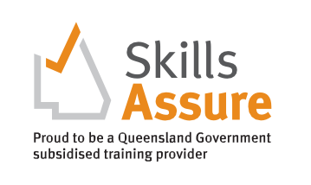
HLTSS00064 Infection Control Skill Set (Health)
Higher Level Skills Program
COURSE OVERVIEW

This unit describes the skills and knowledge required to follow organisational infection prevention and control procedures, including implementing standard and transmission-based precautions and responding to infection risks.
Students will learn the skills and knowledge required to follow organisational infection prevention and control procedures. This nationally accredited training includes implementing standard and transmission-based precautions, responding to standard and transmission-based events and, responding to infection risks.

This course is essential in developing your workplace health and safety capacity. It has been contextualised to meet the immediate need for workers in various roles in the Health Industry to upskill in infection control.

WHY A SKILL SET?
A skill set is one or more competencies grouped together to give you the skills and knowledge to perform practical tasks.
COURSE DETAILS

Start Date
Enrol anytime
Students will be able to access their online learning materials once they finalise their enrolment process, and all outstanding fees are paid. Students are expected to attend Intensive sessions and be assessed in the workplace to complete this skill set.

Location
9 George Street, Caloundra

Delivery mode
Online learning and assessment with one (1) day Intensive on Campus and workplace training and assessment.

Practical Workshops
Will be set once online unit is completed

Units of Competency
Core Unit
- HLTINF001 Comply with infection prevention and control policies and procedures

Award Issued
Statement of Attainment certificate

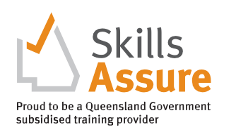
Higher Level Skills Program
COURSE ENTRY
EQUIPMENT REQUIREMENTS

To be eligible for the Higher-Level Skills program, individuals must:
- be employed in the Aged, Disability or Community care industries in a care support role
- have sound literacy, numeracy, and computer skills.
- be aged 15 years or over.
- be no longer at school.
- permanently reside in Queensland.
- be an Australian citizen, Australian permanent resident (includes humanitarian entrant), temporary resident with the necessary visa and work permits on the pathway to permanent residency, or a New Zealand citizen.

TRAINING AND ASSESSMENT
Students will be able to access their online learning materials once they finalise their enrolment process and all outstanding fees are paid. Once enrolled in the course, STEPS will email login details to the Learning Management System (Moodle), which contains all learning and assessment resources. The following must be completed before attending the scheduled workshops.
- Self-paced study – is time spent reading and engaging with the online content and completing the modules’ learning activities.
- Online Assessment tasks – All Units of Competency in this Skill Set contain a range of multiple-choice and short- answer written knowledge, and a range of short-medium response research activities. These assessments are submitted electronically in the LMS.

All applicants into this course will need:
- Access to a personal computer or tablet-style device with web-browser software and other general office software such as Word and PDF reader.
- It is recommended that you have access to a reliable internet connection to access STEPS Education and Training LMS and a computer with up-to-date software, including Microsoft Office, Adobe Acrobat Reader, and Adobe Flash Player.
- Scanned colour image of your own Government-issued photo-ID, an active personal email address and an active (mobile) phone number.
- A valid Unique Student Identifier (USI). If you don’t have a USI you can create one here usi.gov.au.
- To undertake a Language, Literacy, and Numeracy assessment.

- Workplace training and assessment – The Unit of Competency (UoC) HLTINF001 Comply with infection prevention and control policies and procedures require completion of workplace training and assessment tasks and activities. These activities may occur in conjunction with the Work placement activities, or they may not as the client’s care plan and availability will dictate if this can happen. Evidence is collected by the Trainer and submitted into the LMS.

Students are expected to attend the Intensive session and be assessed in the workplace to complete this skill set.

COST
PATHWAYS FROM THE COURSE

Fully Subsidised
Under High Level Skill Funding
Achievement of this unit of competency provides credit towards qualifications in a range of training packages where infection control skills are required.

