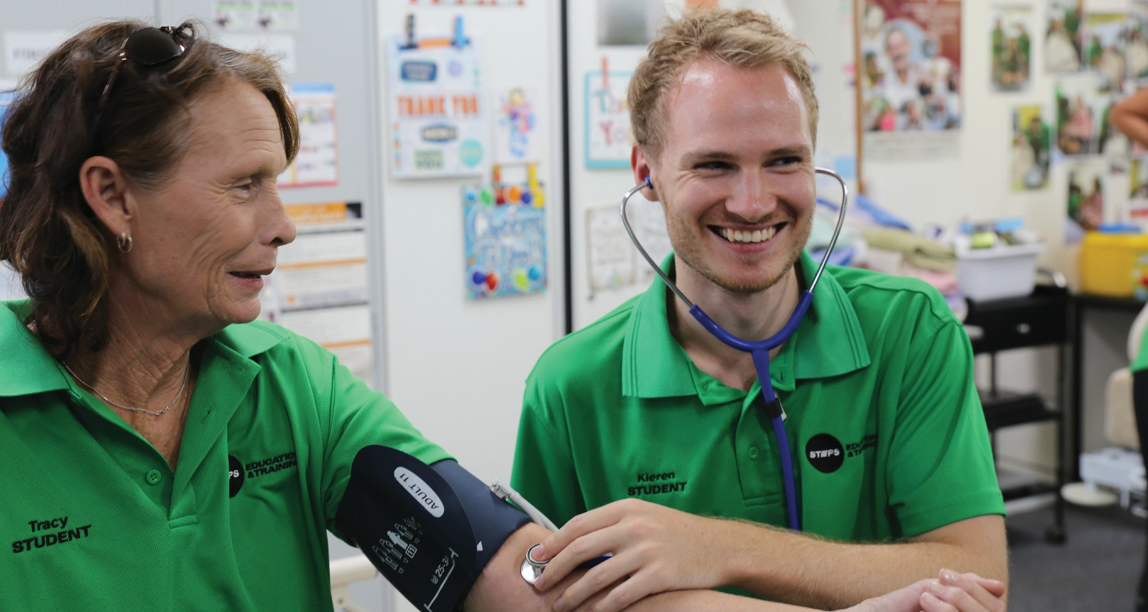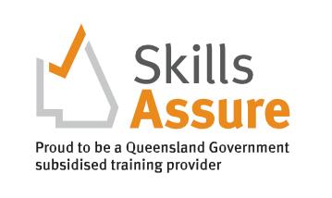
CHCSS00081 Induction to Disability Skill Set
Higher Level Skills Program
COURSE OVERVIEW

This skill set reflects the skill requirements for supporting people living with a disability. It provides a set of skills to support the induction of new workers into a variety of roles supporting people living with a disability.
This course is designed for Persons who:

Do NOT hold a qualification at Certificate III level or higher in an area involving the provision of direct client care or support for persons who have disabilities, and/or
- Are currently working in various care and support roles in the community services industry who wish to support people living with a disability.
- Require formal training and assessment in this Skill Set as per their organisation’s guidelines or employment requirements.
COURSE DETAILS

Start Date
Enrol anytime

Course Duration
5 (five) weeks
Students will be able to access their online learning materials once they finalise their enrolment process, and all outstanding fees are paid. Students are expected to attend Intensive sessions and be assessed in the workplace to complete this skill set.

Delivery mode
Blended (online learning and assessment plus workplace training and assessment)

Practical Workshops
Will be set once online unit is completed

Units of Competency
- CHCCCS015 Provide individualised support
- CHCCOM005 Communicate and work in health and community services
- HLTWHS002 Follow safe work practices for direct client care
- CHCDIS007 Facilitate the empowerment of people with disability
- HLTINF001 Comply with infection prevention and control policies and procedures

Award Issued
Statement of Attainment certificate

WHY A SKILL SET?

A skill set is one or more competencies grouped together to give you the skills and knowledge to perform practical tasks.
CLUSTERED DELIVERY

There are three clusters in this Course, with no break between each Cluster. The delivery schedule for each of the Clusters is provided in the table below:

CLUSTER | UNITS OF COMPETENCY | WEEKS | ACCUMULATED WEEKS
1 | CHCCCS015 Provide individualised support  CHCCOM005 Communicate and work in health and community services | 1 & 2 | 2
2 | HLTWHS002 Follow safe work practices for direct client care  CHCDIS007 Facilitate the empowerment of people with disability | 3 & 4 | 4
3 | HLTINF001 Comply with infection prevention and control policies and procedures | 5 | 5
COURSE ENTRY
EQUIPMENT REQUIREMENTS

To be eligible for the Higher-Level Skills program, individuals must:
- be employed in the Aged, Disability or Community care industries in a care support role
- have sound literacy, numeracy, and computer skills.
- be aged 15 years or over.
- be no longer at school.
- permanently reside in Queensland.
- be an Australian citizen, Australian permanent resident (includes humanitarian entrant), temporary resident with the necessary visa and work permits on the pathway to permanent residency, or a New Zealand citizen; and
- not hold, and not be enrolled in, a certificate IV or higher- level qualification, not including qualifications completed at school and foundation skills training.

All applicants into this course will need:
- Access to a personal computer or tablet-style device with web-browser software and other general office software such as Word and PDF reader.
- It is recommended that you have access to a reliable internet connection to access STEPS Education and Training LMS and a computer with up-to-date software, including Microsoft Office, Adobe Acrobat Reader, and Adobe Flash Player.
- Scanned colour image of your own Government-issued photo-ID, an active personal email address and an active (mobile) phone number.
- A valid Unique Student Identifier (USI). If you don’t have a USI you can create one here usi.gov.au.
- To undertake a Language, Literacy, and Numeracy assessment.

TRAINING AND ASSESSMENT

The scheduled duration of training and assessment for this Course is four (4) weeks. This will be achieved by a combination of self-paced study, watching training videos, receiving scheduled training calls, preparing, and submitting online assessment tasks, and practical skills training and assessment in the workplace. Once enrolled in the course, each participant will be emailed login details to the Learning Management System (Moodle) which contains all learning and assessment resources for this Course:
- Self-paced study – is time spent reading and engaging with the online content and completing the modules’ learning activities.
- Online Assessment tasks – All Units of Competency in this Skill Set contain a range of multiple-choice and short- answer written knowledge, and a range of short-medium response research activities. These assessments are submitted electronically in the LMS.
- Workplace training and assessment – The Unit of Competency (UoC) HLTINF001 Comply with infection prevention and control policies and procedures require completion of workplace training and assessment tasks and activities. These activities may occur in conjunction with the Work placement activities, or they may not as the client’s care plan and availability will dictate if this can happen. Evidence is collected by the Trainer and submitted into the LMS.
Students are expected to attend the Intensive session and be assessed in the workplace to complete this skill set.

COST
PATHWAYS FROM THE COURSE

Subsidised
Under High Level Skill Funding Per Unit: $50
Total Price: $250
These units provide credit towards a range of qualifications in the CHC Community Services Training Package including the CHC33015 Certificate III in Individual Support.

