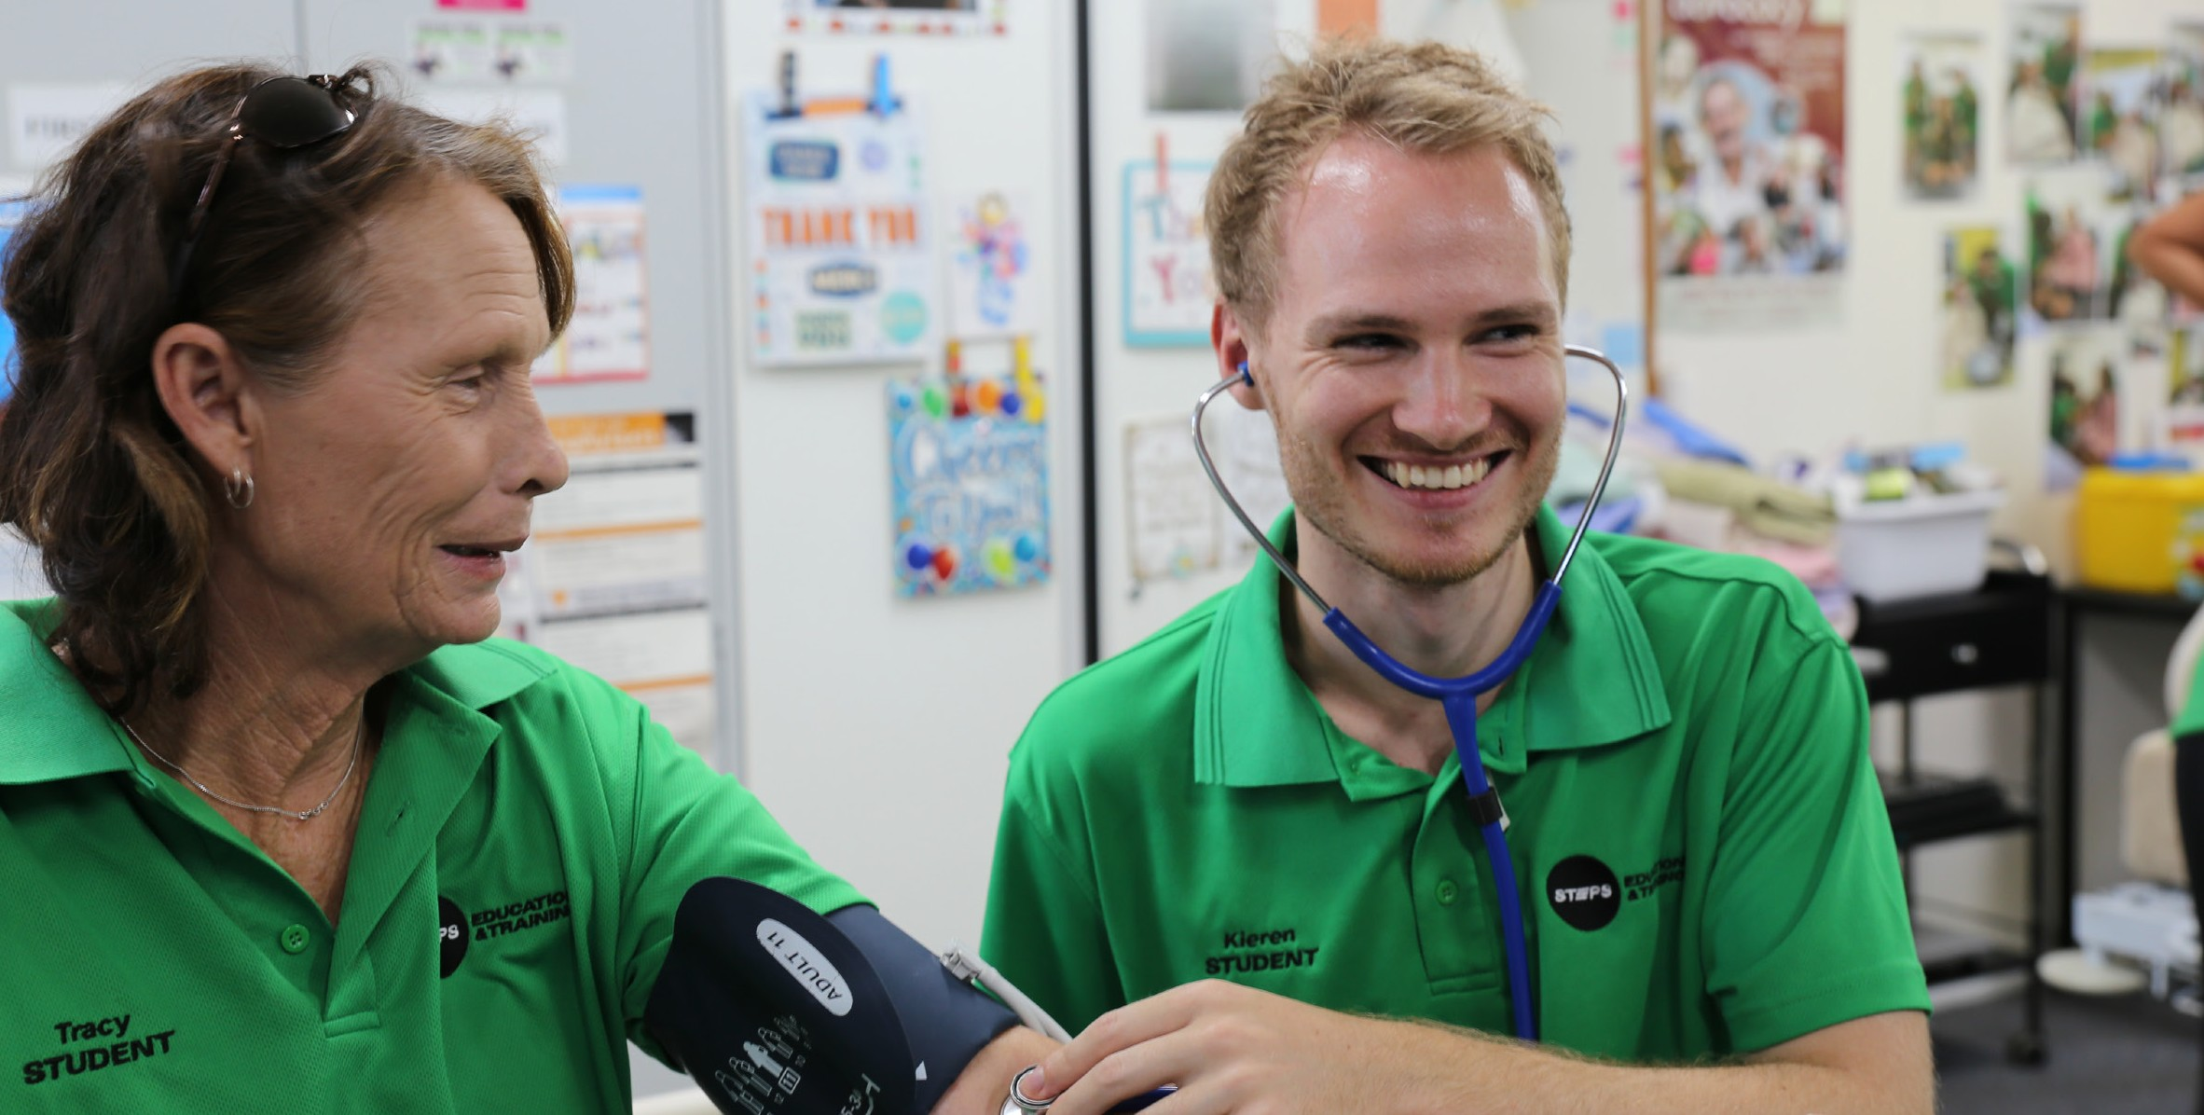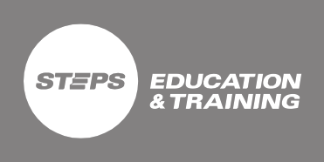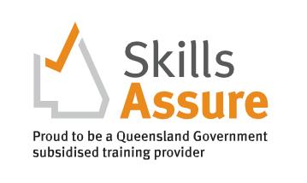
CHCSS00098 Individual Support - Disability Skill Set
Higher Level Skills Program
COURSE OVERVIEW
This skill set will prepare you to provide person-centred support to people with a disability in a range of community services and health contexts. Learn how to follow and contribute to an individual plan to implement behaviour support strategies and support the ongoing skills development of a person living with a disability. Gain skills to facilitate the empowerment of people living with a disability and deliver rights-based services using a person-centred approach.
You will also learn on how to assist people living with a disability to maximise their participation in various community settings to enhance their psychosocial well-being.
Successful completion of this industry-standard skill set will prepare you to provide individualised support in various disability services contexts.
WHY A SKILL SET?
A skill set is one or more competencies grouped together to give you the skills and knowledge to perform practical tasks.
COURSE DETAILS

Enrol Anytime Course Duration
Course Duration - Four (4) weeks

Delivery mode
Blended (online learning and assessment with one (1) practical workshop day on Campus)

Location
25 Bulcock Street, Caloundra

Units of Competency
- CHCDIS001 - Contribute to ongoing skills development using a strengths-based approach
- CHCDIS002 - Follow established person-centred behaviour supports
- CHCDIS003 - Support community participation and social inclusion
- CHCDIS007 - Facilitate the empowerment of people with disability

Award Issued
By completing this skill set, eligible students may receive a Certificate III in Individual Support – Disability

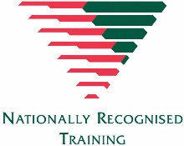

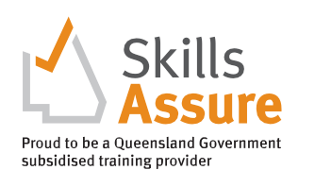
CHCSS00098 Individual Support - Disability Skill Set
Higher Level Skills Program
COURSE ENTRY
EQUIPMENT REQUIREMENTS

To be eligible for the Higher-Level Skills program, individuals must:
- be employed in the Aged, Disability or Community care industries in a care support role
- Hold a Certificate III in Individual Support
- have sound literacy, numeracy, and computer skills.
- be aged 15 years or over.
- be no longer at school.
- permanently reside in Queensland.
- be an Australian citizen, Australian permanent resident (includes humanitarian entrant), temporary resident with the necessary visa and work permits on the pathway to permanent residency, or a New Zealand citizen; and
- not hold, and not be enrolled in, a certificate IV or higher- level qualification, not including qualifications completed at school and foundation skills training.

All applicants into this course will need:
- Access to a personal computer or tablet-style device with web-browser software, and other general office software such as Word and PDF reader.
- It is recommended that you have access to a reliable internet connection to access STEPS Education and Training Learning Management System (LMS), and a computer with up-to-date software, including Microsoft Office, Adobe Acrobat Reader and Adobe Flash Player.
- Scanned colour image of your own Government-issued photo-ID, an active personal email address and an active (mobile) phone number.
- A valid Unique Student Identifier (USI). If you don’t have a USI you can create one here usi.gov.au.
- To undertake a Language, Literacy and Numeracy assessment.

TRAINING AND ASSESSMENT

The scheduled duration of training and assessment for this Course is four (4) weeks. This will be achieved by a combination of self-paced study, watching training videos, receiving scheduled training calls, preparing and submitting online assessment tasks, and practical skills training and assessment in the workplace. Once enrolled in the course, each participant will be emailed login details to the Learning Management System (Moodle) which contains all learning and assessment resources for this Course:

- Self-paced study – is time spent reading and engaging with the online content and completing the learning activities within the modules.
- Online Assessment tasks – All Units of Competency in this Skill Set contain a range of multiple-choice and short-answer written knowledge questions, and a range of short-medium response research activities. These assessments are submitted electronically in the LMS.
- Workplace training and assessment – For two (2) Units of Competency there are workplace training and assessment tasks and activities to complete.
- Students are expected to attend practical workshop sessions and be assessed in the workplace to successfully complete this skill set.

Students will be able to access their online learning materials once they finalise their enrolment process and all outstanding fees are paid.

COST
PATHWAYS FROM THE COURSE

Subsidised Under Higher Level Skills Funding
Concession - $20
Non-concession - $20
Fee For Service - $660
These units provide credit towards a range of qualifications in the CHC Community Services Training Package including the CHC33015 Certificate III in Individual Support.

