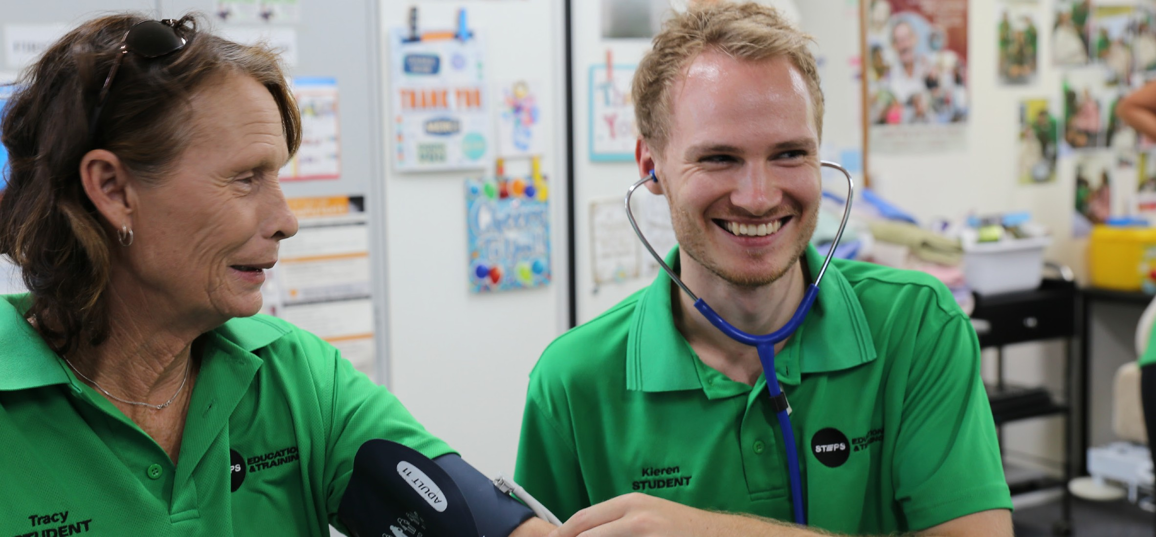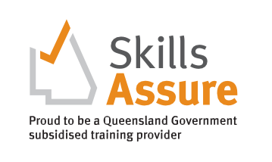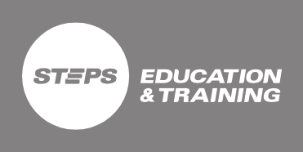
CHCSS00070 Assist Client with Medication Skill Set
Higher Level Skills Program
COURSE OVERVIEW

This skill set will give you the essential, entry-level skills you need to safely support a client to self-administer medication in a range of health care settings.
In this introductory course you will learn basic information about the human body, how to recognise and promote ways to maintain healthy bodily functions and use and interpret information that includes references to client anatomy
and physiology. You will also discover how to prepare for and provide medication assistance, complete medication documentation, and support clients to self-administer medication.
Successful completion of this skill set will prepare you for work involving the provision of medication assistance in a range of community services and health care contexts.
WHY A SKILL SET?
A skill set is one or more competencies grouped together to give you the skills and knowledge to perform practical tasks.
COURSE DETAILS

Face to Face Delivery
Upcoming Dates - Caloundra Intensive:
24th September 2021, 29th October 2021, 26th November 2021
Students will be able to access their online learning materials once they finalise their enrolment process and all outstanding fees are paid. Students are expected to attend Intensive sessions and be assessed in the workplace to successfully complete this skill set.
Location: 9 George Street, Caloundra

Delivery mode
Online learning and assessment with a two (2) day Intensive on Campus and workplace training and assessment
Customised Delivery Start Date: Enrol anytime
Delivery Mode: This skill set can be customised and delivered to health care and disability organisations on request.

Units of Competency
Core Units
- HLTAAP001 Recognise Healthy Body Systems
- HLTHPS006 Assist Clients with Medication

Award Issued
Statement of Attainment certificate

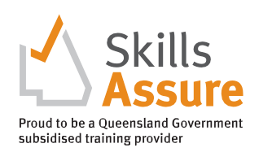
Higher Level Skills Program
COURSE ENTRY
EQUIPMENT REQUIREMENTS

To be eligible for the Higher-Level Skills program, individuals must:
- be employed in the Aged, Disability or Community care industries in a care support role
- have sound literacy, numeracy, and computer skills.
- be aged 15 years or over.
- be no longer at school.
- permanently reside in Queensland.
- be an Australian citizen, Australian permanent resident (includes humanitarian entrant), temporary resident with the necessary visa and work permits on the pathway to permanent residency, or a New Zealand citizen; and
- not hold, and not be enrolled in, a certificate IV or higher- level qualification, not including qualifications completed at school and foundation skills training.
TRAINING AND ASSESSMENT
Students will be able to access their online learning materials once they finalise their enrolment process and all outstanding fees are paid. Once enrolled in the course, each participant will be emailed login details to the LMS (Moodle) which contains all learning and assessment resources for this Course. The following must be completed prior to attending the scheduled Masterclasses
- Self-paced study – is time spent reading and engaging with the online content and completing the learning activities within the modules.
- Online Assessment tasks – All Units of Competency in this Skill Set contain a range of multiple-choice and
short-answer written knowledge questions, and a range of short-medium response research activities. These assessments are submitted electronically in the LMS.

All applicants into this course will need:
- Access to a personal computer or tablet-style device with web-browser software, and other general office software such as Word and PDF reader.
- It is recommended that you have access to a reliable internet connection to access STEPS Education and Training Learning Management System (LMS), and a computer with up-to-date software, including Microsoft Office, Adobe Acrobat Reader and Adobe Flash Player.
- Scanned colour image of your own Government-issued photo-ID, an active personal email address and an active (mobile) phone number.
- A valid Unique Student Identifier (USI). If you don’t have a USI you can create one here usi.gov.au.
- To undertake a Language, Literacy and Numeracy assessment.

Students are expected to attend the Masterclass sessions and be assessed in the workplace to successfully complete this skill set.
- Workplace training and assessment – The Unit of Competency (UoC) HLTHPS006 Assist Clients with Medication require completion of workplace training and assessment tasks and activities. These activities may occur in conjunction with the Work placement activities, or they may not as the clients care plan and availability will dictate if this can occur. Evidence is collected by the Trainer and submitted into the LMS.

COST
PATHWAYS FROM THE COURSE

Subsidies are available for eligible students. Subsidised Under Higher Level Skills Funding
- JobTrainer (if eligible) $nil (no charge)*
- Higher Level Skills funding (concession) $30 per unit ($60 total) Employer can pay this fee on behalf of eligible student according to HLS fact sheets.
- Higher Level Skills funding (non-concession) $60 per unit ($120 total) Employer can pay this fee on behalf of eligible student according to HLS fact sheets.
- No funding applicable (not eligible) $220 per unit ($440 total)
These units provide credit towards a range of qualifications in the CHC Community Services Training Package or HLT Health Training Package at Certificate IV and Diploma level.

*JobTrainer is a jointly funded initiative of the Australian and state and territory governments.

