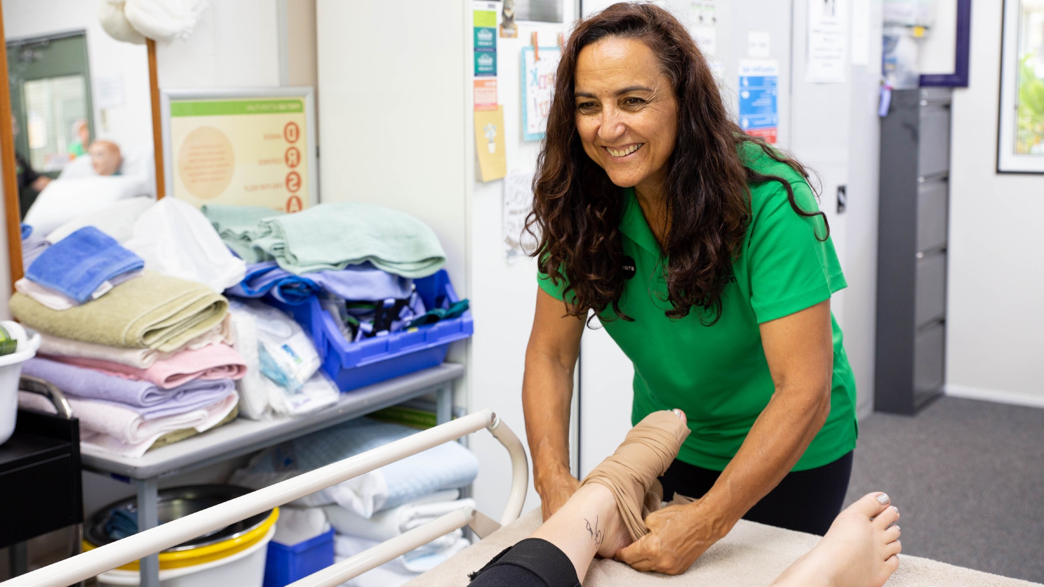

CHC33015
Certificate III in Individual Support
(AGEING OR DISABILITY)

COURSE OVERVIEW

Start a rewarding career in one of the most in demand and fastest growing industries – care and support. A career in care enables you to provide person centred assistance to people who require support due to aging or disability. The CHC33015 Certificate III in Individual Support in Ageing or Disability is a nationally recognised qualification providing you with the skills and knowledge needed to gain entry level employment in a range of care and support roles.
COURSE DETAILS

Qualification
CHC33015 Certificate III in Individual Support

Duration
18 weeks (including work placement)

Course Delivery
Monday to Friday, 9am to 3pm

Expressions of Interest
Taking course expressions of interest only at this point. Email individualsupport@stepsgroup.com.au to enquire Location
46-50 Spence St, Cairns City

Delivery mode
Blended delivery including face to face and online. There will be two days of face to face delivery which will be supported by trainer-led online learning and assessment activities.

Work Placement
STEPS will arrange for you to complete your required work placement in a care facility. All students are required to complete 4 weeks (120 hours) work placement in order to receive their qualification. This may require Monday to Friday attendance at the placement facility.
*Students are responsible for any transport required for work placement.

CHC33015 Certificate III in Individual Support

(AGEING OR DISABILITY)
WHAT WILL I LEARN?

The CHC33015 Certificate III in Individual Support is made up of 19 units including 7 core units, 6 electives for the Ageing specialisation and 6 electives for Disability support specialisations.

Core Units:
CHCCCS015 | Provide individualised support
CHCCCS023 | Support independence and well being
CHCCOM005 | Communicate and work in health or community services
CHCDIV001 | Work with diverse people
CHCLEG001 | Work legally and ethically
HLTAAP001 | Recognise healthy body systems
HLTWHS002 | Follow safe work practices for direct client care

Elective Units:

Group A electives - Ageing Specialisation

CHCAGE001 | Facilitate the empowerment of older people
CHCAGE005 | Provide support to people living with dementia
CHCCCS011 | Meet personal support needs
HLTINF001 | Comply with infection prevention and control policies and procedures
CHCPAL001 | Deliver care services using a palliative approach
CHCCCS020 | Respond effectively to behaviours of concern
Group C electives - Disability Specialisation
CHCDIS001 | Contribute to ongoing skills development using a strengths-based approach
CHCDIS002 | Follow established person-centered behaviour supports
CHCDIS003 | Support community participation and social inclusion
CHCDIS007 | Facilitate the empowerment of people with disability
HLTINF001 | Comply with infection prevention and control policies and procedures
CHCCCS011 | Meet personal support needs

During your course you will be provided with:
- Work Placement
- National Police Check
*Satisfactory results of a National Police Check is required for work placement
Language, literacy and numeracy support along with other learning support will be provided to students to assist with their studies.

FEES
Talk to STEPS to find out which funding options may be available for you. Course fees vary depending on funding eligibility.

Certificate 3 Guarantee Program Fees
Certificate 3 Guarantee is funded by the Queensland Government. To find out if you’re eligible under the Certificate 3 Guarantee visit www.stepsgroup.com.au/training/ certificate-3-guarantee
The following co-contribution fees are payable for those eligible under the Certificate 3 Guarantee;
Eligible Students
Full co-contribution Fee $ 399
Per Unit $ 30.70
Eligible Concessional Students
Full co-contribution Fee $ 300
Per Unit $ 23.05

Full fee paying student (non funded)
Full Course Fee $2900

CHC33015 Certificate III in Individual Support

(AGEING OR DISABILITY)
CAREER PATHWAYS
WHY STEPS?

The CHC33015 Certificate III in Individual Support will provide you with the qualifications to help you start an exciting career in Aged or Disability Care.

Employment opportunities may include work in the following areas:

- Residential Aged Care
- Disability Sector
- Home and Community Care
- Respite Care
- Personal Care
- And a range of other care and assistive roles
STEPS Education & Training offer training solutions that meet real local market needs. Our courses are designed in consultation with local employers to improve our students’ employment opportunities and on the job skills.
Our highly qualified trainers bring hands on industry experience to their role allowing you to feel confident that you are gaining the best workplace preparation possible.

PAYMENT PLANS
ENTRY REQUIREMENTS

Payments can be made in full or by a weekly payment plan. For weekly plans, a $150 non refundable deposit must be paid prior to course commencement followed by weekly instalments.
*Certification will not be issued until fees are paid in full

RECOGNITION OF PRIOR LEARNING

You may be eligible for credit towards your qualification based on previous workplace skills or study. Contact us to find out if you are eligible at individualsupport@stepsgroup.com.au
- Successful completion of a Language, Literacy and Numeracy (LLN) Indicator
- Clear Federal Police Check
- Physical ability to be able to perform the required manual handling duties of a carer

HOW DO I ENROL?

For more information about this course or to enrol phone us on 07 4034 5400 or email individualsupport@stepsgroup.com.au

