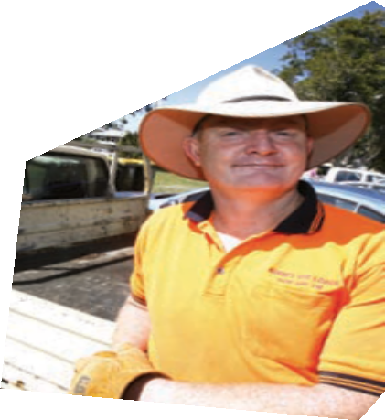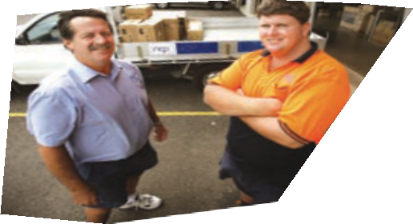

Annual Report
2007-2008

Our vision

To enhance our community by empowering people to maximise their potential.

Foundation values

Trust, honesty, integrity

Respect for and recognition of individual needs

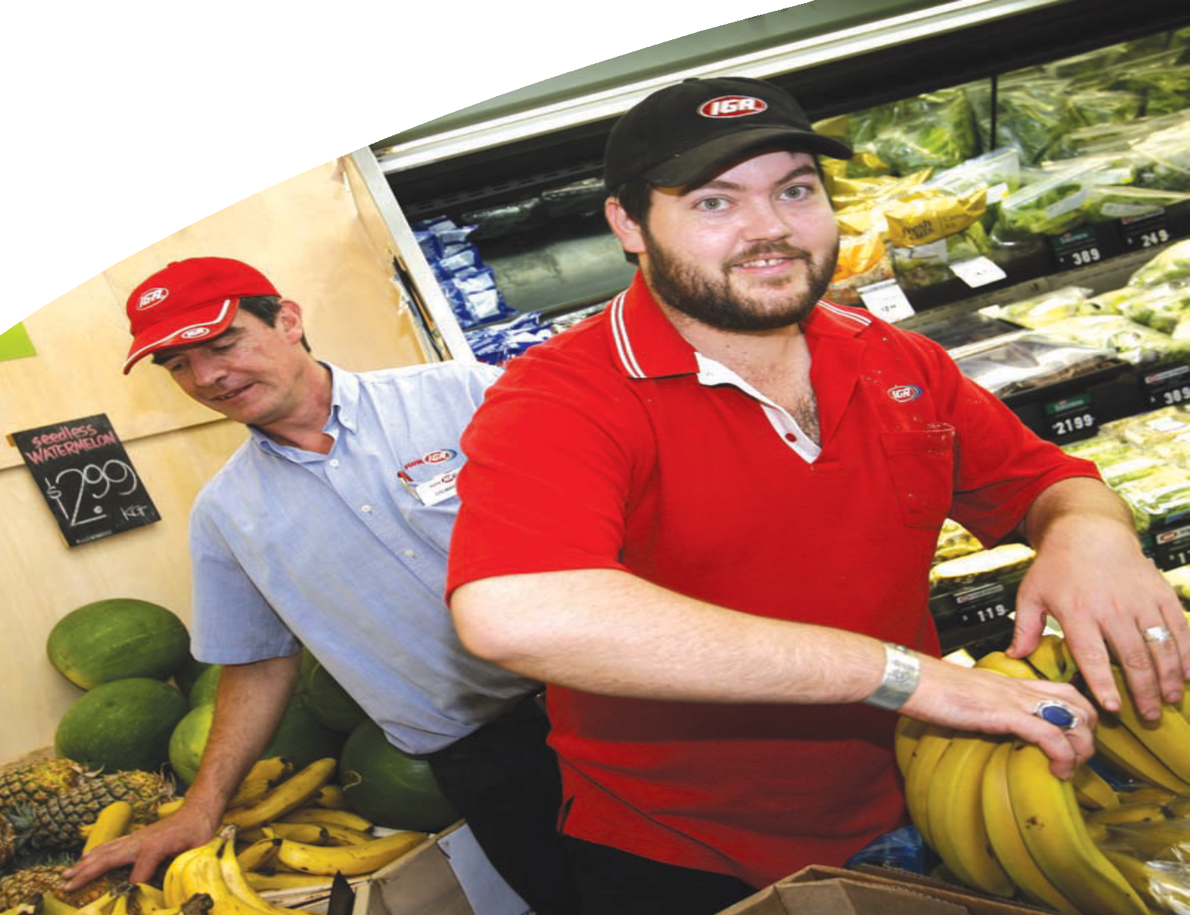
It’s all about you.

Valuing individuals – their worth as individuals and their contribution

Valuing opportunity for growth, development and support

Determination and commitment

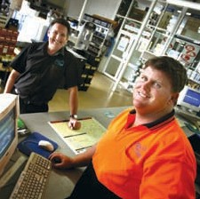

Contents

Our mission 2
Board of Management 2
President’s report 4
CEO report 5
Organisational chart 6
Community Services report 7
Training report 13
Employment report 17
Business Development report 24
Corporate Services report 25
Finance report 29
STEPS 2007 Disability Awards 31
Staff 34
Locations 36
Funding 37

1

Our mission

STEPS will exercise self-determination and ensure continued success and rejuvenation through service, research, development and expansion.

STEPS will provide high quality services that are founded on our vision, mission and values, ensuring ethical and professional behaviours.

STEPS will create an organisational environment that seeks and encourages innovation and continuous improvement.

STEPS will strive to be the organisation of choice for all Stakeholders through a caring commitment to our values.

As an employer, STEPS will provide staff with a secure environment that is stimulating and challenging, embracing open communication and professional development.

Board of Management

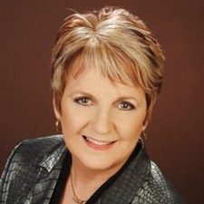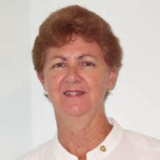
President Carmel Crouch Secretary Christine Jones Treasurer Helen Ferguson

2

Adelaide’s slice of life

CASE STUDY

For Adelaide, working at Sister’s Organic Café is like baking your cake and eating it too.
The view of the Maroochy River from the balcony is refreshing, staff are helpful, and Adelaide’s doing what she loves – working with food.
“I would love to work every day at Sisters”, said Adelaide who currently works three half-days a week, after initially starting with a job trial. Her tasks include assisting the chef
with recipes, kitchen preparation, washing up, taking food to tables and occasionally chatting with regulars.
Adelaide’s fondness of Sister’s is shared by her father, Russell, who is thrilled with the positive changes that part-time work and a range of other lifestyle choices have made to his 18-year-old daughter.
Through the discipline of work
– around the home and at Sister’s – a fitness plan, and the social interaction with her work mates, the world is now seeing the real Adelaide.
Somewhere between one in 10,000 and 20,000 people are born with William’s Syndrome, a genetic condition first identified in the early 1950s.
The condition throws up many challenges for Adelaide, who after leaving Year 12 in a Special
Education Unit gained a Certificate II in Hospitality. With the help from
others including STEPS Employment Adelaide is now achieving many personal goals, and with her own personal trainer and free weekends, she’s the envy of her workmates.
“Adelaide has more ability to be responsible around the home, and she’s become more articulate,” said Russell.
“Before she’d try to describe something and be all over the place. Now she can think, and articulate what she wants to say. That’s
only happened since she’s been working.”
Daryl, a chef at Sister’s, works with Adelaide regularly. He said he believes his responsibilities extend beyond guiding her around tasks needed in the kitchen.
“It’s more than teaching Adelaide to be a kitchen-hand and waitress.
For me it’s showing her how to communicate with people and have work relationships – something she’ll need later down the line.
“When Adelaide is at work, everyone gels together – there’s a lot more consideration. There’s extra effort needed to help her eventually go on to be an independent worker – that’s the big motivation for me.”
Andrew, the STEPS Employment Consultant who continues to support Adelaide, said his great challenge when working on-site is resisting the amazing array of delights on display.

“The team at Sister’s Organic Café are great! They are giving Adelaide the opportunity to grow, both in her work life and as a person as well.”

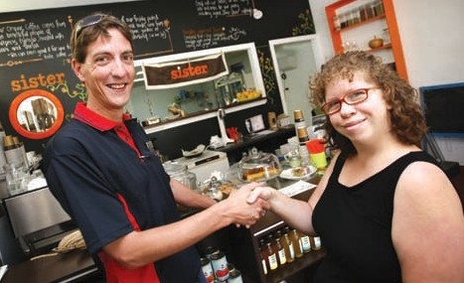

3

President’s report

As I sit down to write this report on the 2008 year a number of achievements come to mind and I am reminded of the advances and challenges STEPS has overcome over the last 12 months. Just as important as achievement, is the way that we reach our goals.
Our CEO, Garry Hooper, continues to guide our expanding team from strength to strength, rallying behind management and staff to ensure that they never lose sight of STEPS’ core values.
The vision and mission of STEPS is prominently displayed in all our
offices as a source of reference and inspiration.
I have heard both the vision and mission statements quoted many times at various STEPS meetings, along with regular mention of the strategic plan. I am proud to be part of an organisation that truly believes in, and acts out, its purpose.
On behalf my fellow members on the Board of Directors I would like to thank the entire team at STEPS for their tireless commitment to our service, and ensuring that STEPS Disability Qld Inc continues to enhance our community by empowering people to maximise their potential.
I would especially like to acknowledge the dedication of my fellow Board Members of whom it is a privilege to work along side. Each member has readily accepted the responsibilities of being part of STEPS in addition to being operational business owners in their own right.
However it is with great sadness and the deepest of respect that I must announce the retirement from the Board of Shelly Wabersinke after 13 years and Ron Studdock after five years, both of whom have helped shape the direction that STEPS has taken to become the successful and flourishing organisation it is today.
Looking ahead to 2009 brings with it an enormous sense of triumph when I stop to consider that STEPS will be celebrating it’s 20th year of commitment to helping people with disabilities.
It all began in 1989 with a small group of concerned parents from the Sunshine Coast who recognised the need for a variety of employment options for their children and other young people with an intellectual disability.
They applied for and received funding to establish a supported employment agency which commenced operations in 1990 and the rest, as they say,
is history.
1989-2009

4

CEO report

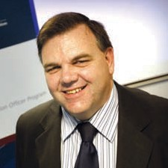

The challenging financial year of 2006-2007 is now well behind us. Due to a steady flow of uncapped referrals and increased outcomes, the 2007-2008 years have become our finest years for a variety

of reasons.
Outstandingly, STEPS reported a record surplus, reaching almost
$800,000. This amount is equivalent to STEPS entire income for the year 2000 - a fact that vividly illustrates the organisation’s growth over the last eight years. Growth in staffing and client numbers are also noteworthy. During the same period, staff numbers have increased from 18 to 108 and client numbers in employment alone from 120 to almost 1200.
The finalisation of our fourth merger, this time with Impact Employment in Townsville, has positioned the organisation as one of the largest
providers in North Queensland, now offering both capped and uncapped programs.
The strategic plan was reviewed and now confirms the general direction of the organisation, highlighting
long-term key result areas in growth, diversification, strengthening of administration systems through the Business Excellence Framework, and a greater emphasis on staff development and customer service.
I am grateful for the time our Board and staff volunteered for this process.

The Board’s approval of the full introduction of a new corporate structure represented one of the first steps toward implementing the strategic plan.
A Senior Management Team is now in place, with Managers and General Managers covering the Employment, Community Services and Corporate divisions. A Business Development Manager is included in the team to facilitate growth and diversification within the organisation.
Community Services experienced dramatic growth, with the success of the NDCO (National Disability Coordination Officer) tender in two
Queensland regions, and the handover of Capability Concepts’ in-house respite, in-home care and advocacy programs in Gin Gin. Along with the Supported Wage and Workplace Modification programs, a strong base for growth is now in place.
Based on the strategic plan’s direction, STEPS Training consolidated and re-focused on accredited training, seeking to take advantage of the
new Federal Government’s plans for the skilling of Australia through the productivity program. STEPS Training will maintain its good reputation in professional development courses and encourage mutually-beneficial partnerships.
The organisation is now being examined to strengthen corporate governance, to define the roles of Board members, CEO and senior staff, and to maintain the current practice
of keeping operational matters at staff level and strategic matters at Board level.
To assist in this process, the Board has begun the TAGS (The Australian Governance system) program in writing its corporate policies.
I would like to once again thank the Board for their support during the year, and particularly the President Carmel Crouch for being a sounding board as we weave our way through our “new world”. I would also
like to thank the staff who continue to adapt very quickly to our new environment.

5

Organisational chart

STEPS Disability Qld Inc

Board of Directors
Chief Executive
Officer
Executive
Assistant
Business
Development Manager
STEPS Training
Manager
Community
Services Manager
General Manager
Employment Programmes
Corporate
Services Manager
Recptionist
Administration Assistant
Administration
Co-ordinator
Marketing/Public
Relations Coordinator
BEU
Advisors
ICT Human Resource Human Resource Finance
Manager Coordnator Advisor Manager
Contract Trainers/
Assessors
Service
Development Officer
Workplace
Assessors
NDCO’s
Senior
Finance Officer
Admin/Records
Management Administrative
Officer Assistants
BEU
Trainee (vacant)
Web/Systems Payroll Officer
Developer HR Assistant
Finance
Officers
Alice Springs
Manager
Bowen
Ayr/Collinsville Manager
Bundaberg
Manager
Hervey Bay
Maryborough Manager
Caloundra
Manager
Maroochydore
Manager
Nambour
Noosa Manager
Aitkenvale
Manager
Townsville
Manager
JPO
Manager
Branch
Secretary
Branch
Secretary
Branch
Secretary
Branch
Secretary
Branch
Secretary
Branch
Secretary
Branch
Secretary
Branch
Secretary
Branch
Secretary
Receptionist
Administration Assistant
Receptionist Jobsearch Trainer
Administration Assessment
Assistant Officer (SC)
Employment
Support Consultants
Employment
Support Consultants
Employment
Support Consultants
Employment
Support Consultants
Employment
Support Consultants
Employment
Support Consultants
Employment
Support Consultants
Employment
Support Consultants
Employment
Support
JPO
Administration
Employment
Sales Consultants
Employment
Sales Consultants
Employment
Sales Consultants
Employment
Sales Consultants
Employment
Sales Consultants
Employment
Sales Consultants
Employment
Sales Consultants
Employment
Sales
JPO
Sales Consultants
PSP
Consultant

6

Community Services report

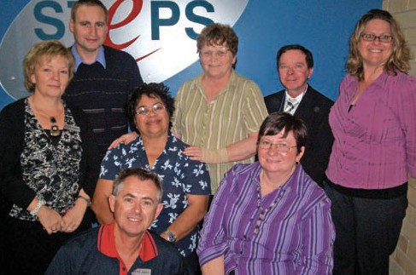Community Services report

Where opportunity meets aspirations

Late in 2007, STEPS Community Service (SCS) became a new division of STEPS Disability Inc. This new division is built on the strategic vision to drive a new future for STEPS

by providing a comprehensive range of community services and products.

The STEPS Community Service team
It is intended that Community Services will extend STEPS excellent services and strengthen the organisation’s reputation as a respected provider of services throughout Australia.
By developing quality disability and community care programs STEPS Community Services will help build better communities through the inclusion of people with a disability and other disadvantaged groups.
By the first quarter of 2008, Community Services had established its administration and management capability, an important prerequisite for future growth. Recruitment of 12 employees each with specific skills and knowledge also took place.
Quick progress in a range of areas came as a result of a collaborative development with all departments within STEPS - meeting legislation requirements, financial management, ICT needs and marketing and promotional materials. Only through

Barbara Davidson, Manager of STEPS Community Services

STEPS’ capacity to provide strategic leadership and operational structure in a responsive and timely response was this made possible.
Five separate disability programs under the SCS umbrella are now in progress, working across Queensland from offices in Caloundra, Bundaberg and Townsville.

8

Program description and geographical boundaries

NDCO
The National Disability Coordination Officer (NDCO) works toward the Australia-wide referral, coordination and referral program to deliver support services for people with disabilities that are, or will be attending, university, TAFE or other training organisations.
It seeks to achieve this by building links with services so that they have assistance at all levels.

NDCO Region 20:
Covering Moreton (including the Lockyer Valley), Toowoomba, Darling Downs, South-West Queensland, Sunshine Coast, Central-West statistical boundaries.

NDCO Region 22:
Covering Mackay, Whitsundays, Burdekin, Townsville, Hinchinbrook, Cassowary Coast, Cairns, Cape York, Tablelands, Charters Towers, Mt Isa and North-West Queensland, including the Gulf.

Workplace Modification Scheme
The Workplace Modification Scheme funds SCS assessors to determine what physical or
environmental workplace adjustments, or specific items of equipment, will reduce restrictions and barriers
to employment for workers with a disability.

Supported Wage Scheme
The Supported Wage Scheme funds assessors to determine productivity of a worker in a specific workplace by measuring that worker’s productivity against a co-worker
who is skilled to do the same job, in the same workplace. This process decides on formal and legally binding, minimum productivity rates and wages. STEPS Assessors cover Queensland and northern New
South Wales.

Disability Support Services
Disability Support Services provide in-home respite and community access support covering Gin Gin and North Burnett.

STEPS Community Service’s Commonwealth and State contracts, with an annual gross income of $440,000

NDCO Region 20
NDCO Region 22 Workplace Modifications Supported Wage
Disability Support Services

9

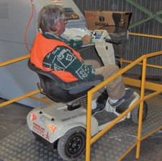STEPS moved the already functioning Workplace Assessor service into SCS division with a directive to expand and increase service to metropolitan and regional Queensland. The assessors provide three separate services to employers, jobseeker/workers and employment service providers.
SCS has, and will continue, to allocate resources for the promotion of these schemes, with a view to increase public awareness.
Workplace modifications can reduce restrictions and barriers to employment. They can greatly benefit people with a disability and employers, resulting in:
Since January 2008 the NDCO’s have made a significant impact in identifying and meeting with key stakeholders within the Regional Disability Networks, universities, TAFE, councils, Disability and Education state government departments.
Using this information, the NDCO

This workplace modification carried out at a business in Gympie brought a smile to Robert, who could continue working

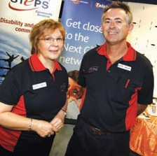
STEPS’ Workplace Assessor, Brian Kerr, and STEPS Community Services Manager Barbara Davidson
These are Workplace Modifications, Supported Wage and Infirm Workers Permit Productivity Based Wage Assessments. Funded by Department of Education, Employment and Workplace Relations (DEEWR) these services are currently deemed as under utilised by the employment industry.
- finding a job
- keeping a job
- improving productivity
- making the impossible, possible.

SCS’s successful NDCO tender resulted in being allocated two regions of the national program, which combined, cover 70% of Queensland.

Strategies for growth and development of the STEPS workplace assessors will be achieved through:
- Employer and community awareness campaign
- Comprehensive media branding
- Excellent customer service “word of mouth”
- Employer and Disability Employment Network consultation
- Increasing assessors’ regional listings.
In keeping with current federal government objectives of social inclusion and skilling for the future, the program aims to increase the number of people with a disability accessing higher education, specifically a Certificate III qualification or above.
Initially, SCS’s two NDCOs tackled the challenge of profiling education,
training and service providers, building relationships, and proving that they could make a difference to the fragmented communication between providers. The large geographical area is a constant consideration to strategies.
team developed a comprehensive website, with the end-user firmly in focus. The website provides
information about the NDCO program, news, events, tools for career pathway development, an innovative “search for service” facility and much more.
The site has become an important communication medium and also an instrument used in TAFE’s course delivery, and by DEEWR itself. Other
NDCOs have endorsed the website as the “high benchmark” for the NDCO program.
The NDCO’s activity progressed into running events called “Tertiary Taste Testers” where students, prospective students with a disability, and their families could learn more about services available at institutions.
Collaborative working parties were also formed to address key barriers to participation, for example, the reasons for a high rate of students with mental health conditions dropping out during the first five weeks of enrolment.

10

STEPPING into community partnerships

SCS forms community partnerships to build the best opportunities for people with a disability and extend quality service. Partnerships include:

Gin Gin Disability Support Services
In the first half of 2008 SCS established its foundational operations, undertook research to understand
and grow existing programs, and to provide strategic and operational support to new programs.
Building a public profile and image

- Telstra Country Wide
- Regional Councils - Sunshine Coast, Bundaberg, Mackay
- Regional Disability Networks
- COAG Mental Health action plan working group
- Education Queensland
- USQ, CQU, JCU (universities)
- Humanware
- Chinchilla Group Training Group
- JinJinburra Aboriginal community
- Wandiny Home and Community (Aboriginal and Tores Strait Islander Service)
- Community Radio 96.3 FM
- Sunshine Coast Daily
- Education Queensland, TAFE
from scratch was considered a priority, and a key to sustained growth. Through establishing new community partnerships, networking, marketing and promotion, results are beginning to emerge.
After 12 months of planning and negotiation, SCS acquired a Disability Support Services operating from Gin Gin delivering services to Kolan and North Burnett Region. The small, established service first approached STEPS a larger organisation with a similar value base.
This acquisition required STEPS to become an approved Disability Services Queensland (DSQ)
non-government service provider, and gave SCS opportunity to grow state-funded services. Compliance with DSQ Quality Assurance Standards required substantial development, but SCS looks forward to meeting its new clientele with excitement and enthusiasm.

Gin Gin staff

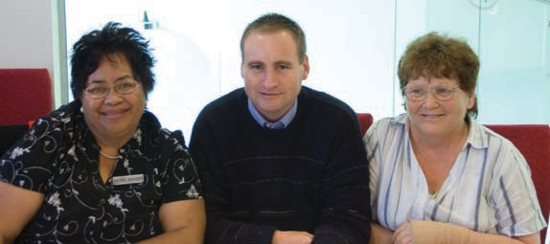
11

New support plan development tools will ensure SCS capture the individual attributes,

talents, interest, priorities and support needs of our clients from the start of service delivery.
Due to the absence of suitable professional office space in Gin Gin, the search continues for a headquarters from which to provide administrative and technical support for the service. Currently, the plan
is to find a residence located in a commercial zone on the main street of Gin Gin.
SCS management visited similar high performing services in other parts of the country to gain business
intelligence and develop SCS’s unique programs.
For example, STEPS Post School Service is ready to be delivered to school leaver who do not have access to vocational training or employment options. The program provides skill training, community connections and participation in community projects.

12

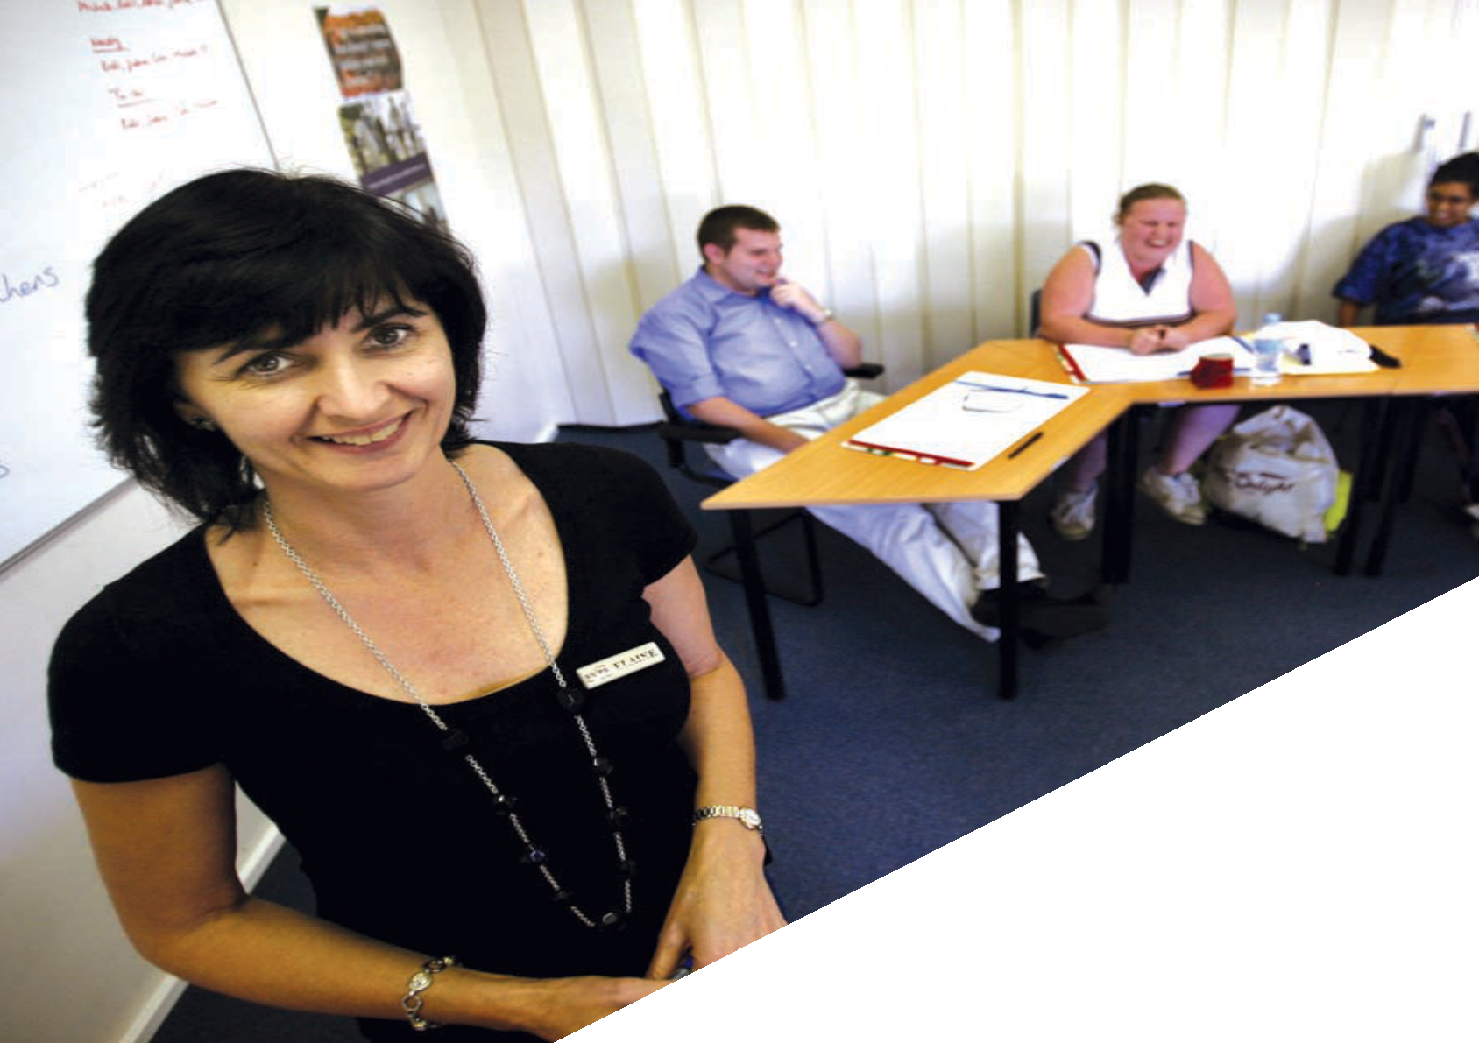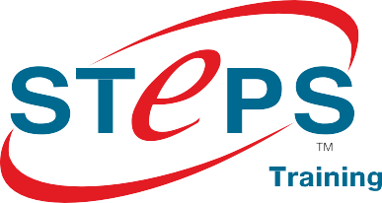

Training report

Training report

Shelly Campbell, Manager, STEPS Training

The future looks bright for STEPS Training. Over the last 12 months the organisation’s registered

training organisation (RTO) has built a solid foundation of systems and resources.
These assets equip us to respond quickly to trends and opportunities, for example those afforded by the new Labour Government’s push to close the ‘skills gap’ and increase participation in the workforce.
STEPS Training successfully extended its scope of registration across
a diverse range of industry and qualification levels in line with our overarching strategy to move back to an accredited training focus. This expansion will support our ability to
match the industry demand skills gaps with high quality, nationally recognised skills training.
Further expansion into complimentary industries is a priority, as shown in the STEPS Training Business Plan. Our ability to match industry demand will be further enhanced by engaging in an active research and development function, as well as networking and consultation with employers and industry through strong community integration across all STEPS regions in Queensland and Northern Territory.
Identifying and acting on opportunities is the key.

Our scope of registration now includes:

Qualifications
CHC20102 Certificate II in Community Services Support Work CHC20202 Certificate II in Community Services Work
CHC20302 Certificate II in Community Services (First Point of Contact) CHC30102 Certificate III in Aged Care Work
CHC30202 Certificate III in Home and Community Care CHC30302 Certificate III in Disability Work
CHC30802 Certificate III in Community Services Work CHC40102 Certificate IV in Aged Care Work CHC40302 Certificate IV in Disability Work CHC40502 Certificate IV in Employment Services CHC40902 Certificate IV in Community Services Work
CHC41602 Certificate IV in Community Services (Lifestyle and Leisure) SIT20207 Certificate II in Hospitality

Accredited courses
30369QLD Course in Adult Literacy and Numeracy 30625QLD Certificate I in Work Readiness 30719QLD Course in Adult Literacy and Numeracy 39099QLD Course in Skills for the Future 39150QLD Course in Vocational Literacy 39151QLD Course in Vocational Literacy 1 39152QLD Course in Vocational Literacy 2 39153QLD Course in Vocational Literacy 3 39154QLD Course in Vocational Literacy 4 39160QLD Course in Vocational Numeracy 39161QLD Course in Vocational Numeracy 1 39162QLD Course in Vocational Numeracy 2 39163QLD Course in Vocational Numeracy 3 39164QLD Course in Vocational Numeracy 4 39170QLD Course in Pre-Training Assessment 39171QLD Course in Pre-Training Assessment 39180QLD Course in Vocational Literacy 39181QLD Course in Vocational Numeracy

14

Job seeker training

The ‘Get that Job’ program, was trialled over the last

12 months, part of STEPS Training’s commitment to the continued social and vocational development of job seekers registered with STEPS Employment.
The program is designed to assist job seekers identify career goals, learning pathways, develop effective job search skills and apply these in close consultation with trainers, employment support and employment sales consultants.
Positive feedback from many job seekers who successfully finished the program is complimented by a high percentage of graduates gaining secure employment. Congratulations to all participants and staff who have helped make the program a success.
STEPS Training secured funding for the delivery of the TAKE AIM II program on the Sunshine Coast.
This program seeks to enhance the vocational and life skills of 20 job seekers with a goal of maximising opportunities for sustainable job

placements in housekeeping. With the support of local accommodation providers, participants will be given the opportunity to experience working in the industry and practice their skills first hand.
STEPS Training will continue to research and apply for funding opportunities and develop innovative jobseeker programs to assist job seekers up-skill and move into employment.

15

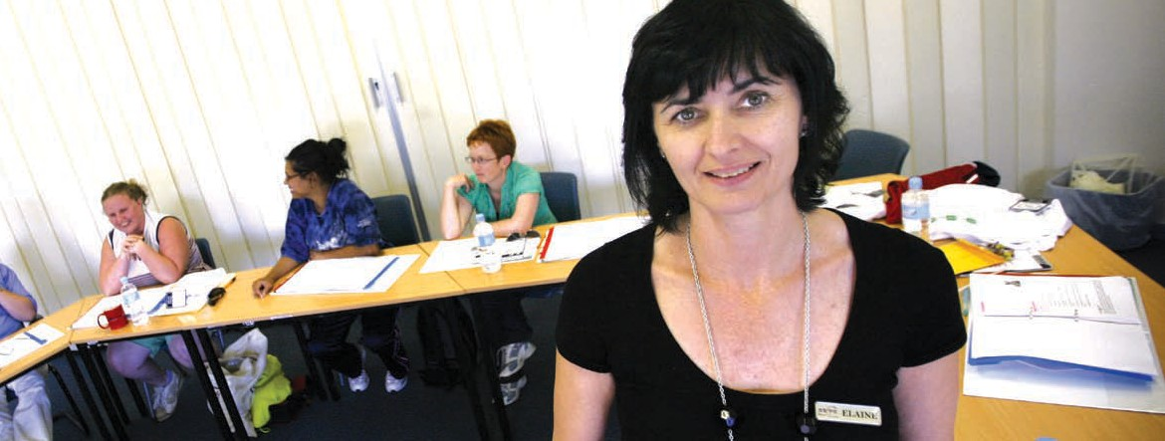Professional development training

It is clear that the STEPS Training brand continues to be a household name within the Disability Employment Network around Australia.
A sustained level of requests for in-house professional development training delivery continues.
Opportunities to strengthen our position as a leader in the delivery of quality
DEN-specific training will be presented by positioning STEPS Training to respond to the expected changes over the next 12 months.

Industry training partnerships

The long-term success of STEPS Training is dependant on strong relationships with stakeholders. One of these key stakeholders is ‘industry’.
STEPS Training is currently working with STEPS Employment in the development of a workplace specific training program that aims to develop and recognise the skills and knowledge of our marketing and sales consultants.
Successful implementation of this project will provide the platform on which STEPS Training will build the ‘partnership’ component of business growth with the aim of becoming a ‘training provider of choice’.

16

Employment report

Employment report
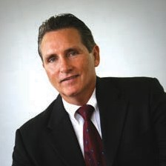More importantly we are supplying quality programs, services and job opportunities. At the heart of this work we see the potential of many people realised, to live more full and meaningful lives through employment.

John Conway, General Manager, STEPS Employment

The past year has been one of significant growth for STEPS Employment Services Division from both an operational and leadership perspective.
Once again substantial changes in government policy and funding has created extra costs, adjustments and replanning to the division, but the challenges are being met.
We have substantially expanded our service capacity and continue to enhance our community by providing support to a greater
number of individuals and employers.

Empowering people to maximise their potential
STEPS Employment Division has gone from strength to strength through assisting a record number of jobseekers with a disability into
employment. In addition, the Personal Support Program has assisted participants with non-vocational barriers to realise their aspirations.
Many Australians with a disability who want to work still experience difficulties finding suitable employment, while
at the same time a large number of employers struggle to find people with suitable skills. As a result training and assistance have become crucial for the welfare of individuals.
In this context there is a great deal of opportunity for STEPS Employment to assist people with disabilities
to realise their aspirations, so that they can participate in the labour market and enjoy the same degree of self determination as the broader community.

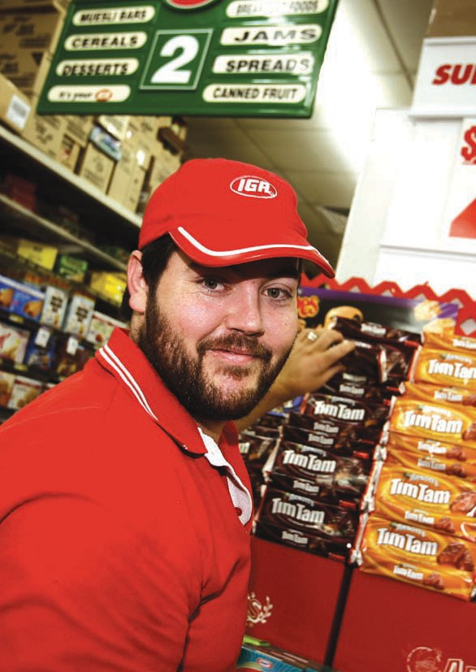

18

Joanne’s building a shining future

CASE STUDY

If needed, you can check your hair by looking in the stainless steel doors at Kawana Shoppingtown KFC.
The regular shine, and pristine condition of the shop inside and out, is courtesy of Joanne, a determined young lady who’s going places.
Joanne came to STEPS Employment with a broad range of training under her belt and some firm personal goals, including world travel.
“I’m working toward a holiday in Europe,” said Joanne. “My best friend really wants to go to Italy and a few other countries. So we’ve just got to wait until we save the money.”
After graduating from Year 12 and earning qualifications in Horticulture, Information Technology and Child Care, personal issues threw Joanne’s life and career plans into a tail spin.
With help, Joanne tackled the challenges and begin rebuilding, regaining the resolve to reach for her goals.
She faithfully attended job search sessions at STEPS’ office until the opportunity arose at KFC.
Management were so impressed by Joanne’s work ethic at the job trial, they responded with a ‘definite’ when asked if they wanted to employ her part-time.

“Joanne is very dedicated to her job,” said Emelia, Manager of the KFC Kawana. “She is reliable, punctual and usually very thorough with her cleaning.

“She completed all tasks each week including any additional tasks allocated by the manager on duty.”
STEPS Employment Consultant, Jerome, supported Joanne in the initial stages, getting her familiar with the chemicals required for the job, and giving her moral support.
“Since Joanne started, her checklist has grown, such is the quality of her work,” said Jerome.
“Her first goal was to gain employment. She’s done that, and her future goal is to get work in her chosen field of retail and of course to travel to Italy with friends.”

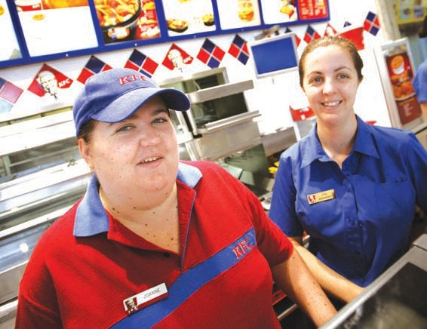
19

Job placement by industry
The graph demonstrates the range of industry sectors where participants have been placed into work.

9%

Work Capacity
Work capacity for the purpose of eligibility and streaming into STEPS Disability Employment Network program is determined by Job Capacity Assessment (JCA) conducted by a JCA provider. Once eligibility to STEPS Employment is determined, job seekers are referred into one of two streams:

21%
●
5%

4% 

3%
capped - a stream which provides services to job seekers who have an assessed work capacity of eight or more hours per week who require either long-term support in the workplace and/or are unable to work at award wages.
uncapped - a stream that provides services to job seekers who require part-time work only, an assessed work capacity of 15 to 29 hours per week, and an ability to work at award wages and to become independent in the workplace within two years.

STEPS Employment Participants by Disability %

16%

21%

Agriculture/Marine/Animal Care Clinical/Medical/Aged Care/Child Care Fast Food
Government Industrial

17%

4%

Information Technology/ Banking & Finance
Outdoor/Trades Retail Tourism/Hospitality
Acquired Brain Injury

Autism Intellectual Neurological
Physical Psychiatric
Specific Learning/ADD

Speech Vision

0% 10% 20% 30% 40% 50%

Uncapped Capped

20

Our people
In order to achieve our goals STEPS Employment is continuing to develop new strategies and improve upon our service delivery.
As part of this process, significant resources have been invested into staff training conferences held in November 2007 and February 2008. Practical training and strategies to improve performance were the main focus of the conferences. However the secondary objective was to bring back a disability focus with staff and management.
At individual branches, staff attended a variety of training courses including specific mental health training to increase their skills base and better assist and support both participants and their employers.
Likewise, staff across the Employment division contributed to the successful implementation of a new third party software program, DENMAX. This system delivers major reductions in the administration burden, and provides more detailed and timely reporting, analysis and management reports.
STEPS Employment Division staff have worked hard to achieve great results and I thank them for their commitment.

Quality Assurance and Business Excellence
In an audit conducted by Focus Integrated Services, STEPS Employment Division was confirmed to be meeting or exceeding all of the Disability Service Standards.
The author noted:

“STEPS presented as an organisation of high professional standards committed to the achievement of merit based employment outcomes targeted to the individual preferences of the client base. A sound procedural system has been established against the 12 service standards that enables the achievement and maintenance
of a quality service outcome. Feedback from participants was extremely positive across all sites and demonstrates the commitment of
all staff in providing excellent quality outcomes and customer satisfaction”.
Although we take pride in this excellent report, STEPS Employment continues to make minor administrative improvements to systems and processes as part of our commitment to business excellence. Through
the SIR process we constantly strive to further identify areas where improvements can be made.

Strategic accomplishments
It is a pleasure at the end of another financial year to to report on a successful year both financially and in our performance measures.
STAR Ratings contract to date (June
- are being compiled and are due to be released in August. Our most recent Health Checks indicate that we continue to make steady progress. Our goal is to be an organisation with an average “4 Star rating” by June 2009.
Our capped program grew by over 45 places; predominately through our Alice Springs office which received additional places from DEEWR as part of the intervention in the Northern Territory. Caloundra,
Maroochydore,
Bundaberg and Bowen also received small allocations of additional clients.
Our uncapped program passed the 300 participant milestone and continues to grow. Performance in the uncapped stream is very strong with all offices above the national average in securing 26 week outcomes for our participants.
The Department of Employment, Education and Workplace Relations (DEEWR) approved the merger of STEPS with Impact Employment Service in Townsville. Management and staff at Impact remain very positive about the change, and transition issues progressed smoothly due to the level of cooperation between the
two organisations.

21

Future developments

The Federal Budget announcements and the discussion paper on “The Future of Employment Services in Australia” brought both positive and challenging news.

CASE STUDY

Who needs a forklift when you’ve got Heath?

NCP Bathroom Centres

The Government extended DEN and
Volunteer Rehabilitation Services (VRS) contracts until 28th February 2010 to allow further consideration of the disability employment service’s future, including the outcomes of the National Mental Health and Disability Employment Strategy.
This presents an excellent opportunity for STEPS to strengthen its position to tender in 2010 through performance improvement.
Merger and partnership possibilities with like-minded providers continue to be explored through a consultative approach. It is expected that, in the lead up to the Disability Employment Services tenders in late 2009,
the market will contract providing opportunities for further growth.
We are expecting the release of the tender for the new Employment Service in August 2008. The new Employment Services model (to replace Job Network) will replace seven contracts with one universal
employment service comprising four streams of assistance. Providers will be encouraged to help jobseekers
develop an individualised plan
including a mix of vocational and non-vocational activities with a focus on developing skills needed by employers.
This presents a real opportunity for the Employment division to tender for mainstream employment services.

In closing
Our work is not possible without the support of many people, employment managers and staff, Corporate Services, divisional managers and staff, and of course, our hard working Board.
We thank everyone who has made a contribution to our success. We would also like to express our thanks to DEEWR, employers and our business partners.
Next year marks the 20th year of delivering successful services helping people with disabilities achieve their goals and aspirations. In the year ahead we look forward to continuing the delivery of services to our existing clients, and the the opportunities that will unfold.

have been in business for 55 years and employ over 100. But they have to work pretty hard to keep up with Heath.

Store Manager, Dave Cherry, admits to being hesitant at first, but he has no regrets now.

“We hired Heath as a truck driver and storeman.
He’s a real gentle giant, everyone likes him, and we always get good reports from our customers,” David said.

“He has become a good asset for us, allowing us to get through more deliveries and expand our business.”
And Heath wouldn’t want to be anywhere else: “I like making the deliveries best and chatting to the other truck drivers.”
Dave was very pleased with the backup-service they got from STEPS.
“STEPS came in and supervised with the training and it was a great help. Heath is trustworthy, reliable – and always there. We wouldn’t hesitate to recommend.”

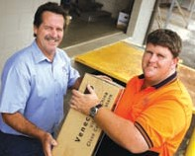
22

STEPS
Business Development and Corporate Services

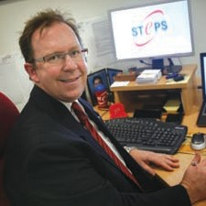Business Development report

The Business Development Division of STEPS Disability Qld Inc exists to ensure the organisation continues to operate from a sustainable base. A broader base ensures greater stability.
National and even international operations are desirable and entirely feasible. Consider that in less than 20 years a small group of people with a regional focus has grown into an
The Business Development Division itself is growing, yet to reach the first anniversary of its launch at the time of writing. Since inception, projects undertaken include:

Stuart Coward, STEPS Business Development Manager

Like most business sectors of today, STEPS operates in an environment of change. Innovation and diversification are needed in order to flourish and build for the future.
Business Development supports all existing divisions of the organisation with a view to growth and maximising potential of existing operations. It also seeks and investigates new business and growth opportunities.
The strategic objectives of the Business Development’s division are:
  - Identifying industry needs and trends,
  - Identifying opportunities for business improvement,
  - Generating leads to establish new business opportunities,
  - Assessing potential opportunities and determining their feasibility.
Looking back at the history of STEPS, growth and development is a continuing theme. So too is a
strong grip on core values and vision. There is every confidence that these attributes, so firmly established in the organisation, will continue.
organisation with branches throughout the state of Queensland, and the Northern Territory.
To this end, the Business Development Division will establish, develop and maintain key relationships with existing and potential clients, partners, service providers and stakeholders nationally and internationally.
We will also continue to research and develop new business enterprises that will create employment for all of our Disability Employment Network clients, for example, the provision of contract cleaning services and other suitable employment creation strategies.
Where possible synergies exist, partnerships with other businesses and providers will be explored to engineer employment.
All surplus funds will be re-injected back into the organisation to enable us to continue offering excellence in service and support, as well as growth and development for our client base.
  - Supporting of STEPS Training through promoting of existing programs to new markets and exploration of new program delivery opportunities
  - Investigation of specific and targeted business opportunities within the growing aged-care sector
  - Maintaining and developing the organisation’s profile through local and national networking events, seeking to build new business relationships and opportunities.
  - Assisting the Marketing/Public Relations arm of STEPS in developing and implementing marketing strategies
  - Identifying merger and partnership opportunities
These are very exciting times for STEPS as we continue to grow and diversify, while at the same time becoming an employer of choice, and achieving business excellence.

24

Corporate Services report

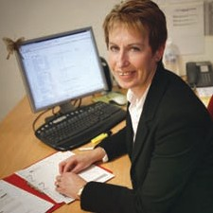
Corporate Services Manager, Paula Payne

STEPS Corporate Services reflects the structural change of the organisation during 2007-2008.
This change involved the formalisation of the Corporate Services Division (CS) to strengthen the cohesion between the six corporate departments - Finance, Human Resources, Information
Communication and Technology (ICT), Administration, Business Excellence Unit (BEU) and Marketing/PR.
As STEPS expands, Corporate Services seeks to manage the significant exchange of corporate knowledge, and provide greater corporate support to the operational divisions.
CS supports the delivery of STEPS’ business functions and programs by providing cost effective, efficient and timely corporate services to all divisions:
- HR: human resource management, industrial relations, occupational health and safety, staff development, compensation and remuneration management.
- Finance: financial reporting, processing financial transactions, and management of STEPS revenue and investments
- Administration: property management, provision of general business services, records management, travel, fleet management and insurance
- ICT: information management and management of STEPS information technology infrastructure including systems maintenance, user support and IT equipment and stores
- Marketing/Public Relations: community relations, incident management, publications, education campaigns and media liaison and releases
- BEU: audits (internal and external), quality management, performance monitoring and systems development.
Through the recent time of change and expansion, CS has successfully supported the operational divisions in bringing various projects to fruition.
In addition to these accomplishments, CS has assisted in developing the overall strategic direction for the organisation and managed its human, financial, informational and physical resources.

25

Business Excellence Unit (BEU)

Human Resources

The Business Excellence Unit (BEU) was established in December 2007 through a restructure within the Corporate Services Division. The BEU was formed in response to the strategic plan and organisational focus on Business Excellence which is an integrated leadership and management system that embraces all facets of an organisation including, leadership, customer and market focus, strategy and planning, people, information and knowledge, process management (improvement and
innovation), success and sustainability.
The role of Business Excellence Advisor was developed from the interrelated responsibilities contained in the positions of Quality Manager; Project Manager and Auditor/ Management Relief.
Three incumbent staff members became the three members of the BEU and brought with them 19 years of combined experience, knowledge and skills derived from various roles within STEPS Disability Qld Inc. including administration and finance, client services, employment services branch management; performance monitoring and measurement and quality management. In addition to this, the team also has tertiary qualifications in Training and Assessment and degrees in Learning Design and Social Science.
The BEU conducted the following internal audits:
  - Eight Disability Service Standards (DSS) audits within eight branches of the STEPS Employment Division;
  - Personal Support Programme (PSP);
  - Australian Quality Training Framework (AQTF); and
  - A gap audit for Capability Concepts prior to merging.
The external audit for Employment Placement Services (DSS), completed in November 2007, found STEPS to be an organisation of high professional standards, maintaining quality service outcomes, with a sound procedural system established against the
12 DSS.
The auditors also noted extremely positive feedback from participants across all sites, that demonstrates the commitment of all staff in providing excellent quality outcomes and customer satisfaction.

Staff Statistics at a glance
Since 1 July 2007 the number of employees at STEPS Disability Qld (SDQ) increased by 14 from 80 to 94.
The 94 staff members are distributed as follows:
Division Number
of Staff
Business Development 1
Community Services 7
Corporate Services 21
Employment Services 63
Training Services 2
The 63 staff employed in the Employment Services Division are located at the following branches:
Branch
Number
of Staff
Alice Springs 5
Bowen 6
Bundaberg 8
Caloundra 10
Hervey Bay 6
Maroochydore 8
Nambour 13
Aitkenvale 7
During the same period 43 staff left the organisation. These 43 staff include seven casual staff who did
not continue in regular employment and five redundancies due to operational reasons and the closure of
STEPS Job Placement Organisation (JPO) following the decision by the Department of Education, Employment and Workplace Relations (DEEWR)
to discontinue the Job Placement program.
In February 2008 the payroll function was transferred from the Finance Department to Human Resources.
Some of the major achievements of Human Resources in the past year include:
  - Drafted a new Collective Agreement that was accepted by the majority of staff and lodged on 17 January 2008.
  - Conducted a job analysis and redesigned position descriptions into a new format that uses Key Result Areas (KRA’s) to describe the critical aspects of each role and provide the basis for setting annual performance goals in the Performance Management and Review Process.
  - Provided training to all staff in the Performance Management and Development Policy and procedures (that encompasses
performance planning, a progress review and an annual review)
that replaced the Performance Management Program.

26

Marketing / Public Relations
The launch of the Community Services and Business Development Divisions, reinvigoration of STEPS Training,
and a growing geographical base for Employment meant a greater need to communicate with the organisation’s broadening customer base.
Improving relationships with employers
– existing and new customers – was seen as a priority.
To achieve this improvement,
STEPS launched a full-time marketing and public relations department at the start of 2008. The priority was, and continues to be, developing
an integrated, multi-media approach to marketing and communications
– a continuum from branding to sales support.
Researching the needs of stakeholders as a basis for developing a strategic marketing plan is another priority, as is establishing a set of reliable and accurate tools to measure the effectiveness of marketing strategies against business goals.

The 12-month TV campaign began in early June in three regional areas
– Sunshine Coast, Wide Bay and Townsville. Radio and newspaper advertising featured in Alice Springs and Bowen respectively.
The campaign’s launch coincided with the release of a research report compiled from surveys conducted by employment staff throughout all branches. Responses from just over 300 employers were analysed, with recommendations for improving relationships tabled.
Two strong central themes are being promoted as the key to marketing STEPS and its services:
- Story-telling – communicating success stories from across the organisation through various media to relevant stakeholders;
- Association – developing professional, synergistic relationships with people of like- mind in our communities, and promoting these relationships.

STEPS’ new website, combining all divisions of the organisation and featuring a strong emphasis on success stories, was under development.
An employer breakfast on the Sunshine Coast featuring Brisbane Broncos coach Wayne Bennett as guest speaker was being planned.
An employer’s breakfast was held in Caloundra earlier in the year, and
all divisions and branches of STEPS attended numerous expos and events.
Through attending these and networking, many employment consultants continue to build strong strategic partnerships with disability, community and industry groups.
The key to increasing and improving business through marketing and public relations will be through a ‘whole-of-organisation’ approach to corporate communications, that is, all staff contributing to the marketing and promotion of STEPS.

Employer engagement became a central theme through the coordination and production of new television commercials featuring employer testimonials.
These two themes were evident in several key marketing and public relations initiatives under development in 2008.

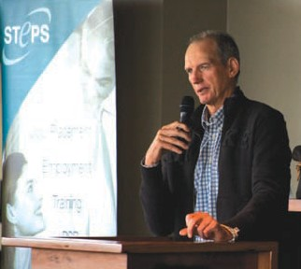

27

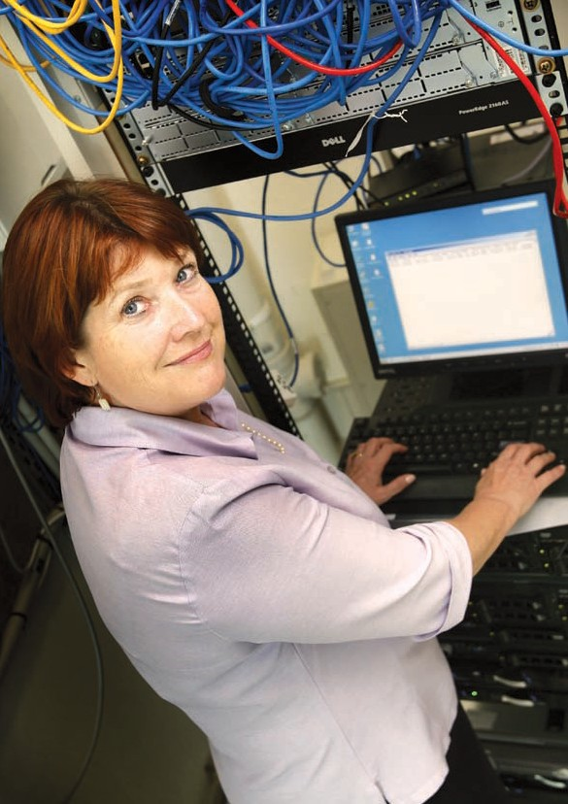

Information & Communication Technology (ICT)

STEPS ICT support is provided in-house. It covers three essential operational areas: network/systems administration; systems/web development and help desk support.

In 2007–08 STEPS’s ICT Organisational Plan was updated to identify the ICT support requirements.
During the year several ICT projects were undertaken, including:
  - Replacing the existing client management software with DENMAX SAAS. Employment staff benefited from the productivity gains provided by its integration with EA3000.
  - Designing and creating a new website for STEPS Community Services, NDCO programme. The resulting website (www.ndco.stepscs.net.au) has been exceptionally well received in peer reviews.
  - In recognition of STEPS diversification our website (www.steps.net.au) has been completely rebuilt, and our domain email address changed from
@stepsemployment.com.au to @steps.net.au.
  - During the year ICT hardware was refreshed under the STEPS three-year replacement strategy, including servers, desktops and laptops. Through the generous donations of the Microsoft Unlimited Potential and Donortec programs we upgraded our Windows Server software and migrated our domain to Exchange 2007.
  - In 2008-2009 we are undertaking a major network upgrade to IP MAN with our strategic partner Telstra. We will act as a reference site during the roll-out of Telstra’s best of breed high definition videoconferencing solution in our major regional areas.

28

Finance report
STEPS Disability Qld Inc
ABN 77 168 213 648

Income Statement for the year ended 30 June 2008

 | 2008 |  | 2007
Revenue | 7,597,672 |  | 5,324,444
Salaries & employee benefits expenses | 4,284,012 |  | 3,758,314
Advertising & promotion expenses | 44,128 |  | 80,988
Depreciation expenses | 367,609 |  | 213,699
Other Expenses | 2,108,661 |  | 1,621,864
Profit from activities before income tax expense  Income tax expense  Profit from activities after income tax expense | 793,262  -  793,262 |  | [350,421]  -  [350,421]

29

Finance report cont.

Statement of Financial Position as at 30th June 2008
STEPS Disability Qld Inc
ABN 77 168 213 648

CURRENT ASSETS
2008 2007

A full financial report is produced as an appendum to this annual report and is available upon request from STEPS Corporate Office.
 | Cash | 698,521 |  | 174,673
 | Receivables | 329,241 |  | 159,783
 | Other | 28,502 |  | 135,101
 | TOTAL CURRENT ASSETS | 1,056,264 |  | 469,557
 | NON-CURRENT ASSETS
 | Receivables | 316,338 |  | 35,000
 | Property, Plant & Equipment | 1,608,487 |  | 1,211,776
 | TOTAL NON-CURRENT ASSETS | 1,924,825 |  | 1,246,776
 | TOTAL ASSETS | 2,891,089 |  | 1,716,333
 | CURRENT LIABILITES
 | Payables | 162,597 |  | 268,713
 | Interest-bearing liabilities | 423,244 |  | 259,840
 | Current tax liabilities | 195,103 |  | 148,027
 | Provisions | 237,132 |  | 195,712
 | TOTAL CURRENT LIABILITIES | 1,018,076 |  | 872,292
 | NON-CURRENT LIABILITIES
 | Interest-bearing liabilities | 710,031 |  | 418,892
 | Provisions | 60,353 |  | 25,782
 | TOTAL NON-CURRENT LIABILITIES | 770,384 |  | 444,674
 | TOTAL LIABILITIES | 1,788,460 |  | 1,316,966
 | NET ASSETS | 1,192,629 |  | 399,367
 | EQUITY
 | Member’s Equity | 1,192,629 |  | 399,367
 | TOTAL EQUITY | 1,192,629 |  | 399,367
30

STEPS 2007 Disability Awards

The STEPS 2007 Disability Awards rewards the creativity, aptitude and dedication of people

with a disability, their carers, educators, and the organisations and businesses who assist them. It was a night to celebrate their

immeasurable contribution to our society and culture.
The Awesome Aussie nominees harnessed their drive and ambition to alter minds, attitudes and perceptions.
They have all made a real difference, standing by their commitments, transforming words into action and achieving outstanding results.
While applauding all nominees, STEPS will continue to work on behalf of all people with a disability, pushing the boundaries, networking with governments, employers and others, to identify the most effective ways of opening up opportunities and establishing further rewards for Awesome Aussies who take up the challenge to excel.
Since holding these awards two years ago there have been many changes to the expectations placed upon jobseekers with a disability. Where once it was a personal decision to obtain employment, for many it has become a requirement. In the face
of these changes, many jobseekers continue to show courage and drive to succeed.
As the traditional labour market shrinks for many businesses, many have employed people with disability, and experienced first hand the real rewards that these staff can bring. STEPS thanks all
participating employers for taking the time to understand the value of your employees, and for recognising their contribution to your successes.
The sponsors of the STEPS awards allowed us to provide the vehicle to acknowledge and reward outstanding contribution and achievement.
To the many family members, carers and friends, your support ignites the will to achieve and your encouragement keeps the flame of ambition burning.
The Awesome Aussie finalists are a guiding light, who inspire us to move towards a more inclusive society.

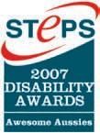

31

Award Winners

1 2 3

Our Major Sponsors were:

    - Worldwide Online Printing
    - Zinc 96.1FM
    - Southern Cross Ten Queensland
    - Brandmax Media and Marketing

4 5

6 1 Brett Hooper (left) winner of the Youth Achievement Award with Joe Odessa, winner of Manager/Supervisor of the Year Award

- Ty Belnap, the Sports Person of the Year Award winner

- Daniel Bateman, Employment Achievement of the Year Award winner

- Matthew Yee, Artist of the Year award winner

- STEPS’ 2007 Disability Award winners

- Josephine Chadwick, winner of the Roger Cox Personal Achievement Award

Awards Absolute

Employment Achievement of the Year
Finalist Raymond Bube from Simply Delicious Bakery
Winner Daniel Bateman The Bricos Group

Employer of the Year finalists Finalist Bundaberg Trolley Service Finalist Digeridoonas, Caloundra
Winner Simply Delicious Bakery, Kunda Park

Sportsperson of the Year
Finalist Anthony Shing, Mount Coolum Finalist Jason Rosendahl,
Finalist Peter Goodrich, Nambour
Winner Ty Belnap, Buddina

Artist of the Year
Finalist Luke Fitzgerald, Maleny
Winner Matthew Yee, Golden Beach

Accessibility Award
Winner Endeavour Industries, Kunda Park

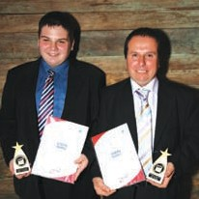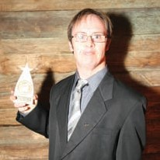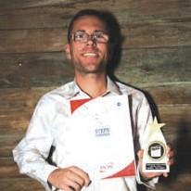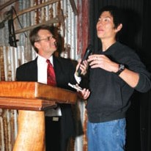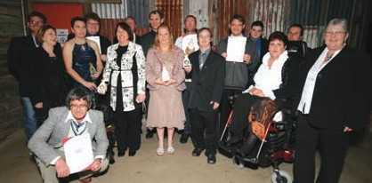
32

Media Coverage Award
Winner Jointly won by Southern Cross Ten Queensland and Brandmax Media & Marketing, Minyama

Manager or Supervisor of the Year Award Finalist Joshua Money from HomeArt, Maroochydore Finalist Chris Sales from Total Biz Solutions, Warana Winner Joe Odessa, Joe’s Garage, Noosaville

Educational Service Provider of the Year
Winner Wide Bay Institute of TAFE

Lifestyle Enhancement Award
Finalist Be Lifestyle Connections, Cooroy
Winner Rydges Oasis Resort, Caloundra

Apprentice or Trainee of the Year Award
Finalist Debra Viles
Winner Clinton Van Der Berg

Carer of the Year Award
Winner Sherrie Auld

Supportive Work Team of the Year Award
Finalist Dick Smith Electronics, Finalist Vanilla Café, Noosaville Finalist McDonald’s, Currumundi Finalist Erowal Blue Care Retirement
Finalist Village Maintenance Department, Maleny
Winner Nambour General Hospital’s Human Resource Development Department, Nambour

Student Achievement Award
Finalist Patrick Gillett, Mooloolaba
Winner Leona Canniford, Ridgewood

Youth Achievement Award
Finalist Alex Somerville, Palmwoods Finalist Joseph Maher, Coolum Beach Winner Brett Hooper, Eumundi

The Roger Cox Personal Achievement Award
Finalist Shane Ratcliffe, Twin Waters Finalist Belinda Wardlaw, Cooroy Winner Josephine Chadwick,
Eumundi

33

Staff

Divisional List of Staff

Chief Executive Officer Garry Hooper

Executive Assistant Stephanie Byrne

Manager – Business Development

Stuart Coward

Employment Services

General Manager

– Employment Services John Conway
Program Manager Le Anne Cartwright

AITKENVALE

Branch Manager – Aitkenvale Lee-Anne Whalley
Kylie Budd
Janet Glynn-Armstrong Heather Goldstein Mark Jenkins
Phyllis Iker Joanne Patroni

ALICE SPRINGS

Branch Manager – Alice Springs Katrina Whan
Andrew Garoni Joanne Lukehurst Denise Murray Mister Shaun

BOWEN

Branch Manager – Bowen Greg Cummins
Elrae Connell Julie Finch Greg Martin Anita Short
Sarah Thompson

BUNDABERG

Branch Manager – Bundaberg Glynn Eiser
Kathlene Brown Matthew Chamberlin Jennifer Goodchild Simon Mills
Rebecca Sunnerdale Evelyn Thompson

CALOUNDRA

Branch Manager – Caloundra Steven Chand
Maria Bowis Sandra de Jersey Greg Harris Aimee Hollonds Cristina Mihalache Eva O’Reilly
Kelly Paton Sharon West

HERVEY BAY / MARYBOROUGH

Branch Manager –

Hervey Bay / Maryborough Martin Heneker
Sherrie Auld Rachael Finn Karen Goffinet Ann Horridge Lori Keevers Jodi Logovik
Jerome Tueta-Nicholls

MAROOCHYDORE

Branch Manager – Maroochydore Trish Cameron
Siobhan Ablett Scott Baker
Jacqueline Cartwright Bradley Heir
Darren Hilliard Shelly Nichols Toni Usher

34

NAMBOUR

Branch Manager – Nambour Nikki de Jonge
Rhonda Casey Rose Dale
Anne-Maree Dearden Marlene Dearden Elaine Dornan Yvonne Higgs
Hazel Innes David Lindsay Liza Scriven Lee Shea
Andrew Spencer Gleyn Warren Kylie Watson

TOWNSVILLE

Branch Manager – Townsville Joanne Wittmaack
Linda Di Betta Karen Easterbrook Susan Marron Megan Murray Gail Naismith Christine Sheriff Morgan Wittmaack

Community Services

Manager – Community Services Barbara Davidson
Kim Anderson Cynthia Cedergreen Sharon Dulac
Ian Hulsman Antonia James Brian Kerr Marilou Pech Heather Robson
Deborah Rooskov Gary Travers

Training Services

Manager – Training Services Shelly Campbell

Corporate Services

Manager – Corporate Services Paula Payne
Sheila Bhola Helen Brooks Jennifer Carter Chris Eaton Marja Forbes
Samantha Geeson Kaitlin Hayes
Kris Hobbs Isabel Hooper Margaret Hooper Narelle Jones Sharon Manzone
Christina Nysschen Helen Ray
Melissa Slaby Stacey Spencer Darren Trinder
Alison van Herberghen Teisha Wernowski

35

Locations

Corporate & Executive Offices
Floor 2, 84 Sandalwood Lane FOREST GLEN QLD 4556 PO Box 1184,
MAROOCHYDORE QLD 4558
Ph: (07) 5458 3000
Fax: (07) 5458 5033

Community Services

SUNSHINE COAST
Shop 2 Otranto House 8 Otranto Avenue
PO Box 1804 CALOUNDRA QLD
Ph: (07) 5437 2064
Fax: (07) 5438 2249

GIN GIN
21 Mulgrave Street GIN GIN QLD 4671
Ph: (07) 4157 2884
Fax: (07) 4157 2883

TOWNSVILLE
Shop 7, 358 Flinders Street
PO Box 1604
TOWNSVILLE QLD 4810

Training
Shop 29 Centenary Square Currie Street
NAMBOUR QLD 4560
PO Box 1184,
MAROOCHYDORE QLD 4558
Ph: (07) 5453 8720
Fax: (07) 5453 8770

Employment Branches

AITKENVALE
Tenancy 4, Level 1
281-285 Ross River Road PO Box 122
AITKENVALE QLD 4814
Ph: (07) 4727 2600
Fax: (07) 4727 2666

ALICE SPRING
Jock Nelson Centre
Shop 9 / 16 Hartley Street ALICE SPRINGS NT 0870 PO BOX 79
ALICE SPRINGS NT 0871
Ph: (08) 8950 7600
Fax: (08) 8950 7650

AYR
139B Young Street PO Box 587
AYR QLD 4807
Ph: (07) 4783 4811
Fax: (07) 4783 3800

BOWEN
Shop 4 / 36 Powell Street
PO Box 574
BOWEN QLD 4805
Ph: (07) 4727 2600
Fax: (07) 4727 2666

BUNDABERG
Shop 3 / 2 Bourbong Street
PO Box 2059
BUNDABERG QLD 4670
Ph: (07) 4150 1900
Fax: (07) 4150 1919

CALOUNDRA
37 Bowman Road
CALOUNDRA QLD 4551
PO Box 1184
MAROOCHYDORE QLD 4558
Ph: (07) 5438 5500
Fax: (07) 5438 5599

COLLINSVILLE
Shop 1, 45/47 Railway Road COLLINSVILLE QLD 4804
PO Box 574
BOWEN QLD 4805

HERVEY BAY
2 / 17 Torquay Road
PO Box 3040
PIALBA QLD 4655
Ph: (07) 4194 3900
Fax: (07) 4194 1504

MAROOCHYDORE
78 Duporth Avenue
PO Box 1184
MAROOCHYDORE QLD 4558
Ph: (07) 5409 9000
Fax: (07) 5409 9090

MARYBOROUGH
Shop 1, 373 Kent Street
PO Box 597
MARYBOROUGH QLD 4650
Ph: (07) 4120 2800
Fax: (07) 4123 4600

NAMBOUR
Shop 29 Centenary Square Currie Street
NAMBOUR QLD 4560
PO Box 1184
MAROOCHYDORE QLD 4558
Ph: (07) 5453 8700
Fax: (07) 5453 8770

NOOSA
Suite 2, 3 Lanyana Way Noosa Fair Shopping Centre NOOSA HEADS QLD 4567 PO Box 1184
MAROOCHYDORE QLD 4558
Ph: (07) 5447 2711
Fax: (07) 5474 9302

TOWNSVILLE
Shop 7, 358 Flinders Street
PO Box 1604
TOWNSVILLE QLD 4810
Ph: (07) 4771 2840
Fax: (07) 4771 2974

36

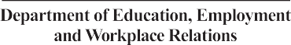Funding

STEPS would like to thank our funding bodies for their continued support.

Department of Employment and Training

37

STEPS Disability QLD Inc.
PO Box 1184, Maroochydore Q 4558
Phone: (07) 5458 3000
Fax: (07) 5458 3033
Email: enquiries@steps.net.au

www.steps.net.au

