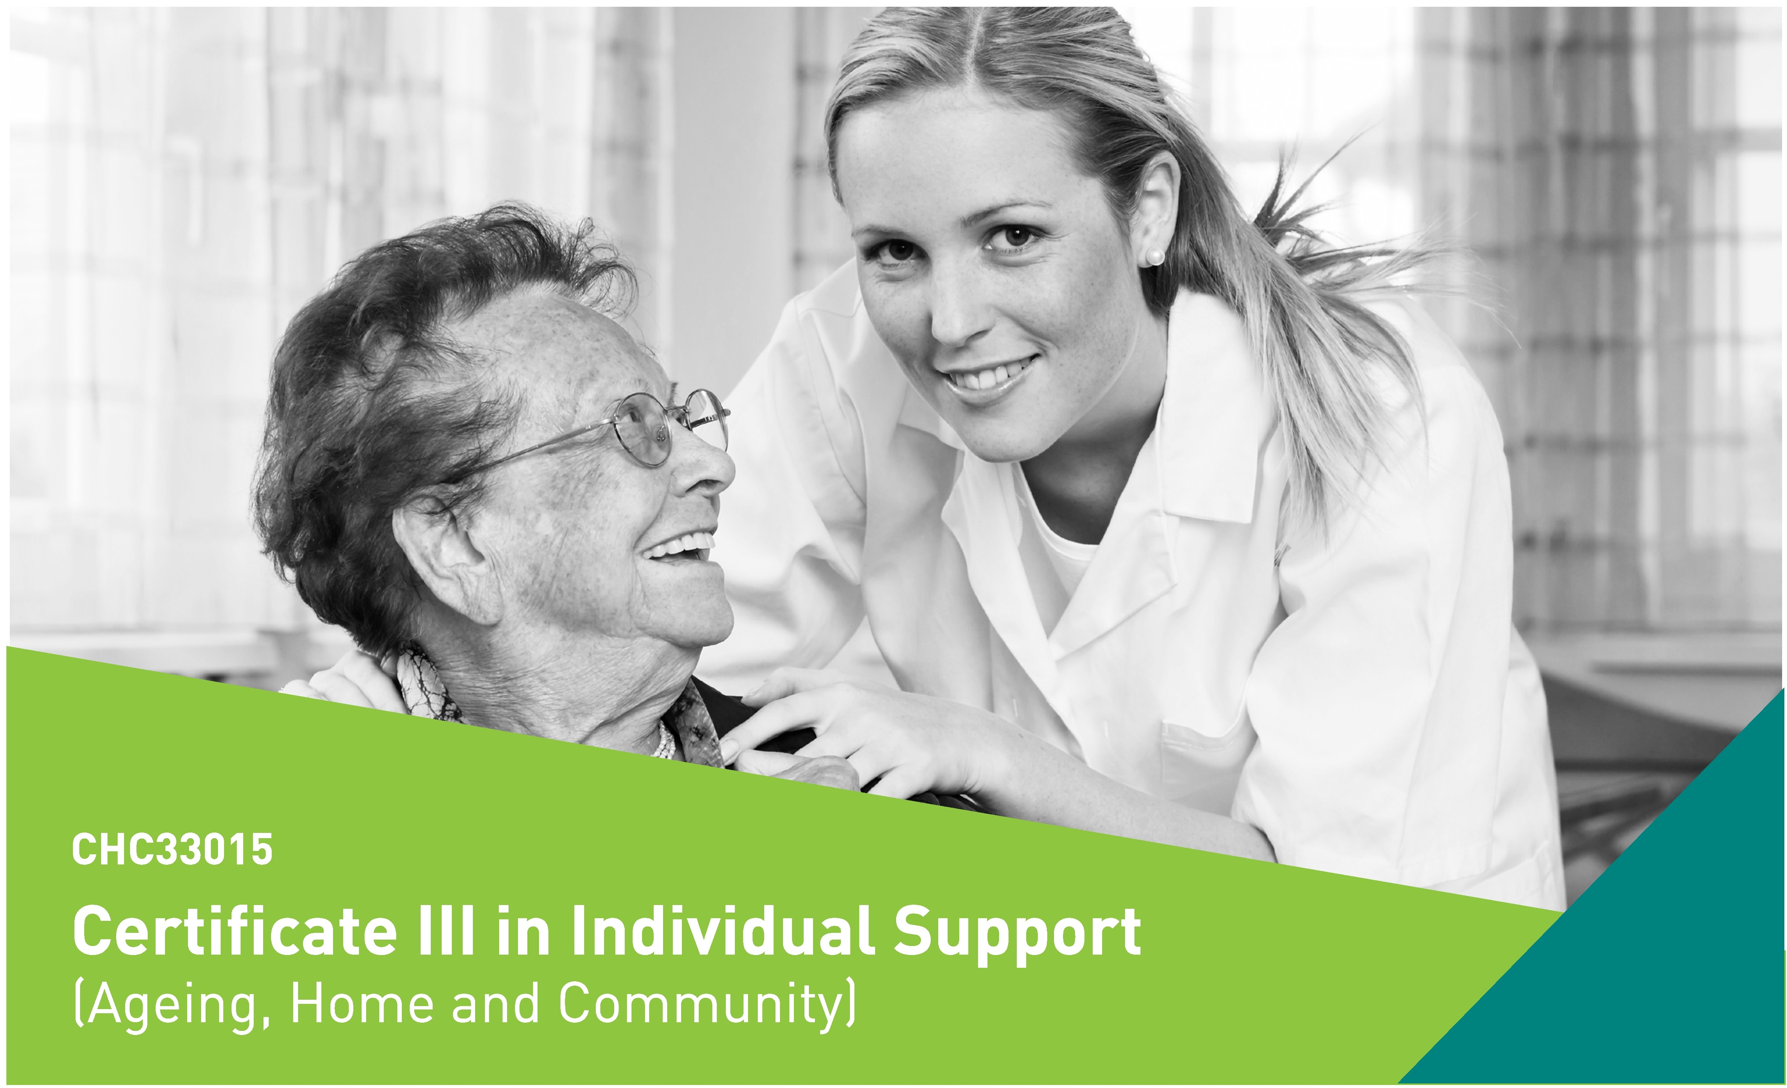

COURSE OVERVIEW

Start your career in care today and join one of Australia's fastest growing industries. The Certificate Ill in Individual Support [Ageing, Home and Community) is a nationally recognised qualification providing you with the skills and knowledge needed to gain entry level employment in a range of care and support roles.

COURSE DETAILS

Qualification
CHC33015 Certificate Ill in Individual Support [Ageing, Home and Community]
Duration
12 weeks [including work placement]
Course Delivery
Monday to Thursday, 9am to 3pm, on campus
Start Date
Monday 22nd January 2018 - 1 week of home studies [workbook provided at Orientation]
Monday 29th January 2018- class commences on campus
Location
9 George Street, Caloundra
Orientation (bookings essential}
Come along to our FREE workplace visit and orientation session to meet your trainers and ask questions about working in the Aged Care industry prior to enrolment.
Date: Thursday 18th January 2018
Time: 9:30am
Location: Southern Cross Care, 57 Village Way, Little Mountain; followed by an information session at Caloundra
Work Placement
STEPS will arrange for you to complete your required work placement in an aged care facility and home care setting. All students are required to complete 4 weeks work placement in order to receive their qualification.
Dates: 5th March - 23rd March 2018 9th April-13th April 2018
*Students are responsible for any transport required for work placement.

For Further Information
Phone 07 5436 6000 or email
training@stepsgroup.com.au
www.stepstraining.edu.au

NATIONALLY RECOGNISED TRAINING

Registered Training Organisation Number 1847

EDUCATION &TRAINING

FEES

Course fees vary depending on eligibility under the Queensland Government’s Certificate 3 Guarantee Program. To find out if you’re eligible under the

Certificate 3 Guarantee Program Fees
The following co-contribution fees are payable for those eligible under the Certificate 3 Guarantee;

Certificate 3 Guarantee visit www.stepsgroup.com.au/ training/certificate-3-guarantee

Full fee paying student (non funded)
Full Course Fee $2900
Eligible Students
Full co-contribution Fee
$ 399
Per Unit
$ 30.70
Eligible Concessional Students
Full co-contribution Fee
$ 300
Per Unit
$ 23.05

WHAT WILL I LEARN?

The Certificate III in Individual Support CHC33015 is made up of 13 units including 7 core units and 6 elective units specialising in Ageing and Home and Community support.

Group C electives - Home and Community Specialisation
Core Units:
CHCCCS015 | Provide individualised support
CHCCCS023 | Support independence and well being
CHCCOM005 | Communicate and work in health or community services
CHCDIV001 | Work with diverse people
CHCLEG001 | Work legally and ethically
HLTAAP001 | Recognise healthy body systems
HLTWHS002 | Follow safe work practices for direct client care

CHCCCS025 | Support relationships with carers and families
CHCHCS001 | Provide home and community support services
HLTHPS006 | Assist clients with medication

Elective Units:
Group A electives - Ageing Specialisation
CHCAGE001 | Facilitate the empowerment of older people
CHCAGE005 | Provide support to people living with dementia
CHCCCS011 | Meet personal support needs

During your course you will be provided with:
- Work Placement
- National Police Check
*Satisfactory results of a National Police Check is required for work placement
Language, literacy and numeracy support along with other learning support will be provided to students to assist with their studies.

CAREER PATHWAYS

The Certificate III in Individual Support will provide you with the qualifications to help you start an exciting career in Aged, Home and Community Care. Employment opportunities may include work in the following areas:
- Residential Aged Care
- Home and Community Care
- Respite Care
- Personal Care
- And a range of other care and assistive roles

WHY STEPS?

STEPS Education & Training offer training solutions that meet real local market needs. Our courses are designed in consultation with local employers to improve our students’ employment opportunities and on the job skills.
Our highly qualified trainers bring hands on industry experience to their role allowing you to feel confident that you are gaining the best workplace preparation possible.
The STEPS campus is well located set amongst 2.8 acres of landscaped gardens close to public transport, shops and services, and is fully equipped with the latest technology and modern facilities to ensure your study at STEPS is both enjoyable and rewarding.

PAYMENT PLANS |  | ENTRY REQUIREMENTS

Payments can be made in full or by a weekly payment plan. For weekly plans, a $150 non refundable deposit must be paid prior to course commencement followed by weekly instalments.
*Certification will not be issued until fees are paid in full
RECOGNITION OF PRIOR LEARNING |  | HOW DO I ENROL?

You may be eligible for credit towards your qualification based on previous workplace skills or study. Contact us to find out if you are eligible at training@stepsgroup.com.au
- Successful completion of a Language, Literacy and Numeracy (LLN) Indicator
- Clear Federal Police Check
- Physical ability to be able to perform the required manual handling duties of a carer

For more information about this course or to enrol phone us on 07 5436 6000 or email training@stepsgroup.com.au

