annual review
201 5

who are steps? 1

who are STEPS?

To make a difference by providing opportunity
We’re lots of things to lots of people and communities
across Australia. We’re carers and creators, agitators and
innovators, movers and shakers.
We provide opportunities for
individuals to achieve and shine. We want to make a difference,
and we do.
We’re a not for profit committed to making a difference by
providing opportunity through the provision of services that enable. Whether it’s learning,
working, supporting or inspiring we help individuals realise their potential and achieve their
goals.
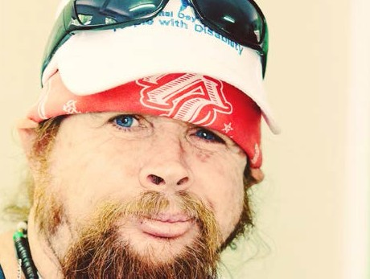STEPS believe that everyone has the right to participate in life fully, free to access places and spaces, information and
knowledge, and free from the possibility limiting opinions
of others. We’re here to build brighter futures.

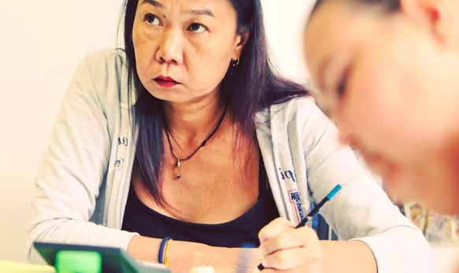

md’s message 2

MD’s
message

In 1989 a small group of
parents were drawn together by a shared concern for their children’s future. They
decided to create the change that needed to occur for
their child to have a happy, independent life. I was one of those parents all those
years ago and I can say first hand that while STEPS has grown and diversified over
the last 26 years, we are still as passionate as ever about helping others achieve their life goals and aspirations.
Recently we took some time to review the vision, mission and values that have brought STEPS to where we are

made the change because we wanted to embody our passion and determination in a commitment to the
Australian community, a promise that we will
accomplish what we set out to achieve. Our new commitment is to make a difference by providing
opportunity. The philosophy of teaching individuals the
skills they need to set their own goals and path their

The last 12 months has
been a very full and vibrant year for STEPS, and I hope even a small reflection of
our efforts can be seen in
this year’s Annual Review. I wish everyone could see the passion and determination of the people I work with every day, and experience
the positive interactions we have with our customers.
I’d like to thank the STEPS Board and employees, our

contents

today. Invigorated by future
possibilities and determined to be the makers of change we decided to replace our
vision and mission with a
commitment driven by a set of values.
Why? Because at STEPS we are all visionaries, and our mission to positively
impact the people and
communities we work with is unwavering. This is who we are and is a reflection of the type of workforce we have worked hard to achieve. We
own road to success is a
philosophy STEPS strongly believe in.
Our commitment to our
customers may be simple but it’s powerful. The
values that drive STEPS have been simplified to
four key attributes we felt most integral to ensuring our customers receive the service they expect and
deserve; a service and
business ethic that embodies integrity, courage respect
and understanding.
most valued volunteers, and our amazing customers for their support throughout
the year. I’d also like to
thank our partners in the community, in business
and in government for their significant contribution to STEPS, and to everyone
who has supported us and
helped STEPS to become the organisation it is today.
I look forward to embarking on this next year with you all, and what a journey I’m sure
it will be.
who are STEPS?

MD’s
1
2
message

a year in review
5

our footprint
6

employment solutions
8
mental health

social & community
10
12

social return on
14
investment

education
20
& training

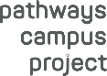24 charity pathways campus
25
project
26 diversity
meet the
27
board

executive leadership
28
team

our organisation
29

30 volunteers
partnering for success
31

a year

pathways to
hope after pr iso n working together
success for
industry

in review

small changes, big dreams
STEPS officially changed its legal identity from an incorporated association to become STEPS Group Australia Ltd, a company limited by guarantee

better cho ices, better life
STEPS Community Services became a host provider under the Queensland Government’s Your Life Your Choice model for disability support services

happiness
A new range of programs was developed to enrich the lives of our Community Services customers, with a main focus on fun. Made up of a range of social, arts and health
related activities our customers enjoy improved health and wellbeing, have learnt social and team working skills, and importantly experience greater joy in their lives.

awareness for indigenous
disability
The NDCO Aware Project was established with funding from the Department of Education and Training, in consortium with National Disability Coordination Officer Programmes from Northern Qld, Northern SA and the Northern Territory. NDCO Aware aims to develop understanding of how different disabilities are viewed in Aboriginal and Torres Strait Islander communities, and the diversities within distinct cultural groups.
Language, literacy and numeracy support was provided to early release prisoners' training for careers in
the Automotive Industry. The joint project saw us working with the Motor Trades Association (NT), the Northern Territory Department of Corrections, the Centre for Appropriate Technology and Charles Darwin University, and went on to win the NT Training Award for Industry Collaboration.

promoting mental well being
The Pet Companions program was established to encourage people experiencing mental illness to seek the support needed to recover by helping to care for pets during periods of hospitalisation or mental duress.
This year we formed significant relationships across our Employment Service Areas with hospitals, mental health organisations, and drug and rehabilitation centres, providing supported employment services to assist in the recovery of mental health clients.

suppor ting future stockmen
In January we began a collaboration with the Indigenous Land Corporation to train 70 indigenous Australians in a range of Agricultural qualifications.
STEPS provide trainees with language, literacy and numeracy training and foundation skills to support their training.

creating change
STEPS National Panel of Assessors Coordinator, Sharon Dulac, was invited to join the Technical Group advising
on the development of historical productivity data draft guidelines for use in the supported employment (ADE) sector.

indigenous job seekers
A change in government saw the Indigenous Employment Program become part of the government’s Indigenous Advancement Strategy (IAS). STEPS deliver services in the Hobart and outer region achieving an 80% outcome success rate for our clients and gaining excellent relationships with local employers.

changing li ves
Four new employment sites were
opened as part of the Disability Management Services (DMS) contract. These sites provide mental health specific employment services and significantly add to the scope of work we do to support people experiencing mental illness

g et up and g et mov ing
We continued working with Rio Tinto Alcan Gove helping Yolgnu men and women undertake training to prepare them for a career in mining as part of the Ralpa programme, Ralpa meaning “get up and get moving” in Yolgnu.

pa r tnerships for employment
STEPS Education & Training teamed up with the Housing Institute of Australia (HIA) for the Get Skilled pilot program funded by the Northern Territory Government. 16 Darwin students graduated from the program with skills to start work in the construction industry.

ho listic roads to recovery
STEPS were involved in a collaborative research project which proved employment to play an important
part in the mental health recovery process. As a result referrals to our employment service programs climb and our workforce expands to help more people experiencing mental illness find work as part of a holistic approach to wellness.

passion pays off
STEPS Employment Solutions won the 2015 Disability Service Provider award presented by the Australian and New Zealand Mental Health Association for our work in assisting people experiencing mental illness into employment.

year in review 5

our
footprint

derby, WA

hobart, QLD
16
indigenous advancement strategy
bundaberg, QLD
17
care for carers program
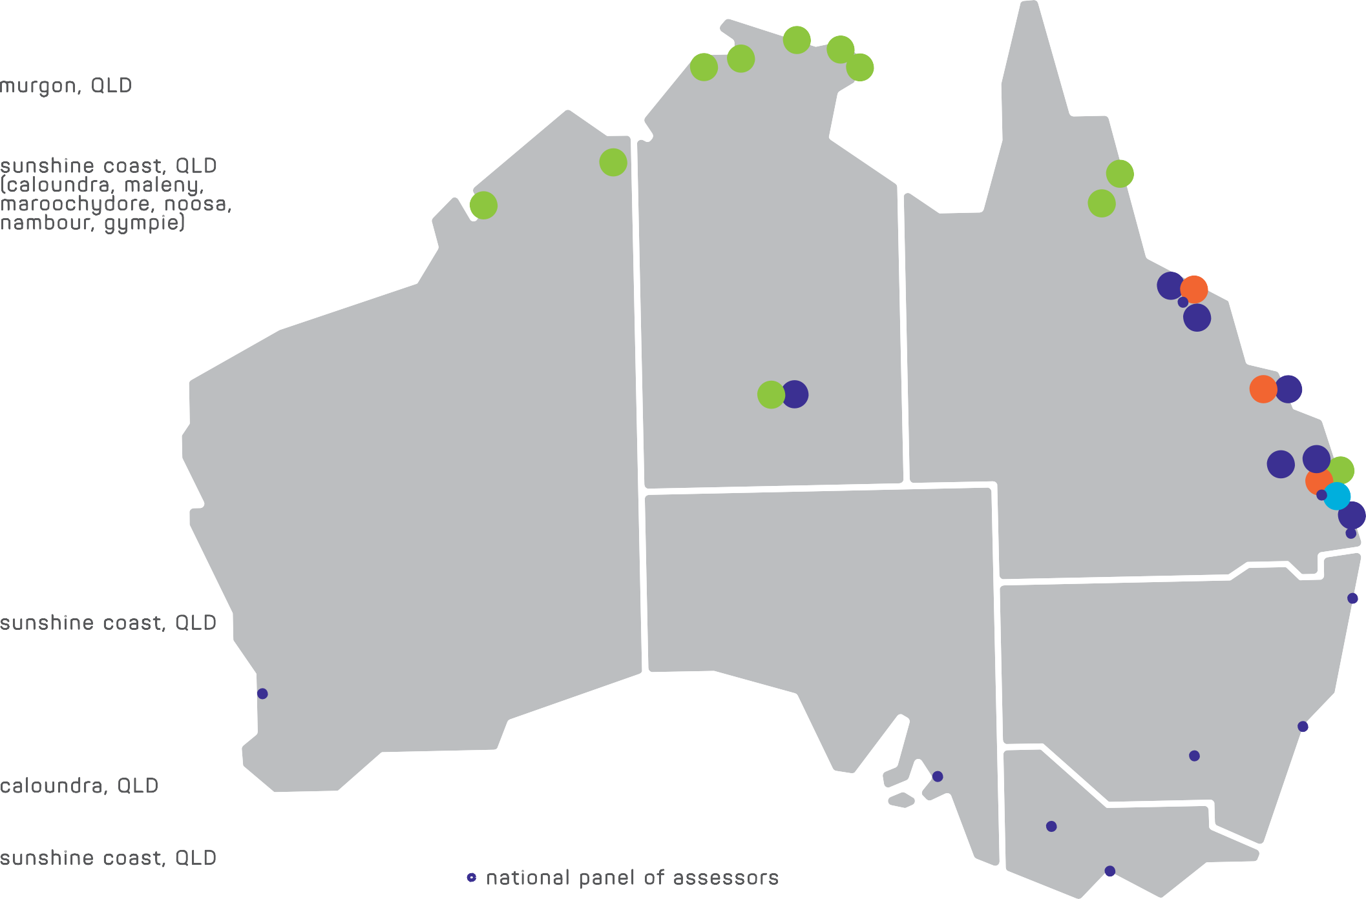bundaberg, QLD
18
disability employment services incl.
mental health specific disability 7
8

1 skills for education and employment
kununur ra, WA
2
skills for education and employment
darwin, NT
3
skills for education and employment
gunbalanya, NT
4
skills for education and employment
alice springs, NT
5
skills for education and employment northern territory aged care project
alice springs, NT disability employment services milingimbi, NT
6
7
skills for education and employment
galiwinku, NT
8
skills for education and employment
nhulunbuy, NT
9
skills for education and employment
a therton, QLD
10
skills for education and employment
cair ns, QLD
11
skills for education and employment
to wns ville, QLD
12
disability employment services incl. mental health specific disability
employment services
murgon, QLD
19
mental health specific disability employment services
sunshine coast, QLD ( caloundra, maleny,
20
maroochydore, noosa, nambour, gympie)
disability employment services incl. mental health specific disability employment services

sunshine coast, QLD
21
social & community programs
national disability coordination officer programme (region 20)
3 4 9

2

1

5 6

11
10

12 13
14

17 18

19 20 23
21
22
24

13
progr
disability coordination officer 22

to wns ville, QLD
national
amme (region 22)
ayr, QLD
14
disability employment services

hobart, QLD
15
skills for education and employment
caloundra, QLD
STEPS shared services
head office
sunshine coast, QLD registered training organisation redcliff e, QLD
23
24
mental health specific disability employment services

- na tional panel o f assessor s
(perth, adelaide, stanwell, melbourne, wagga wagga, sydney, yamba, brisbane, sunshine coast, & townsville)

16
15

our footprint 6

Disability Employment Services
Disability Employment Services is an Australian Government initiative to help people with
a disability to find and keep a job. STEPS Employment Solutions provide Disability Employment Services to 11 communities throughout Queensland and the Northern Territory.
employment solutions 9

National Panel of Assessors
The National Panel of Assessors is an
Australian Government program providing independent assessment of an individual’s ability to participate in the workforce with consideration to physical, psychological or
intellectual disabilities. Our Assessors help
job seekers overcome barriers to employment through Ongoing Support Assessments,
Supported Wage Scheme assessments, and Workplace Modification Assessments.

employment solutions

STEPS Employment Solutions have been
providing job seekers with a disability, injury , or health condition with assistance in finding and
maintaining work for more than two decades. But STEPS don’t just help people find jobs, we build
relationships with local employers so that we can better understand their workforce needs and
provide the right recruitment solutions.
Additionally job seekers are provided with the opportunity to achieve their career aspirations through tailored support and motivation to
succeed.
Our commitment is bigger than this though.
STEPS are passionate about improving the
work prospects for people with a disability and continue to advocate for workplace equality.

“Our long term goal is to change perceptions about employing people with a disability,
and by doing so open up opportunities to our clients that otherwise may have been lost,
despite having the willingness, fortitude, and appropriate skills to succeed in the role.
Over the years we have been fortunate enough to work with many businesses who have
looked beyond the ‘disability’ label to find hard working, loyal employees who have remained
employed year on end based on their exemplary performance and dedication to the job.
Our hope is that one day all employers will
focus on the person and their abilities not the disability”.

Lee-Anne Whalley,
Manager - S T EPS Employment Solutions

Aaron’s career blooms at Alice Springs Desert Park

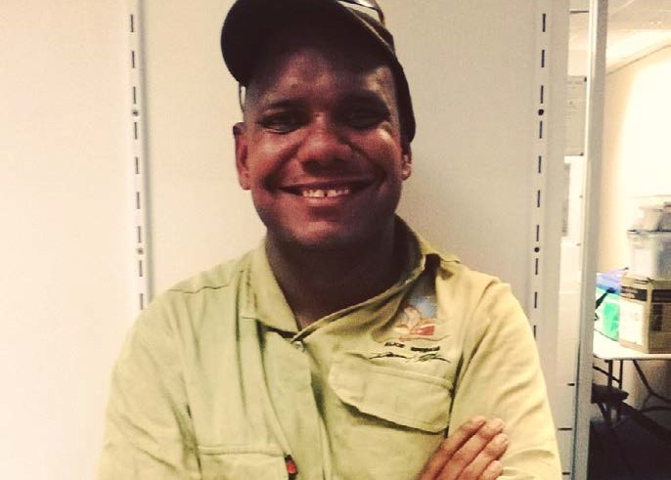
Getting a job at one of Alice Springs’ top tourist attractions isn’t easy.
But with a little hard work, dedication and a whole lot of passion one young man has
remained employment with the famous Alice Springs Desert Park for almost 5 years.
Aaron Curtis got his foot in the door at the Park as a school based trainee studying a Certificate II in Tourism specialising in Guiding.
Throughout his traineeship Aaron showed great work ethic, completing his traineeship while
maintaining a casual job at McDonalds, and successfully graduating from high school.

Aaron’s duties at the Park have been full of excitement from day one where he began working with the Park’s birds of prey.
After months of keenly observing Park guides presenting to tourists, Aaron soon started
joining in on talks and Q&A sessions.
He began working full time at the Park speaking to thousands of tourists every year about local
flora and fauna, cultural men’s business, and guiding visitors on the Park’s nocturnal tour.
Today Aaron has moved on to the Park’s
horticultural department where he is learning new skills such as plant cultivation, land
biodiversity and conservation.
Aaron says he wouldn’t have achieved what he has today without the ongoing support of the team at STEPS Employment Solutions. “They have always been so supportive, and very
respectful”.
Aaron is now studying a Certificate III in Land Management while continuing to work at the Alice Springs Desert Park.
While he hopes to one day travel and explore the Northern Territory, for now he is happy continuing doing what he likes the most.
“I love working outdoors, talking with visitors and guiding them through the Park”.

employment for mental health
social
community
&

Over the last few years we have been
working more and more to provide mental health specific employment services in our communities. We understand that the very
nature of mental illness means that each of our customers have different requirements in terms of the type of support needed to find work and stay in work.
This year STEPS opened our 8th office dedicated entirely to helping people
experiencing mental illness into employment. STEPS have co-location arrangements in place with headspace and Queensland Mental Health and Addiction Services where we support
individuals into employment as part of an
holistic approach to recovery. We also work closely with local private hospitals and drug
and alcohol rehabilitation centres helping their clients enter back into the workplace.
Mental illness can lead to social isolation, low self-esteem, and difficulty in securing or
maintaining employment. This causes financial strain creating a hopeless cycle that’s simply not conducive to recovery. By providing individualised support into employment we break the isolation and poverty, and as a result we see our client’s confidence bloom, and a cycle of positive mental wellbeing form.

Liza Scriven – Manager,
S T EPS Social & Community
STEPS Social and Community encompasses the work we
do in the community for the community.
Our social and community programs and services
promote wellbeing and quality of life for both individuals and the community as a whole.
We work one on one with people to create positive
living experiences, helping individuals discover and
grow to achieve their life
aspirations. Our community projects encourage care
and respect for our precious resources and local
environment, while providing forums for social engagement celebrating diversity and
inclusiveness.
Over the next few years STEPS endeavour to
continue building our social and community initiatives. We look forward to providing greater support to those in need and help individuals to realise their full potential
in life.

Partners In Recovery
As part of the Partners in Recovery Partnership
Council, STEPS work in collaboration with 14 organisations across the Sunshine Coast and
Gympie regions to develop a united and holistic strategy for helping people with severe and
persistent mental illness towards recovery. This includes helping carers, family and friends by
establishing a network of advice and support services to improve the mental wellbeing of
individuals impacted by severe mental illness.

ST EPS Commercial Cleaning
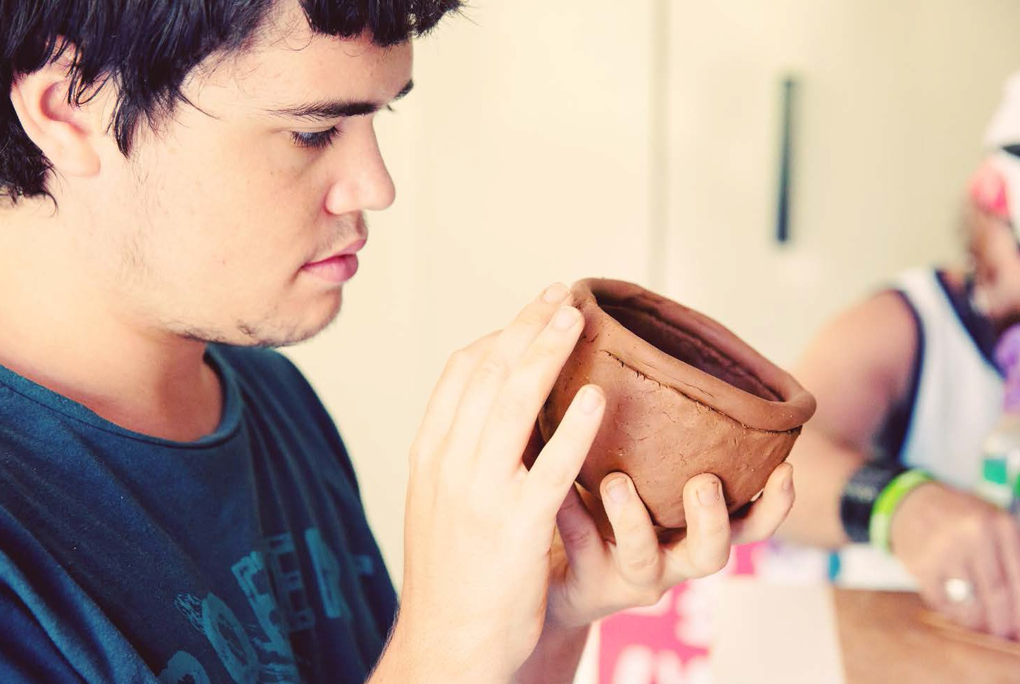STEPS provide commercial cleaning services to
government organisations and private business.
A major contract with Queensland Health employs 15 STEPS job seekers to provide commercial cleaning at a number of their office locations. Our commercial cleaning
services gives job seekers with a disability the opportunity to work knowing they have the
support of our employment services team to help them develop skills and maintain long
term employment. This year we launched car cleaning as part of our commercial cleaning
services which we hope will provide many more of our job seekers the opportunity to participate in the workforce.

mental health 10

social & community 11

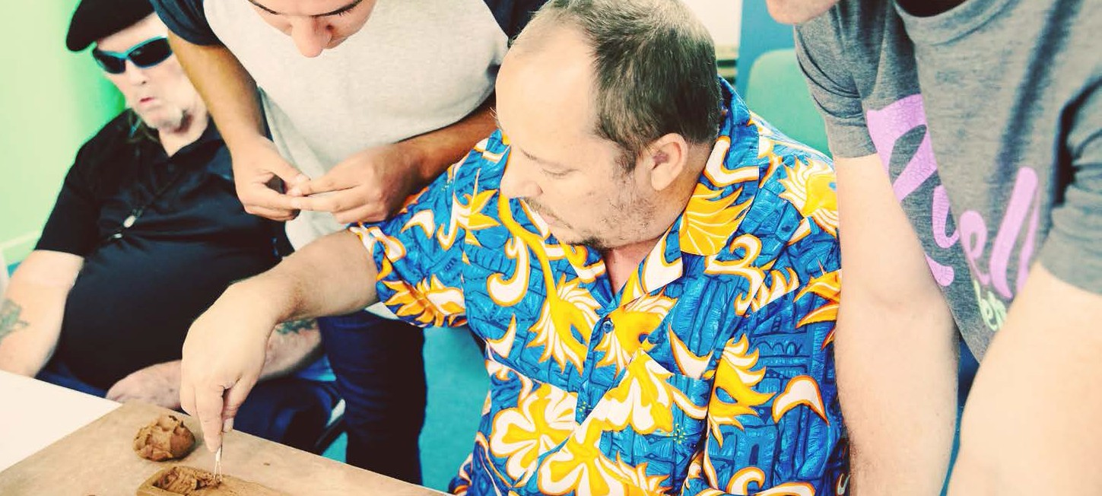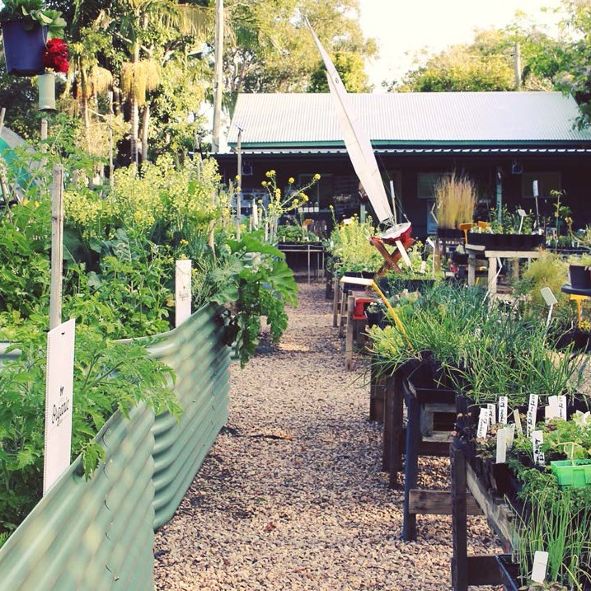the george
street nursery

community services

STEPS Community Services provide flexible,
individualised services to improve quality of life for our customers. Our services are designed to provide greater well-being, enjoyment, and
independence in life.

Support services include:
- Assistance with day to day activities
- 24/7 personal care
- Supported accommodation
- Recreational and social activities
- Community access and participation
- Self directed funding support
- Help with finding work
- Development of life skills for independent living
Our nursery is a place where the community can come together and work on projects that reward with tangible results. Volunteers, students, staff and the community working as one to create,
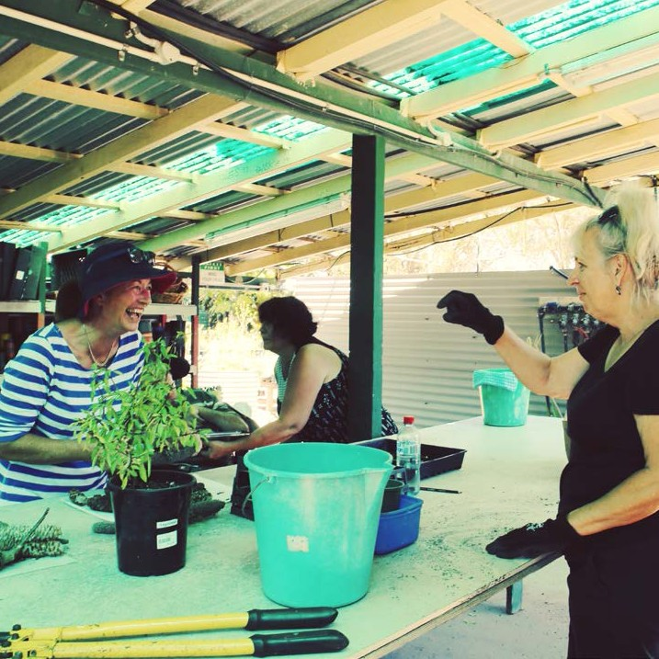build and share.
People come to our garden for many different reasons. Some come to learn new skills and build confidence as they prepare for their
journey back into employment. Others gain
great satisfaction in giving their time to support our organisation, and some people come for
the feeling they get working with the earth and watching things grow. Whether people come to learn, give or grow, STEPS appreciate all of our garden keepers and the achievements we make together.

Better Choices, Better Life
As an approved host provider under the Queensland
Government Your Life Your Choice programme, STEPS help people with a disability
to self direct their funding for disability support services,
and gain greater control and
choice in life.

Care for Carers
The STEPS Care for Carers
program provides important support to unpaid carers in the community by focusing
on individual needs beyond a caring role, and by providing counselling and peer support through group meetings,
information and services, and our free Carer Mentor

Pet Companions
Pet Companions was
established to help people experiencing mental illness care for their pets during
periods of mental duress or hospitalisation. The program offers peace of mind to pet owners, allowing them to
care for their own mental
wellbeing with the knowledge
" The nursery is more than just growing plants; it’s about growing people."
Bruce Thompson, Nursery Supervisor

drive through recycle centre

social & community 12
Program. The Care for Carers
program is supported by
funding from the Australian Government under the
Commonwealth HACC
program and the Queensland Government.
that their pets are being cared
for.
STEPS are contracted by the Sunshine Coast Regional Council to manage the front end operations and recycle market at Caloundra’s Drive Through Recycle Centre. The state of the art waste recycle
facility is an essential service to the local community, operating to limit the environmental impact of waste in landfill. Our Mattress Recycling program further reduces landfill by recycling the timber, steel and foam from discarded mattresses. Many items delivered to the Recycle Centre find their way to our recycle market where goods are purchased and given an extended life or upcycled. Over the years we have employed hundreds of people with a disability at the Recycle Centre providing
long term employment, as well as skills and work experience helping individuals to achieve their
employment goals.
social & community 13

what is our
SOCIAL RETURN
on investment?

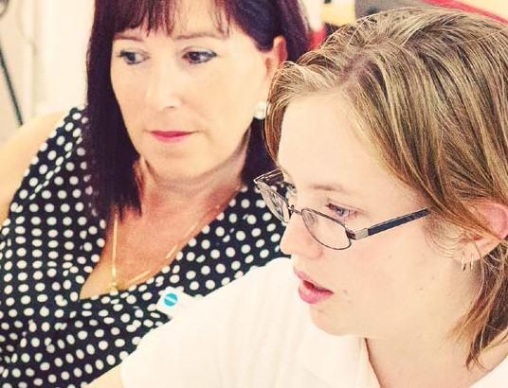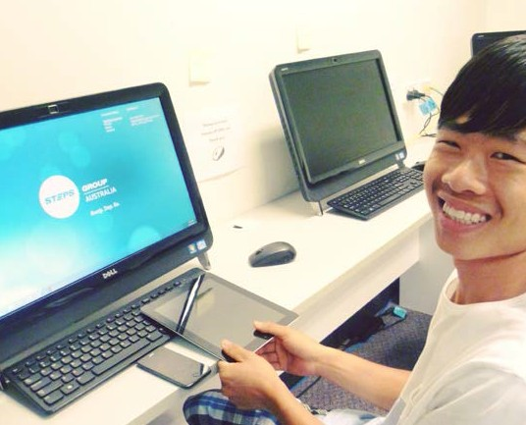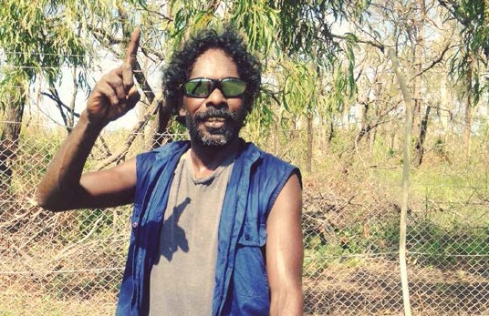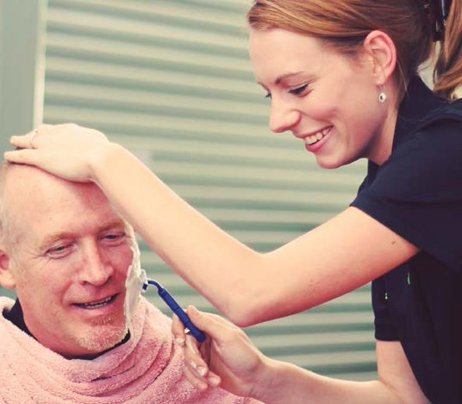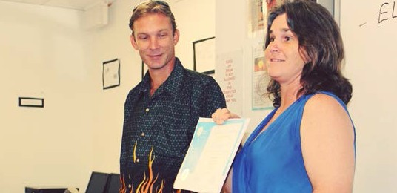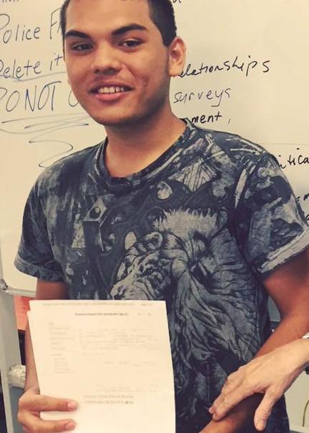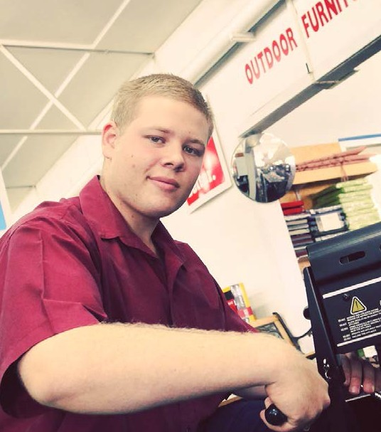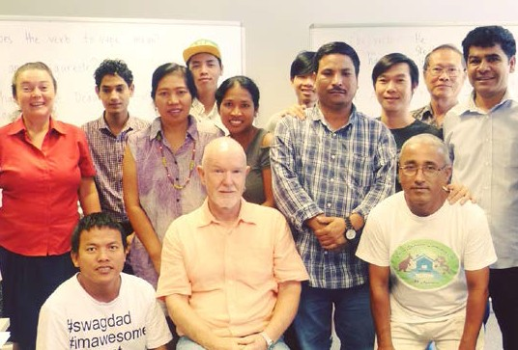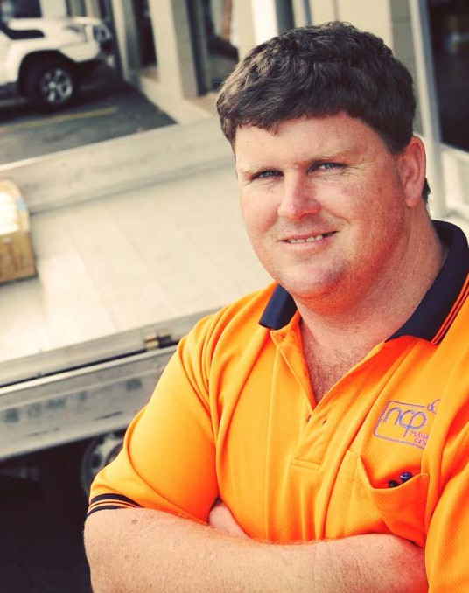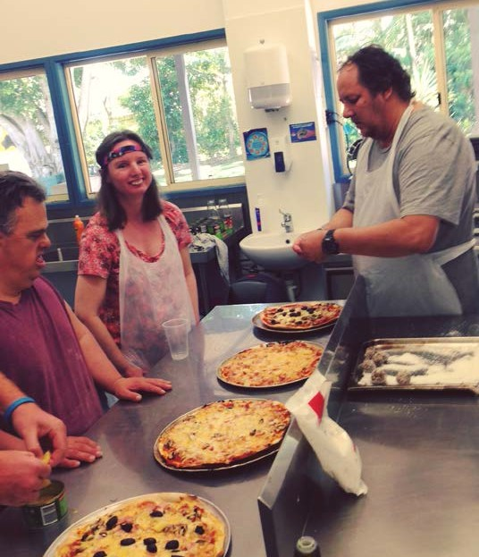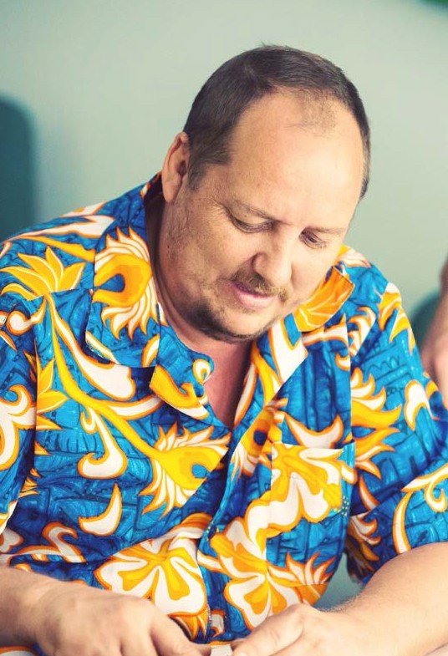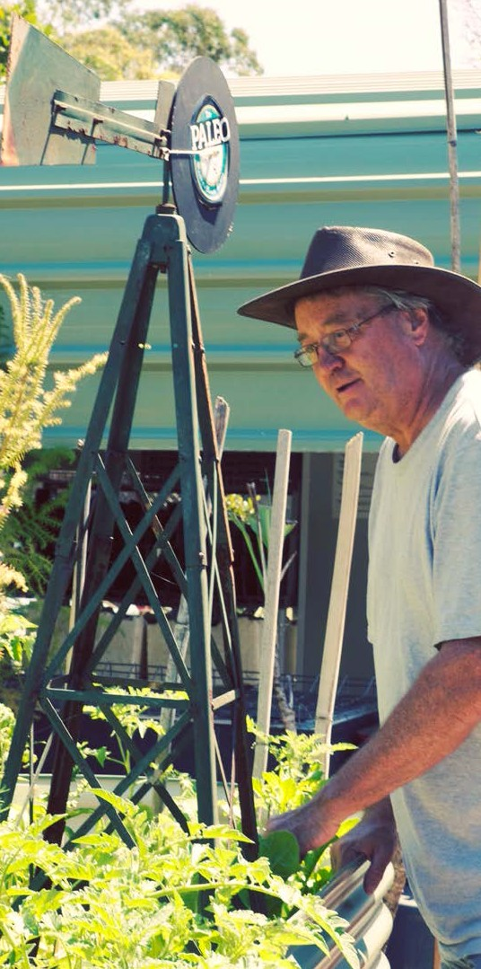

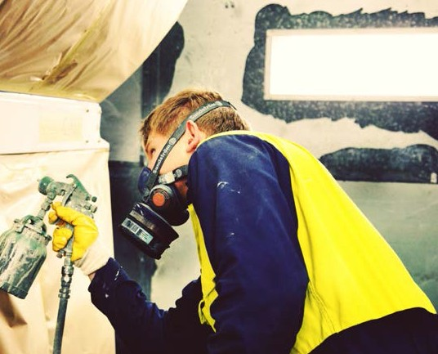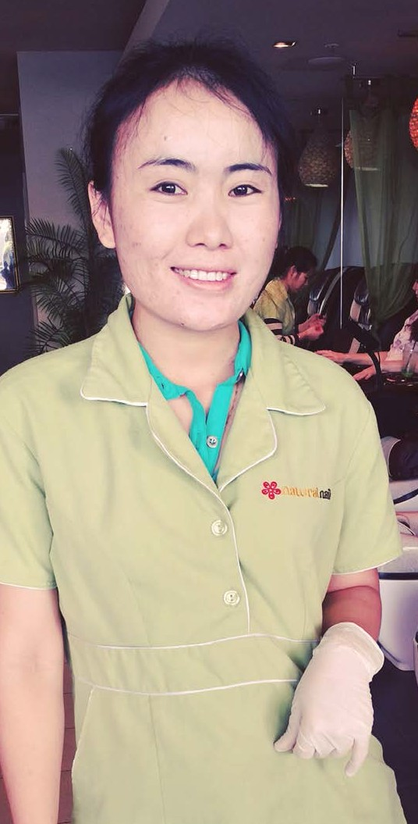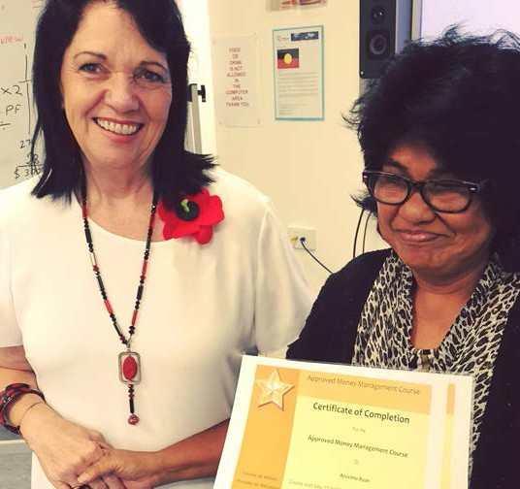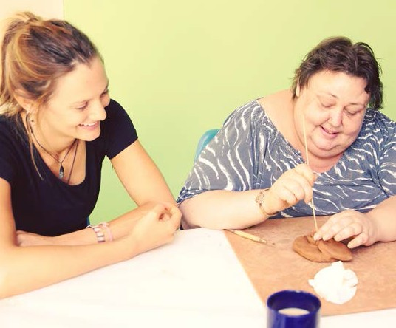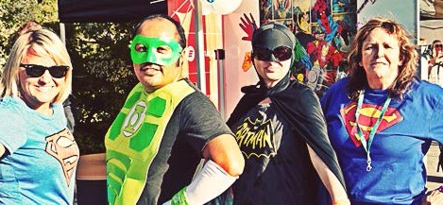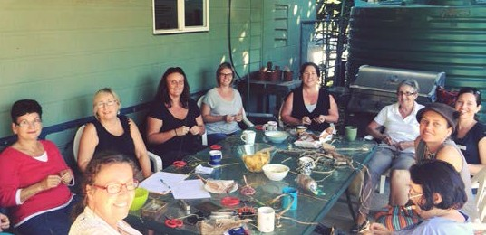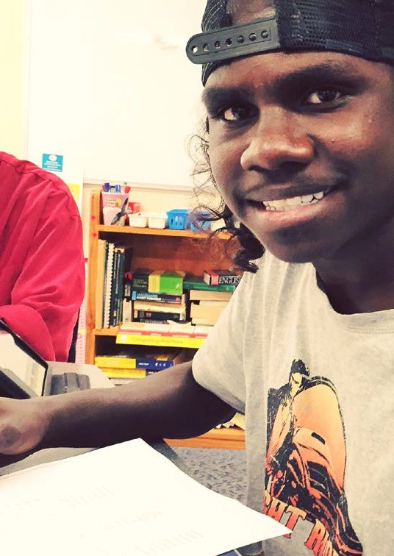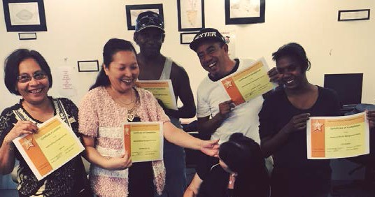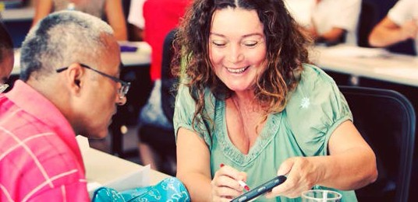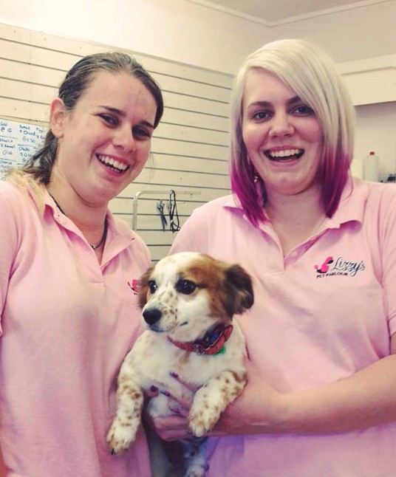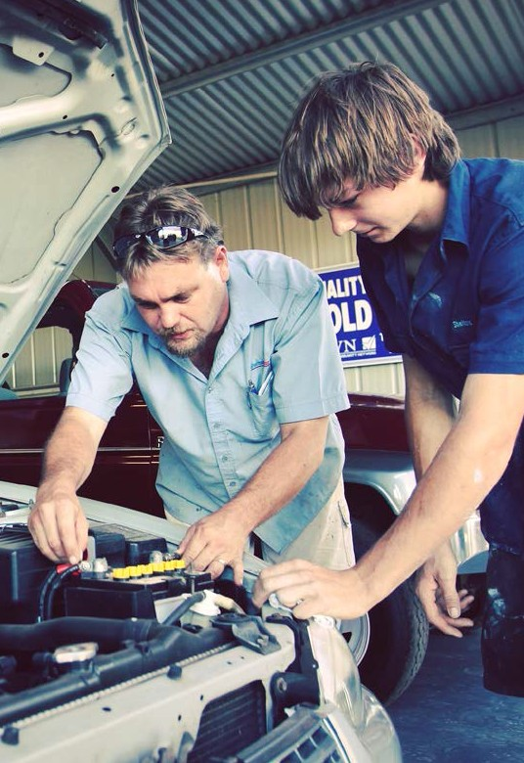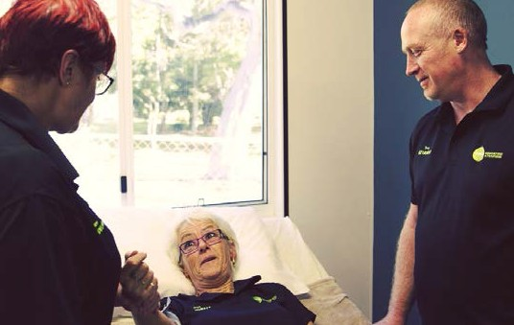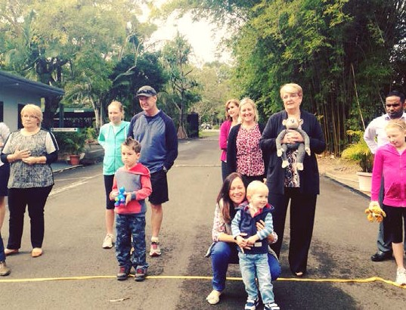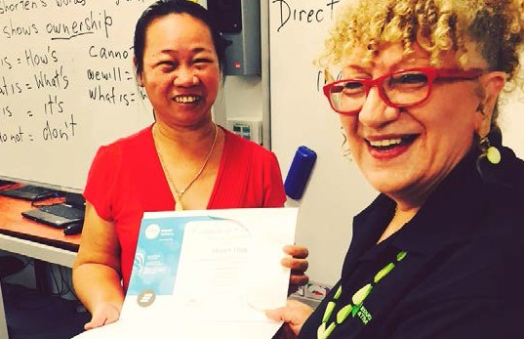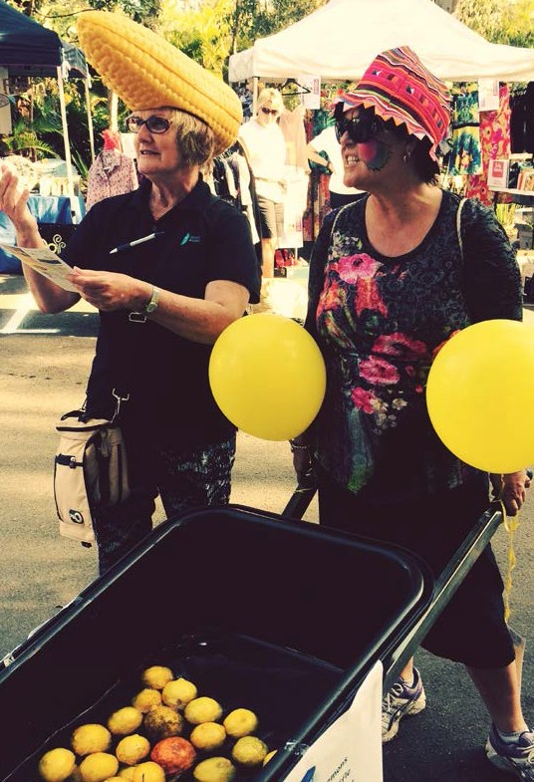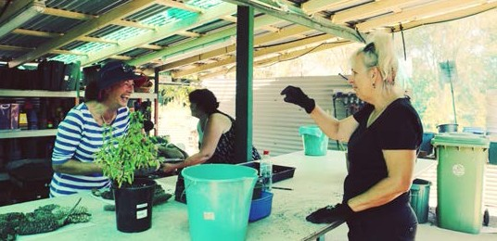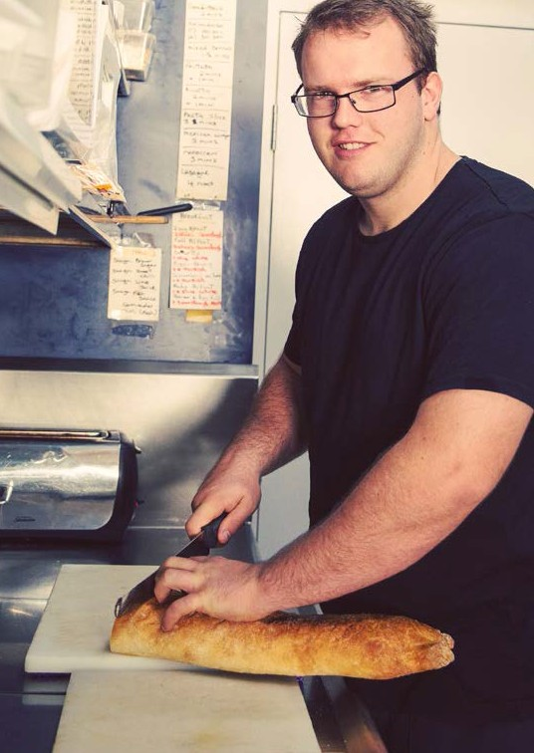

education training
&

STEPS Education & Training design and deliver training solutions that meet real market needs.
Our focus on industry partnerships and flexible delivery achieves successful outcomes for
employers and our students. We believe that by

addressing the needs of our customers we can positively contribute to the social and economic future of a community as a whole.
The geographic diversity of the areas we
service position us as innovators in the field of customised training that is responsive to the
environments we work in and the broad range of industries we support.
At STEPS our success isn’t measured by the number of graduates that pass through our
doors, but by the employment opportunities we provide to our students and the solutions we
offer for the employers we work with.

working on the land

Workplace English Language & Literacy Program
The Workplace English Language and
Literacy Program (WELL) is an Australian Government initiative that seeks to improve
workplace productivity, communications and workplace health and safety in order to improve employment prospects and industry efficiency.
The program encourages employers to access funds to improve job security for employees, and to address industry skills gaps.
STEPS work with individuals under the Skills for Education and Employment Programme in preparation for transition into employment.
We then work with participants post
employment under the WELL program to increase workplace skills and capacity to retain long term employment.
As with all of the training STEPS deliver, we work closely with local employment providers
to understand and identify their specific needs, and custom design training that provides the
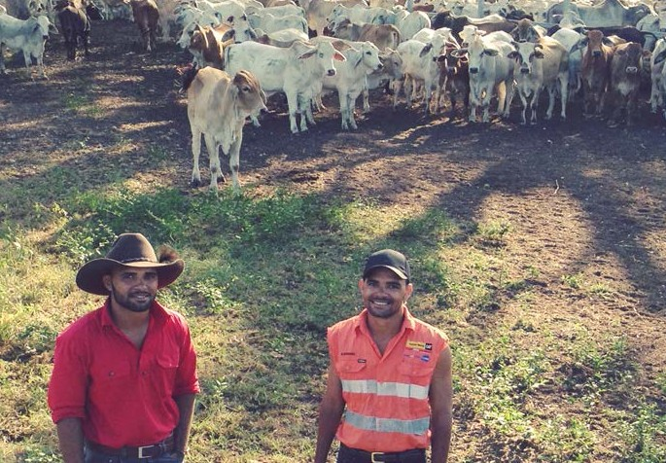best outcomes for their business.

Indigenous Land Corporation
The Indigenous Land Corporation (ILC) works with Indigenous people to acquire
land and manage land in ways that benefit
current generations, and into the future. As a host provider of the Australian Government Workplace English Language and Literacy
Program, the ILC has partnered with STEPS Education and Training to deliver workplace based skills in remote regions throughout
Western Australia, the Northern Territory and Queensland.
Specifically, the ILC and STEPS work in
collaboration to provide functional skills for Indigenous people to work on cattle stations
in line with the ILC’s strategy to support land- based employment and training.
To ensure the best possible outcomes for students, STEPS developed AgrE-learn, a
program combining contextualised training delivery with an e learning platform that
compliments the activities and environment of a remote working cattle station.
Working closely with local Group Training
Organisations, STEPS guide trainees through core literacy and numeracy skills designed to compliment day to day work tasks while
undertaking a range of qualifications
including certification in Agriculture and Meat Processing.
Our partnership with the ILC has provided us with the opportunity to showcase our expertise and dedication to developing training solutions that get the best results for industries while
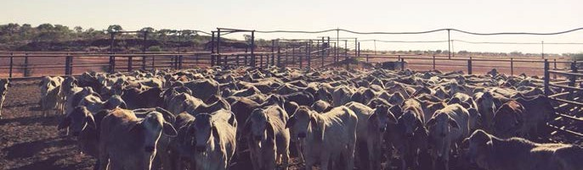directly benefiting the future of Indigenous Australians.

education & training 20
education & training 21

creating pathways to
&
skills for

education
employment
the future

ST EPS National Disability Coordination Officers
STEPS National Disability Coordination Officers (NDCOs) support people with a disability in
the transition to, and participate in tertiary education and employment.
Our NDCO’s establish strategic partnerships that aid the smooth transition for individuals
into study and beyond, working collaboratively to reduce barriers to success.
The NDCO Program is an Australian Government initiative.

Community and Aged Care
STEPS Education and Training deliver Aged
Care and Community Care courses throughout regional and remote Australia. Our courses are designed in close consultation with local Aged Care providers to ensure our students learn
the workplace skills most valued by our local providers.
This approach to training not only makes
it easier for our students to transition into employment, but has led STEPS to become a training provider of choice in many of the communities we work in.

Aged Care in the Northern Territory
STEPS work to improve the quality of care
for the elderly and people with a disability in remote indigenous communities through the delivery of Aged Care, Home and Community Care and Community Services training.
Training across 14 remote communities in the Northern Territory, STEPS work in collaboration with the MacDonnell Shire Council and Central Desert Shires and local service providers to
plan and develop workforce strategies that promote workplace skills and participation.
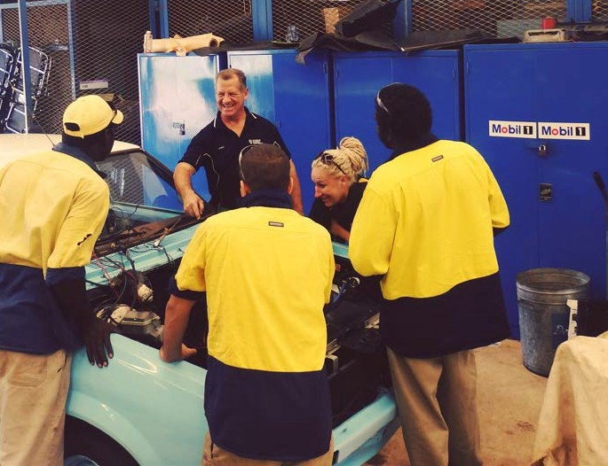This important project not only provides
individuals with the skills required to care for people in their community, it also provides the foundation skills for a career in the growing
aged care industry.
Training is delivered with the support of
the Northern Territory Government and the Department of Social Services.

Jobs, Land and Economy Programme
The Jobs, Land and Economy Programme forms part of the Australian Government’s Indigenous Advancement Strategy that aims to improve
employment opportunities for Indigenous Australians.
STEPS deliver this programme throughout Tasmania where we work with individuals to identify the support and skills they need to reduce barriers to employment. The
level of support we provide is customised to each individual’s requirements ranging from language, literacy and numeracy training and
interview preparation, to assistance in obtaining a drivers licence and support with health
issues.
Our extensive work with the community to identify employment pathways, provide employment-based training and seek out
local employment opportunities has seen us successfully place more than 100 Indigenous job seekers into work across Tasmania.
A collaboration with the Motor Trades
Association (MTA) for the Northern Territory was formed as a result of a proactive move by the peak body to tackle the critical skills shortage affecting the multi billion-dollar
industry.
The MTA (NT) approached this skills shortage through an Indigenous Employment Program
that comprised of multiple collaborations aimed at gaining training and work outcomes for some of the most disadvantaged individuals across
the state.
In conjunction with the Department of Correctional Services, the Centre for
Appropriate Technology and Charles Darwin University, a strategy was formed to develop skills in automotive trades while significantly

SEE
program

STEPS deliver language, literacy and numeracy training to areas in North Queensland, Western Australia, Northern Territory and Tasmania
through the Australian Government’s Skills for Education and Employment Program (SEE). The SEE programme aims to provide individuals
with the foundation skills needed to participate in further study and employment.
Our success has been in understanding local
improving the employability of prisoners post sentence. This strategy was based in part on figures showing that previous prison based
skills building projects significantly decreased
the rate of repeat incarceration from 50% to just 18%.
Utilising a unique blend of training, language, literacy and numeracy support, work
experience, employability skills building, and workplace support, STEPS have helped to
guide students through Automotive Vocational Preparation qualifications, in readiness for
employment in the automotive industry.
Our work with the MTA (NT) is an example of
our innovative approach to training design and our passion for employment outcome focused training. It is in collaborative projects such
as this that great outcomes for industry can be achieved along with positive social and
economic benefits to the local community.

market needs, and importantly the cultural and physiological needs of our students living in
regional and remote indigenous communities,
or who identify as migrants and refugees, where barriers to employment are at their greatest.
We aim to support and motivate our students as they aspire to become important contributing
members of their communities.

education & employment 22
education & training 23

pathways
campus project

In 2015 the STEPS Charity embarked on one of its most ambitious projects to date. The Pathways Campus Project was established to support the rights of people with a disability to have freedom and choice about their
living arrangements and lifestyle. We were motivated to develop an innovative approach to the disability housing crisis amid climbing statistics of young people living in aged care
facilities and hospitals, young people who have no choice about when they eat, shower, or see their friends or family. And we were moved by an aging population of parents fearful for their child’s future, not knowing what would happen to their child when they were no longer able to care for them.
Our answer wasn’t to develop more disability housing, it was to give young people the skills they need to live independently in their own
home.
The Pathways Campus Project comprises of a training facility that simulates an independent living environment, and a training program
where students learn independent living skills. During their stay students are provided with a safe and supportive environment where they
learn life long skills, at a pace best suited to their needs, including but not exclusively:
- Shopping for a healthy diet
- Learning to cook nutritious meals
- Budgeting for living expenses
- Personal care and housekeeping skills
- How to access and arrange the services they need
- Communication, interpersonal and social skills
- Conflict resolution strategies
- Use of modern technology including computers, phones and assistive aids
Over the next 12 months we will continue to raise funds through the STEPS Charity so that we can ensure young people with a disability
have the opportunity to live freely.

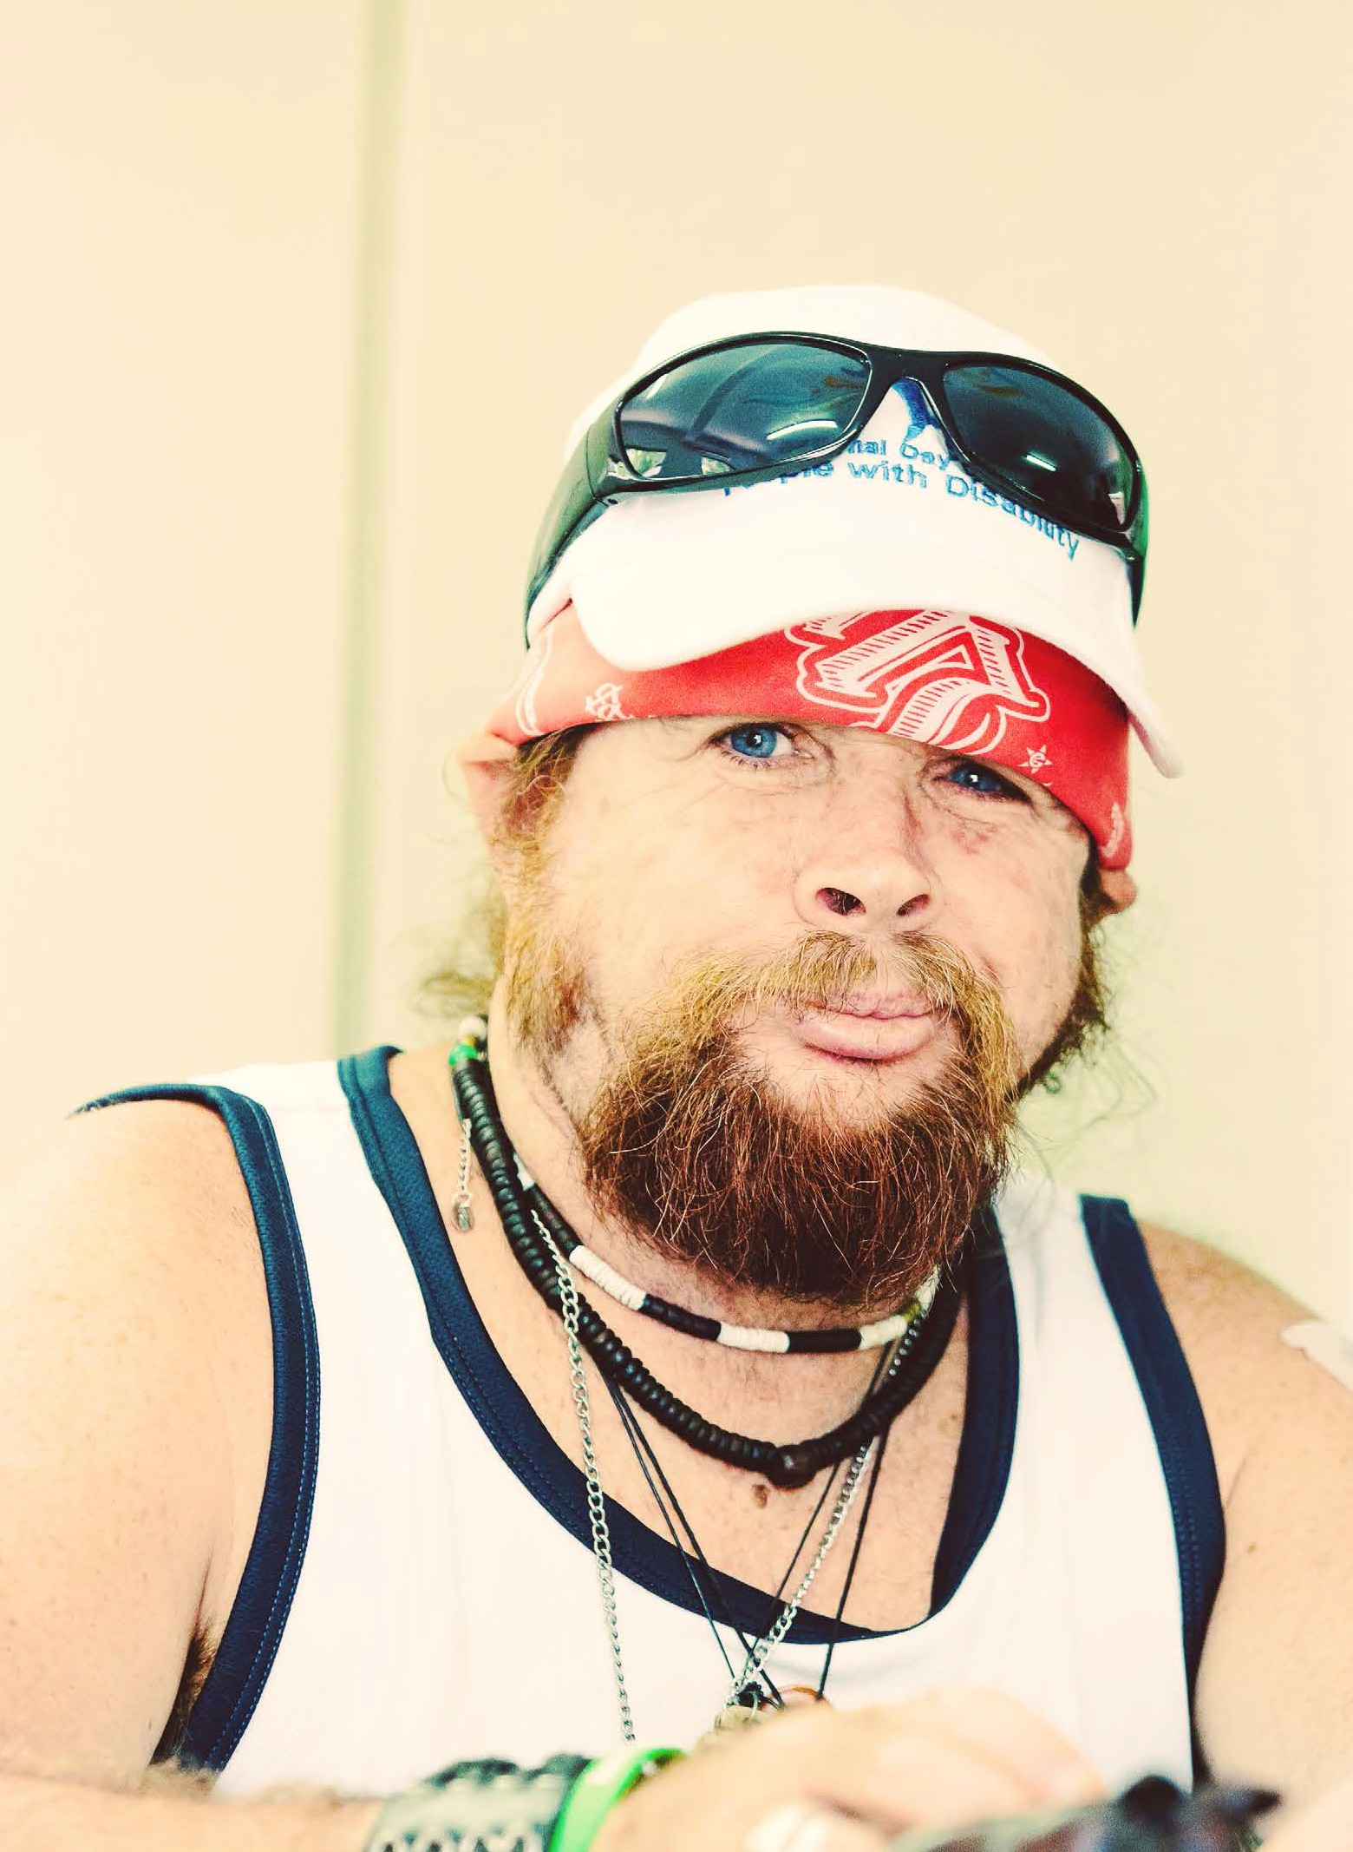charity 24
charity
The STEPS Charity raises
funds to undertake
projects in the community that provide positive
social impact.
We collaborate with local business, industry and community organisations
to develop strategies that promote inclusiveness
and opportunities for
those who need a
helping hand.
pathways campus project 25

diversity

From diversity we get to learn about people and culture, and the differences that
make our lives more vibrant. Diversity is a great teacher of empathy, respect
and understanding. It allows us to grow personally and give back in ways that are more meaningful and valuable.
At STEPS we work with people who come
from a wide range of different backgrounds and communities throughout Australia
and abroad. Our customers are young and old, have different skills and talents, and
celebrate a multitude of cultures that all go to creating our rich social fabric.
Understanding diversity is something we work hard to achieve so that we can provide the best service possible to our diverse
customers. One of the ways we do this is by building a workforce that reflects who we work with - a vibrant mix of people of different ages and gender, ethnicity and religion, celebrating different cultures,
lifestyles, ideas and aspirations.
Just as we advocate for the right to
equality of our clients, we’re too passionate promoters of equity in the workplace and
actively encourage all of our employees to enact on their human right to be treated fairly and equally at work and in life.

diversity 26

"We embrace, promote and celebrate
diversity in every facet of our business operations.
Our workforce is talented, creative and innovative. We genuinely care about each other and the power of working together as a team to make a difference in the lives of others."
Lisa Smith,
Human Resources Manager
carmel crouch | managing director
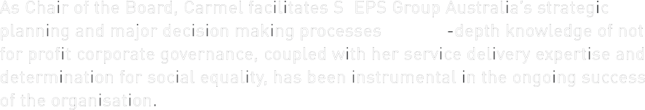As Chair of the Board, Carmel facilitates STEPS Group Australia’s strategic planning and major decision making processes. Her in-depth knowledge of not for profit corporate governance, coupled with her service delivery expertise and determination for social equality, has been instrumental in the ongoing success of the organisation.
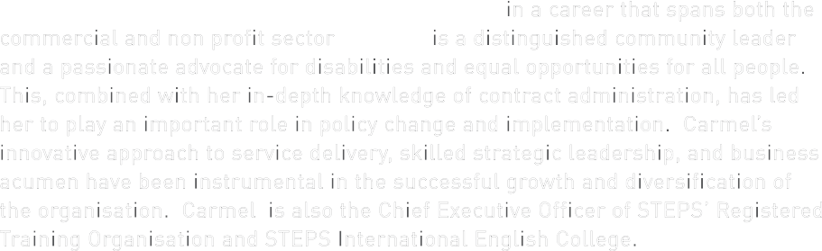Carmel has held numerous senior executive roles in a career that spans both the commercial and non profit sector. Carmel is a distinguished community leader and a passionate advocate for disabilities and equal opportunities for all people. This, combined with her in-depth knowledge of contract administration, has led her to play an important role in policy change and implementation. Carmel’s innovative approach to service delivery, skilled strategic leadership, and business acumen have been instrumental in the successful growth and diversification of the organisation. Carmel is also the Chief Executive Officer of STEPS’ Registered Training Organisation and STEPS International English College.
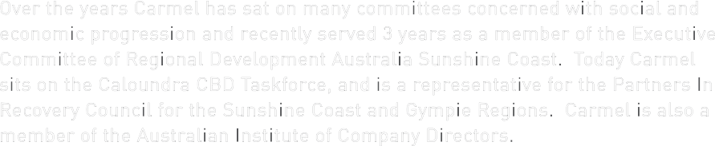Over the years Carmel has sat on many committees concerned with social and economic progression and recently served 3 years as a member of the Executive Committee of Regional Development Australia Sunshine Coast. Today Carmel sits on the Caloundra CBD Taskforce, and is a representative for the Partners In Recovery Council for the Sunshine Coast and Gympie Regions. Carmel is also a member of the Australian Institute of Company Directors.

christine jones | secretary
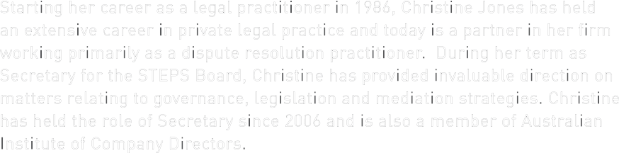Starting her career as a legal practitioner in 1986, Christine Jones has held an extensive career in private legal practice and today is a partner in her firm working primarily as a dispute resolution practitioner. During her term as Secretary for the STEPS Board, Christine has provided invaluable direction on
matters relating to governance, legislation and mediation strategies. Christine has held the role of Secretary since 2006 and is also a member of Australian Institute of Company Directors.

helen ferguson | board member
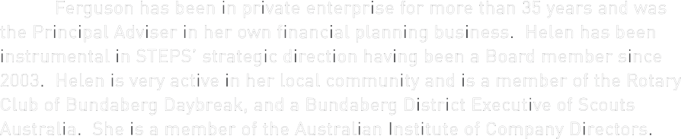Helen Ferguson has been in private enterprise for more than 35 years and was the Principal Adviser in her own financial planning business. Helen has been instrumental in STEPS’ strategic direction having been a Board member since 2003. Helen is very active in her local community and is a member of the Rotary Club of Bundaberg Daybreak, and a Bundaberg District Executive of Scouts Australia. She is a member of the Australian Institute of Company Directors.

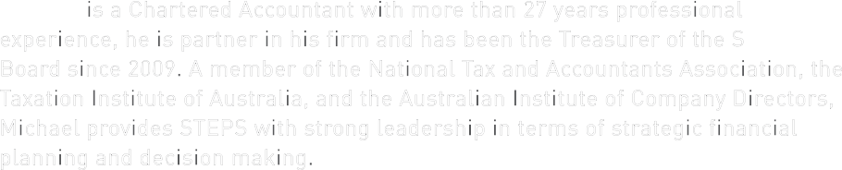michael lutje | treasurer
Michael is a Chartered Accountant with more than 27 years professional
experience, he is partner in his firm and has been the Treasurer of the STEPS Board since 2009. A member of the National Tax and Accountants Association, the Taxation Institute of Australia, and the Australian Institute of Company Directors, Michael provides STEPS with strong leadership in terms of strategic financial planning and decision making.

meet the board

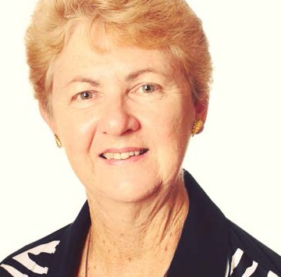

meet the board 27

executive
leadership team

sam geeson
quality and customer service manager

shelly campbell
general manager operations

board of directors
& managing director

education & training

our organisation

Samantha has extensive experience in the recruitment
Shelly Campbell has more than 10 years experience in
executive leadership team • National RTO Manager
  - Training Managers: Cairns, Darwin
community services
- Social & Community Manager

bruce eldridge chief financial
officer

Bruce Eldridge is a CPA with more than 14 years experience working in commercial and industry enterprise before entering the not for profit sector. As Chief Financial Officer Bruce manages a highly effective finance team and is an integral member
of the Executive Leadership Team.
Bruce’s applied knowledge of project and asset management, and skill
in managing supply chain logistics have been fundamental in STEPS’
success in contract delivery and growth. An intricate understanding of corporate governance has led to the smooth transition of large acquisitions and the change of STEPS’ legal entity from an incorporated association to a company limited by
guarantee. Bruce is a member of the Australian Institute of Company Directors.

executive leadership team 28

stuart coward executive officer

Stuart Coward is a highly experienced business professional having established a string of successful business ventures in the training, hospitality and employment industries prior to joining STEPS. Stuart’s strategic negotiating skills and passion for community development has seen him forge effective partnerships nationally and internationally including the securement
of several global sister city agreements.
As Executive Officer of STEPS Group Australia Stuart seeks out innovative partnerships with industry and government that provide opportunities for growth and diversification
in line with STEPS’ strategic objectives.
Stuart has held a number of community leadership roles and today is a representative of the Qld Health and Community Services Industry Skills Council.
and disability sectors having held strategic positions in the UK and Australia. As Quality and Customer Service Manager Samantha is responsible for implementing organisation wide quality management systems, ensuring STEPS’ activities are compliant with relevant legislative and regulatory standards, and the development of service
delivery models for improved contract delivery, staff performance and continuous improvement.
Samantha’s passion for providing opportunities for community and economic participation and enacting positive social change can be seen in her work which is driven by the success and
experiences of our customers.
As a skilled leader of change management Samantha
has been instrumental in managing major projects across the organisation including the implementation of Case Based Funding from Block Grant Funding and achieving ISO 9001:2008 Certification. Samantha holds a BA of Applied Science (Applied Psychology) and a Graduate Diploma in Human Resources.
the community, employment
and Vocational Education and Training (VET) sector and was instrumental in taking STEPS from a local based training provider to one with a national footprint.
As General Manager of Operations Shelly is responsible for the
operational, financial and contractual performance of a diverse range of customer
driven employment, education and training programs and services. Shelly is also responsible for establishing strategic industry partnerships aimed at connecting disadvantaged learners and job seekers with employers in their local community.
Her expertise lies in the establishment of services in new markets, implementation and management of government funded contracts, development of innovative service models, system design, performance rectification and mentoring high performing teams.
Shelly has a Bachelor of Business and is a regular keynote speaker at national conferences where she shares her knowledge on designing and delivering contextualised training for increased workforce participation.
shared services
- Chief Financial Officer & Team
- Quality & Customer Service Manager & Team
- Human Resources Manager & Team
- ICT Manager & Team
- Marketing & Communications Manager & Team
- Administration Team

employment solutions
- Employment Solutions Manager
& DMS Specialist Mental Health Manager
- Site Managers: Aitkenvale, Sunshine Coast Nth, Sunshine Coast Sth, Gympie, Murgon, Redcliffe, Caboolture, Bundaberg, Alice Springs
- Mental Health Coordinator
- NPA Programme Coordinator
& Team
- IAS Coordinator & Recuritment Consultant
- Personal Development Trainer
- Employment Consultants
& Site Administrators

charity
- Charity Manager
& Top End, Alice Springs, Sunshine
Coast
- Training Coordinator Hobart
- WELL Program Coordinator
- RTO Support Coordinator
- NDCO Coordinators
- Trainers & Assessors
- RTO Performance Team
- Community Services Program Manager
- Team Leaders
- Support Workers
- Care for Carers Coordinator & Team
- George Street Site Manager & Team

our organisation 29

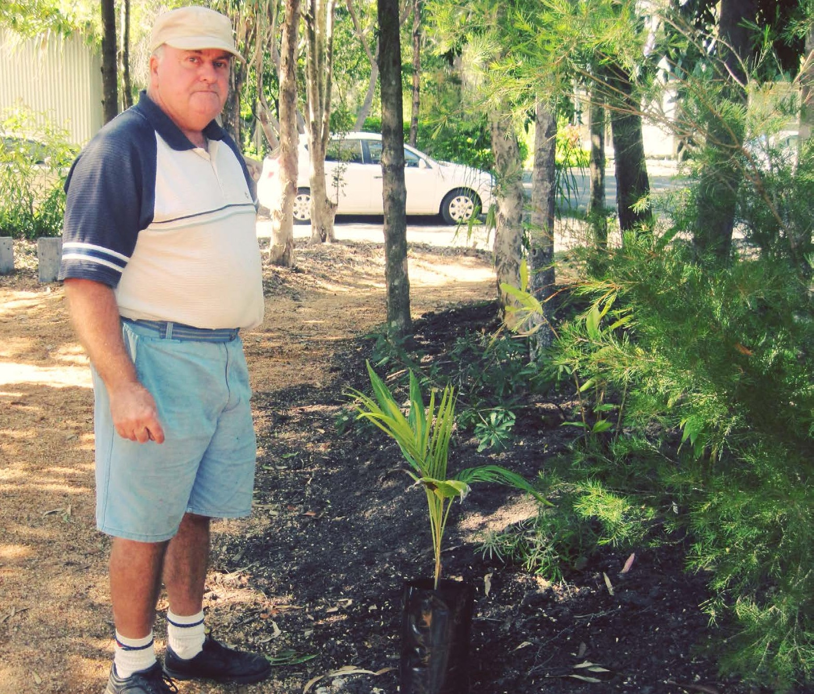partnering
for success

volunteers

It’s easy to say that STEPS could not have
achieved all that we have over the last year
After 27 years in the business of helping people we think
we do a pretty good job. But the fact is, we can create a
much bigger impact when we team up with other people
and organisations who have a shared vision for the future.
That’s why we have made relationships a key part of
our strategy to help us create opportunities and successful outcomes for our customers.
So who are our partners? They are community organisations
and government, training and employment service providers, health and
professional services, local
employers and industry. And they are mums, dads, sons
and daughters. They are carers and custodians, and
they are our customers. Our partnerships provide mutually beneficial opportunities, and
they create opportunities for the broader community.
Our partners have helped us to create jobs for entire
communities, helped us to provide hope to those who have struggled to find their way, and they have helped us to make a difference by
providing opportunities to the people and the communities we work with.
Our partners add value to our business and our customers everyday.

10,472
the average number of hours our volunteers
have contributed to STEPS over the last 12 months.
without the significant contribution of our
volunteers. People volunteer with STEPS
because they are passionate about the work we do, they volunteer to gain work experience that will set them on path to achieve their career
goals, and they volunteer because they have an inherent desire to give back to the community
they live in.
One thing we know for sure is that our
volunteers are absolutely dedicated to helping STEPS make a positive difference to the people and the communities we support.
To all of our volunteers Australia wide who have worked with us throughout the year to make
change happen, we thank you - 10,472 times.

We know that
together, we can do amazing things.

volunteers 30
partnering for success 31

I have had help that has CHANGED
me for life
CHANGME DELLER

Registered Training 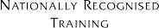 Organisation Number 1847

www.stepsgroup.com.au
9 george street
caloundra, qld, 4551 07 5458 3000
enquiries@stepsgroup.com.au

