2 13

STEPS GROUP AUSTRALIA
ANNUAL REVIEW

EMPLOYMENT SOLUTIONS EDUCATION & TRAINING
SOCIAL & COMMUNITY

STEPS CHARITY

CONTENTS

BOARD PROFILES
05
06
09
10

MESSAGE FROM THE MANAGING DIRECTOR

EXECUTIVE LEADERSHIP TEAM

REGIONAL SERVICE DELIVERY MAP
EMPLOYMENT SOLUTIONS

EDUCATION & TRAINING SERVICES
12
18
24
27

SOCIAL & COMMUNITY INNOVATIONS

STEPS CHARITY

3

Positive change, one step at a time.

4

BOARD
PROFILES

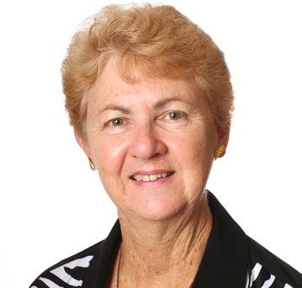

CARMEL CROUCH
Carmel has extensive knowledge and experience in the commercial and community sectors having operated as an industry leader in both fields. Carmel is the Managing Director of STEPS Group Australia incorporating STEPS Disability Qld Inc, Community Agency for Development Employment and Training Inc, and is the CEO of the groups two RTO’s.
As Chairman of the Board of STEPS Disability Qld Inc Carmel has played an integral role in the growth and direction of STEPS since 1990.
Carmel has been a Director of Community Agency for Development Employment and Training Inc since 2010. Carmel is also a member of the Australian Institute of Company Directors and is a member of Regional Development Australia Sunshine Coast.
CHRISTINE JONES
Christine is a solicitor in private legal practice. She was admitted as a legal practitioner initially in 1986, and
now practices primarily as a dispute resolution practitioner.
Christine has been a Director and Secretary of STEPS Disability Qld Inc since 2006, STEPS Ahead Ltd since 2008 and Community Agency for Development Employment and Training Inc since 2010. These entities all form part of the STEPS
Group. Christine is also a member of the Australian Institute of Company Directors.
HELEN FERGUSON
Helen Ferguson has been in private enterprise for more than 35 years and until recently retiring, was the Principal Adviser in her own financial planning business.
Helen joined the Board of Directors of STEPS Disability Qld Inc in 2003 following STEPS merger with
Work Support Inc., and has been a Director of Community Agency for Development Employment and Training Inc since 2010. These entities all form part of the STEPS
Group. Helen is also a member of the Rotary Club of Bundaberg Daybreak, is a Bundaberg District Executive of Scouts Australia, and is a member of the Australian Institute of Company Directors.
MICHAEL LUTJE
Michael is a Chartered Accountant and a partner in his firm with over 25 years experience.
Michael has been a Director and Treasurer of STEPS Disability Qld Inc since 2009, and Community
Agency for Development Employment and Training Inc since 2010. These entities all form part of the STEPS Group. He is also a member of
the National Tax & Accountants’ Association, the Taxation Institute of Australia and the Australian Institute of Company Directors.

5

CARMEL CROUCH
MANAGING DIRECTOR & CHAIRMAN OF THE BOARD

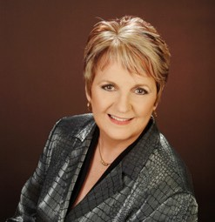Flexibility. Diversity. Passion. Determination. Over the last twelve months these are the four words I have come to use to describe STEPS Group Australia as defined by the attitude and efforts of our people.

FLEXIBILITY over the last little while for us has been about making lemonade. Like many of our friends in the industry this past stretch has not been easy. The not-for-profit sector was impacted similarly to the private sector
during the global financial crisis and the ripples, though subsiding, are still creating small bumps. Our work in the Disability Employment Services sector has been impacted significantly by changes to government contracts leading to changes in our own organisational structure.
These changes came in the form of streamlining each of our service delivery areas to create leaner, meaner cogs in what has become a well oiled machine providing quality services to the community. This however was only possible because of the flexibility of our staff who took
it on the chin, changed roles, took on greater responsibilities, worked to learn new skills and better old skills, and when life threw them lemons – well, they made lemonade.

DIVERSITY will be a core aspect to future sustainability in the not-for-profit sector. Diversity is a strong focus for STEPS Group Australia that is approached with a steady
balance of planning and opportunity. Strategically we hope to continue to develop our service
scope to provide opportunities for people to gain greater levels of independence. We also however recognise the need to remain open to opportunities, take chances and champion

Diversity is a strong focus for STEPS Group Australia that is approached with a steady balance of planning and opportunity.

innovation in a relatively new environment where not-for-profits are competitive, and wait for it, make a profit! This has not been an easy pill to swallow and has required an adjustment of mindset across the sector. It is however
a necessary adjustment, as the Australian Government continues to tighten it’s drawstrings and we see the establishment of the National Disability Insurance Scheme which will further promote competition in a new user choice market. Where this leads us to is diversity. The ability to deliver a range of services in future will be market driven – customers will want to access the range of services available to them in groups rather than individually. Most of our services support each other in some way or other as part
of our aim to provide clients with this holistic experience.
STEPS Group Australia’s service offering includes the delivery of training and education in remote and regional areas incorporating an international college, disability employment services, environmental and waste management programs, mental health and wellbeing programs, and a host of community focused services that help to better the lives of others.
Our staff too are diverse. Our commitment to creating a positive and equitable work environment is a driving force behind our
recruitment process and today we are proud to say we have a rich, culturally diverse team who come from different backgrounds, enjoy different lifestyles, and bring with them a range of unique skills and abilities. What is special about STEPS Group Australia though is that while we have a diverse workforce, carrying out a diverse range of services, we are truly united in our mission to help others and enact real positive social change.

PASSION. We’ve got it in bucket loads! The not- for-profit sector is manned by people who are passionate about helping others. The passion that I have watched exuding from our people in the last 12 months has been awe inspiring. When you experience tough times like we have recently you get to see the bare bones of people, what really makes them tick, and what gets them up

6

out of bed in the morning. I suppose what I have learnt during this time is that our Board of Directors, our staff, our partners in the community, and myself, care more deeply for the vision and mission of STEPS Group Australia than even we realised.
That’s not to say we weren’t always passionate – I can assure you as one of the founding parents who started this organisation that we most certainly were. But having just experienced one of the most difficult periods of our organisation’s 25 year history I have seen a new passion arise, a different passion. The kind of passion that makes people stand up and fight for what they really believe. The type
of passion that says look out, because here we come!

DETERMINATION has been a by-product of our passion. The determination needed to build an organisation that can withstand a storm also requires courage. For that the award must go to our Executive Leadership and Senior Management Teams who have worked tirelessly to create efficiencies across the organisation while improving productivity and quality of service. This has included making those critical decisions like the choice to withdraw from service delivery areas, or withdraw programs altogether. This has been most challenging
for a group of people passionate about the good these programs contribute to the community. Then of course there is the loss of staff that goes with the removal of programs. Making decisions that effect the livelihood of another being are some of the most difficult decisions to make
- especially where employment is lost through no fault of the individual but for factors out of their control, stemming from government and industry change.
Over the last 12 months we have lost some good people in this way, however these tough calls were made out of stoic
determination from the management team to ensure the future sustainability of our organisation. With leadership from myself and the Board of Directors, the Executive Leadership and Senior Management Team have battled through the storm to build a stronger, healthier, shinier STEPS.

WHAT’S NEXT FOR STEPS?
The short term future of STEPS Group Australia will be guided by four new words; Knowledge, Focus, Innovation and Growth.
Strategically we aim to add to our scope of delivery in the mental health sector and become an expert body in the support and employment of people tackling mental health issues. As we continue to strive to be a market leader in disability
employment services we believe a customised client approach differentiating between psychiatric, non-psychiatric and combined disabilities will see us achieving greater success.

The short term future of STEPS Group Australia will be guided by four new words; Knowledge, Focus, Innovation and Growth.

Over the next year we will be working to grow our International College to include study tours, and harness the power of technology to provide first class e-learning opportunities for our students in remote indigenous communities.
Our community programs will be developed by identifying gaps in support. We know that identifying these gaps and working to overcome the issues caused by these gaps greatly contribute to our clients success in their training and employment endeavours and overall wellbeing.
The environment is something we care deeply about and we feel a great
responsibility to ensure we do our bit so that future generations can enjoy the same lands and oceans we have. To do this we will look to expand our footprint of environmental programs that will incorporate training and employment opportunities for our clients.
All of these things we will do with the same ability to be flexible during change, by celebrating diversity and acknowledging the opportunities diversity presents, by remaining passionate about what we believe in, and by acting with the same determination needed to drive STEPS Group Australia forward as an industry leader.

We envision a future where every individual, regardless of circumstances, has access to quality education, training and employment services that enable them to realise their potential.

7

WHO
WE ARE

STEPS Group Australia (STEPS) is a vibrant, not-for- profit community organisation focused on creating positive change in our communities.
Through core services of employment and training we enable individuals and communities to take confident steps forward and create opportunities to help people towards independence.

In 1989 a small group
of parents on Queensland’s Sunshine Coast came together to take steps to promote opportunities for their children.
In the months and years that followed, an organisation was born whose passion is to ensure all people are given the opportunity to be independent,
to contribute actively to their communities and to find success in ways that are meaningful to them.
OUR VALUES
Integrity. We lead by example in our commitment to being honest, transparent and accountable in our communications and interactions.
Mutual Respect. We encourage a sense of worth in one another, accept an individual’s right to their opinion and actively encourage contribution.
Courage. We build strength and foster resilience when we act with the courage of our convictions.
Compassion. We recognise that empathy, care and understanding are essential in our relationships with others.
Possibility Thinking. We look at situations in new and creative ways to open up unrealised opportunities for positive change.
Learning. We strengthen our skills and knowledge by pursuing informal and formal education opportunities, challenging our own ideas, asking questions, embracing feedback and reflecting on the outcomes of our actions. We understand this is essential for continual improvement.

8

EXECUTIVE
LEADERSHIP TEAM

Shelly Campbell
General Manager Education & Training
Stuart Coward
Executive Officer
Lee-Anne Whalley
Manager
Employment Solutions

Samantha Geeson
Quality Systems Manager
Bruce Eldridge
Chief Financial Officer
Carolyn Turnbull
Human Resources Manager

9

REGIONAL
SERVICE DELIVERY MAP
REMOTE TOP END
Office in Casuarina (Darwin), servicing Milingimbi, Galiwinku, Nhulunbuy and Gunbalanya
  - Education & Training
» Skills for Education and Employment
» Subcontract Skills for Education and Employment services to Tiwi Islands

From ocean to outback, we work throughout Australia to promote the value of diversity and social inclusion.
With 15 offices operating throughout Queensland, the Northern Territory, Western Australia and Tasmania, we assist individuals in over 39 communities to make positive changes in their lives.

DARWIN
Office in Casuarina servicing Darwin and Palmerston
  - Education & Training
» Skills for Education and Employment

KIMBERLY REGION - WESTERN AUSTRALIA
Offices in Derby & Kunnanurra
  - Education & Training
» Skills for Education and Employment

ALICE SPRINGS
Office in Alice Springs servicing Alice Springs, Hermannsburg plus 16 remote communities across the Central Desert and Barkly region
    - Education & Training
» Skills for Education and Employment
» Northern Territory Aged Care Training Project
    - Employment Solutions:
» Disability Employment Services

EMPLOYMENT SOLUTIONS EDUCATION & TRAINING SOCIAL & COMMUNITY STEPS CHARITY
NATIONAL - ALL REGIONS
- National Panel of Assessors Representatives in Perth, Adelaide, Stanwell, Melbourne, Wagga Wagga, Sydney, Yamba, Brisbane, Sunshine Coast and Townsville servicing all 116 regions Australia wide.
10

ATHERTON TABLELANDS
Office in Atherton
- Education & Training
» Skills for Education and Employment

CAIRNS
Office in central Cairns, servicing Cairns, Innisfail and Mossman
- Education & Training
» Skills for Education and Employment

NDCO REGION 22
TOWNSVILLE
Offices in Aitkenvale and Ayr, servicing the region
- Employment Solutions
» Disability Employment Service
- Social & Community Initiatives
National Disability Coordination Officer Program – Region 22

NDCO REGION 20
BUNDABERG
Office in central Bundaberg, servicing Bundaberg, Wide Bay, Burnett and Gympie region
- Employment Solutions
» Disability Employment Service
- Social & Community Initiatives
» Care for Carers Program

HOBART
Office in central Hobart
- Employment Solutions:
» Indigenous Employment Program
- Education & Training
» Skills for Education and Employment
SUNSHINE COAST
Offices in Caloundra, Maleny, Maroochydore, Nambour and Noosa, servicing the Sunshine Coast
- Education & Training
» Campus in Caloundra
» Aged Care courses
» Training partnership services
» International College
» English College
- Employment Solutions
» Disability Employment Services
» By Your Side Mentoring Program
- Social & Community Initiatives
» Caloundra Resource Recovery Centre
» Mattress recycling
» Commercial cleaning
» National Disability Coordination Officer Program – Region 20

11

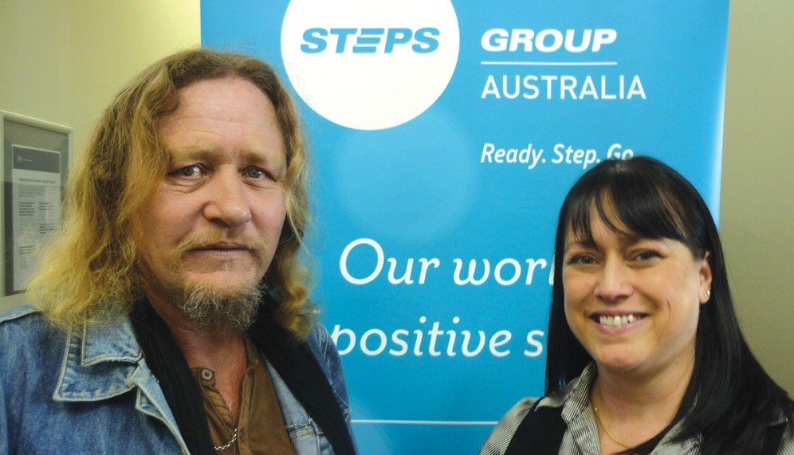EMPLOYMENT SOLUTIONS

We know a diverse workforce makes a valuable contribution to Australian businesses.

STEPS empowers disadvantaged job seekers by giving them meaningful support and opportunities. We help those with a disability, injury or health condition find and maintain sustainable

ROCK STAR AMBITIONS LEAD TO SUCCESS FOR DARRYL

employment.
With more than 25 years experience in the recruitment industry, we’ve made it our business to place talented job seekers in the right roles, every time.
Across Australia, STEPS delivers empoyment services through:
  - Australian Government’s Disability Employment Services (DES) initiative
  - National Panel of Workplace Assessors
  - Indigenous Employment Program.

www.stepsgroup.com.au/employment
BUNDABERG
When STEPS staff in Bundaberg first met 53-year-old Darryl, his one goal in life was to be a famous rock star.
He had been diagnosed with chronic schizophrenia in his mid-20s, and had spent his adult life in and out of mental health facilities. Before his diagnosis, Darryl was working towards becoming a trade qualified electrician, however he had been unemployed for over 30 years while receiving ongoing treatment from Wide Bay Integrated Mental Health Service for Psychotherapy and Medication to manage his condition. Darryl’s aging parents provided great support throughout his life, with help from assisted living and strong social support from Bridges Recovery Services.

Dedicated staff began looking for great employment alternatives for him, and thanks to a combined effort between Wide Bay Integrated Mental Health Services and STEPS Group Australia, Darryl not only has paid employment, he is successfully working two separate job roles. A Merchandising Officer in the Bundaberg and Bargara area, he also works as a Commercial Cleaner and has had excellent feedback about his performance and attention to detail.
Darryl may yet to be a rock star but he’s definitely a STAR in our eyes!

12

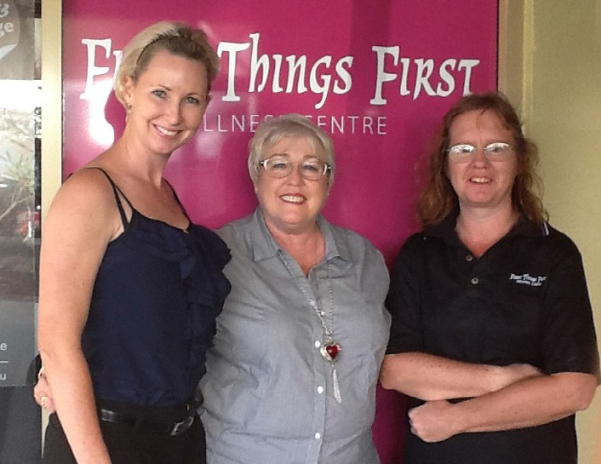JULIE’S EMPLOYMENT SUCCESS

ENHANCING EMPLOYMENT PARTICIPATION
NATIONAL PANEL OF ASSESSORS
STEPS can help employers access Government schemes and initiatives to enhance accessibility for employees with disability, and has over 12 years experience delivering Supported Wage Assessments and Workplace Modifications.
STEPS qualified assessors are based in numerous cities Australia-wide, covering 116
service areas, helping businesses grow with their expert knowledge and advice about government funding for workplaces employing people with a disability.
Feedback received from DES providers all around Australia was overwhelmingly positive in 2013, with one provider stating that our process should be considered best practice!
“I personally found the service provided to be of the highest order, and a cut above most of the other providers of assessments that I have worked with”.
With this important work being carried out, more and more workplaces nationwide are becoming ‘disability confident’ and accessible, something that STEPS is extremely proud of.
TOWNSVILLE
STEPS job seeker Julie is a reliable, friendly and productive worker. Yet at 41 years of age she was still to secure her first job.
Julie’s honest and genuine personality is what prompted Megan Flux, Director at Townsville’s First Things First Wellness Centre to give Julie her first step on the journey to gainful employment. With help from the STEPS Employment Program, First Things First, who offer a holistic range of wellness systems designed to treat clients with pain problems or lifestyle issues, gave Julie the opportunity to kick-start her career.
Things are going swimmingly for both Julie and the wellness centre, with Julie thriving in her role. “She’s blended in so well and has become an integral member of our team”, enthuses Megan.

SONNY’S DETERMINATION PAYS OFF
NAMBOUR
STEPS first met Sonny when he approached the employment team in Nambour for support in securing a job at Sound in Motion. Sonny had heard so many wonderful stories about the work of the owners, Brian and Lyn Bugenhagen, that he wanted to be part of the team.
Both STEPS and Sonny paid Sound in Motion a visit, but at the time, there was no position available. Undeterred, Sonny called in regularly, presenting his resume each time, even though they already had a cabinet full of copies.
His perseverance paid off when he was offered a part-time position at the store.
Unfortunately, the offer came at the same time Sonny learned he needed a corneal transplant, and he was unable to accept the opportunity.
The dream was not to be forgotten that easily. As soon as Sonny was well enough to work, he approached Sound in Motion again. Although initially hesitant after
the transplant, Brian and Lyn agreed to a trial period – with great success.Sonny’s bright, friendly nature saw him fit well into the team. With support systems put into place by STEPS, Sonny was able to attend medical appointments and make up time on the weekend.
Working with STEPS gave Brian and Lyn the opportunity to identify their own needs along with Sonny’s. This in turn contributed to their understanding that we all have capabilities, skills and the capacity to
deliver valuable expertise to each other.
Sonny works at Sound in Motion three days a week and absolutely loves his job. STEPS extends a warm thank you to Brian and Lyn for their continued support to Sonny, and for leading by example to other employers.

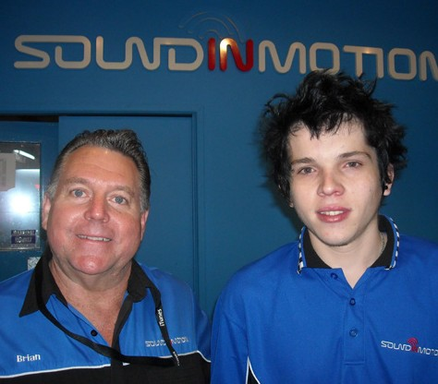

13

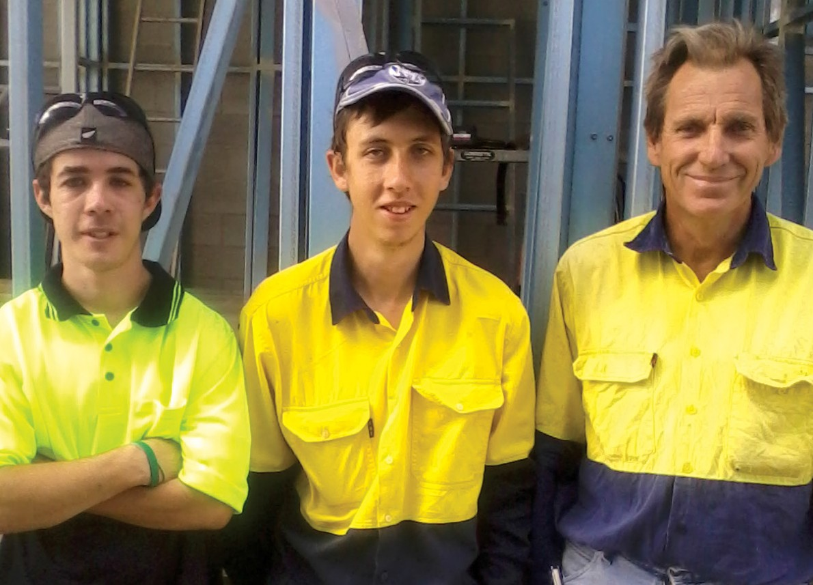

14

STEPS JOBSEEKERS THE PERFECT FIT FOR LOCAL CONSTRUCTION COMPANY

TOWNSVILLE
Owner of Custom Steel Structures, Kelvin, is a great employer for STEPS. He understands first hand what it’s like to have a disability and to want to be part of the workforce. Kelvin employs only local engineers for his projects and has helped train STEPS jobseekers in the construction industry for the past four years.
- year-old Benjamin has tried several different vocations but his barriers
to work have made finding the right fit difficult. He has, however, taken to working with Kelvin like a duck to water, stating this is the first time he
really feels that he knows what to do. Benjamin appreciates that Kelvin takes
the time for explanations, leading him to better understand why things need to be done a certain way, and wishes he’d started on this path two years ago.
Working for Custom Steel Structures is Anthony’s first paid job. The 22-year-old likes to work with his hands and prefers to be outdoors so he was the perfect
fit when Kelvin was looking for a trade assistant.
“I admire that Anthony will always ask questions and listens carefully”, says Kelvin. “He’s keen and has proven to be one of the most dedicated workers I’ve had – he’s even beginning to second guess me on site, which makes the job that much easier”.

NEW TRIAL PROVIDES HOPE FOR MENTAL ILLNESS SUFFERERS LOOKING FOR WORK
Details of a new trial aimed at improving job opportunities for people suffering from mental illness were revealed at the annual national Jobs Australia Conference in Sydney this month.
The trial will be held across multiple, randomly chosen sites across Australia and will involve employment specialists working in collaboration with mental health teams to provide individualized support for mentally ill jobseekers.
Mental Health Program Manager for STEPS Group Australia Liza Scriven announced the trial at the recent conference to employment industry leaders from around the country.
Ms Scriven, who was the first employment specialist in Queensland to partner with Qld Mental Health

“I truly believe that working with mental health treating staff to find work for people with a mental
illness is absolutely fundamental to gaining sustainable, and importantly
meaningful work”, she said.

“The ability to work - something many of us take
for granted - provides and instils self worth and empowers you to be able to look after yourself. It’s about basic human rights.”
treating teams to deliver targeted
employment solutions, said the evidence to date for co-located employment service models was irrefutable.
“It can be very difficult for those suffering from a mental illness to get and then hold down a job when the nature of mental illness is often cyclic and psychotic episodes are common”, Ms Scriven said.
“An holistic, supportive approach provides job seekers with greater confidence leading to improved independence and a happier, more inclusive life”, she said.
STEPS Group Australia will be promoting Mental Health Awareness training and Mental Health First Aid training throughout Mental Health Week from the 7th - 12th October.

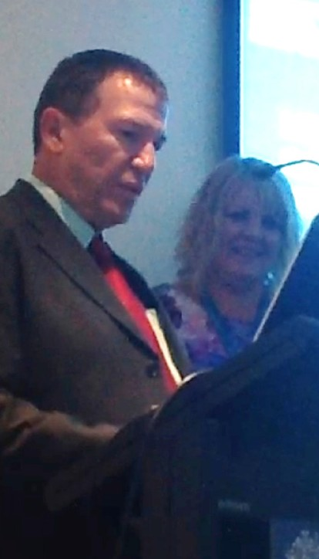

15

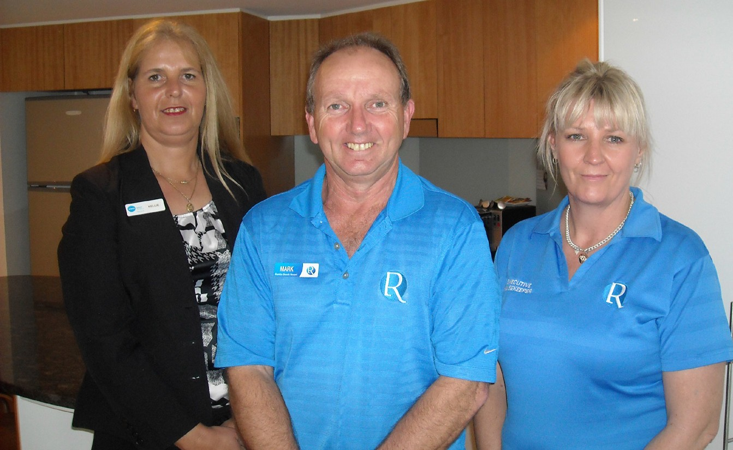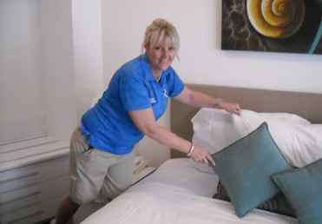

SUNSHINE COAST PARTNERSHIP LEADS TO NEW SKILLS AND OPPORTUNITIES
IEP-TASMANIA
The Indigenous Employment Program (IEP) in Tasmania is an Australian Government funded initiative with the aim of assisting Indigenous jobseekers prepare and take
up employment opportunities. Additional support is provided to participants including LLN training, assistance to overcome barriers such as lack of a driver’s license, lack of appropriate education, skills and knowledge, health issues, support with resumes, interview skills and lack of experience.
Lilly* was referred to the STEPS IEP program in Hobart after being involved in a bad car accident which left her with some ongoing physical issues. After an initial discussion, her keen interest in administration work was identified.
Hobart’s dedicated STEPS staff helped her gain part-time employment at a local law firm. Lilly absolutely loved the work, as well as her co-workers, and management informed STEPS that she was doing a fantastic job. So well in fact, that after initially looking into options of undergoing further training to assist in her long term
goal of becoming a full time employee, Lilly’s manager made her position full time.
Lilly has since put the training on hold, and has now been employed full-time for over six months in work she thoroughly enjoys!
The IEP offers eligible job seekers the chance to learn new skills, discover new career pathways and promote employment opportunities. STEPS currently deliver IEPs in the Hobart and Launceston region, helping indigenous Australians with a disability enter the workforce.
*Names have been changed

CALOUNDRA
Sometimes our STEPS jobseekers have few transferable skills to help them gain meaningful employment. However, a great working partnership between Rumba Resort & STEPS Group Australia is changing all that!
The Caloundra business has made a wonderful contribution to the local community by giving STEPS jobseekers the opportunity to learn new and valuable housekeeping skills.
Director of Rumba Resort, Mark Hall, has supported STEPS jobseekers to train on site, learning the 5-star skills maintained by the Rumba Housekeeping team first hand. This training has proved invaluable for building our
job seekers’ confidence and workplace skills. The results speak for themselves!. Since Rumba training commenced early in the year, three of our job seekers have gained successful employment, while another is now ready to start her new career in housekeeping. “It’s such a pleasure to offer training in such a friendly supportive environment”, says Kellie, an Employment Consultant with STEPS. “I often see some of the ladies and when I think back to their first training day, it’s amazing to see what a difference it’s made. We all know the importance of a person’s confidence and sense of belonging when they feel that they are contributing in the community, and the team at Rumba are making that happen”, she adds.

16

EMPLOYMENT FEATURE
ALICE SPRINGS
The cultural landscape in Alice Springs is vastly different to our other locations and fittingly, the delivery of our Employment service in this region is unique. 50% of our clients are Indigenous and the majority
of them have Mental Health, Drug and Alcohol Addiction, Traumatic and Acquired Brain Injury. To build rapport and trust takes time, cultural awareness and an understanding of family relationships, along with the cultural, business and personal issues that our Indigenous and remote clients face.
Although our employment service in this region is proportionately smaller than that of other regions and the number of
participants is less, often the period of time we are working with clients in Alice Springs is longer. Accordingly, the service that we offer is more holistic and often involves linking clients with other community agencies to assist them with addressing
a wide range of barriers. Our continual
networking with other services in the region has gained STEPS a good reputation within the community and we have been successful in building strong partnerships with the local schools, Centrelink, Aged and Disability Services, the Guardianship board and numerous other services.
Building rapport with employers is important to the work that we do in Alice Springs and we have spent a lot of time educating potential employers in disability. We have been able to secure great relationships with numerous companies, who continue to seek our assistance in finding suitable staff and offering the support we are renowned for including
on job support, conflict resolution and supported wages. We have also been responsible for delivering disability awareness to other staff to assist in our clients maintaining employment and also for social well being.
The success that our staff has had in building trust with all of our stakeholders in Alice Springs is a great testament to the work they do in this region.
Isobel* has been with our service for three years, and has an intellectual disability and Williams Syndrome. After a full year of addressing barriers and making links with employers, Isobel has successfully gained employment. We provide high ongoing support by working alongside her and the employer in the workplace resulting in
a boost to her confidence and skills. We are also proud to report that the Student Access Department approached us offering Isobel a traineeship in administration after witnessing the support we offered her and wanted to take advantage of this. This has since commenced and needless to say Isobel is excited and eager in her new role!
Ethan* is an Indigenous man that has been with our service intermittently for four years, and we were able to
successfully place him into employment. He is provided with high ongoing support and requires constant directives at work which we provide three times a week.
Communication has also been a barrier, as English is Ethan’s third language and he also experiences some hearing loss. We are fortunate however that due to the
long-standing relationship and the rapport we have built with Ethan, he now feels comfortable in teaching us his language and also has enough confidence in us to accept our referrals to help him better manage his finances. Ethan has now
been able to set up a savings account and identify and save for his long term goals.
Jade* has been with our service for five years and suffers from schizophrenia and alcohol addiction. Jade has been successful in gaining employment with
moderate ongoing support however due to her mental health barriers she constantly suffers periods of relapse. Our long- standing relationship with Jade means that we have been able to identify when these occur and have built up a relationship
with the employer where our support and guidance throughout these periods ensure that her employment is secure. We have also been able to partner and network closely with the Mental Health Services in the community in regards to Jade’s needs and ensure both Jade’s mental and general health is safe.
*Names have been changed

17

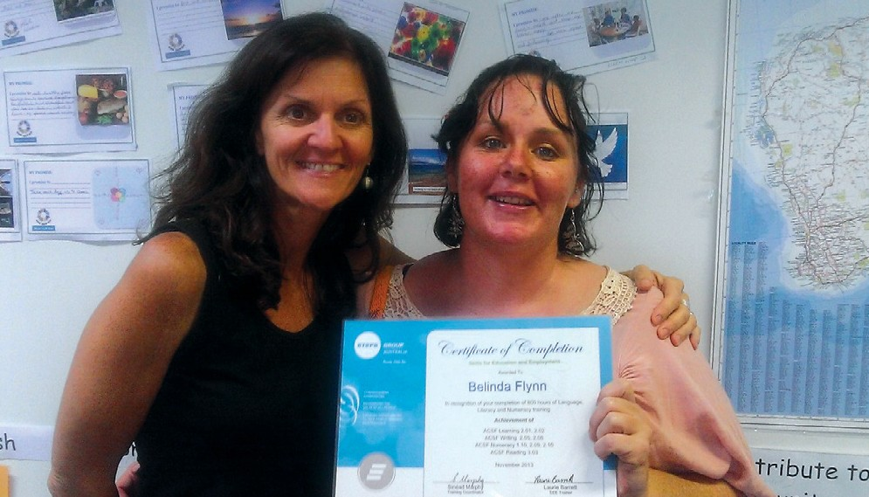EDUCATION & TRAINING SERVICES

We combine our passion for quality service and training to give you the best opportunities possible.

Ever since our Education and Training division launched in 1993, we’ve been committed to giving individuals the chance to develop new work skills and knowledge. STEPS is a Registered Training Organisation (RTO) and we provide education, training programs and partnerships across the following areas:
  - Language, Literacy & Numeracy
  - International Hospitality
  - Community and Aged Care
  - Business
  - Foundation Skills
  - Training and Assessment
  - Health

www.stepsgroup.com.au/training

FOLLOWING HER DREAM
CAIRNS
Belinda is a young woman who had recently experienced a number of setbacks and personal challenges in her life. A single mother who spent some time in a homeless shelter, she was determined to improve her situation and follow her dream of becoming a Childcare Assistant.
Realising she needed some help in improving her Language, Literacy and Numeracy (LLN) skills in order to achieve this goal, Belinda decided to join the STEPS program in Cairns with the support of her job search agency.
Belinda began the Skills for Education and Employment (SEE) program with STEPS,

and after completing a total of 800 hours in training, she has made commendable progress in all LLN skill areas. Not only that, she has gained greater confidence and an understanding of her own learning requirements and goals.
Since completing the SEE program, Belinda contacted a local training organisation offering a Certificate III in Childcare. After successfully passing their LLN entrance test, Belinda is now enrolled and looking forward to beginning her course in January 2014. Her goal of a
career in child care is now that step closer!

18

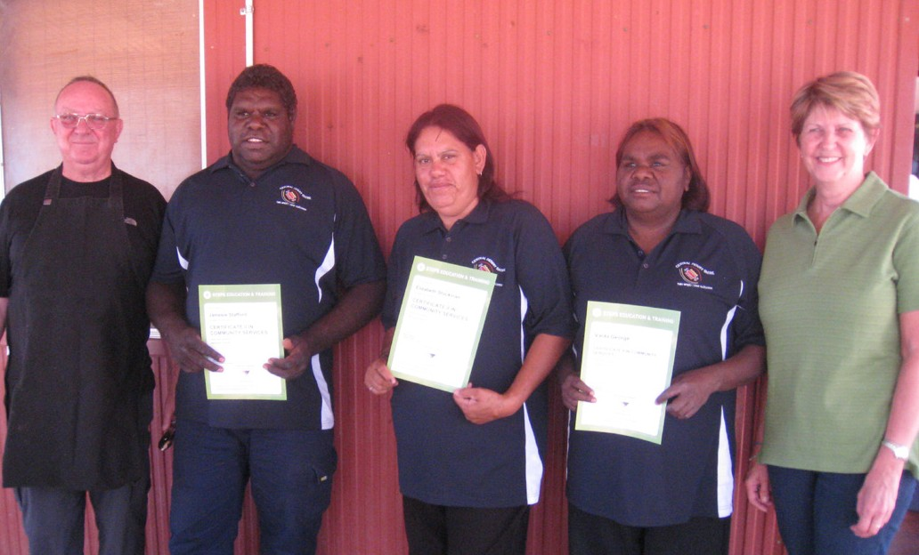LARAMBA STUDENTS RECEIVE CERTIFICATE II IN COMMUNITY SERVICES

LARUMBA. REMOTE NT COMMUNITY
Three staff members at the Aged Care facility in Laramba have now successfully completed their Certificate II in Community Services. 200km north west of Alice Springs, Laramba is just one of the remote communities where STEPS offers Aged Care training.
This Certificate II qualification has helped the staff to maintain their employment at the Laramba Aged Care facility. It will also allow them to continue with their training and go on to achieve their Certificate III in Aged Care.
Following the presentation of certificates, a few words were delivered by STEPS staff and also from the Aged Care coordinator for the community.
STEPS Project Coordinator, Terry Hanrahan, had the job of cooking the barbeque for all those in attendance. “It was a great day and was evidence of the ongoing commitment of STEPS to this project, and to the advancement of workers at similar remote facilities throughout the Northern Territory.”

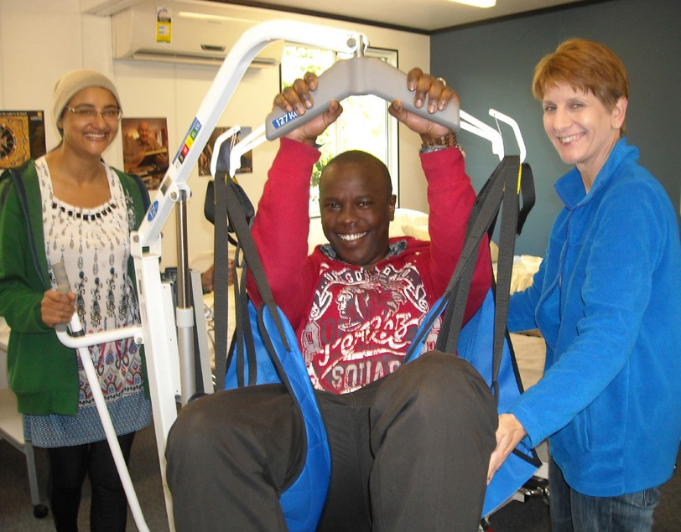100% EMPLOYMENT OUTCOMES FOR AGED CARE TRAINING GRADUATES

CALOUNDRA
Not only did every student who enrolled in the most recent STEPS Career in Care course successfully complete their Certificate III in Aged Care, they have all gained employment in their chosen field. Some of the students obtained jobs weeks before their course finished, while others were offered more than one position to choose from.
The students came from all walks of life, with different ages, life experiences and different cultures – all with a goal of changing their career. Linda Barton who started the course as a mature- aged student said, “This course was an investment for a change in my career path and learning with Wendy at STEPS has opened up a whole new world of possibilities”.
This is not the first time that the STEPS Aged Care course has had such a successful outcome. Nearly every course over the past few years has had a greater than 95% strike rate for employment. Vicki Hudson was one of the students who found the course to be “enjoyable, valuable, beneficial and very thorough”.
Recently released statistics show that the Community Services industry is currently the largest employer on the Sunshine Coast with a large number of opportunities in aged care facilities.
During the graduation ceremony trainer Wendy Nunn said that she was extremely pleased all the students have become competent AINs (Assistants in Nursing) and represented themselves and STEPS so well in the community.

19

STEPPING UP LITERACY SKILLS THROUGH ART & CULTURE

HARMONY DAY CELEBRATIONS IN CAIRNS
DARWIN
The Skills for Education and Employment (SEE) program is one in which the STEPS offices in Darwin and Palmerston have been achieving positive and encouraging results. Adult students participating in this course have discovered that the Visual Arts can be a very constructive tool in helping them with their language and numeracy skills, particularly in the concepts of space and measurement (size, length, distance, time etc). Not only that, but the students can learn the practical skills involved
in managing an art gallery – budgeting, stocktaking, managing money and banking, and purchasing and selling creative products.
All these learning opportunities were put into practice when, as part of Literacy and Numeracy Week, the Darwin and
calculated how long the excursion would take, and with their new-found numeracy skills they costed the event.
This excursion proved valuable in all aspects, in particular in connecting with the local Darwin community. The students returned from their excursion full of enthusiasm, and eager to follow up by creating their own artwork, and using their literacy skills to write and research further as to what art and culture means to them.
A great success story for STEPS Darwin and Palmerston!
STEPS delivers the Federal Government’s SEE program throughout the Northern Territory, from communities in the remote Top End down to Alice Springs. General Manager for Education and Training, Shelly Campbell, says, “The success of

CAIRNS
The STEPS office in Cairns celebrated Harmony Day on March 21 in great style. With thirty different nationalities represented by staff and students on the Cairns site, there was much cultural diversity to celebrate.
Many hours were spent by the students practising traditional songs and music, making national flags and cooking up
Guests were treated to beautiful and
vibrant dancing from the Cook Islands and West Papua, as well as traditional Aboriginal dancing complete with body art and accompanied by didgeridoo.
Literacy students performed traditional Cook Island songs with terrific crowd participation, and a Bhutanese love song and dance were performed by language students. Students showcased their traditional dress in a fashion parade,
Palmerston students organised a walking excursion to a variety of local art galleries, using reading and mapping skills to research locations on the internet. Applying their new skills of time and distance, they
the program has been partly due to the
innovative ways in which our fantastic trainers go about providing experiences and opportunities to develop skills in real world practical situations”.

a storm for all to enjoy on the day, and
indeed a delightful array of dishes were sampled on the day, including kangaroo and crocodile meat, curry, lamingtons and kup muri (cooked at a secret location!)
much to the enjoyment of those present.
Harmony Day was a huge success in Cairns this year, and those in attendance considered it a privilege to have been a part of it.
“We stand by our ethos that no individual or
community should be disadvantaged by not having regular access to training as a result of isolation or distance.”

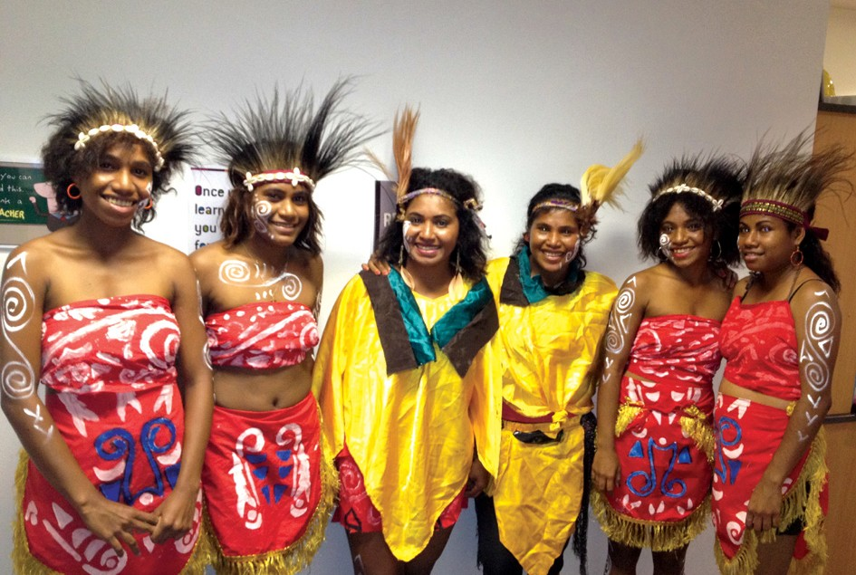

20

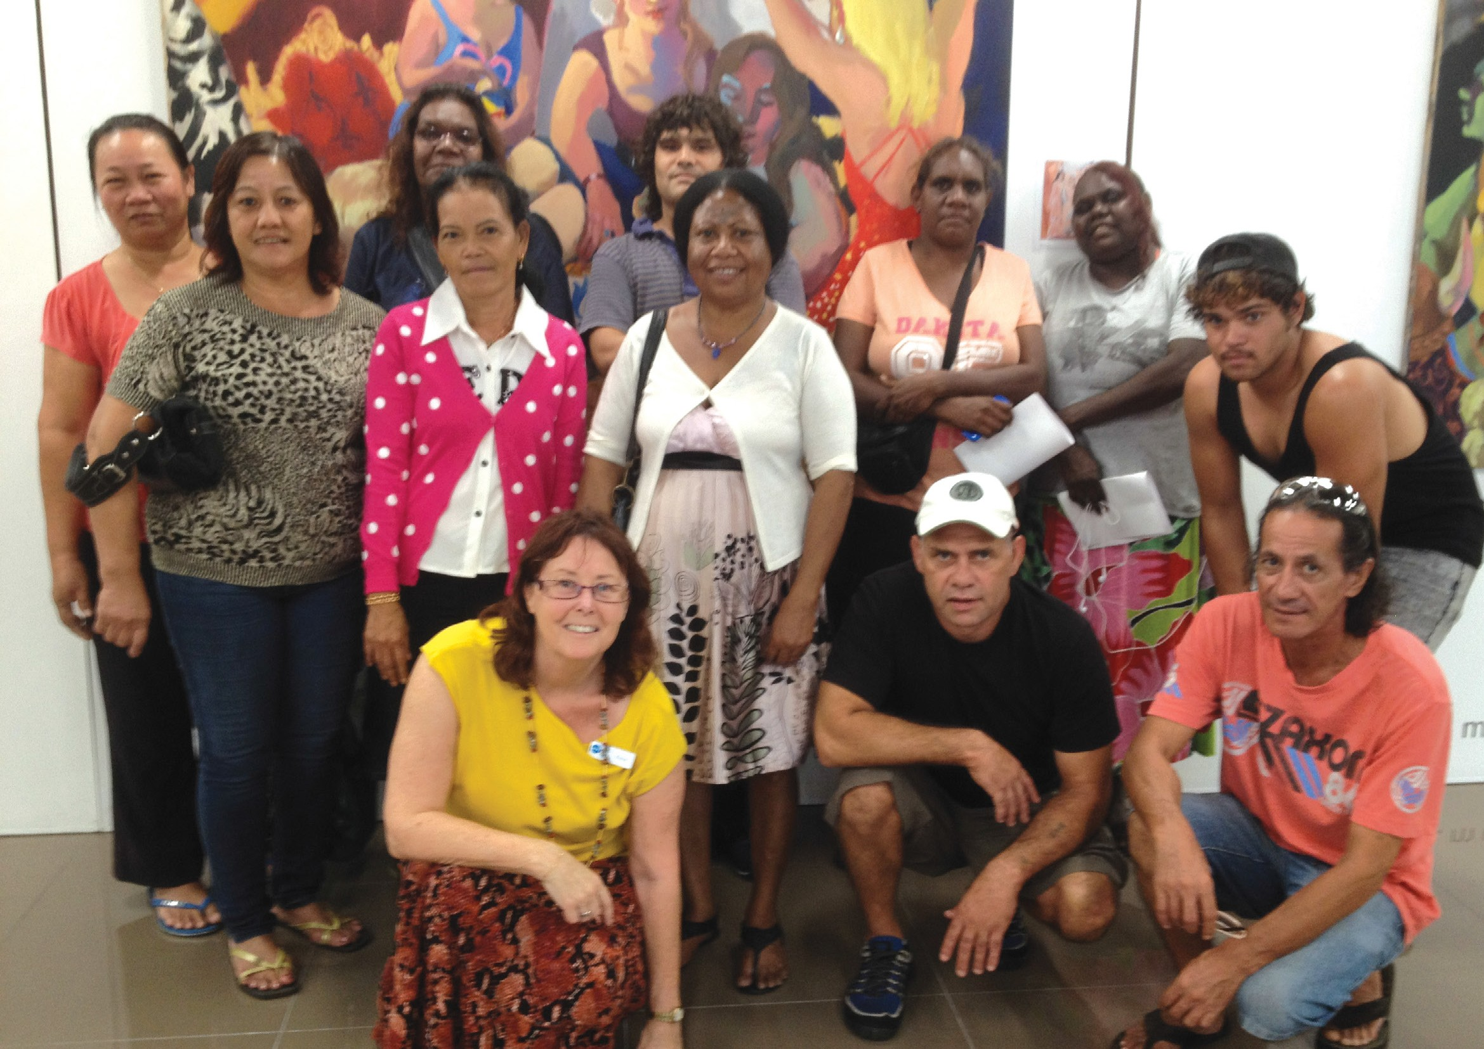

21

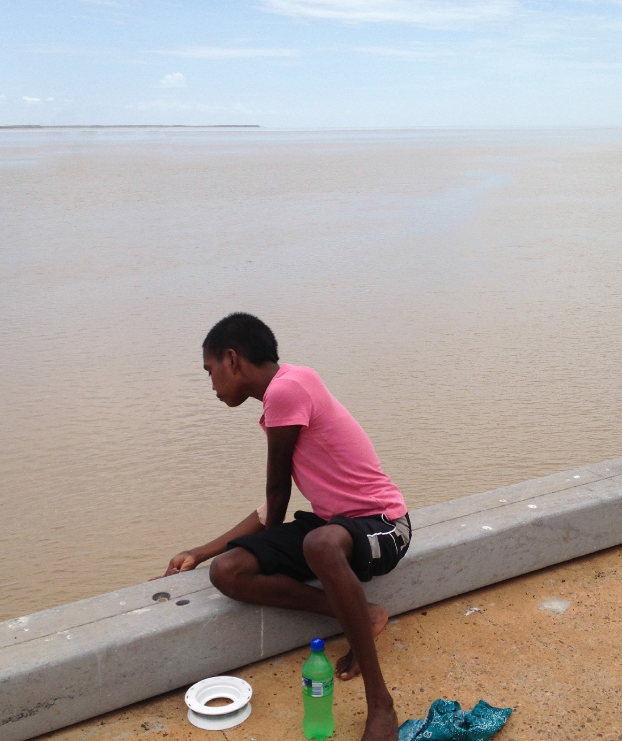
STEPS FOOTPRINT REACHES WESTERN AUSTRALIA
STEPS would like to welcome a new region and maintain employment. STEPS recognises that two new offices to the STEPS family. STEPS gaining the necessary skills and knowledge to Derby and STEPS Kununurra in the Kimberley ‘do the job’ is more important than simply getting Region WA now deliver Skills for Education and a certificate or qualification’, and with this in Employment. mind, the SEE program is designed to deliver
The SEE program is designed to build essential customised training that meets the real world skills to help jobseekers prepare for and needs of employers and industry.
22

PARTNERSHIPS ADDING TREMENDOUS VALUE
Community organisations coming together and working in a collaborative manner can make a remarkable impact in a
variety of ways. STEPS has partnered with several organisations throughout the year with great results for not only the businesses involved, but particularly the students.

As a Registered Training Organisation (RTO), STEPS has offered individual trainers and organisations the opportunity to use the STEPS Training Scope of Registration to deliver
accredited training and assessment services. This arrangement provides benefits such as reduced financial, administrative and compliance burdens for the auspicing organisation while still providing quality training and assessment.

Redpath Education from Alice Springs in the Northern Territory had this to say about the partnership undertaken with STEPS. “The relationship we have with STEPS is an example of how life can be easy if we are honest and willing to develop and respond to meet a common goal, in business, as in life”.

Focus Health Network on the Sunshine Coast commented on their experience with STEPS, “Focus Health Network has enjoyed a great working relationship with STEPS since
partnering with them mid-2012. We came to STEPS after a poor experience with another Registered Training Organisation and could not believe the difference in support we received. We look forward to continuing our partnership with STEPS in the future”.

Connect2 Group who are located in Brisbane and have worked with STEPS to deliver Certificate III and IV Disability Training, have found the whole process exceptionally easy and
uncomplicated. “When we had to close our Training Department, Ferne Robinson (STEPS RTO Partnerships Manager), went out of her way to help us sort out where people were up to and assist those students that had completed units unmarked. Without this support and dedication, Connect2Group would not have been able to either offer our students the training in the first place
or help them get recognition for work they had undertaken. Working with STEPS has been a truly remarkable experience and one I feel privileged to be able to say I was part of”.

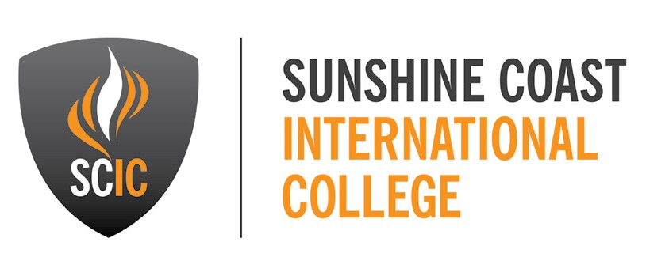

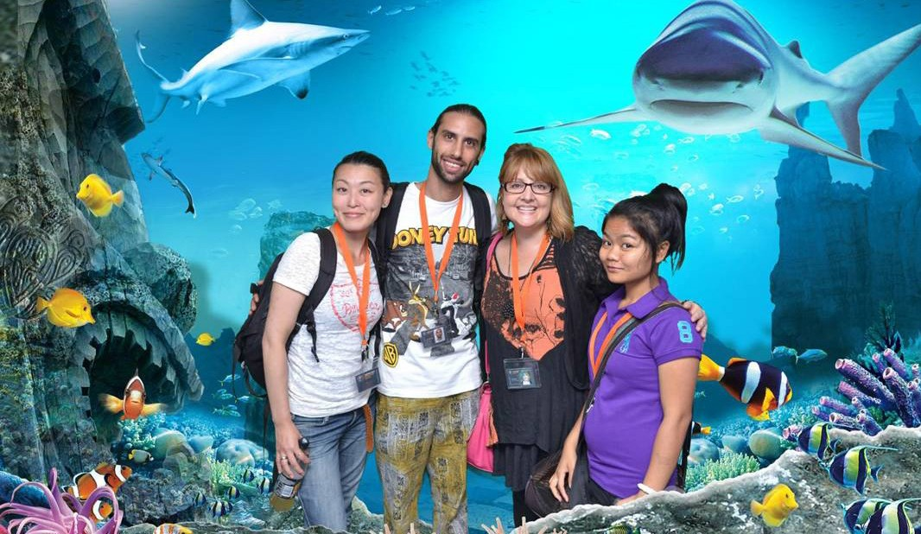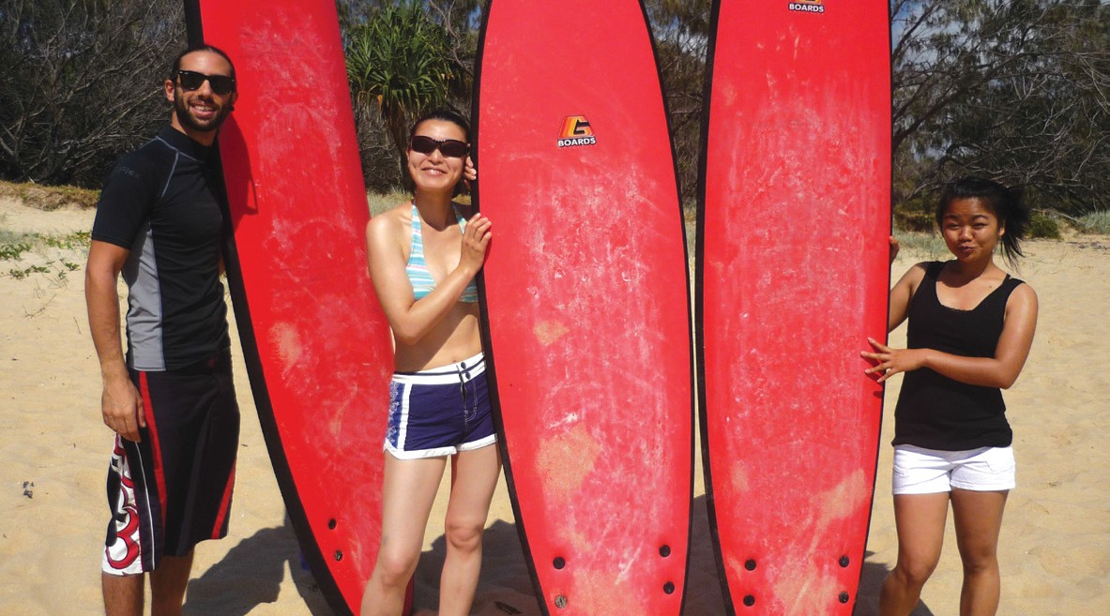THE PERFECT PLACE TO EXPERIENCE AN AUTHENTIC AUSTRALIAN LIFESTYLE

Sunshine Coast International College (SCIC) is part of STEPS Group Australia and, as the name suggests, is located on Queensland’s beautiful Sunshine Coast, in the city of Caloundra, just an hour drive north of Brisbane. The campus is situated in a leafy precinct that includes purpose built classrooms as well as spacious lawns and a volleyball court – the perfect place for international students to soak up some true Aussie culture.
Students come to us from a number of different countries to brush up on their English skills or to complete a qualification in Hospitality.
One of our students graduating in 2013 had this to say, “Now my dream is connecting with people all over the world in Australia through good education. I am very excited about the future and would love to let you know how much I appreciate this school. I appreciate [that] profits go towards STEPS assisting Australian people who need help. This is another important reason why I was happy to study here”.

VISIT US ONLINE: www.scic.qld.edu.au

23

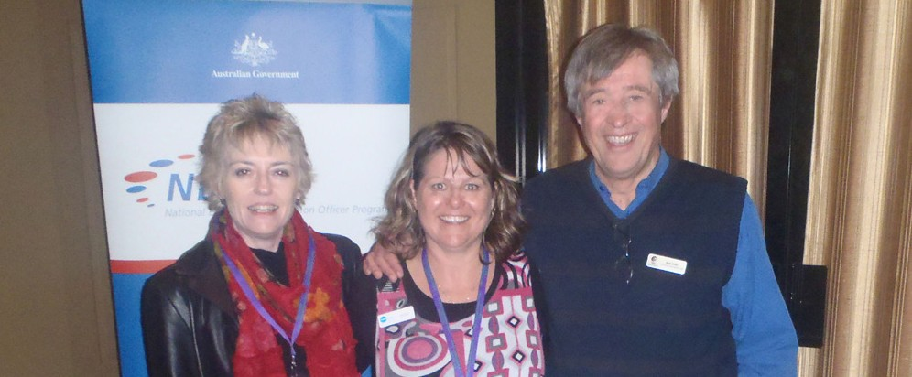SOCIAL & COMMUNITY INITIATIVES

We understand it’s important to reach out to different people in different ways.

That’s why we offer initiatives that recognise and nurture
TENDER SUCCESS FOR THE NDCO

the value of individuals to local communities. Our social and community programs include:
    - Caloundra Resource Recovery Centre
    - Care for Carers Program
    - National Disability Coordination Officer Program (NDCO)
    - George Street Community Nursery
    - Cleaning & Property Maintenance
STEPS National Disability Coordination Officers (NDCO’s) have organised and delivered support services for people aged 15 to 64 years with a disability that are, or will be, attending tertiary education since 2008.
The news that STEPS was successful in its application for Regions 20 and 22 (covering Southern, South West and Northern Queensland) in the 2013 NDCO tender
was affirmation of the invaluable work our dedicated NDCO’s do. The recurrent
To assist the program to meet these goals, NDCO has established an Advisory Committee comprising representatives from key stakeholder sectors to provide
strategic leadership, support and guidance to ensure that planning and program activity is aligned with the identified needs in the region.
2014 is set to be another big year for the NDCO, continuing to break down
systemic barriers in tertiary education and employment for people with a disability.

funding ensures that STEPS NDCO’s will continue to provide support for people with

a disability, enabling them to successfully transition to tertiary education, and subsequent employment.
VISIT US ONLINE
www.ndco.stepscs.net.au

www.stepsgroup.com.au/community

24

CELEBRATING NATIONAL RECYCLING WEEK

The diversity of STEPS services was showcased at the Caloundra Resource Recovery Centre’s inaugural Recycle Fun Day as part of celebrations throughout National Recycling Week.
Many Sunshine Coasters joined the festivities which comprised the Recycle Markets, as well as a variety of exhibitors and entertainment including live music, arts and crafts using only recycled materials, a live art display, information stalls, face painting, food, and raffles with some great prizes on offer.
STEPS operate front-end activities including the extremely popular Recycle Markets at the Caloundra Resource Recovery Centre as part of a recycling contract for the Sunshine Coast
Regional Council. The STEPS Mattress Recycling program is an innovative addition which helps improve environmental sustainability while employing disadvantaged people in meaningful work.
Many of STEPS’ clients find employment at the Caloundra Resource Recovery Centre. On top of that, profits from the Recycle Markets go back into helping others gain employment or training for a brighter future.
All participants, stallholders and volunteers played a very important role in helping raise community awareness about recycling and better caring for the environment, and it’s safe to say, with such a delighted group of visitors, that the Recycle Fun Day was a resounding success!

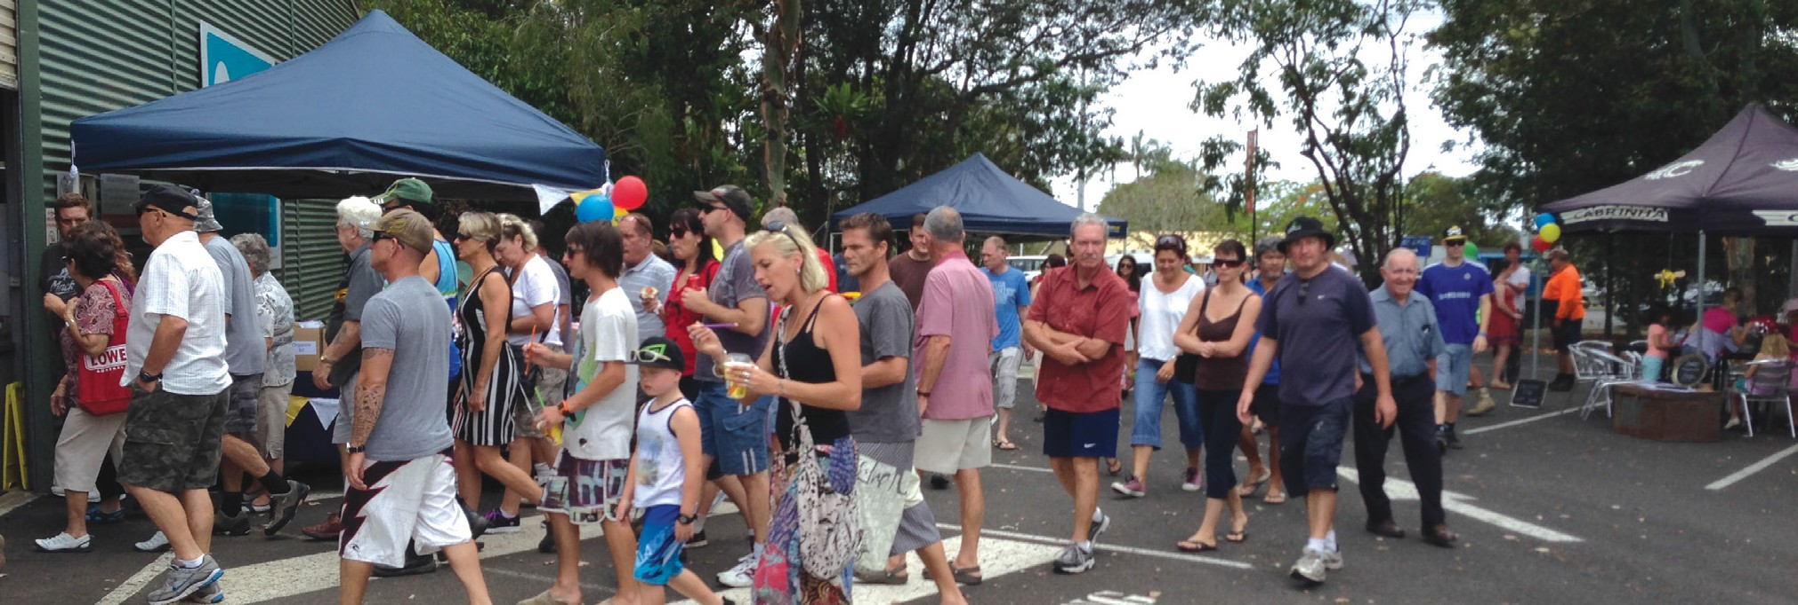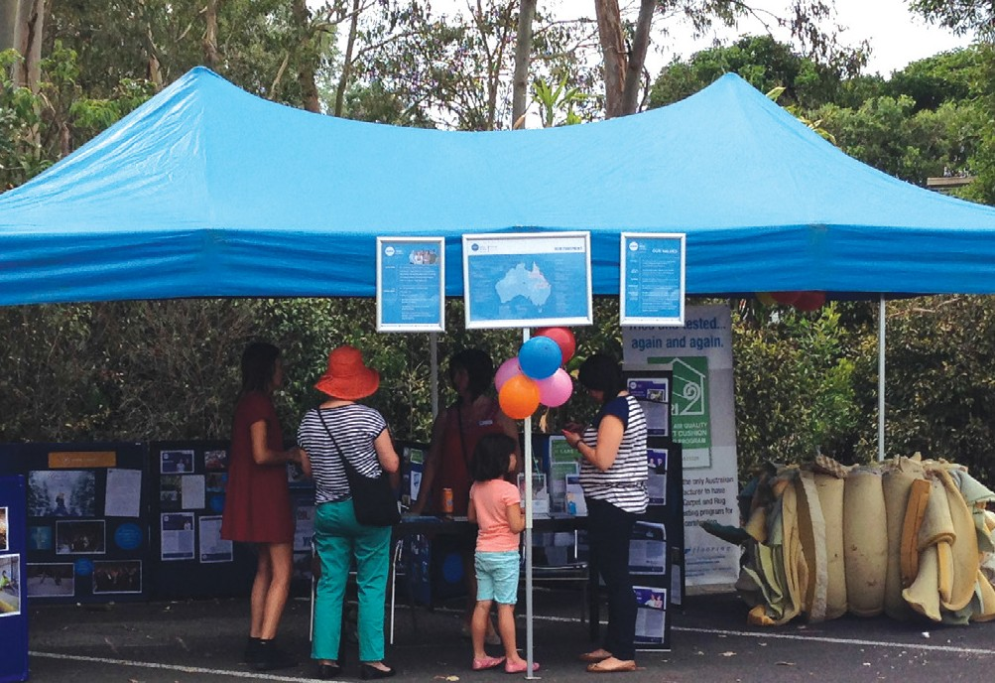

Every year we salvage an astounding 17,000 mattresses to make our environment just a little more sustainable – step by step.

25

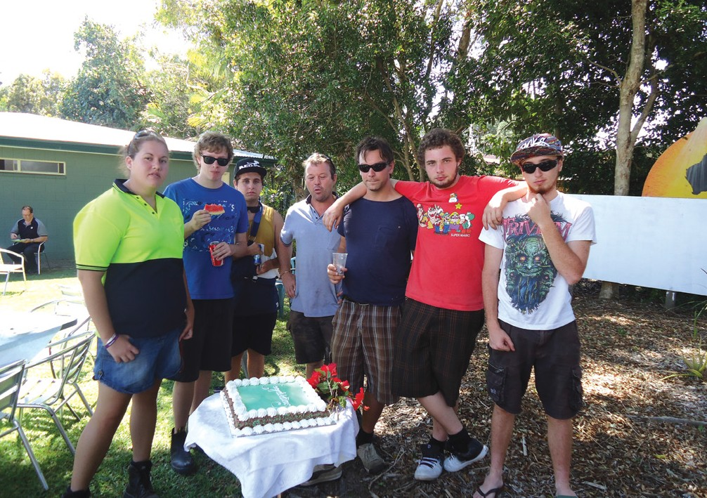A STEPS COUNSELLOR’S STORY

BUNDABERG.
CARE FOR CARERS PROGRAM
I first met Janice* after she walked out of a Carers Support Group. It was the morning of our monthly meeting, and the group members were already exchanging tips and information about their individual carer circumstances over their cups of coffee.
At first I thought she was someone who had wandered into the wrong room, as she entered uncertainly through the doors before backing out as quickly as she arrived. “Excuse me”, I called pleasantly,
“were you looking for the carers group?” A slight older lady clutching what appeared to be one of our Care for Carers flyers nodded and said “I think so, but perhaps I shouldn’t be such a bother”. She smiled then and held out her hand. “My name’s Janice and what I mean is, I read your brochure and it sounded good but I am not really a carer. I do look after my son Paul, but I am his mother after all. That’s my
non-verbal and intellectually disabled, with a range of challenging behaviours that deem him as high care. She bathes, dresses, feeds and cares for Paul seven days a week, except when he works for a few hours at the Endeavour Foundation.
Not once had Janice considered respite, as she was worried Pau would ‘fret being away from me too long.’ She did not have any home assistance, had not been
assessed for Home and Community Care, and didn’t realise she was eligible for a Carers Allowance. She lived in a rapidly diminishing social bubble with no real support, and it wasn’t until a reluctant visit to the doctor because she was feeling anxious and teary that she became aware of our STEPS program when her GP handed her one of our brochures.
Nowadays her son attends, and looks forward to regular respite, while Janice accesses an array of home and health services, and receives the Carers

LIFE THRIVING AT GEORGE STREET COMMUNITY NURSERY

job.”
She accepted my offer to sit and talk, and haltingly her story emerged. Janice had been widowed for two years, and had cared for her autistic son Paul ‘since he was born, thirty-eight years ago’. Until her husband died it had never seemed a big deal, adding that it was a blessing she had Paul home for company. I was immediately touched by the sincerity and humility of her narrative.
After I assured her that she was exactly the type of person we were trying to reach through our program, she joined the meeting. I later discovered that Janice’s
Allowance every fortnight. She hardly misses a Carers Support meeting, and has learnt to recognise the warning signs of low Emotional Energy before it gets
to crisis point. She has formed close friendships within and through the group, has rediscovered a passion for quilting, and is writing her memoirs. It is becoming increasingly difficult to recall that shy and introverted lady I met all that time ago.
*Names have been changed

VISIT US ONLINE
www.careforcarers.com.au
Bursts of new life emerged in 2013 at the George Street Community Nursery in Caloundra, when its doors once again
opened to the public following an upgrade to the Nursery facilities, funded by the Australian Government Department of Education, Employment and Workplace
Relations through the Local Employment Coordinator Flexible Funding Pool. As part of this funding, training programs were run throughout a 12 month period to June 2013 which contributed a great deal to the upgrade particularly during
the construction phase. A very successful launch of the project was held in
training participants who worked towards a Certificate II in Construction Pathways.
The George Street Community Nursery Caloundra has been in business
for 15 years, initially providing a successful training venue for budding horticulturalists. Now the Nursery is a wonderful retail outlet that also provides a place for local much appreciated
volunteers, jobseekers, community service workers to give back to their community
as well as being a venue for horticulture training and day to day gardening education.
The nursery has hosted hundreds of

son has profound autism, meaning he is

26
conjunction with the graduation of our first
trainees, jobseekers, volunteers and

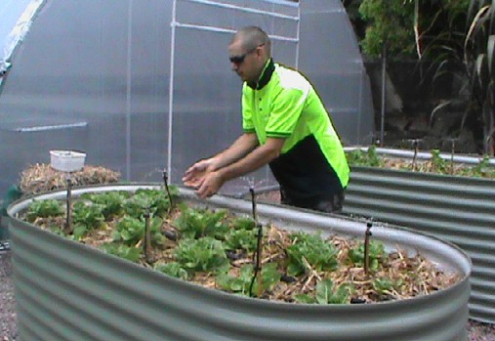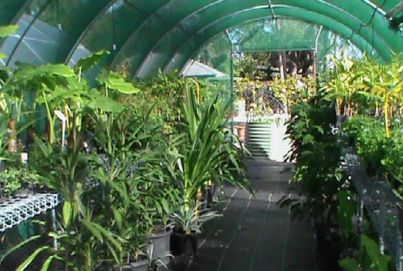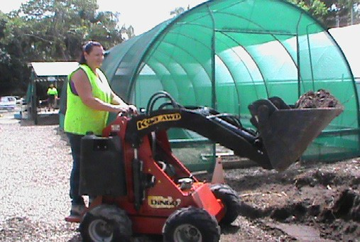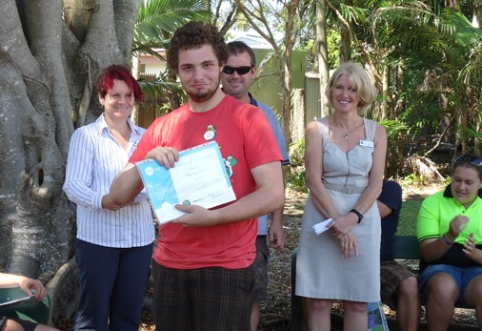STEPS CHARITY

We’recommittedtoformingsustainable partnershipsto strengthen and grow our local communities.

more since 1998 and these workers were instrumental to the building of new shade and hot houses, installation of the
water tanks, new community garden beds and helping expand the edible gardens. Contributing approximately 100 volunteer
& participant hours per week over the past 12 months, they all play a crucial role in ensuring this sustainable and accessible community resource continues to function smoothly.
Adjoining the more formal nursery, Volunteers have developed an educational, interactive garden area which will soon boast a wood-fired pizza oven and timber nest boxes, thanks to a grant from the

Australia Post Our Neighbourhood Community Grants. It is hoped that this area will be used by local schools as
an educational facility as well as being open to all who wish to visit and enjoy the experience.
Members of the public can visit the gardens and purchase fresh home grown vegetables and a range of healthy native
& domestic plants at very reasonable prices. STEPS Charity Manager, Cheryl McGrath said, “People love to come in and have a look, purchase stock and help out in the garden. They just enjoy being part of the wonderful community spirit and camaraderie that thrives in the Nursery”.
As a registered charity we provide a vital service to the community, but we can’t deliver all of our services and initiatives without the support of others. Since 2011 we have been raising money to deliver our unfunded services
through initiatives such as The STEPS Grand Winter Ball and strategic, mutually beneficial partnerships with businesses in our local communities.
We’re always on the lookout for new opportunities to partner with organisations and we’re always thankful to our partners who, each and every day, help us to support the people that need it most.

www.stepsgroup.com.au/charity

27

CONNECT WITH US
@stepsgroup

/stepsgroup

/stepstvaustralia steps-group-australia

GENERAL ENQUIRIES

1300-0-STEPS or 1300-078-377

@ enquiries@stepsgroup.com.au www.stepsgroup.com.au

