Annual Report

Our Vision
Vision, Mission and Purpose

To be a leading national provider of services that strengthens communities by recognising the value of all people.

Mission

To strengthen communities nationally STEPS will:
  - Grow and expand services
  - Strengthen quality pathways
  - Promote innovation to ensure sustainability
  - Value skilled staff
  - Deliver exceptional service that is customer focused

Purpose

Through core services of Employment, Training, Community Services and Social Ventures STEPS will create opportunities to help people towards independence.

2

Contents
Contents

Board profiles 4
President’s report 5
CEO’s report 6
COO’s report 7
Case study (Healthscope) 8

Employment services 9
Employment overview 11 Case study (Scott Abdy) 12 Case study (Sari Anderson) 13
Mental Health Centre of Excellence 14

Community programs overview 15
Care for Carers 16 Civil Skills 17
Disability Services, Indigenous Dementia Awareness 18
Interactive Arts Centre 19 Multicultural Project 20
NDCO 21
Protect Your Head, Participate in Prosperity 22
Workplace Assessors 23
Youth Connections 24

Training overview 25
LLNP 26
NT Community
Aged Care Program 27 PPP 28
CADET Training and International College 29
Scope of registration 30

STEPS Central,
Business Development 31
Marketing and Communications 32
People Knowlege & Systems, Quality Systems report 33
HR report 34
ICT report 35
Community involvement 36
Financials 37
STEPS locations 38
Funding bodies 39
3

Carmel Crouch
4
Board Profiles
Carmel is the owner of her own International Property Investment Consultancy company and also the Managing Director of STEPS Ahead Ltd in a part time capacity.
Carmel has been owner or partner of business since 1985 with an extensive career in commercial business.
Carmel is also the President of STEPS Disability Qld Inc and has played
an integral role in the growth and direction of STEPS since 1990.
Carmel is also a Director of STEPS Ahead Ltd and Community Agency for Development Employment and Training Inc since 2010. These entities all form part of the STEPS Group.
Carmel is also a member of Australian Institute of Company Directors.
Garry Hooper
Garry is the Managing Director and CEO of STEPS Disability Qld Inc since 2000. He is also a Director of STEPS Ahead Ltd since 2006, the Managing Director and CEO of STEPS Foundation Ltd and CEO of
Community Agency for Development Employment and Training Inc since 2010.
Garry has worked in the disability sector since 1997 and prior to this in local government and Aboriginal
communities throughout Queensland.
He is a national board member of ACE National Network, a representative on the Sunshine Coast Regional Disability Council (a regional ministerial advisory body) and a member of the Australian Institute of Company Directors.
Christine Jones
Christine is a solicitor in private legal practice. She was admitted as a legal practitioner initially in 1986, and
now practises primarily as a dispute resolution practitioner.
Christine is a Director and Secretary of STEPS Disability Qld Inc since 2006, STEPS Ahead Ltd since 2008 and Community Agency for Development Employment and Training Inc since 2010. These entities all form part of the STEPS Group.
Christine is also a member of Australian Institute of Company Directors.
Helen Ferguson
Helen Ferguson has been in private enterprise for many years and is currently Principal Adviser in her own financial planning business.
Helen joined the Board of Directors of STEPS Disability Qld Inc in 2003 following STEPS merger with Work Support Inc. She is also a Director of Community Agency for Development Employment and Training Inc since 2010. These entities all form part of the STEPS Group.
Helen is also a member of Australian Institute of Company Directors.
Michael Lutje
Michael is a Chartered Accountant and a partner in his firm with over 25 years experience.
Michael is a Director and Treasurer of STEPS Disability Qld Inc since 2009, and Community Agency
for Development Employment and Training Inc since 2010. These entities all form part of the STEPS Group.
He is also a member of the National Tax & Accountants’ Association, the Taxation Institute of Australia and the Australian Institute of Company Directors.

Carmel Crouch, President - STEPS Board of Directors
Presidents Report

It is my pleasure once again to write to you on the continued success of STEPS Disability Qld Inc. The years pass so rapidly and it seems only yesterday when my involvement with STEPS began, however as I cast my memory back over 20 years of STEPS 21 year history, what
a journey it has been for those who devoted their time, unselfish love and energy to this amazing organisation.
Looking back,it is timely to reflect on how the organisation started and what’s happened since STEPS’ inception in 1989. A small group of concerned parents from the Sunshine Coast recognised a need for a variety of employment options for their special children and other young people with an intellectual disability. They decided to meet to find a solution, sourcing any available funding stream they applied for, and in 1990 received Federal Government funding to establish a supported employment agency. The organisation continued to grow and adapt to ever-changing environments and the rest, as they say, is history.
During these past years of writing this report I believe that without fail I have reported yearly on the constantly changing environment in which we operate. As an organisation we have become
experts at both anticipating and adapting to the changes that are often forced upon us by government contract expectations, always coming out at the other end with better results and more focused on the vision and mission for our organisation. Still after all these years of showing strong and constant growth, STEPS’ focus remains strongly on the provision of employment, training, community services and our social enterprise businesses.
Our review of the STEPS’ Strategic Plan this year provided an opportunity to refresh our vision and mission to align with the direction of the sector, and for the strategic direction of the organisation to meet the needs of our stakeholders to 2013.
The STEPS vision - ‘to be a leading national provider of services that strengthens communities by recognising the value of all people’ - is supported by our mission - ‘to strengthen communities nationally, STEPS will grow and expand services, strengthen quality pathways, promote innovation to ensure sustainability, value skilled staff and deliver exceptional service that is always customer focused’.
Our vision clearly identifies our commitment to being a leading national provider of services, and it has been essential to review our governance structure to ensure we have a sustainable platform for the continued growth and diversification required to attain this goal.
The outcome of this review highlighted our need to move to a company limited by guarantee, with an amended structure
which allows for the incorporation of other entities either through acquisition, amalgamation or organic growth. This company has been established as STEPS Group Australia Ltd and we are working together to implement the new organisational governance structure over the coming year.
This past year has been a year of change and growth for our staff with an organisational restructure and the takeover and integration of Community Agency for Development Employment and Training (CADET).
This has been achieved through the dedication of our teams in Employment, Training, Community Services and Social Ventures.
Expansion into new programs has also been very successful in this past year, and our geographic penetration has spread to encompass offices in coastal Queensland, Northern Territory, Tasmania, Victoria and contracts delivered nationally.
On behalf of my fellow members of the Board of Directors, I would like to thank the entire team of STEPS for their tireless commitment to our service in adapting to the changing environment of our sector and our restructured organisation. We know and understand
its many complexities and difficulties and appreciate greatly the continued passion and dedication to its success that our staff bring to our organisation every day.
Also on behalf of the Board of Directors I would like to thank Garry Hooper for his continued passionate support and dedication to our success. This year Garry celebrates 10 years as STEPS’ CEO, and we welcome him to the Board of Directors of STEPS Disability (Qld) Inc, STEPS Group Australia Ltd and STEPS Ahead Ltd Boards.
Garry has adapted his diverse experience, and thrown all his skills, energy and passion into the organisation’s growth and financial sustainability. His driving force, a self imposed responsibility for sustaining and nurturing the culture of the organisation.
I would like to take this opportunity to welcome Michael Lutje to our Board of Directors and congratulate him on his appointment as Treasurer of STEPS Disability Qld Inc, and thank Helen Ferguson for her support of the organisation in her roll of treasurer for the past two years.
It is with pleasure that I take a moment to acknowledge the dedication of my fellow Board Members, who aside from being operational business owners in their own right, give freely of their time, support and good counsel. It is invaluable both to me and the organisation in helping to steer this rather large ship through the rocky waters of economic and government change that is our daily challenge in this sector.
I thank them from the bottom of my heart for their commitment to our organisation.
It is with much anticipation that I look forward to the coming year and the opportunity to work with our dedicated team to continue to strive to be an industry leader and a provider of choice for our clients and stakeholders.

5

Garry Hooper, Managing Director and Chief Executive Officer - STEPS
CEO’s Report

From an organisational perspective the 2009-10 year has been one of the most momentous years in STEPS’ history. It has been a year of change and stunning growth whilst achieving a positive financial result.
The growth achieved over this past year has included the delivery of 31 contracts
across employment, training and community services locally and nationally, with almost 50% growth in revenue being achieved.

The 2009-10 year has been one of the most momentous years in STEPS’ history.
acquisition, amalgamation or organic growth. This company has been established as STEPS Group Australia Ltd and the structure should be fully implemented over the 2010-11 year.
The organisational structure was adjusted to allow for growth, flexibility, adaptability and accountability. The structure was implemented at an operational level with the introduction of Area Managers followed by a central office restructure utilizing a matrix model designed to improve quality of decision making.
The takeover of CADET strongly aligned with our strategic direction and strengthened our platform for the continued success in our training unit.
CADET is an organisation based on the Sunshine Coast providing training and employment services for disadvantaged people.
which are essential to our future direction including Business Development, Mental Health Centre of Excellence and a new focus on Social Ventures which will be managed by STEPS Ahead.

It is STEPS Staff who take the dreams and directions of the Board and create a reality in the operational realm

It is important to recognize that our Board of Directors play a large role in ensuring the direction of the organisation remains clear and in alignment with the future of the sector. The Board’s expertise and long-term strategic perspective is more critical
as the organisation grapples with an increasing range of critical

CADET also includes an international college providing training
opportunities in skill shortage areas for international students.
The year included a review of the strategic plan, an overhaul of the
decisions.
I would also like to publicly show my appreciation for the support

operational and governance structures of STEPS and takeover and commencement of the integration of CADET, a well established training organisation in Queensland that complimented our existing training business unit.
The strategic planning undertaken this year is the first major change of our vision in 8 years. The new STEPS vision, “to be a
With this growth, the number of employees at STEPS Disability Qld
Inc has more than doubled in this financial year to now total 288 including the integration of the CADET team. Our dedicated team of staff are now spread across 24 locations in coastal Queensland,
Northern Territory, Tasmania and Victoria providing services
which respond to both individual community needs and services delivered on a national basis.
the Board and especially the President, Carmel Crouch has given me throughout the year as STEPS has moved through this period of growth and development.
I wish to also take this opportunity to sincerely thank our team of staff for their tireless provision of services to our clients,
commitment to finding innovative solutions to barriers faced within

leading national provider of services that strengthens communities
by recognising the value of all people” is supported by our mission
our sector and support of our restructure throughout this changing
environment. Without this team, STEPS would not be where it is

– “to strengthen communities nationally, STEPS will grow and expand services, strengthen quality pathways, promote innovation to ensure sustainability, value skilled staff and deliver exceptional service that is customer focused.”
6
Our swift growth throughout the country highlighted our need to become a company limited by guarantee with a structure that allows for the integration of other entities either through

The organisational structure was adjusted
to allow for growth, flexibility, adaptability and accountability

It is said that with change, comes opportunity and STEPS has embraced this to include new operational units in the restructure
today.
It is STEPS Staff who take the dreams and directions of the Board and create a reality in the operational realm of the organisation to work together to achieve our vision and provide these services to our stakeholders.
Thank you one and all.

STEPS moved into our new premise at
60 Wises Road, Maroochydore on August 14th 2009

Adrian Robinson Chief Operating Officer - STEPS

Taking the time to reflect on the past year allows one to take stock, but more importantly, provides the opportunity to look to the year ahead.
The changes that took place within STEPS prior to my commencement were momentous, and the changes that have taken place since have been equally so.
Reorganisation and structural changes are difficult for staff under any circumstances, and the acquisition of CADET at this critical time added to the uncertainty faced by staff from both organisations. Needless to say the amalgamation is proceeding smoothly with the cooperation and assistance of all involved.
The CADET acquisition created further opportunities for STEPS, with ambitious plans for the expansion of business for the international college and the addition of several community services and training contracts.
The new Disability Employment Services (DES) contract and the unprecedented growth created by referrals through the newly established Mental Health Centre of Excellence has been a challenge, which has been enthusiastically met by staff and managers.
Augers well for the year ahead, particularly so, as 2011 brings the submission of the draft tender for the next DES contract which is so critical to the future success of STEPS.
Growth in the training area has also been unprecedented, with
significant expansion of existing programs in the Northern Territory, and the recent offer by the Department of Education Employment and Workplace Relations for STEPS to deliver Language Literacy and Numeracy in two business service areas in Far North Queensland.
In addition to this there has been significant growth in fee for service training in the Northern Territory, and in State Government funded training programs in all areas.
The establishment of the Business Development Unit within STEPS has been a forward-looking decision that sees a number of
business opportunities being explored. Some of these have already materialised and many of which will, no doubt, come to fruition in the near future.

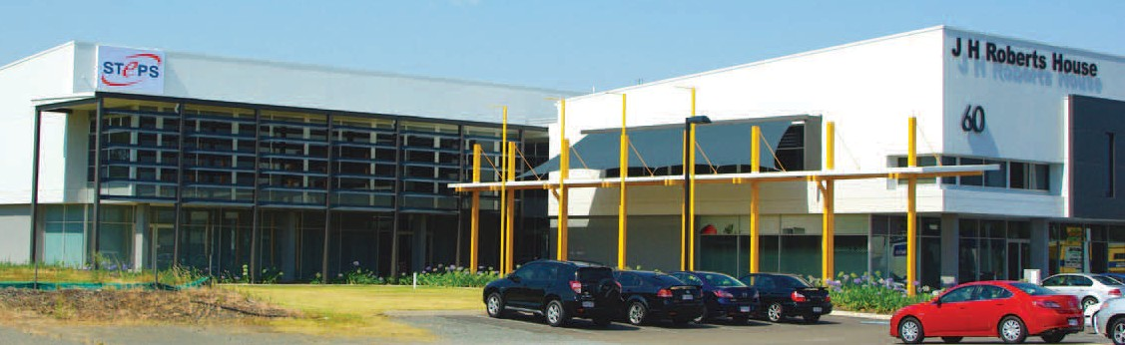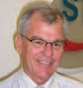
COO’s Report

7

Leading health provider partners with STEPS
Case Study | Healthscope

Since the recent formation of a partnership between STEPS Training and a leading private healthcare provider Healthscope Community Programs in Darwin, workers in disability services are staying one step ahead of the game.
8
New government legislation will make it compulsory for disability service workers to have completed a Certificate IV in disability services by 2012 in order to work in their fields. This partnership has already made great strides to getting staff members to the level required.
The Northern Territory regional coordinator of Healthscope Community Programs (a division of Healthscope Ltd) Liz Taylor was the catalyst behind the decision to make an early move to upskill existing staff working in the care of disabled people, and she contacted STEPS Training about providing training.
“Liz rang the office looking for ideas regarding basic training and upskilling for her staff. She was working with a new team who were providing community services in Darwin via Healthscope,” says David Sheasby, a STEPS Training trainer who works
with Healthscope staff to help them gain the Certificate IV qualifications.
“Liz manages a group of staff who work in services for people with a disability and we introduced her to a range of courses that we provide. We discussed the Productivity Places Program with her, which is a government initiative to have people upskill and prepare them to work in the disability sector.”
The first group of seven Healthscope staff began the certificate shortly before Christmas last year and are now nearing completion of the course, with two of the units provided by STEPS Training.
In addition to the assistance with the specifics of the qualification, STEPS Training provides Healthscope staff with support on a weekly basis, and that extra help was the key behind Liz’s decision to contact STEPS Training in the first place.

“STEPS Training have been wonderful in helping us achieve our goals and helping me support my staff”

“We were looking at providing further education internally to keep up to date with skills and experiences needed in the work space,” she said. “We were searching for local training services in Darwin when one of the staff members found an ad about STEPS Training and their training in the local paper.
“When we called David, he came out to the house and discussed the different options of training courses we could do. STEPS Training have been wonderful in helping us achieve our goals and helping me support my staff.”
Liz says her staff in Darwin are working with many patients with early stage dementia, which requires staff to be upskilled in this area.
With increasing numbers of residents with a disability admitted to Healthscope Community Programs residential services, the new skills learned through the Certificate IV in Disability Services are more important than ever to Healthscope and that means the
assistance and support provided by STEPS Training is also of huge importance.
“David has been wonderful and very supportive,” Liz says. “I think he has helped my team get through this and also made this appropriate to our day-to-day work schedule. We also have been able to receive one-on-one support that I believe has made this a lot easier. We know we are very lucky as a team to be able to receive this assistance.”
The next step for Healthscope and its relationship with STEPS Training is to continue putting staff through the government- subsidised Certificate IV qualification and remain ahead of the required standards as determined by the government.
Liz is also looking to do further training through STEPS Training and that is something David and his team are only too happy to help with.
“We work with their work schedules and tailor courses to what they will need in their practical working life,” he says. “We have three trainers who are training up to 120 people and we will have another 33 students in two weeks.”

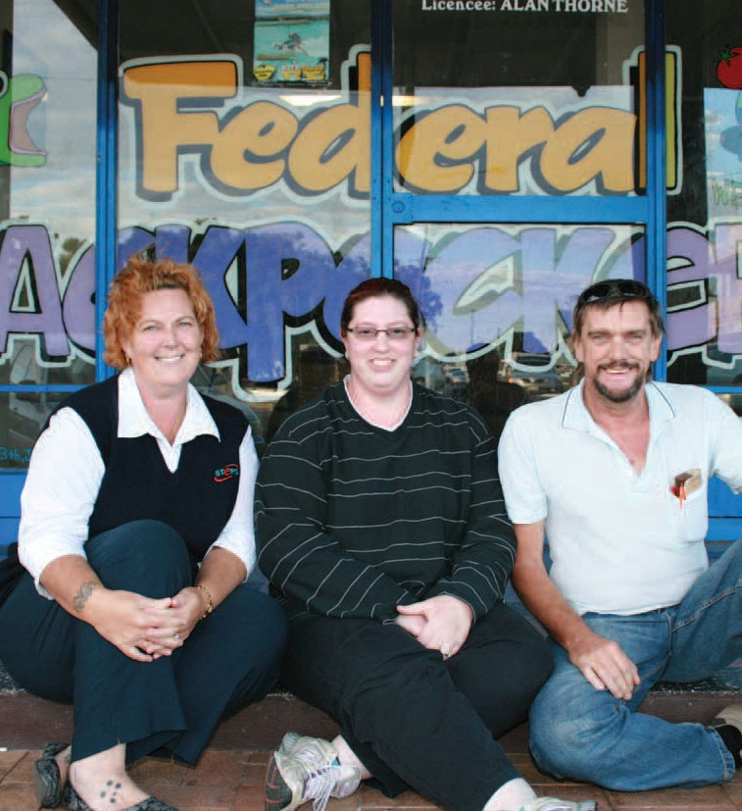
Employment
Services
In this its 21st year, STEPS made significant advances in its vision to become a leading national provider of
employment services.
9

From left: Kathy Zarins (STEPS Bundaberg), Belinda Harlick (Federal Backpackers), and Tony Gahan (Federal Backpackers).
STEPS sucessfully helped Tony to secure a bus driving position which has proven ideal for the 53-year-old, who previously struggled to gain employment due to a spinal injury.

Recommendations from employers
Employment Services
“I strongly believe helping and working with groups like STEPS is more about doing the right thing in the community. We’ve had great support from STEPS, and the team are so keen to take Matthew under their wing and ensure it all works out. STEPS are a fantastic organisation and are fantastic to work with.”
“I am very happy with the staff that I have received from STEPS. They seem to have a positive approach to their job because they really want to work”.
In a year of such change, credit for STEPS’ ongoing success must go to all those who showed such adaptability and commitment to the central focus of our work. So many people contribute – so many
STEPS’ staff and our external stakeholders such as DEEWR, employers and our business partners. The next 12 months promises a period
of consolidation and a continuation of successfully helping people to achieve their goals and aspirations.

From participants
“I had an appointment with you today - please accept this (card) as a token of my appreciation. You were so lovely to me and made me realise I can’t do this on my own. Hopefully I should be on the road to recovery.”
“The people at STEPS were supportive and encouraging in helping me find work. I appreciate the professional service and the integrity in the staff.”
“I found the staff at STEPS gave me more emotional support than I imagined. It gave me the courage to leave my problems and attempt to get my life back on track. I would never have been so brave as to take this huge step without your belief in me. I thank you with all my heart.”
I am very grateful for the opportunity to be part of the STEPS program. It’s made the difference and it gives me hope in the simple knowing that STEPS is there to help me if I need a hand.
“Everyone has been very supportive. I have been very anxious and everyone has put me at ease.”

17-year-old Winnie Mudiman (pictured) has been
10 taking part in a school-based traineeship with the support of STEPS Bundaberg

Employment overview
Employment Services | Overview

This financial year ushered in new programs, new sites and innovation in the delivery of services, and through a new service model, ensuring that an individualised, personal approach to
The previous ‘capped’ and ‘uncapped’ programs were replaced with Disability Management Service (DMS) and Employment Support Service (ESS) programs.
new position descriptions were developed to function within the model. Staff training was undertaken to assist the transition from one contract to the other.

service quality remains preeminent.
Previous roles were adjusted to reflect those outlined in the tender

The aftershocks of the ‘global financial crisis’ led to a continual decline in employment opportunities in some regions, making it more difficult for those with a disability to find sustainable employment. Ongoing support in the workplace and other
government assistance such as workplace modifications remain a crucial point-of-difference in the job market.
Despite the difficulties, and through all the changes, STEPS continued to assist individuals overcome barriers and realise their potential to live more full and meaningful lives through employment.
Much of the year’s focus revolved around the new Disability Employment Service (DES) contract (2010-2012). From June through to September, employment staff from across the organisation contributed to the significant effort of writing and compiling the tender bids. All staff involved in the process made significant contributions, whether they were ‘subject matter experts’, ‘editors’ or ‘solutions architects’.
Throughout the bidding process, STEPS maintained strong performance, reflected in DEEWR’s unpublished STAR Ratings for the period up to December 2009. In the uncapped stream all sites retained a rating over 3.5, with Townsville site at one stage enjoying a five-star rating. In the capped stream, all but one site retained or improved on previous STAR ratings.
In late 2009, Department of Education, Employment and Workplace Relations (DEEWR) advised STEPS that due to its strong performance, the organisation had retained the DES contract in all existing six regions through an “invitation to treat”.
Employment staff’s commitment to the vision of the organisation is to be commended,
facing the inevitable challenges that come with change and growth

ESS, for jobseekers with permanent disability and with an assessed need for more long-term, regular support in the workplace represented a continuation of previous service delivery, however with a range of amendments. This service was transitioned across all STEPS sites, and the new region around Tennant Creek was added.
DEEWR awarded STEPS DMS contracts on the Sunshine Coast and Tennant Creek.
Due to changes in the DEEWR’s Employment Service Areas (ESAs) STEPS was given the opportunity to establish a new full-time site in Mackay. Services were also extended in existing ESAs with
a new annexe site established in Cannonvale (servicing mostly participants from Proserpine), and previous part-time sites at Ayr, Noosa and Maleny extending to full-time. Also, two sites in
Townsville were merged and moved into a bigger, new location in Aitkenvale.
The new DES contract brought a range of changes, including different compliance requirements. In addition, STEPS introduced a new service model based on a “person centred approach”, and
bid, with the new roles of Employer Engagement Consultants, Community Engagement Representatives and Employment Pathway Mentors being filled mostly internally.
Due to DEEWR removing the restrictions on enrolment numbers in ESS (uncapped the program), numbers of participants across the organisation rose significantly after the new contract began. The new organisational strategy to integrate services – employment, training and other community programs at each site – began to unfold.
To assist in the change, Area Managers were appointed for South-East Queensland, Northern Queensland and the Northern
Territory, and Team Leaders for Employment staff were appointed at each established site.
STEPS’ Graduate Program, a professional placement service for graduates with a disability, based on the Sunshine Coast, continued to flourish.
STEPS continuing commitment to providing a quality service to both participants and employers is reflected in some of the feedback received throughout the year.
In a year of such change, credit for STEPS’ ongoing success must go to all those who showed such adaptability and commitment
to the central focus of our work. So many people contribute – so many STEPS’ staff and our external stakeholders such as DEEWR, employers and our business partners. The next 12 months promises a period of consolidation and a continuation of
successfully helping people to achieve their goals and aspirations.

11

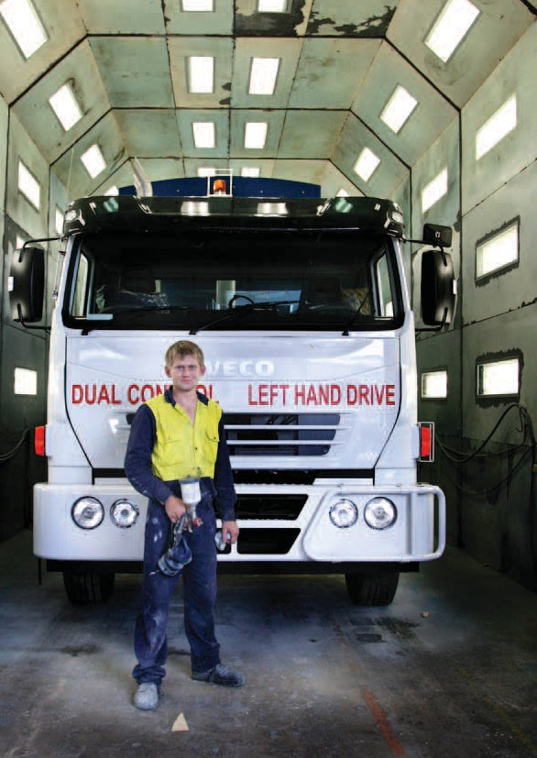

Small changes open big doors
Employment Services | Case Study

Thanks to the support from STEPS, Scott Adby has a safer and more accessible workplace.
Scott’s employer, Superior Pak, received Job Access funding as a result of applications made by STEPS on their behalf.
“I have been legally deaf since I was three years old after I contracted HIB meningitis,” Scott said.
The 22-year-old is trade qualified and is currently working as a spray painter with Superior Pak, a manufacturer of waste management equipment in North Bundaberg.
While Scott’s skills were enough to qualify him to do the work, his hearing disability would have presented a few problems in the workplace without the modifications made by Superior Pak through the Job Access funding.
Paul contacted STEPS to seek assistance with an application for funding from Job Access and was awarded close to $20,000 to spend on workplace improvements.
“They have installed movement sensors on a number of the doorways where forklifts are used and I wear a wrist-watch-like device with an in-built vibrator and flashing light that is connected to the fire alarm,” Scott said.
In addition, Superior Pak staff undertook Auslan Language training so they could communicate more effectively with Scott.

12

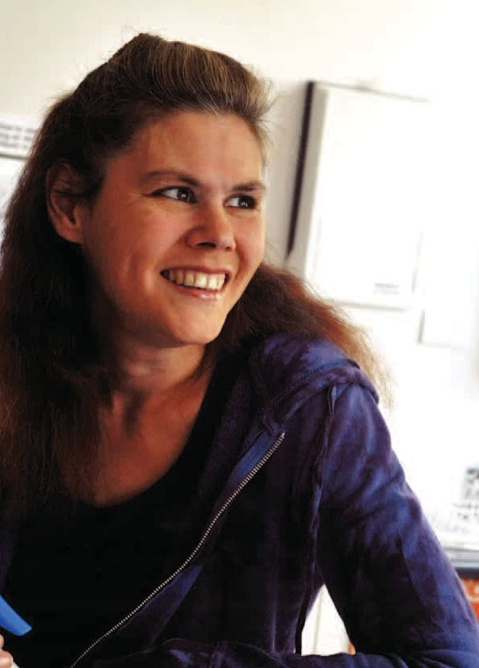
13

Battlers set up in life through partnerships
Employment Services | Case Study

TWO-years-ago, Sari Anderson (left) didn’t want to continue living.
After living with a number of mental illnesses for most of her life and going through a dark period that really set her back, Sari just didn’t know what to do to stop herself from sinking further and further into depression.
It wasn’t until she connected with STEPS Disability Mental Health Advisor Liza Scriven, through the Sunshine Coast based LinkIn program, that things began to take a different track for Sari.
Liza began working with Sari to create stepping stones to finding employment. After working with Sari and helping her through a number of personal issues, Liza found her work last year as a cleaner for a local office block.
“Liza has been amazing,” Sari said. “I remember when she called me to tell me she had found the cleaning job. I was not sure I could do it. But she was great and so supportive.
“She even took me to work at 6am on my first day and stayed with me while I worked to just check I was ok.
“She stayed with me as long as I needed and until I was confident I could do it,” Sari said.
“STEPS have been great support. They gave me a real purpose and a reason to get out of bed in the morning. They really gave me a chance to re-enter the real world.”
STEPS has been able to provide Sari with appropriate support through a partnership and program with Mental Health Service, Southern Cluster, Sunshine Coast Wide Bay Health Services District, which came into effect in February 2009.
Mental Health Service, Southern Cluster, Sunshine Coast Wide Bay Health Services District’s occupational therapist, Elise Hampton, said the integration of the employment consultant with the support team had proven very successful.
“Sourcing employment has proven to be a very powerful and successful treatment for people with mental illnesses,””Elise said. “We have seen many case studies of people who are really going forward thanks to this program.
“The ability to work - what many of us take for granted – provides and installs in people self worth and empowerment to be able to look after yourself. It’s about basic human rights,” Elise said.

Mental Health - Centre of Excellence
Mental Health Centre of Excellence

STEPS is pleased to announce the launch of its Mental Health Centre of Excellence.
The Centre will be responsible for the up-skilling of STEPS employment staff and introducing a “best practice” model to ensure STEPS delivers the best service possible to those participants living with mental illness.
The launch of the Centre follows the successful “Sunshine Coast Integrated Employment Project” run on the Sunshine Coast, a partnership between STEPS and Queensland Health on the Sunshine Coast.
The project involved co-locating a psychiatric-specific employment consultant within two mental health units to be part of treating teams. During the course of the project, STEPS’ Nambour site was found to be the highest performing employment service provider, and commended for their proactive approach to empowering people living with severe mental illness access employment and educational goals.
Since the finalisation of the formal project, the relationship between STEPS and Queensland Health continues to strength, with three co-located psychiatric specific Employment Pathway Mentors now working with Queensland Health.
Similar agreements have been formalised in Wide Bay, opening the door for a similar service in Hervey Bay, Maryborough and rural Bundaberg. Expressions of interests to work in other regional areas where STEPS runs disability employment services have been successful.
Nikki de Jonge, STEPS’ longest serving staff member, has been appointed STEPS Mental Health Service Manager.
“STEPS acknowledge that in excess of 50% of our current clients have identified as having a mental illness or impairment,” said Nikki. “We also recognise that in order to give our clients the best service possible, it’s essential that we up-skill the organisation.”

14

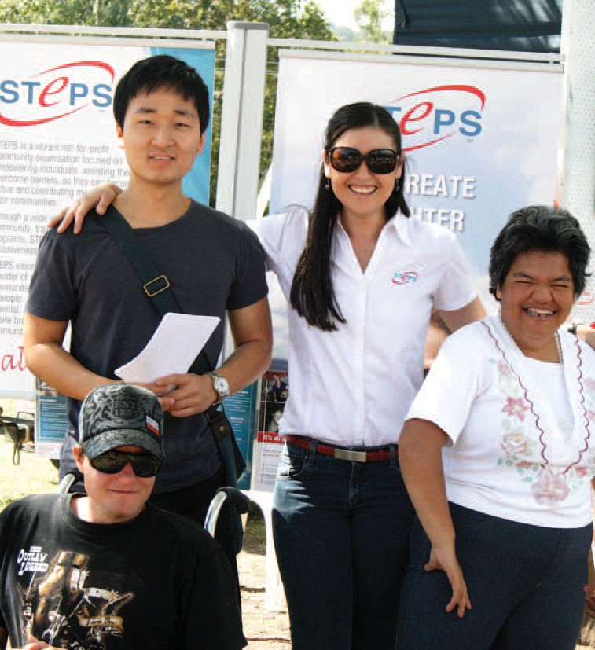

Community Programs

The scope of community programs offered through STEPS continued to broaden and expand throughout this financial year.
From young people, to the more mature, from the ocean to the outback, STEPS’ services touch many different people groups in
many ways.
Strengthening communities is a challenge. The common thread through all STEPS’ community programs is that regardless of the problem or challenge at hand, recognising and nurturing the value of individuals, one person at a time, will always bring
positive change.
Through a new integrated approach to STEPS service delivery, looking for commonalities between employment, training, community programs and social ventures, the potential effectiveness of community programs increased.
The merger with CADET mid-year brought new programs together with the personal expertise of those responsible for service management and delivery. These programs included Civil Skills, Participate in Prosperity, and the Indigenous
Employment Program.
The strategic plan for community programs in the future will target nationally identified priority areas of youth, age care, mental health and disability. Through STEPS’ expanding network, leveraging internal knowledge and community consultation, STEPS will continue to develop and deliver services that are responsive to local community needs.

A STEPS community event 15

Care for Carers
Community Programs | Care for Carers
Carers are relatives or friends who are caring for people with disabilities, mental illness/disorder, chronic illness or who are frail.
The role of a carer can be challenging, balancing the demands of one’s own life with that of caring for another.
STEPS’ Care for Carers program in the Bundaberg/Wide Bay region is providing proactive support to carers in their demanding role.
Through funding from the Department of Communities, through the Home and Community (HACC) Program, STEPS launched Care for Carers in late 2009.
The program offers services across the Wide Bay region, including Bundaberg, North and South Burnett and Fraser Coast, to support carers and improve their quality of life.
Among services offered through the program is advice and counselling, support and education, and above all else, permission to have a break.
Only several months after starting the program achieved a significant milestone by setting up peer support and weekly individual counselling sessions in Bundaberg, Gin Gin, Maryborough and Hervey Bay.
Program coordinators have received much positive feedback, and increasing amount of referrals mostly through word of mouth.
Clients have preferred one-on-one and face-to-face service provision, as well as phone and group support. Social outings are in the pipeline.
The Care for Carers Program is a joint Federal and State funded program funded through Home and Community Care (HACC), and seeks to alleviate premature admittance into residential care for care recipients.

16

Civil Skills Program
Community Programs | Civil Skills Program

Focused on providing local jobs for local people, STEPS’ Civil Skills Project (SCSP) is a partnership between STEPS, Sunshine Coast TAFE and industry partners.
The aim of SCSP is to provide opportunities for over 160 job seekers to secure employment in the civil construction industry. The project offers jobseekers training specifically identified by the industry as providing the minimum set of skills required to be ‘job ready’.
SCSP is fully supported with training, training material, personal protection clothing and transport at no cost to participants, and opportunity for work experience with industry leaders.
During 2009-2010 SCSP recruited and trained job seekers from non-traditional labour sources such as disadvantaged youth, mature-aged people, and the long-term unemployed including Indigenous Australians, ex-offenders and migrant Australians.
Despite a long rainy season which reduced the availability of some work experience, three courses were completed between February and July, with almost 60 jobseekers taking part, and over half now employed in the civil construction industry. (refer to table below)
Job Services Australia agencies and jobseekers both gave favourable feedback about the project, confirming the need for civil construction training on the Sunshine Coast. Waiting lists have filled mainly through favourable word-of-mouth.
Special thanks go to industry partners, Shadforths Civil Contractors at Forest Glen, where many trainees have undertaken two weeks’ work experience, with most acquiring work after that period. Many other Sunshine Coast civil contractors have also joining the program as industry partners.
With four more courses planned until the end of 2010, and further intakes in 2011, the project is well on the way to becoming the leading program for supplying accredited trainees to the Sunshine Coast civil construction industry.
SCSP is a funded initiative of Federal Government’s Job Fund “Get Communities Working” initiative, developed in response to the Government’s $18 billion investment in infrastructure,
including $500 million earmarked for the Sunshine Coast region.

17
 | Commenced | Completed | Job outcome
Course 1 | 20 | 17 | 13
Course 2 | 18 | 12 | 6
Course 3 | 20 | 18 | 12
Table 1. Participant Numbers for 2010 Civil Skills Project - Sunshine Coast

Disability Services
Community Programs | Disability Services, Indigenous Dementia Awareness
Indigenous Dementia Awareness

STEPS Disability Services in the Gin Gin and North Burnett provides a range of services to support people with a disability including In-Home Respite, Home Respite and Community Access, and Post School Services.
The client, carer and in some instances entire families continue to receive benefits from STEPS services. For example, through In-Home Respite, STEPS provides support workers who come into the home and assist with activities, giving the care-giver an interval of rest.
Through the support of Government, and the dedication of staff who go the extra mile, the service continues to be a valuable contributor to the local community, and earning a number of commendations from the audit in late 2009.
Through support offered to clients, assisting them to overcome barriers and regain confidence, a number of clients exited
the program during this year and are thriving in their chosen vocations.
For example, a client who 18 months prior showed suicidal tendencies is now in full-time employment. Through the right program, a nurturing support worker and the correct professional support, this client developed greater resilience, and regained people handling skills. As a result, the client
began to communicate, integrate and participate in the wider community – previously a huge hurdle.

STEPS successful Dementia Project in Gin Gin provided care and education services, informing community members about dementia symptoms and care in a culturally appropriate way.
Attendance to dementia activities and field trips captured a 90% attendance rate, and feedback from participants showed overwhelming support.
Although funding for the program finished in February 2009, participants presented strong reasons for the program to continue.
Queensland Health offered to continue the program on a monthly basis and is now in collaboration with STEPS’ volunteer staff and a local community group to continue outworking the project’s objectives, including increasing its scope to include all the Gin Gin community.

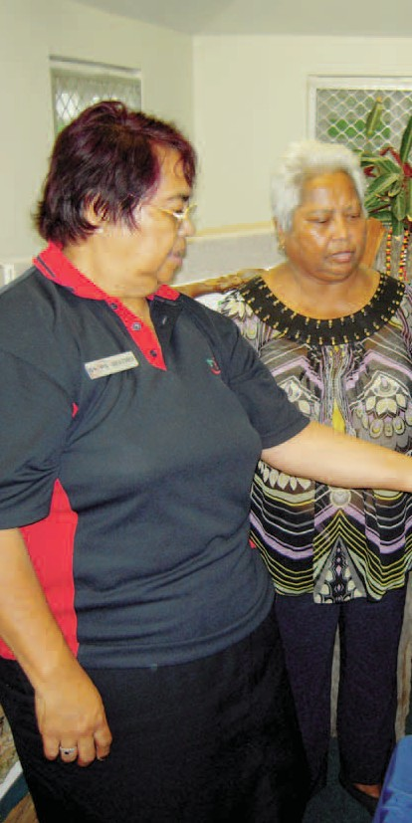

18 STEPS is actively involved in the Gin Gin community

19

Interactive Arts Centre
Community Programs | Interactive Arts Centre

The 60-odd Indigenous folk who regularly attend STEPS’ Interactive Art Centre in Alice Springs come from a number of Central Australian and Alice Springs Communities, but all have a common interest in art.
The artists come together at the Centre, not only to paint, but to be trained in life skills that will ultimately give them greater independence.
Every day is different at the Centre. One day the artists may be working on a canvas, the next day learning how to read a recipe and planning a trip to the shopping centre to buy ingredients.
The Interactive Art Centre is one of 33 employment and training projects around Australia funded by the first round of Jobs Australia’s Innovation Fund.
Located in a tourist precinct next to the Alice Springs Reptile Centre and across from the Royal Flying Doctor Service Visitor Centre, the Pioneer Women’s Hall of Fame and the Old Gaol, the centre is in a prime location for visitors to interact with the artists.
The centre is serving as a training facility, skilling the participants in numeracy, literacy and various life skills to communicate well in the Art Centre with the visitors, and with their everyday needs on route to becoming independent in the Alice Springs community.
Participants’ lives have also been enhanced through gaining exposure to different services around town, including going to the hairdresser and undertaking money management skill development. Some have gone on to become students at Charles Darwin University in Certificate II in Visual Arts and Contemporary Craft.
In the future, when the centre opens to the general public and tourists, the artists will be given the chance to sell their artwork, and some will give hands-on Indigenous art lessons. A bush tucker garden is also planned for the centre so people can understand what the artists are painting.

“Damper seed Dreaming” by Shirley Kaditja Painted at the Interactive Arts Centre NT

Multicultural Project
Community Programs | Multicultural Project

This project uncovered and promoted the rich cultural diversity in the Gin Gin/Mount Perry region. STEPS’ staff brought together a number of community groups to underline the richness of diversity in the region, and the benefits in working together.
Community Group ‘chit-chats’ were well attended and a wide variety of contributors stepped forward to display various symbols and wares at a successful multicultural festival.
Due to the success of the project and the input received from community groups that wish to remain viable stakeholders in future programs undertaken by STEPS, the search for funding continues to extend the program.

20 Photo caption / credit here

National Disability Co-ordination Officer Program (NDCO)
Community Programs | NDCO

Through a commitment to innovation, information sharing and forging strong links with stakeholders, STEPS’ National
Disability Coordinator Officers (NDCOs) continue to build on past developments and momentum.
With the two regions (20 and 22) covering 70% of Queensland, STEPS NDCOs have called upon a number of resources and concepts to outwork the program’s objectives of building links between the education, training and employment sectors so that people with a disability have assistance at all levels.
The influence of the successes within Regions 20 and 22 have spread far and wide, with other NDCO regions and service providers around the nation making use of some of the resources developed.
Previous initiatives were strengthened and new projects started
– all looking to improve transitions, increase participation and establish better links. During this period, a total of 47 projects were completed across both regions. Some of the most significant are listed below.
Laptop Giveaway
NDCO partnered with Hewlett Packard Australia in a promotion that spanned the disability officers at all universities, TAFE campuses across the two regions.
Through offering students four prizes of new HP laptops, installed with software for their studies, the project aimed to gain valuable data and support the objectives of the NDCO program.
Over 100 applicants took part in the promotion, answering a questionnaire on the benefits of continued education, the support received through disability supports, and information future students should know about.
Through the project the NDCO and its services gained improved recognition among the institutions, and also raised awareness of
reasons for disability disclosure and contact with disability support staff. The four winners will provide on-going contact with NDCO to assist in building the bank of case study material collected throughout the project.
Due to its success, a similar project will be held across all NDCO regions in the State during 2010.
Mental Health Information Expo
In response to an increased demand for mental health services in the community, an expo attended by representatives across the education, training and employment sectors was held on the Sunshine Coast during Mental Health Week 2009.
Representatives were given an opportunity to establish a first point of contact with Queensland Health, establish networks, share information and collaborate to find solutions to often difficult situations.
The expo sought to highlight positive work practices, improve linkages between specialists and service providers and reduce the stigma and stereotyping often linked to mental health. A powerful presentation delivered by a person who had lived through the journey highlighted both problems and solutions.
The expo proved to be a launching pad for other activities and strategies focused around mental health issues, and the momentum continues to build.
Steps for the future game
In a bid to communicate more effectively with students with disabilities, NDCO Region 22 joined forces with a group of multimedia game development students from James Cook University (JCU) to create an interactive computer game called Steps for the Future.
Funded by the Federal government, the game uses a futuristic storyline with information about the wide array of post-school
options and support available to students with disabilities embedded.
Much more than a source of information and entertainment, Steps for the Future has proven to be an amazing door opener. The game opened doors to organisations previously shut to NDCO approaches, and at expos, information events and school visits, the game attracted the attention of many young people and assisted in engaging them in conversation.
NDCO Regions 20 and 22 have distributed over 1500 copies of the game in response to email requests and after meeting with students at expos and careers events. Over 500 of these have gone to service providers with full reproductive rights and instructions how to make duplicate copies of the game.
Copies have also been distributed through All NDCOs across Australia, and DEEWR have reproduced a further 2500 copies of the game for national distribution, and Email addresses of all game recipients have been recorded for future follow-up.
At best estimate, currently between 5000 and 6000 of STEPS for the Future have been distributed across Australia, and the video trailer has been viewed on YouTube has been viewed over 1000 times. Following publicity of the game across various channels, traffic to the NDCO website increased in March to almost 35,000, an increase of 75%.
Teachers and disability support staff have welcomed Steps for the Future, allowing them to build their own discussion topics around events in the game and relate them to today’s issues and solutions.

21

Protect Your Head
Community Programs | Protect Your Head, Participate in Prosperity
Targeting the Bundaberg, Childers and Gin Gin communities, Protect Your Head makes the unlikely connection between the condition of dementia and youth.
The program is designed to raise awareness about dementia in the community, support early intervention and encourage
improvement of services for people with dementia, their families and carers.
Subject matter includes sports injuries, drugs and alcohol, healthy living and exercising the brain.
Attendance of public gatherings and the numbers of people viewing public forum information has underlined the need for the program. Well over 1000 written responses from various program communications has been received.
Shock tactics, for example showing advertising from Main Roads, has received the greatest response.
The program goes from strength to strength, with plans underway to approach primary schools to promote the prevention of head injuries through education, and to promote community engagement through trivia nights.

Participate in Prosperity
STEPS offers Participate in Prosperity (PiP) in Caboolture. The program, which last year supported 120 people, assists clients in overcoming barriers to employment and training.
The PiP strategy is to identify key communities and population groups who are largely locked out of the labour force, and address increased workplace participation and sustainability of employment for individuals and families with barriers.
The assistance offered by PiP can stretch from anything to helping with obtaining documentation such as birth certificates, working with legal aid, sourcing accommodation to providing fuel vouchers so clients can make job interviews.
Each case, and the program’s level of assistance are dependent on each individual client. Assistance can be given for up to 18 months.
Funded through the State Government’s Skilling Queenslanders for Work initiative, the program works alongside a number of community organisations, state and federal agencies.

22 Protect Your Head program seeks to connect with youth

Workplace Assessors
Community Programs | Workplace Assessors

STEPS Community Services provide Assessment Services for participants of other DES businesses and for employer’s who have employee’s who are not assisted by a DES – the assessments form an integral part of an individual’s pathway to success in the workplace.
- From July 1, 2009 to February 28, 2010, STEPS assessors provided Assessment Services for Supported Wage and Workplace Modifications only.
- As of March 1, 2010 STEPS actioned its new contract to provide National assessment Services to include Ongoing Support assessments as well.
STEPS now has a National Panel of Assessors (NPA) and through market share of all ESAs in Australia, STEPS conducts National Supported Wage (SWSA), Workplace Modifications (EAP) and Ongoing support (OSA), assessments.
This National assessment contract has seen the total number of assessments increase dramatically – tripled, when this four month period is compared to the previous eight months total, with NPA staff conducting assessments in all states and territories.
Assessment services are provided to industries including hospitality, retail, transport / motoring, government / local council, private business administration, banking, emergency services, child care, agriculture / horticulture, aged care and cleaning.
STEPS assessors have received a variety of extremely positive and professional comments from Disability Employment Service providers, participants, employers, JobAccess, Supported Wage Management Unit and OSA contract managers. As well, other
feedback to assist improvement has been welcomed and acted upon enthusiastically.

Supported Wage System
The Supported Wage System funds Workplace Assessors to determine the productivity of an employee in a workplace by measuring their productivity achievements against a co-worker who is skilled to do the same job - recording replicable detail is also a valid part of the process. An initial assessment takes place soon after employment commences and thereafter on a yearly basis, unless circumstances change and an interim assessment is requested.
The objective of the assessment is to establish a fair, formal and legally binding agreement that reflects a minimum acceptable productivity level and wage rate, together with a written report detailing task actions.
- Between July 1, 2009 and February 28, 2010, (8 months),STEPS assessors completed 77 SWS assessments in Queensland.
- From March 1, 2010 to June 30, 2010, (4 months), STEPS NPAs completed 68 SWS assessments in Australia.

Employment Assistance Scheme – Workplace Modifications
The Employment Assistance Scheme funds physical or environmental workplace adjustments or specific items of equipment that reduce barriers to employment and can increase productivity, do improve circumstances and personal satisfaction
and do enhance career paths for workers with a disability.
- Between July 1, 2009 and February 2010, (8 months), STEPS assessors completed 14 WPM assessments in Queensland.
- From March 1, 2010 to June 30, 2010, (4 months), STEPS NPAs completed 8 WPM assessments in Australia .

Ongoing Support Assessments
Ongoing Support Assessments are conducted to determine a funding level of support a DES will need to provide for a person in a workplace and / or an employer needs, to ensure that person
is not only successful in their employment, but stands highest chance of maximizing their potential.
Parties to the employment are interviewed and together with evidenced documentation of support, information is gathered and evaluated to determine an appropriate level of future support.
Reports are written for all components of the assessment and a level of future support recommended.
- From March 1, 2010 to June 30, 2010, (4 months), STEPS NPAs completed 198 OSA assessments in Australia.
Note: The numbers of assessments indicated for the 4 month period 1 March, 2010 to 30 June, 2010 above, refers to completed assessments – there are a number of other
assessments accepted by STEPS during that period, but due to their complexity, are yet to be finalised.

23

Youth Connections
Community Programs | Youth Connections

Youth Connections is a program that helps young people overcome barriers such as personal, social or educational problems so they can complete their education, access training or find employment that is right for them.
STEPS offers Youth Connections in two regions within the Northern Territory – McDonnell and Alice Springs (NT05) and the Central Desert and Barkly region (NT04). Previously STEPS offered the similar program of Youth Pathways in these regions.
Despite multiple challenges, the total number of young people registered with the program more than doubled throughout the year to close to 130. STEPS continues to work collaboratively with other organisations and Warlpiri Youth Development Aboriginal Corporation (WYDAC) as partners to achieve program outcomes.
Initially, the Youth Connections Program was received cautiously by individual youths at risk, especially those living in remote communities. However, as STEPS youth workers gained their trust, interest and support for the program from community members increased.
Cultural barriers and the vast distances involvement in delivering the program proved to be consistent challenges throughout the year.
It was therefore essential for STEPS to establish rapport with trusted community elders, significant sports figures and other respected community members and peers who could reinforce the benefits
of the program. Their assistance enabled STEPS youth workers to gradually build credibility based on action rather than words.
Taking a holistic approach to engaging the youth, seven key elements were identified as necessarily to keep students engaged in mainstream education. These elements included a connection to family members and stable accommodation, a stable personal income, and other elements that many in cities and towns around Australian take for granted.
Santa Teresa, an indigenous community of about 300 people 100 kms from Alice Springs, and accessible by an often flooded dirt road, presents a case study of the possible effectiveness of the Youth Connections program.
Working closely with one of the Brothers from Marist Brothers School, STEPS’ Youth Pathways officers developed a strong relationship with the Santa Teresa community. Gradually they gained the trust of students who were seriously at risk of disengaging from education and training.
Initially STEPS’ officers drove through the community, waking up young people in the middle of the day to take them to school.
Gradually some of these young people reengaged with the school and their teacher.
Eventually, at the beginning of 2010 nine young indigenous men boarded a bus to attend two boarding schools in Adelaide with the blessing of their parents and community.
STEPS continues to work with disengaged youth to empower them through training and education.

24

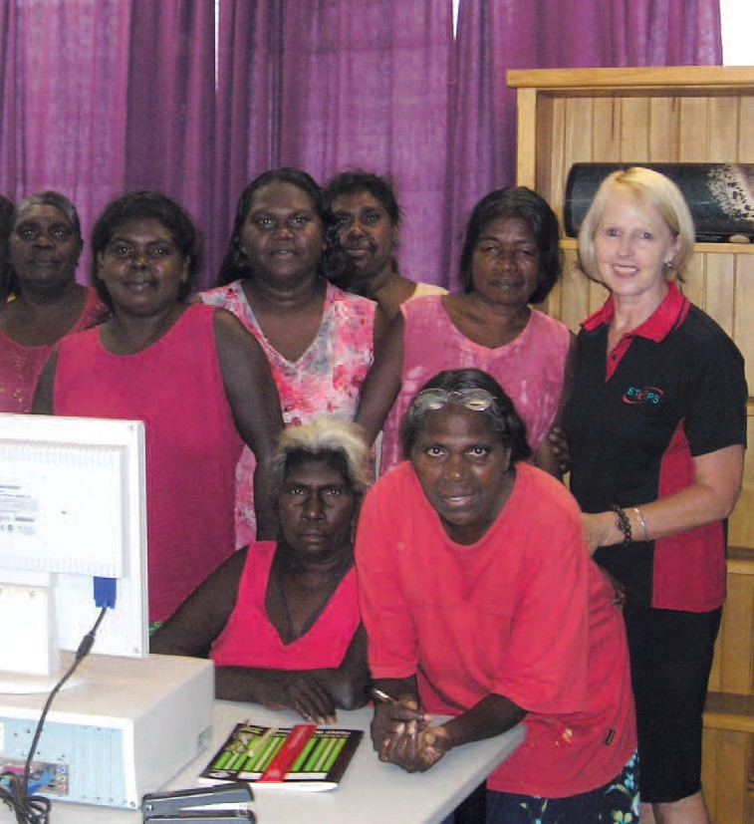
Training
After a year of rapid expansion in 2008-2009, STEPS Training
continued to grow throughout the Northern Territory.
It is remarkable to ponder that what started as a small Registered Training Organisation based on the Sunshine Coast is now influencing communities over such a broad
geographical reach.
With the number of training staff multiplying four-fold, the continued success of STEPS’ training programs in such remote regions is only made possible by the coordinated effort of many
people across the organisation.
With the future merger of CADET and STEPS, training will extend to fee for service, an International College, and Group Training.
25

Photo caption / credit here

Language, Literacy & Numeracy Program (LLNP)
Training | Language, Literacy & Numeracy

Alice Springs
26
STEPS Alice Springs operated both a men’s and women’s LLNP. The women’s program began operating out of the Interactive Art Centre (see page 19) since it opened in early 2010. LLNP also operated in Harts Range (Atitjere) and Hermannsburg.
Trainers have been using innovative ideas to engage the participants, such as cooking, and using recipe cards for literacy and measuring of ingredients for numeracy. These methods have been popular with participants, giving them easy cooking recipes that can be created in their own home.
One trainer in a remote community took his participants hunting, and used the animals and plant life as part of literacy, as they created an inventory of local foods.
Incorporating these innovative ideas into the participants’ lifestyle has increased engagement and given extra depth to the delivery of LLNP. With technology in many of the communities becoming increasingly available, trainers will soon start to include computers and the internet in the delivery of LLNP.

Tennant Creek
One of the success stories of STEPS’ Tennant Creek site since it was established in 2009 is the Language, Literacy and Numeracy Program, delivered by trainer Ron Ferguson.
While many people in remote areas of the Northern Territory have real barriers with literacy and numeracy but are reluctant to address those barriers, Ron achieved great results by working extremely closely with the community as a whole and more specifically with JSAs, Centrelink, the local drug and alcohol rehabilitation centre, aged care and child care facilities.
Ron structured his classes at times that suited the students and tailored classes around their schedules. For example, he arranged classes to suit the 16-hour week schedule of the Community Development Education Program students.
The attendees from a nursery could only manage two hours a day so Ron worked with them to create a class that allowed students to learn with minimal impact on their working lives. Ron continues to create and implement programs that suit individual needs while still achieving positive outcomes, with regular attendance of up to 30 students a week.

STEPS Training uses high quality, culturally engaging methods of training, delivered to urban and remote communities in Alice Springs, Tennant Creek (and surrounding areas) and the Top End

None of this would be successful without the excellent rapport Ron maintains with past and present students
“One student came to STEPS with the intent of gaining work for the night patrol once she could read well enough,” Ron said.
“After helping this student with her reading and her application it was a proud moment for us both when she was accepted for night patrol and she still works there.
“I use a variety of teaching ideas to keep my students interest, including Greek mythology and the medieval times to reinforce ideas.”
The success of the LLNP program at Tennant Creek is proof that STEPS’ aims and mission are as relevant in the remotest and most disadvantaged parts of our huge country as they are on the Sunshine Coast.
Northern Territory’s Top End
LLNP in Northern Territory’s Top End went from strength to strength in the past year. STEPS’ remote sites of Maningrida, Galiwinku and Milingimbi have continued to deliver LLNP and Workplace English Language and Literacy (WELL) programs to diverse groups in each community, from workers at local aged care facilities and the local Shire, through to those at the health clinics and arts centres.
Through a consistent approach to training and a commitment to remain visibility, STEPS’ trainers have built trust in their respective communities. The trainers have demonstrated how the programs can develop the skills and confidence of individuals, and as a result, many locals can see a pathway to full-time employment.
STEPS also began delivering training in the Groote Eyelandte and Nhulunbuy communities, where trainers will begin to deliver literacy and numeracy skills to as many people as possible, fostering the STEPS mission and Values throughout the Top End.
STEPS Training won the contracts to deliver LLNP to the greater Darwin area, Palmerston and Casuarina. Classes are growing daily and the only limit is how fast STEPS can recruit and induct new trainers.
A local indigenous drug and alcohol rehabilitation centre is benefiting from the LLN program, with STEPS Training delivering the course on site as part of the counselling schedule. The centre’s clients have many barriers to employment, however improving literacy and numeracy, and opening employment pathways is seen as a catalyst for overcoming other barriers and can go along way to building the clients back into the local
community. An educational excursion to Berry Springs Nature Park gave clients much to write about.

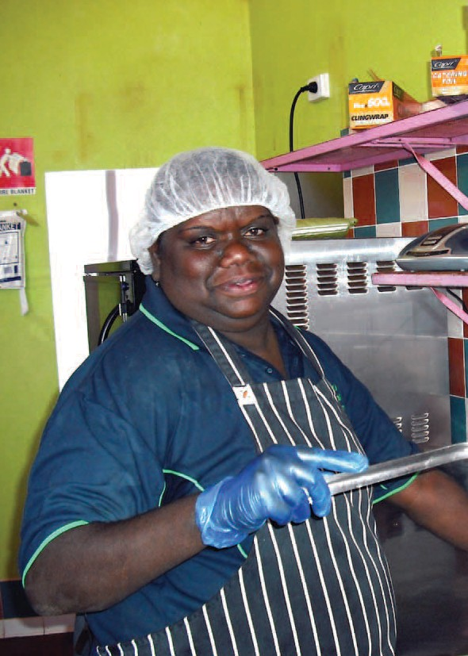
27

NT Community Aged Care Program
Training | NT Community Aged Care Program

Through funding from the Department of Health and Aging (DoHA), STEPS has successfully offered the NT Community Aged Care program in 14 Northern Territory communities.
Each remote community supports their elderly through existing services. This program attempts to come alongside existing community care to enhance the quality of life for frail older people, younger people with disabilities and their carers. It aims to prevent inappropriate or premature admission into long-term residential care.
So far the HACC program has delivered accredited training to over 35 students. Certificates issued include Certificate II in Community Services, Certificate III in Home and Community Care, and Certificate IV in Aged Care.
This program has been well received, with local delivery of training in remote communities, not without its challenges. With some parts of the Northern Territory receiving twice the expected annual rainfall (in excess of 500 mm), many trainers found themselves bogged getting to and from communities, and digging out themselves and others stuck fast in mud. In some instances trainers needed to charter flights to communities to achieve outcomes.

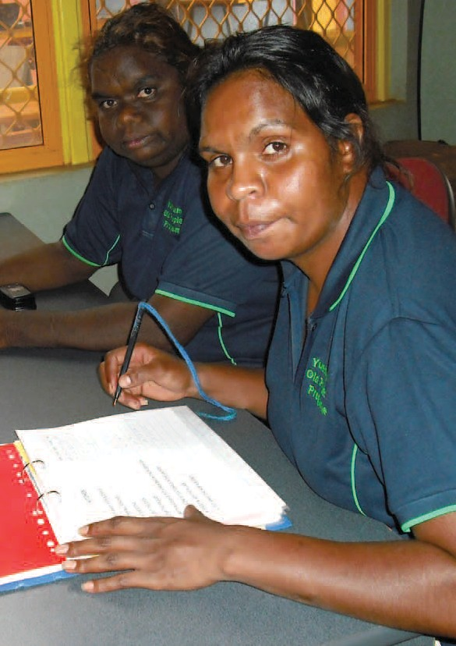

Productivity Places Program (PPP)
Training | Productivity Places Program

STEPS has delivered PPP in Darwin since October 2009. PPP is a Federal initiative, which in conjunction with registered training organisations (RTOs), assists both short and long term unemployed to gain the formal qualifications needed to re-enter the workforce.
Existing workers are also given the opportunity to complete a certificated course within the industry that they work, with the cost heavily subsidised by the Federal Government and a token payment by the employer or employee.
In Darwin, STEPS delivered Certificates in Community Service under the PPP scheme, ranging from Certificate II in Community Services to Certificate IV in Aged Care and Disability Work. Training is held over a 15 to 20 week period with assessments in both the theory and the practical areas of these certificates.
The vast majority (90%) of STEPS PPP students-job seeker places are from non-English speaking backgrounds, with most having spent time in refugee camps before relocating to Australia. They face unique challenges and barriers to entering the workforce. The remaining places are filled by long-term unemployed students who face their own barriers in an area where there are more jobs advertised than their people to fill them.
The training and support STEPS gives to these students is having a positive affect with most finding full time employment for the first time since arriving in Australia, or re-entering the workforce after many years. Employers have responded with great feedback, impressed with STEPS’ students’ knowledge and enthusiasm.
Previously, a certificate was not required to work in the Northern Territory’s community service sector, however a minimum of Certificate III will become mandatory for all staff in the sector by 2012. Currently STEPS is delivering Certificate III and IV training to existing workers in a number of prominent organisations, including Somerville Community Services (the main disability and community service provider in the NT), the Department of Health and Families, and Health Scope Community Services.
STEPS looks forward to continuous involvement with organisations in the Northern Territory, assisting them by supplying quality training to students who will become their future staff members.

28

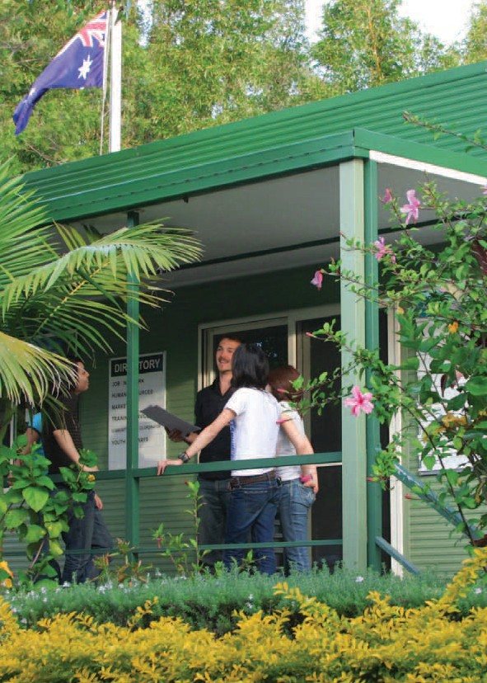
29

With the future merger of STEPS and CADET, STEPS training operations will extend to a domestic and international training college
Training | CADET Training and International College

Cadet Training College
The CADET Training College provides a variety of accredited training for trainees as well as short courses for all members of the community. Operations also include running funded courses, projects and fee for service.
The Training College offers flexible delivery options including evening classes, with trainers providing a high level of support and encouragement to students.

Cadet International College
The CADET International College offers international students quality training in an ideal study environment, with the location of the Sunshine Coast providing an attractive option for overseas students.

STEPS Scope of Registration
Training | Scope of Registration

(All within NSW, Qld, SA and NT)
30
BSB20107 Certificate II in Business

BSB40807 Certificate IV in Frontline Management CHC20108 Certificate II in Community Services CHC30108 Certificate III in Community Services Work CHC30208 Certificate III in Aged Care
CHC30308 Certificate III in Home and Community Care CHC30408 Certificate III in Disability
CHC40108 Certificate IV in Aged Care CHC40308 Certificate IV in Disability
CHC42008 Certificate IV in Employment Services SIR20207 Certificate II in Retail
SIR30207 Certificate III in Retail

SIT20207 Certificate II in Hospitality

Accredited courses (16)
21772VIC Certificate I in General Education for Adults 30625QLD Certificate I in Work Readiness
30719QLD Course in Adult Literacy and Numeracy 39150QLD Course in Vocational Literacy - Preliminary 39151QLD Course in Vocational Literacy 1 39152QLD Course in Vocational Literacy 2 39153QLD Course in Vocational Literacy 3
39160QLD Course in Vocational Numeracy - Preliminary 39161QLD Course in Vocational Numeracy 1 39162QLD Course in Vocational Numeracy 2 39163QLD Course in Vocational Numeracy 3
39170QLD Course in Pre-Training Assessment
(Vocational Literacy)
39171QLD Course in Pre-Training Assessment
(Vocational Numeracy)
39180QLD Course in Vocational Literacy - Contextualised 39181QLD Course in Vocational Numeracy - Contextualised 91421NSW Certificate I in Spoken and Written English

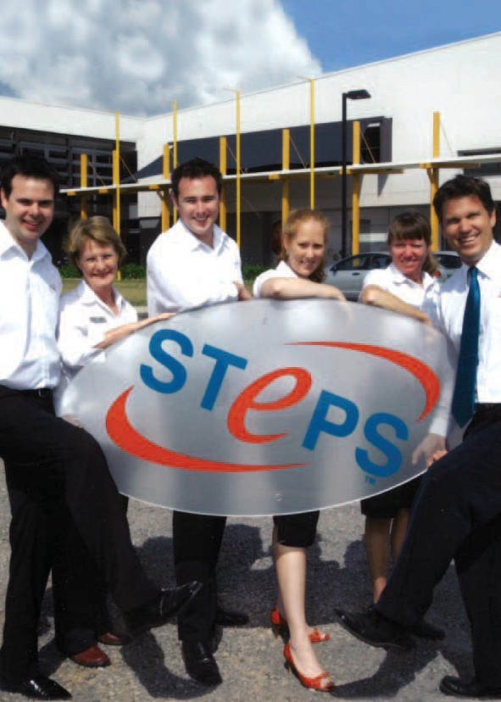

STEPS Central
STEPS Central delivers a wide range of corporate services to
support service delivery across the organisation, as well as facilitating continual growth and improvement through a business
excellence framework.

Business Development

The Business Development Unit was formed in May 2010 to develop new services in specific sectors including employment, training, community services and social venture enterprises to meet the strategic growth objectives of the organisation.
The BDU works across the organisation to identify and develop opportunities that increase and strengthen the range of services provided by STEPS and also to facilitate research and development initiatives in order to better service the communities we serve.
The BDU team are responsible for business development, partnerships, research, business intelligence and funding initiatives. It also provides communication, marketing and project support through our Marketing, New Ventures/Implementation functions.
The continued growth of the organisation are reflective of the commitment to develop and maintain viable alternative sources of revenue which will enable STEPS to confidently maintain and diversify its services.
Since coming together in May 2010, BDU has submitted 25 applications resulting in 11 successful tenders; three unsuccessful and 11 pending at the time of writing.
New business for the STEPS Group includes six Queensland State Government employment projects to be delivered in Townsville, Bundaberg, Caboolture and Caloundra; an Indigenous Employment Program in Hobart; and expansion of the LLNP Program into Cairns and Torres Strait.
The future objectives of the BDU include establishing a national footprint . As a successful
not-for-profit organisation that has successfully served the community for 21 years, STEPS Group has both the experience and the foundation to become a significant provider in the national marketplace.

31

Marketing and Communications
Central | Marketing and Communications

STEPS’ marketing and communications activities sought to build on the momentum of brand awareness started in the 2008-2009 period.
Significant diversification and growth of programs, together with geographical expansion brought challenges, but the objectives remained the same – to build the brand value of STEPS.
This year the focus of marketing and communications transferred from mass media campaigns to direct marketing, increased publicity and supporting local initiatives.
Throughout the course of the year, marketing and communications supported 18 programs (community, employment and training) together with managing organisational branding and marketing initiatives. This was assisted through key staff appointments.
With the addition of Employer Engagement Consultants and Community Engagement Representatives, the organisation gained an increased personal presence to not only raise its profile, but to better connect with critical external stakeholders. The marketing and communications department doubled with the appointment of a marketing assistant/graphic designer.
New programs, new regions and new types of media meant re-evaluation of past strategies, and indeed the identity of the
organisation. Planning began to re-evaluate the STEPS brand in the near future to ensure the structure of branding and marketing fits with the future strategy of the organisation. Watch this space.
Some key initiatives throughout this term included:
  - STEPS sponsored (together with St George Bank and Investa) the 2009 Sunshine Coast State of the Region Summit in November. The summit focused on key drivers for continuing development of the Sunshine Coast Region, with STEPS presenting a research paper entitled “Community Building:
A strategy for community, business and local government interaction”.
  - The Equity Employer Group was launched on the Sunshine Coast in September with a breakfast event at the Buderim Tavern, with 18 employers from around the Sunshine Coast being inducted. The group, a new venture, seeks to reward and recognise employers who provide opportunities to people with disabilities.
  - The upgrading of STEPS’ newsletter, Stepping Stone, to a full colour production, and the subsequent doubling of circulation.
  - The development of a new range of publications and marketing collateral to support Employment Support Services, including the new “Value for Business” series.
  - The development of the STEPS Training website.
  - Awarding of the inaugural STEPS Bursaries to students attending the University of the Sunshine Coast. The bursaries are awarded annually to second-year students with disabilities.
  - Re-branding of several CADET programs to STEPS, including Civil Skills and Participate in Prosperity.
  - Significant increase in publicity in several forms of media. For example, a “good news story” together with photo of a workplace modification arranged by STEPS Bundaberg
featured in the Careers section of 17 regional newspapers, from Mackay to Coffs Harbour. This happened on the Easter long weekend, when newspapers reported their highest readership.
  - Providing support to local expos and conferences, including an on-line Virtual Careers Fair where STEPS promoted its Graduate Employment program.

32

People Knowledge & Systems Quality Systems
Central | People, Kowlege & Systems, Quality Systems

STEPS established the People, Knowledge and Systems (PKS) Unit in November 2009. The PKS Unit includes the following corporate service departments:
    - Contract Compliance,
    - Human Resources,
    - Information Communication Technology,
    - Mental Health Centre of Excellence

    - National Training Services, and
    - Quality Systems.

The PKS Unit is situated in the SDQ Central Office at
Maroochydore, with the exception of the Mental Health Centre Excellence located in the Nambour site.
The primary role of the PKS Unit is to facilitate STEPS’ growth strategy and support the Operations Unit to improve overall performance through the provision of expert advice, planning, development and management of our people, information and resources. The PKS Unit is focused on sustainability, which will be accomplished by establishing quality standards, rigorous systems for monitoring and measurement and more efficient use of resources.
As part of the restructure of the organisation, a matrix structure has been instituted. This structure allows the PKS Unit the necessary authority to establish standards and benchmarks designed to maintain high performance in the Operations Unit. This structure will continue to be refined to ensure its operational effectiveness and alignment with the principles of the Australian Business Excellence Framework.

STEPS maintained certification for ISO 9001:2008 – the international standard for quality management systems. The auditors complemented the staff on their commitment to ensuring opportunities for service improvement were identified and followed through, and stated that there was consistency in the application of the quality management system.
A recertification audit was conducted under the National Disability Service Standards – Disability Employment Services Quality Assurance (DESQA) with STEPS maintaining its certification.
The auditors stated that STEPS received highly complimentary feedback from all clients interviewed as part of the audit process.
They were particularly impressed by the restructure to facilitate a more holistic approach to service delivery, the professionalism and commitment of the staff, the achievement of real outcomes, and the culture of continuous improvement at all levels.
The Gin Gin Site underwent STEPS’ first audit under the Queensland Disability Service Standards and achieved certification. The auditors noted the unique culture built on the foundations of social inclusion of smaller rural communities, including the indigenous foundations of “family”. Valuable feedback was received from the audit that will contribute to the improvement of processes and efficiencies.
There will be a continued focus on improving the overall robustness of the quality system to enhance the information available to staff and improve the value provided to stakeholders. This focus compliments our strategy to pursue the philosophy of the Australian Business Excellence Framework.

33

Human Resources
Central | Human Resources
Since 1 July, 2009, the number of employees at STEPS Disability Qld Inc. (SDQ) has more than doubled, from 134 to
288. The major contributor to this increase came from the acquisition of CADET. (Refer to table)
Some of the major achievements of Human Resources in the past year include:
      - Selecting and implementing an integrated Human Resources and Payroll system (Aurion) to improve efficiency and provide accurate reporting and greater access to information for managers and staff.

- Reviewing the Employee Assistance Program and selecting a nationwide company (Davidson Trahire Corpsych) to provide a wider range of services for all staff throughout Australia.
- Providing staff with access to greater salary packaging benefits and flexibility by researching and selecting
an external company (AccessPay) to administer the organisation’s salary packaging arrangements.

Executive
  - Executive Leadership 5
  - Executive Administration 1
  - Strategic Planning Facilitation 2
Operations
  - Site Operations 59
  - Employment Services 47
- Training Services | 38
- Community Services | 13
- Innovation Fund Projects | 2

Business Development
  - Business Development 1
  - Marketing & Public Relations 2
  - Funding Initiatives 1
  - New Ventures
NDCO 2
National Panel of Assessors 7
People, Knowledge and Systems
- Business Excellence and National Training 9
- Information, Communication & Technology 4
- Human Resources 2
Finance and Administration
- Finance 10
- Central Administration 4
CADET Operations
- Administration and Counselling 9
- Training Delivery 18
- Training Projects 7
- Maintenance and Cleaning 2
- Drive-through Recycling Plants 43

Total staff 288

34
Table 2. Distribution of STEPS Staff at 31st July 2010

Information Communication Technology
Central | Information Communication Technology

STEPS network is locally hosted and supported by a small and dedicate ICT team. We use Telstra Managed IP Man technology to interconnect our business sites, as at June 2010, provided ICT support to 22 site offices and 288 staff.
2009-2010 brought significant diversification, growth of programs and geographical expansion for the organisation. These came with their challenges for ICT. Increasingly our workforce has become more mobile, and accordingly the increase in notebooks and wireless broadband cards has increased nearly 300% over the same period a year ago.
Also related to increased mobility of staff is ICT’s support of more Blackberrys with BES 5.0 Enterprise software, and the use of SPOTs (personal safety devices) for our remote workers in the Northern Territory and Queensland.
ICT staff, which increased by one ICT Support Officer during the year, must be commended for their huge effort this year. Some key initiatives and achievements for this term include:
  - Opening of new site offices in Darwin, Tennant Creek, MacKay, Maleny, Alice Springs (Interactive Art Centre), STEPS Ahead office (Forest Glen) and integration of CADET ICT.
  - Through the use of thin client technology which allowed for remote installation, these remote offices were quickly up and running, on time, without the need for a technician’s visit to the site.
  - Moving premises of STEPS Central from Forest Glen to Wises Road, Maroochydore
  - Merging of our Aitkenvale and Townsville sites
  - Implementing ScanSafe web content filter. Scansafe is a pioneer and leading global provider of Web Security-as-a- Service.
  - Adoption of web-based Help Desk ticketing software 2009-2010 has been a challenging year with growth and
organisational change. We are looking forward to the year ahead and have already started the development and implementation of a Server Virtualization Project and implementation of Telstra TIPT (a hosted telephony solution).

Sept 09 Dec 09

April 10 June 10
IT Staff Customers x 10 OfÞces
PC / Notebooks x 1

35
Comparison of IT staff numbers with their customers

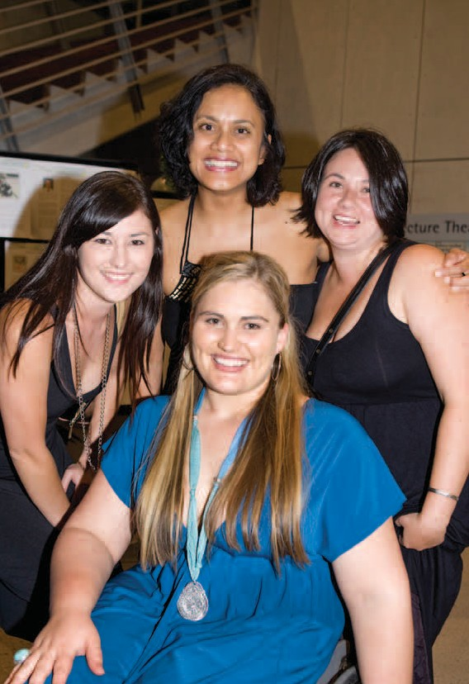

Community Involvement
Central | Community Involvement
A cross section of STEPS’ continuing sponsorship and involvement in their local communities:
    - Silver Sponsorship for TORGAS Awards Night (Apprenticeship and Trainees) in Mackay
    - Naming rights sponsor for Mackay and District Careers Expo, Mackay
    - Sponsorship of James Cook University Inclusive Practice Awards
    - Awarding two students with the Sunshine Coast University STEPS Bursary
    - Sponsorship of the Sunshine Coast Regional Summit, including publishing the “Building Community” research report
    - Sponsorship and event coordination of the 2009 Disability Sector Network Community Luncheon, Bundaberg
    - Sponsorship of the Indigenous Forces at Work Conference, Alice Spring (including a DVD and a book which will feature a dozen ‘storytellers’ sharing their journey from unemployment through training to work
    - Supporting Disability Action Week in all regions
    - Sponsoring an indoor beach volleyball team in Alice Springs, with three staff members
    - Members of the Mental Health Association of Central Queensland
    - Sponsorship of the Hermit Park Tigers AFL club, Townsville
    - Sunshine Coast staff take part in fundraiser, Australia’s Biggest Morning Tea and Jeans for Genes Day

36 STEPS staff at presentation for Sporting Dreams

37
2009 - 2010 Profit & Loss
2009 - 2010 Balance Sheet
Central | Financials
INCOME | 2010 | 2009
Revenue | 14,086,808 | 10,049,391

EXPENSES
Salaries & employee benefits expenses | 8,044,908 | 5,513,853
Advertising & Promotion expenses | 125,369 | 199,977
Depreciation Expenses | 712,821 | 414,016
Other Expenses | 4,654,944 | 2,753,114
PROFIT FROM ACTIVITIES | 548,765 | 1,168,431

CURRENT ASSETS | 2010 | 2009 |  | CURRENT LIABILITIES | 2010 | 2009 |  | EQUITY | 2010 | 2009
Cash and Cash Equivalents | 2,022,076 | 1,934,244 |  | Trade and other payables | 425,849 | 467,465 |  | Retained Earnings | 2,361,060 | 1,192,629
Trade and other receivables | 1,158,426 | 448,911 |  | Financial liabilities | 934,233 | 541,218 |  | Current Year Profit (Loss) | 548,765 | 1,168,431
Other Current Assets | 202,610 | 90,108 |  | Short Term Provisions | 518,156 | 356,817
TOTAL CURRENT ASSETS | 3,383,112 | 2,473,263 |  | Other Accruals | 1,478,108 | 645,074
 |  |  |  | TOTAL CURRENT LIABILITIES | 3,356,346 | 2,010,573
NON-CURRENT ASSETS
Trade and other receivables | 1,153,883 | 514,915 |  | NON-CURRENT LIABILITIES
Property, plant and equipment | 2,237,624 | 1,923,438 |  | Financial liabilities | 405,889 | 462,132
TOTAL NON-CURRENT ASSETS | 3,391,507 | 2,438,353 |  | Long Term Provisions | 102,558 | 77,851
 |  |  |  | TOTAL NON-CURRENT LIABILITIES | 508,447 | 539,983
TOTAL ASSETS | 6,774,619 | 4,911,616 |  | TOTAL LIABILITIES | 3,864,793 | 2,550,557 |  | TOTAL EQUITY | 2,909,825 | 2,361,060

STEPS locations
Locations

Far North Queensland

Aitkenvale
210 Ross River Road,
Aitkenvale
(07) 4727 2600

Ayr
139B Young Street, Ayr (07) 4783 4811

Bowen
Shop 4/36 Powell Street,
Bowen
(07) 4786 9700

Collinsville (Outreach Site)
Shop 1/45-47 Railway Road,
Collinsville
(07) 4785 5900

Cannonvale (Outreach Site)
Lot 2 Hazelwood Crescent (07) 4786 9700

Gin Gin
21 Mulgrave Street, Gin Gin (07) 4157 2884

Mackay
Level 1, 123 Victoria Street,
Mackay
(07) 4957 3950

Northern Territory

Alice Springs
Shop 9/16 Hartley Street,
Alice Springs (08) 8950 7600

Darwin
Suite 1, Level 2, 59 Smith St,
Darwin
(08) 8925 5600

Tennant Creek
Shop 1, 163 Paterson Street,
Tennant Creek (08) 8962 2231

Tasmania
Launceston 194 Charles St Launceston

Hobart
Level 3, 85 McQuarie St Hobart
(03) 6270 2215

Sunshine Coast

Caboolture
Unit 16 The Lakes Centre 8 King St
Caboolture
(07) 5431 6500

Caloundra
9 George St, Caloundra (07) 5436 6000
Central Office Level 1, 60 Wises Rd Maroochydore
(07) 5458 3000

Maleny
Unit 3 Rainforest Plaza 43 Maple Street, Maleney (07) 5429 6090

Maroochydore
78 Duporth Avenue,
Maroochydore (07) 5409 9000

Nambour
Shop 29 Centenary Square,
Nambour
(07) 5453 8700

Noosa
Suite 2/3 Lanyana Way, Noosa Fair Shopping Centre (07) 5455 2700

Victoria

Melbourne
Office 30
204/218 Dryburgh St North Melbourne

Wide Bay Region

Bundaberg
Shop 3/2 Bourbong Street,
Bundaberg
(07) 4150 1900

Hervey Bay
Suite 2/17 Torquay Street,
Pialba
(07) 4194 3900

Maryborough
Shop 1/373 Kent Street,
Maryborough (07) 4120 2800

38

39

STEPS would like to thank our funding bodies for their continued support
Funding Bodies

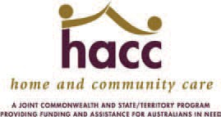

SERVICE
GROWTHVISION

DISABILITY
STRENGTHENING
YOUTH
VENTURES
COMMITMENT RESPECT
EMPLOYMENT

RECOGNISING THE VALUE OF ALL PEOPLE
COMMUNITIES
INTEGRIITY
MOTIVATION
TRAINING
INDEPENDANT
PROFESSIONAL
SOCIAL

INDIVIDUAL
INNOVATION
RECOGNITION

SUPPORT
INCLUSIVE
FULFILLMENT

ACHIEVEMENT
BRIGHTER
FUTURES
PROUD
CREATING
OPPORTUNITIES
PASSION

SUCCESS
INSPIRED

DEVELOPMENT

