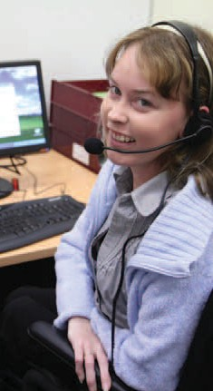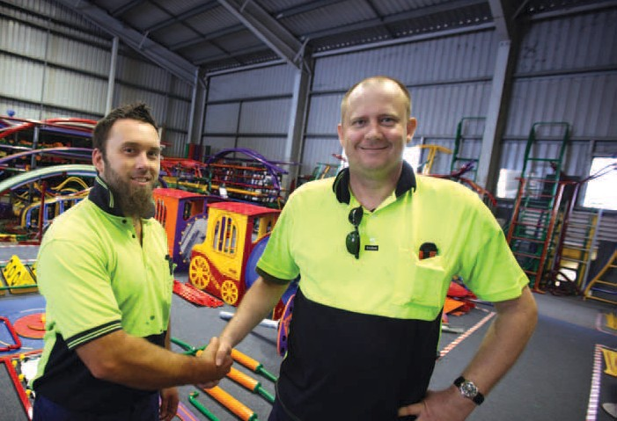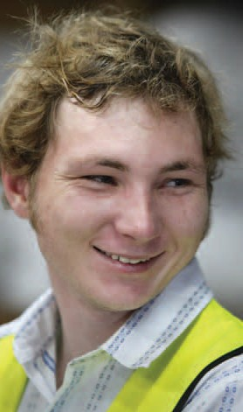
2008-2009 annual report

It’s all about you.

Our vision

To enhance our community by empowering people to maximise their potential.

Foundation values
- Trust, honesty, integrity
- Respect for and recognition of individual needs
- Valuing individuals – their worth as individuals and their contribution
- Valuing opportunity for growth, development and support
- Determination and commitment

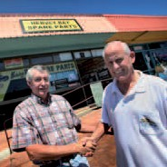annualreport

Contents 1
Our mission 2
Board of Management 2
President’s report 4
CEO report 5
Community Services report 7
Training report 15
Employment report 19
Corporate Services report 29
Finance report 35
Locations 37
Funding 37

annualreport

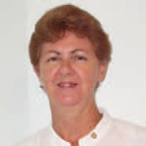

2 Board of Management

President Carmel Crouch Secretary Christine Jones Treasurer Helen Ferguson

Our mission

STEPS will exercise self-determination and ensure continued success and rejuvenation through service, research, development and expansion.
- STEPS will provide high quality services that are founded on our vision, mission and values, ensuring ethical and professional behaviours.
- STEPS will create an organisational environment that seeks and encourages innovation and continuous improvement.
- STEPS will strive to be the organisation of choice for all stakeholders through a caring commitment to our values.
- As an employer, STEPS will provide staff with a secure environment that is stimulating and challenging, embracing open communication and professional development.

annualreport

case study

Porterble Cleaning and STEPS:
10 Stars

Imagine working surrounded by leafy gardens and elegant palms or tackling disgusting A-Current-Affair-style cleanups after a terrible tenant leaves?

3

STEPS Bowen Branch Manager Greg Cummins with Kathy Nicholls, Joadi Bartlett (Owner Manager of Porterble Cleaning Service) and another STEPS client/Porterble Cleaning employee, Jade Paul.

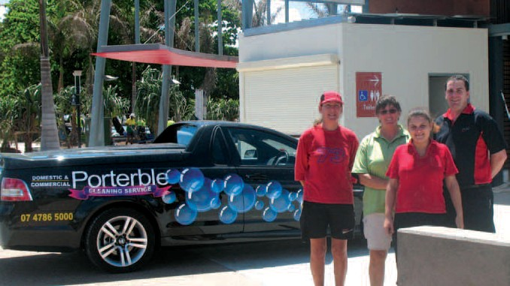These are just a couple of the types of contracts undertaken by Bowen’s Porterble Cleaning Service, all with an eye-for-detail and applying old- fashioned elbow-grease.
STEPS Bowen has developed a strong working relationship with Porterble Cleaning Service, recently placing three clients in suitable work with this reputable local employer. Porterble Cleaning has been a supportive employer, demonstrated by their flexibility in rostering clients according to their capabilities.
Joadi Bartlett of Porterble Cleaning says her greatest reservation as
an employer taking on clients with known disabilities was concern over how her business clients would react.
“I hoped that it would be a positive reaction but until they are in the job and working you never know,” said Joadi, who said she’s encountered only positive responses.

“I am very happy with the staff that I have received from STEPS. They seem to have a positive approach to their job because they really want to work.”

Of the on-the-job support offered by STEPS, Joadi says: “It has been great. It is comforting to know that if we need help, STEPS are there providing support as needed. As
a business we also know that we are giving back to the community of Bowen, providing employment
opportunities for people who are facing some real challenges.”
Kathy is a keen worker with Porterble Cleaning. She moved to Bowen from interstate from
difficult circumstances, looking for a change. On her first appointment with her STEPS Employment Consultant, suffering severe depression, she cried through the whole appointment.
“I was a wreck. There was so much going on in my life,” she said. After stabilising her medication with her doctor, sorting through emergency accommodation and establishing some focus, she began with Porterble Cleaning Service, very nervously.
“It had been a long time since I’d been in an interview, or any sort of work, but STEPS was there and made me feel comfortable. When I found out I had the job I was on cloud nine!

“Right now, I feel invigorated and alive. It is an absolute privilege when clients specifically ask for me to be on their job, because they like what I do. I love working in this team... its like being in a family.”

There are aspects of the job that are unpleasant, like working with harsh chemicals that require wearing “sperm-suits” – protective cover-alls on the job.
It’s just like working-out in a space suit that is very hot and uncomfortable in tropical weather.
Kathy says she focuses on the benefits of being employed. She is excited that she’s bought her own car and is now investing in another love – a horse.
“The truth is without STEPS’ help and support I wouldn’t be where I am now. I feel I have a new life.
In my eyes STEPS gets 10 Stars.”

presidentreport

4

Where does the year go? It seems like such a short time ago that last year’s request came through for the President’s report to be completed, and here I am again to report to you on the ever changing and developing business that is STEPS Disability Queensland Inc.

In these tough economic times, our organisation has not only survived, but continued to grow and prosper.
I credit a good percentage of
that growth and development
as they interact with our valued clients and employers. I am proud to be a part of an organisation that truly believes in, and acts out, its purpose.
increasing ability to find innovative solutions to barriers faced by our industry.
On behalf of my fellow members of
Each member has readily accepted the responsibilities of being part
of STEPS, in addition to being operational business owners in
their own right, with busy lives they
Now is timely to remember the origins of the organisation.
STEPS started in 1989 by a small group of concerned parents
from the Sunshine Coast, who

to our CEO, Garry Hooper who
the Board of Directors, I would like
continue to give of their time freely.
recognised the need for a variety

continues to guide our expanding team from strength to strength, working with our management and staff to ensure the growth of the organisation in line with the strategic plan. His dedication to ensuring the continued success of STEPS is also supported by his commitment that STEPS’ core values remain paramount in the delivery of our services to all stakeholders.
The vision and mission of STEPS is prominently displayed in all of our offices as a source of reference and inspiration. I know that our dedicated staff live and breath
the values of our organisation and implement them into each day
The growth of our organisation over the past financial year has been primarily through the
diversification of our services to provide a broader range of services for the benefit of our clients.

This has been achieved through the dedication of our teams in Training, Community Services and Employment where expansion into new programs has been very successful and our geographic penetration has spread to encompass coastal Queensland
and the Northern Territory. From an operational perspective, staff and management have been energised by our continued growth and
to thank the entire team at STEPS
for their tireless commitment to our service and ensuring that STEPS Disability Qld Inc continues to enhance our community by empowering people to maximize their potential.
I would also like to take this opportunity to acknowledge the dedication of my fellow Board Members of whom it is a privilege to work along side, I am grateful for their support and good counsel, it is invaluable both to me and the organization in helping to steer
this rather large ship through the rocky waters of economic and government change that is our daily challenge.
I thank you from the bottom of my heart for their commitment to our organisation.
Looking ahead, 2010 will provide us the opportunity to celebrate STEPS “coming of age” in its 21st year. It promises to be a year of celebrating our past successes and remembering the challenges we have overcome in our determination to help people with disabilities and disadvantage. We will not allow
this significant year to pass without officially recognising this amazing milestone and in recognition will launch our Foundation at an official function to celebrate our coming of age event; so watch this space.
of employment options for their children and other young people with an intellectual disability.
They applied for and received funding to establish a supported employment agency in 1990, and the organisation has continued to grow and adapt to ever-changing environments, and the rest, as they say, is history.
It is with much anticipation that I look forward to the coming year and the opportunity to work with our dedicated team to continue to strive to be an industry leader and a provider of choice for our clients.

ceoreport

5

From an organisational perspective the 2008-09 year has been a story of growth and diversification. The divisional structure introduced in the 2006-07 financial year was a great success with all divisions experiencing growth and the best financial result in the 20 year history of STEPS.

With growth and diversification
also comes a challenge. The growth in training far exceeded our expectations with our success in the Language, Literacy and Numeracy programs, Health and Community Care training, the only innovation program approved in the Northern Territory called the “Meeting Place”, Productivity Places program, Youth Pathways program and the setting up of new
offices in Tennant Creek and Darwin in the latter half of 2009. These have all contributed to the Northern Territory becoming a major centre for STEPS.
Community Services now has 18 different programs up from the original seven that the division started with in 2008. STEPS purchased a building in the main street of Gin Gin to support the activities of Community Services in that town and its hinterland.
The Employment division has
grown with the merger of Impact Employment Services and the Indigenous Emergency Response in the Northern Territory.
As with any good organisation, new systems have been introduced to simplify procedures and ensure that STEPS remains competitive and efficient.
The present government has made a decision to extend existing contracts by nine months until 28 February 2010, while it determined the future direction of the disability employment sector. As these contracts supply the main income source for the organisation this has been welcomed, but this decision also means that STEPS has not received an increase in income in three years and nine
months. During this time costs have
continued to rise and income will
reduce, so a strategy of growth and diversification continues to be the focus of the leadership team.
What about the future for STEPS? It continues to be bright. At the time of writing we are awaiting
the results of numerous tenders in training, community services and employment. This should ensure the continued growth of STEPS for some years to come. In addition, the uncapping of our employment program will mean literally hundreds of people with a disability will have an opportunity to seek employment earlier than might have been the case under the previous program.
A review of our corporate division will be undertaken to ensure
a focus on customer service and the Australian Business
Excellence Framework is more
prominent. Streamlining of policies and procedures and a greater emphasis on the governance of the organisation will be undertaken.
I would also like to publicly show my appreciation for the support the Board has given me throughout the year, and especially the President Carmel Crouch.
In a fast-changing environment the Board’s expertise and long-term strategic perspective is becoming more critical, as the organisation grapples with an increasing range of critical decisions and weightier issues.
As always, despite the emphasis on income, profit, policy and procedures, STEPS aims to be the best quality organisation it can be for our Board, our staff, our clients and our programs.

Good performance could never happen without the dedication of our staff and the goodwill of those who use our programs.

annualreport

6
case study
Redundancy will be good news for Deb
FEW workers would say that they aim to make their position redundant, but Debbie Rooskov is quite content imagining that a day will come when her job won’t be needed any more.

If that day arrives, it will mean that people with disability will have assistance at all levels because links have been successfully established between the education, training and employment sectors.
A National Disability Coordination Officer (NDCO) with STEPS Community Services, Debbie helps
“These linkages also mean identifying the gaps in local communities and working with other organisations to bring the various services together,” Ms Rooskov says.
“Partnerships are continually being formed or strengthened to create or build on service delivery.”
west and north to the Gulf country. Gary Travers is the NDCO for the northern area.
The program aims to make it easier for people with a disability to make the transition from school or the community to university or TAFE, to increase participation in higher education and to improve links

The program is aimed at any type of physical or psychological disability, from aspergers, autism and ADHD to hearing or visual impairment and injuries.
For some, it will mean support moving to university from high school while for others, it means finding a new career path after an

“NDCO works closely with universities, TAFE colleges, training organisations, secondary schools, providers of employment services, employers and disability service providers to collaboratively engage and provide assistance that
meets the needs of people with a disability,” she said.

make it possible for people with any
between all sorts of organisations for
accident.
More information is available at

disability and of any working age to
“We are inspiring people who
the benefit of people with disability.
www.ndco.stepscs.net.au.

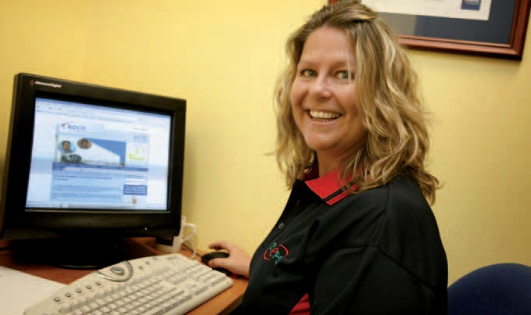advance their education and find
more fulfilling employment.
Her work is about information and referral, as the NDCO
becomes the link that pulls together educational institutions, allied health services, disability service providers, government programs and employers.
may not be aware of the support
available, to enrol for further education and training.”

STEPS has two contracts with the federally funded NDCO program, which together cover almost 70 per cent of the state from the south-east corner to the central
“We also assist with helping move to the next phase of life once the studies have been completed,” she said. “If someone finishes an automotive course, for example, they need to find their way into that industry, not end up as a gardener. We want to make sure they find work in their area of qualification.”
“We need to make sure that people know about all the services that are available to them,” said Ms Rooskov.

community services report

communityservicesreport

8
Barbara Davidson, Manager of STEPS Community Services

The continuing growth of the Community Services division is indicative of STEPS’ increasing focus on community building.

This year ushered in a period of diversification and expansion: new services, new geographical areas, delivered to a wider range of people and people groups.
At the foundation of STEPS Community Services is the delivery of individually tailored services;
the key to strengthening our communities. This has not changed.
The broadening and growth of the division came in response to the Australian Government’s Social Inclusion Policy and priorities, aimed at aiding those marginalised by society, and tackling all forms of disadvantage and deprivation.
This year STEPS Community Services successfully expanded services through procuring various socially inclusive programs and funding released to non- government services. Region-by- region these included:

Wide Bay Burnett
- Multicultural Affairs Grant (Department of Communities)
- Dementia Awareness Initiative Grant (Department of Health
and Ageing)
- Post School Services (Disability Services Queensland )

Northern Territory
- Youth Pathways Program
– Alice Springs, Central
Desert and Barkly Regions (Department of Education, Employment and Workplace Relations)

North Queensland
- NDCO strategic grant to develop an interactive
computer game (Department of Education, Employment and Workplace Relations)
Establishing new programs in regions the size of North
Queensland and Northern Territory presented challenges. In response, STEPS Community Services established a new structure for business planning, forming four separate regions with separate regional plans – Sunshine
Coast, Wide Bay/Burnett, North Queensland and Northern Territory.
The strategy was to identify areas of priority in each region, propose innovative programs for diversification into programs not previously delivered by STEPS, and prove service quality and
experience to new Commonwealth and State funding bodies.
It’s been a busy and exciting time establishing these new programs and taking on the new operations of project management and regional development.

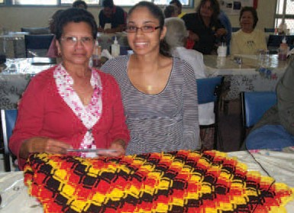Multicultural Affairs Grant, Gin Gin.

With a number of challenges along the way, the journey has taught
us a lot about the importance of local knowledge and the benefits

of forming local partnerships to ensure the acceptance and
success of new program delivery.

Program summary

Multicultural Project
The purpose of this project was to promote ‘community’ through uncovering and celebrating the cultural diversity of the Gin Gin/ Mount Perry region.
Through determination and creativity, the project team assembled, attracted interest and collected wonderful stories about the surprising cultural diversity of the region. Local residents from eight different countries were interviewed. Other activities included:
  - Distribution of a cultural questionnaire to gain a profile of
the region
  - Facilitating community ‘chit- chats’, encouraging interaction
and collaboration

- Working with high schools to create posters and logos
- Production of a community calendar

Through involving prominent individuals, community groups, businesses, schools, government and non-government services, a successful conclusion resulted, that being, ‘mobilising community connection to recognise multi- cultural value’.
A Multi-Cultural Festival is planned to complete the program, and further events to recognise cultural value are planned.

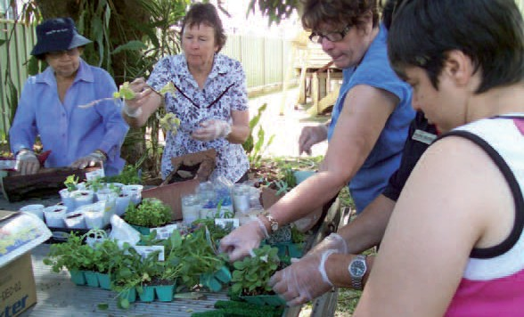 9
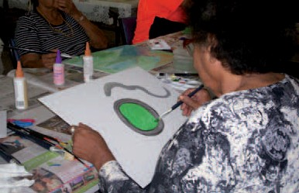Dementia Project

Multicultural Affairs Grant, Gin Gin.
For a number of years, STEPS’ Community Services Coordinator has strongly connected and been involved with the Indigenous Community in the Burnett Shire. Indigenous Elders in the region identified a need to educate their communities about dementia symptoms and care. There are approximately 2277 Indigenous people living in the region, of these 7.8% are over 45 years of age.
In response to this need STEPS has developed and provides a Dementia
Care and Education Program informing community members about dementia symptoms and care in a culturally appropriate way. The objective is to reduce the stigma of dementia and encourage access to care and support.
Elders and community members of Taribelang, Gurang Gurang, Kabi Kabi and Waka Waka Aboriginal Communities have assisted in development of an interactive, activity based program incorporating language, culture and song.
The program is personally tailored to treat each participant by
using such proven methods as reminiscence, validation, sensory and Snoezelen Therapy principles. And of course, the meetings provide opportunities for social interaction and group learning.
Participants have taken ownership of the program and are keen to continue the program beyond its official completion in February.

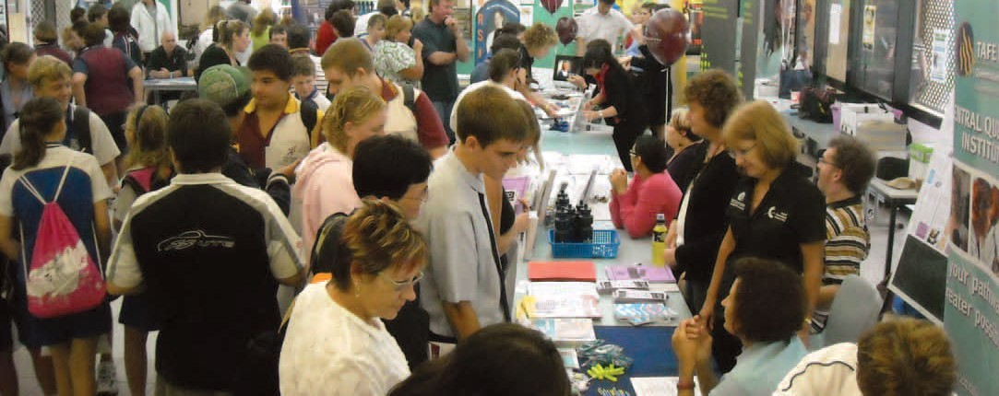communityservicesreport

10

NDCO
(National Disability Coordination Officer)
The momentum of achievement in the two NDCO regions represented by STEPS Community Services continued throughout this year.
The broad geographical range covered by the two NDCO officers (70% of Queensland) continues to present challenges, tackled through innovation and the mobilization
of networks. The groundbreaking NDCO website designed for the two regions (20 and 22) continues to be a key tool, reducing the tyranny of distance, and facilitating information sharing and networking.

A plethora of events and projects initiated in both regions directly delivered on the programs objectives of “coordination and referrals to deliver support services for people with disabilities that are, or will be, attending university, TAFE or other training organisations”.
Throughout this year, stronger links were built with a wide range of services to facilitate this objective of smoothing the transition of people with disabilities between educational facilities and the workplace.
A total of 29 projects were completed across both regions, including:

  - The distribution of several hundred USBs to first-year,
full-time students with disabilities in TAFEs and universities in both regions.
  - Tertiary Taste Programs held in Ipswich (USQ Springfield, UQ
Ipswich, Bremmer TAFE), and Toowoomba (USQ) promoting disability services offered by each educational facility.
  - Holding the first Post School Options event for students with
disability in the Mackay Region. The event, held in September 2008 and again in June 2009 attracted service providers,

students, teachers and parents. Attendance of all target groups more than doubled at the second event, with 23 service providers and 130 students, parents and teachers attending in june.
    - A teacher awareness breakfast held on the Sunshine Coast
facilitated discussion of scenarios to help teachers engage and retain students with disabilities.
    - With the assistance of James Cook University, NDCO are
developing an interactive computer game to address the issues faced by people with
NDCO Mackay Post-School Options Day

disabilities as they move through school, TAFE, University and into employment. The game has a futuristic theme to capture the interests of young people and carries the core message that people with disabilities can succeed if they access the help available.
In the interests of encouraging a whole-of-community approach to the objectives of the NDCO program, partnerships with universities, TAFEs, peak bodies and numerous other program
providers were established in both regions.

Workplace Assessment Services

Disability Services
Youth Pathways Program 11

STEPS Community Services provide Supported Wage System and Workplace Modifications Scheme assessments to metropolitan and regional Queensland. Assessment services are provided to industries including hospitality, retail, transport / motoring, Government
/ Local Council / private business administration, banking, emergency services, child care, agriculture
/ horticulture, aged care and cleaning. STEPS assessors have received consistently positive feedback from employers, Disability Employment Network providers, JobAccess and the Supported Wage Management Unit.

Supported Wage System
The Supported Wage System funds Workplace Assessors in determining the productivity of a
worker in a workplace by measuring the particular worker’s productivity against a co-worker who is skilled to do the same job. The objective of the process is to determine a formal and legally binding agreement determining minimum productivity rates and wage rates. In the past year STEPS workplace assessors have completed 185 assessments.

Workplace Modifications Scheme
The Workplace Modifications Scheme funds physical or environmental workplace adjustments or specific items of equipment that reduce barriers to employment and increase productivity for workers with
a disability. STEPS workplace assessors have completed 40 assessments in the past year.
STEPS Community Services continues to deliver in-home respite and community access to 13 clients in Gin Gin and North Burnett.
Also in this region, STEPS delivers Post School Services for school leavers with disability who do
not have access to vocational training or employment options. The program aims to provide skill development in core life skills areas through individual and community based experiences.
Youth Pathways Program aims to assist the most at-risk young people to successfully complete year 12 (or its equivalent) and ultimately transition to further
education, training or employment; and also actively works to engage young people in the communities of Central Australia.
STEPS Community Services is the third provider of the program in the Northern Territory region. Where other providers have failed STEPS have succeeded, successfully registering 46 participants in 6 months and meeting Government requirements.
The Santa Theresa region is a success story, with both the number of students attending and regularity of student attendance
in the high school dramatically increasing due to STEPS Youth Pathways.

communityservicesreport

12
testimonial
Finding solutions for the workplace
Sometimes very small things make a very big difference, and Brian Kerr can change people’s lives by giving a tweak to their workplace.

The STEPS Community Services Workplace Assessor comes up with all sorts of clever solutions to make it possible for people with a disability to gain or retain employment.
It might be something as simple as an adjustable car seat or a pair of left-handed scissors, or a bigger reconstruction project to allow wheelchair access, but to Brian, it’s just another challenge to be met.
For example, the employer of a woman who lost her arm in a car accident was keen to have her back on the job, but without her right hand, she was unable to return to her former office position. It was agreed she could work in the mail room but it was difficult using her elbow and neck to hold the envelopes.
Brian stepped in and developed a foot-operated machine that clamped down on the back of an envelope and held it while she
inserted a letter. The machine took the place of her missing hand and could also help her folding letters.
“As it was her right hand, she also needed a left-handed guillotine,” he says.
Once it has been determined that a workplace modification is needed, Brian sets to work, inspecting the site to understand and assess
the problem and then compiling a report on how it can be solved.

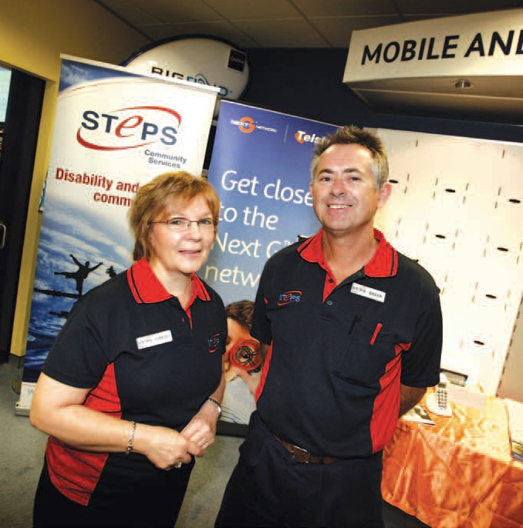

STEPS’ Workplace Assessor, Brian Kerr (right), with Manager of Community Services, Barbara Davidson.

communityservicesreport

“I come in for the assessment and to record the barriers and solutions if they are known. If not, I will come up with a solution to remove the barrier,” he says.

A manufacturing industry worker who had no hearing was at risk in the machinery shed where trucks were constantly coming and going and he had to be constantly

“He couldn’t do it. He couldn’t
understand or accept that the car 13
wasn’t going to fall on him,” Brian says. “We got him a strong steel hoist that put the car well above his

vigilant. Mirrors were placed at
head and he didn’t have to crawl

“If I can’t find something to solve
critical points so that he could
under it. He loved it.

the problem in Australia, I look at
always see what was behind him.

The Braille note reader has many of the functions of a conventional laptop. Through the nine key Braille
what’s available overseas or invent it myself by drawing up something by hand or computer for an engineer to work on.”
His work takes him to many parts of the country and his background is an interesting mix that qualifies him perfectly for the job.
A former teacher and tradesman baker and pastry cook, he has been working in the disability field for 12 years, so that he has an understanding of both sides of the story.

“My life’s experience helps me in finding solutions,” he says.
“By simply putting up some mirrors he was able to have enjoyable employment,” Brian says.
“He could do the job for which he had the skills and also could do what his employer was comfortable in allowing him to do.”
On a larger scale, a wall might be knocked out to modify a toilet or a room design changed to allow
wheelchair access. Similarly a ramp or stair crawler might be all that is needed.
And it’s not all about physical injury. There are also modifications that can help those with psychological
“The psychological barrier
was removed.”

“Modifications to the workplace or equipment reduce barriers to
employment and really do enhance the lives of people and allow
equal opportunities for all,” he says. “It can improve productivity, reduce pain and discomfort, allow someone to be employed for more hours each week, help them work more closely with others and improve self-esteem and confidence.”

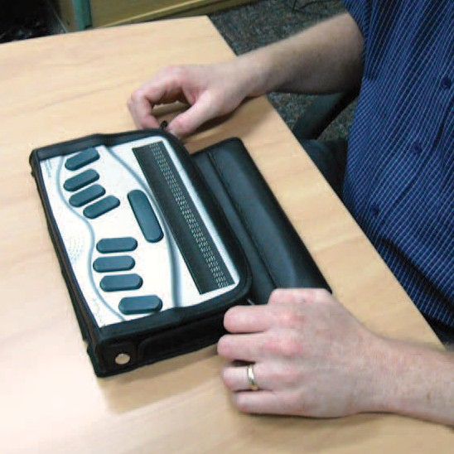keyboard, users can create Braille or Word documents or output to voice.
disabilities remain in the workforce.
A teenager who was hit on the head with a bottle had to learn life over again but was keen to work as a mechanic. His injury had left him with paranoia and he was unable
to climb under the cars for fear the jack would fail.

communityservicesreport

14 STEPS Community Service’s Commonwealth and State contracts and grants provide an annual gross income of $673 200

Supported Wage System

Youth Pathways
Workplace Modifications Scheme

NDCO
Region 20

NDCO
Region 22

Strategic Funding

NDCO Region 20
NDCO Region 22 Strategic Funding Disability Services Multicultural Awareness
Community Development Grant
Dementia Community Program Grant
Youth Pathways Supported Wage System
Workplace Modifications Scheme

Dementia Community Program Grant

Multicultural Awareness Community Development Grant

Disability Services

training report

16
Shelly Campbell, Manager, STEPS Training

This expansion across such a broad geographical area has required a coordinated, cooperative approach from many people across the STEPS organisation – from Information and Communications Technology, Finance, Human Resources and the unwavering support of Employment and Community Services Divisions.

This financial year has seen STEPS Training embark on a journey of rapid growth and expansion across Queensland and the Northern Territory.

Our strategy of cultural integration and empowering our trainers
to deliver individualised and customised training has paid dividends, and has received recognition from our funding bodies, industry and peers.
For example, something as simple as a builder’s metal tape measure has assisted many long-term

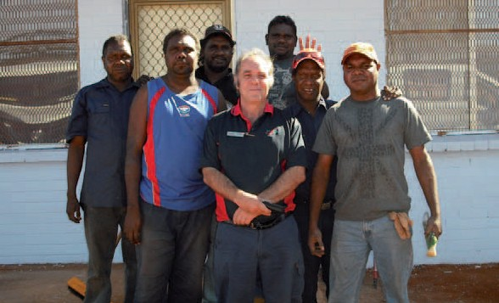

Language Literacy & Numeracy Program (DEEWR)

To all those who contributed to the implementation of new programs and the subsequent great results for so many of our students, I thank you for your commitment.
The past 12 months gave STEPS Training an opportunity to demonstrate the flexibility and responsiveness we have aspired to as a Registered Training Organisation (RTO). We have
delivered new programs in remote regions previously not encountered by our organisation.
unemployed to dream again.
The tape measure, used as a tool to plan and build a fence within a student’s own community as part of numeracy and literacy training, has given students a new
start. Many now have the skills and opportunity to confidently contribute to their community.
STEPS Training was awarded
funding under the Northern Territory Emergency Response to deliver literacy and numeracy
training in seven remote Indigenous Communities in Central Desert and Barkly Shire. These Communities were Yuelamu, Yuendumu, Areyonga, Papunya, Haasts Bluff, Mt Liebig and Imanpa.
Trainers live on community and integrate into the community life, engaging in activities such as football. This strategy provided
us with early success as it has
shown STEPS commitment to the development of skills of individuals as well as the capacity of the community as a whole.
Trainers maximise the engagement with participants by working alongside Community Development Employment Programs, Work for the Dole and Women’s Community Centres to deliver customised literacy and numeracy training.
This training compliments and strengthens the employment
programs in which they are
participating, and develops skills that can be transferred into the real jobs on community that currently remain unfilled due to skills shortages.
Having secured funding for 2009- 2010, STEPS Training will build stronger community links and continue to apply innovative and responsive training and assessment methods to meet the changing needs of indigenous job seekers throughout the Northern Territory.

trainingreport

17
case study
STEPS Training graduates measure up
Sitting on the edge of the Tanami Desert, 350 kilometres north west of Alice Springs,
the remote community of Yuendumu is one of the largest Aboriginal communites in central Australia.

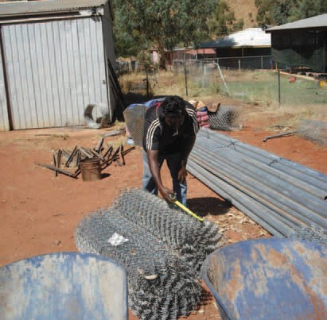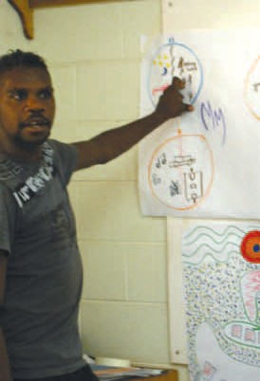Through the work of STEPS Training, nine people from the Yuendumu community enjoyed a renewed sense of achievement and improved self esteem.
trainingreport

17
In August, the nine workers registered with the Community Development Employment Project (CDEP) became the first in the community to complete 160 hours of Literacy and Numeracy training, conducted by STEPS Training’s Tim O’Dea.
Tim is one of several STEPS trainers working in the Northern Territory, conducting the Language, Literacy and Numeracy Program (LLNP) funded by the Department of Education Employment and Workplace Relations (DEEWR).

Through consulting with the local shire, the LLNP training conducted by STEPS not only increased the employability of the local workers, but directly contributed to the community.

Through their registration with CDEP, the nine participants performed general maintenance and cleaning around the community. Through observation, STEPS Trainer Tim O’Dea noted that the participants could do most tasks, but due to limited literacy and numeracy skills, often struggled with more complex duties.
Using such instruments as a Stanley FatMax steel tape measure, (pictured on page 15) STEPS’ training focused the participants
on practical numeracy such as measurement and quantities. As part of their training the participants identified materials needed to refit the shire offices, and assisting in the building of a six kilometre cyclone fence around the community airstrip.

Having completed their first block of training, the graduates now have their sights set on further training in the area of building construction.

This will further maximize their opportunities for securing paid employment, perhaps in
construction to meet the demands of upcoming house projects being rolled out across the Northern Territory.

18 Home & Community
Care Project (HACC)
STEPS Trainers deliver Home and Community Care (HACC) training throughout Alice Springs and Tennant Creek Business Service Areas.
Trainers and assessors travel extensively, working closely with the community care workforce in Ampilatwaja, Ali Curung,
Alpurruralam, Utopia, Elliot District, Julilikari (Tennant Creek), Ti Tree, Yuelamu, Yuendumu, Nyrippi, Wilora, Lajamanu, Laramba and Atijere. This training is funded jointly by the Department of Health and Ageing (DoHA) and the Northern Territory Department of Health and Families (NTDHF).
Trainers provide a training environment that incorporates lateral methods of training and assessment, with consideration given to working to overcome identified low levels of literacy and numeracy of participants in these remote areas.

Productivity Places
Program (PPP)
Under the Skilling Australia for the Future initiative, the Australian Government has funded the Productivity Places Program (PPP) which will deliver 711,000 training places over five years.
These training places are being delivered in an industry-driven system, ensuring that training is more responsive to the needs of industry and participants.
STEPS Training have risen to this challenge by delivering customised training to 14 job seekers that incorporated an innovative mix of both classroom and on-the-job traning in line with the demands of employers in the Sunshine Coast area to maximise opportunity of securing paid employment on completion.
90% of participants were awarded their qualification of Certificate IV in Disability Work with the majority now working in the industry.

Take Aim II
STEPS Training has received funding from the Queensland State Government under the Skilling Queenslanders for Work initiative. The Take Aim II program seeks to enhance vocational and life skills of 20 job seekers with a goal
of maximising opportunities for sustainable job placements in Housekeeping.
With the Support of Twin Waters Resort, job seekers were able to practise their new skills first hand.

Scope of Registration

Our scope of registration now includes:
(all held within NSW, Vic, Qld, SA and NT)
BSB20107 Certificate II in Business
BSB40807 Certificate IV in Frontline Management
CHC20102 Certificate II in Community Services Support Work CHC20202 Certificate II in Community Services Work
CHC20302 Certificate II in Community Services (First Point of Contact) CHC30102 Certificate III in Aged Care Work
CHC30202 Certificate III in Home and Community Care CHC30302 Certificate III in Disability Work
CHC30802 Certificate III in Community Services Work CHC40102 Certificate IV in Aged Care Work CHC40302 Certificate IV in Disability Work CHC40502 Certificate IV in Employment Services CHC40902 Certificate IV in Community Services Work
CHC41602 Certificate IV in Community Services (Lifestyle and Leisure) SIR20207 Certificate II in Retail
SIR30207 Certificate III in Retail SIT20207 Certificate II in Hospitality 30625QLD Certificate I in Work Readiness
30719QLD Course in Adult Literacy and Numeracy 39099QLD Course in Skills for the Future 39150QLD Course in Vocational Literacy 39151QLD Course in Vocational Literacy 1 39152QLD Course in Vocational Literacy 2 39153QLD Course in Vocational Literacy 3 39160QLD Course in Vocational Numeracy 39161QLD Course in Vocational Numeracy 1 39162QLD Course in Vocational Numeracy 2 39163QLD Course in Vocational Numeracy 3
39170QLD Course in Pre-Training Assessment - Vocational Literacy 39171QLD Course in Pre-Training Assessment - Vocational Numeracy 39180QLD Course in Vocational Literacy - Contextualised
39181QLD Course in Vocational Numeracy - Contextualised

employment report

employmentreport

20
John Conway, General Manager, STEPS Employment

There has been another year of growth and diversification for STEPS Employment Services division from both an operational and leadership perspective.

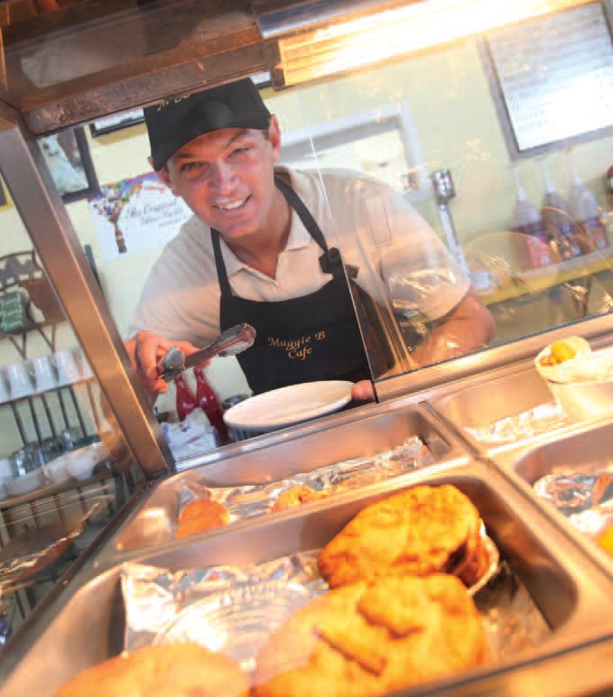
There has been another year of growth and diversification for STEPS Employment Services division from both an operational and leadership perspective.
Staffing levels have increased due to additional numbers of jobseekers and workers being assisted, principally through the uncapped Program and the 2008 school leavers allocation.
The global financial crisis saw a decline in the numbers of positions available in the labour market compared to the previous year, and required STEPS staff to double their efforts to ensure that we continue to supply quality programs, services and job opportunities.
At the heart of this work we see the potential of many people realised to live more full and meaningful lives through employment.

Empowering people to maximise their potential
Over the last 12 months we have seen growing numbers of people experience difficulties as housing affordability rates and the cost of living has risen and opportunities for employment have declined. Many Australians
with a disability who want to work still experience difficulties finding suitable employment. Training and assistance have become crucial for the welfare of individuals.
In this context there is a great deal of opportunity for STEPS Employment to assist people with disabilities
to realise their aspirations, so that they can participate in the labour market and enjoy the same degree of self determination as the broader community. STEPS Employment has responded to these challenges and demands across all program areas.

employmentreport

Our People
In order to achieve our goals STEPS Employment is continuing to develop new strategies and improve upon our service delivery. As part of this process significant resources have been invested into updating policies and procedures, staff training and succession planning. At individual branches, staff attended a variety of training courses including specific mental health training to increase their skills base in order to better assist and support both participants and their employers.
In December 2008, STEPS Nambour were successful in becoming the preferred provider of Disability Employment Services for a research project with Queensland Mental Health (QMH) on the Sunshine Coast. The partnership with QMH commenced in February 2009. The project - Sunshine Coast Integrated Employment Project (Southern Cluster) - involves co-locating a psychiatric specific Employment Consultant within
two mental health units to be part of their treating teams. The aim is to provide a more intense and individualised service for participants suffering from severe mental illness resulting in better employment outcomes.

I was pleased to ensure that the STEPS Graduate Placement Program, assisting graduates with a disability, was approved by the Board to continue following the DEEWR funding end date of 13 June 2008. The program was
re-launched as a Sunshine Coast initiative of STEPS Employment that will cover stakeholders from Sunshine Coast and Brisbane. The long term objective is to extend the program to a national level.
I would like to congratulate staff across the Employment division who have continued to contribute to the improvements in our third- party software program, DENMAX. This system has delivered major reductions in the administration burden as well as providing more detailed and timely reporting, analysis and other management reports.
STEPS Employment Division Regional Managers, Branch Managers and staff have worked hard to achieve great results and I thank them for their commitment.

Quality Assurance
STEPS Employment division is committed to providing a quality service to all its stakeholders including service users and employers. An important part of our service is encouraging feedback from stakeholders to assist us in determining whether the service we deliver is of a high standard.
Every year STEPS Employment must be externally audited to be a certified provider. NCS
International’s external audit report confirmed STEPS Employment meets or exceeds the 12 Disability Service Standards requirements. The author noted:
“STEPS Employment is to be commended for the high level of commitment to providing quality employment outcomes for people with disabilities demonstrated at all levels of the organisation.”

21
The professionalism of the staff was evident through interviews and observations of interactions with clients during the site visits.
This was further validated by the participants with comments such as:
- “they make me feel fantastic”
- “they go above and beyond”
- “they show they care”
- “they do an excellent job”
- “they are on my team”
- “they are 100% behind you”.
STEPS also achieved ISO 9001:2008 certification in December 2008 and in June 2009, this was confirmed during a successful follow up audit.
Although this was an excellent result, STEPS Employment continues to make improvements to our systems and processes as
part of our commitment to Business Excellence.

employmentreport

22

Strategic Accomplishments

It is a pleasure at the end of another financial year to report a successful year both financially and in our performance measures.
STAR Ratings contract to date (DEC 09) were released in March 2009 and confirmed our continual improvement in performance with most sites improving in rating or percentiles across the board. Our most recent Health Checks indicate that we are continuing to make steady progress. Our goal is to be an organisation with an average 4 STAR rating by June 2009.
DEEWR have offered us the opportunity to take over the DEN contract at Tennant Creek from the existing provider. This contract is for 25 capped places and puts us into an area where STEPS Training and Community Services are already delivering services. This has increased our capped program contracted capacity by 3%.
We have increased our organisational capped capacity by 21 places by taking up DEEWR’s offer of additional capped places for 2008 school leavers. This
represents a 2.5% growth in
our capped program contracted capacity and will also improve our Invitation to Treat (ITT) position.
Our uncapped program has now passed the 400 participant
milestone and continues to grow. Performance in the uncapped stream is very strong with all offices above the national average in securing 26 week outcomes for our participants.
The merger with Impact Employment Service in Townsville officially took place on 1st July
2008. Management and staff at Impact have embraced the
change and the level of cooperation between the two organisations
has resulted in the transition progressing smoothly over the last 12 months. Plans are well
underway for the colocation of both services to a new purpose built site in Aitkenvale in August 2009.
We have begun the roll out across all branches of the STEPS Equity Employer Group to formerly recognise and reward employers who provide opportunities to
people with disability. Our initial event hosted Wayne Bennett, well known NRL and Australian coach, and was attended by over 150 employers in Townsville. Another event is planned to launch the Equity Employers Group on the Sunshine Coast.

employmentreport

case study

Trailblazing a new career

Bruce White is a valued staff member with Maleny-based business, Fraser Island Trailblazer Tours.
23

Bruce White (left) with Tom Bradbury, Company director of Fraser Island Trailblazer Tours.

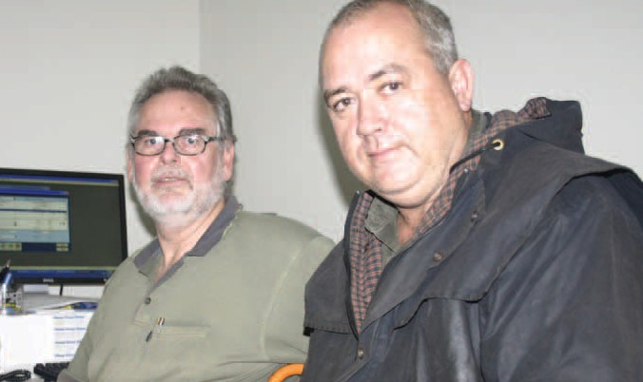He coordinates the bookings and logistics of tour groups of up to 20 people, mostly students and
backpackers, for three-day guided tours. It can be hectic.
Since joining the business last year, Bruce has taken on more and more responsibilities, and
Company Director Tom Bradbury is thoroughly confident in handing the responsibilities over.
Looking back however, Tom admits to hesitation when Bruce entered the interview room in a wheelchair. In fact, on first impressions he wanted to cancel the interview, thinking Bruce unsuitable for the rigorous demands of working for an outdoor adventure tour business.
But six months later, Tom is so glad he made a few small changes to accommodate Bruce, who will soon graduate from the University of the Sunshine Coast with an accountancy degree.
“Bruce had everything I needed in an employee, except that ability to go to Fraser Island. But there was a lot to do, and I needed another person anyway so I put a young bloke on to do the running around,” said Tom.
“Bruce is very stable and has a very positive attitude. He’s never
depressed and he’s always up. He’s virtually running the business like
it’s his – he’s the exact employee I needed.”
Since losing the use of his legs through a string of sporting injuries at the age of 21, Bruce filled a number of administration roles in the health industry and earned two degrees in Health Services Management. After an illness, he found himself unemployed, looking
for answers. He felt that his age and disability often became barriers to employment.
“I couldn’t find work in the health sector – either government or private – so I decided to close that chapter. I hadn’t seen too many unemployed accountants, so I went back to university and did something that would be viable,” said Bruce.
One day a poster at the University, advertising STEPS Graduate Program, caught Bruce’s eye. The program offered free assistance for students with disability to find employment; Bruce applied and became the program’s first client.
While STEPS Graduate Program didn’t directly source the job with Fraser Island Trailblazer Tours, Bruce said that the specialised support offered during his journey from education to employment was invaluable. Program coordinators also arranged for significant modifications to Bruce’s new workplace and a wage subsidy.
“The Graduate Program gave me the opportunity to ‘get out there’
a little more. The program gives you another pair of eyes and ears looking for a job that fits your skills capabilities.”
Bruce said that Tom was shocked to learn a specially modified desk and bitumen resurfacing of the car park, both necessary to sustain Bruce’s job, were fully funded by the Federal Government.
“I love the variety and autonomy I have in this position. Whatever gets thrown at me I do – administration, accounting, customer service
and a little bit of human resource management. I’m ordering a new bus at the moment. This job’s given me the opportunity to combine a lot of skills.”

employmentreport

24

case study
Taking giant steps
Having a career with a disability is much easier with the right help

While most students relax on their study-free days, Rebecca spends the day volunteering at a child-care centre to further her career.
Every second Thursday since February, Rebecca has been volunteering as a child-care assistant, while completing a Certificate II in Children Services through school.
This work experience was formalised by Rebecca’s employment consultant at STEPS Employment.

“As a matter of course, we don’t expect our jobseekers to do unpaid work experience, but we do believe that it gives them a taste for the industry that they want to enter, while enhancing their employability skills,” STEPS Marketing Consultant Geoff Dettl said.

Rebecca has been diagnosed with Autism Spectrum Disorder and has been a participant on the STEPS Employment program since January 2009, where she has attended Job Club, which discussed resume preparation, interview techniques and job skills.

This dedication to her finding employment has now paid off.

Rebecca has been offered a school-based traineeship.
The traineeship will see Rebecca complete her Certificate II and then go on to undertake her Certificate III in Children Services while still completing her senior years at Bundaberg High.

employmentreport

25

case study

Best person for the job
Chantelle Woolston was over the moon when she was appointed as project co-ordinator for Disability Action Week and International Day of People with Disability in July.

Chantelle Woolston (right), and STEPS Employment Consultant Evelyn Thompson.

Chantelle has been employed by Best Choice Bookkeeping, a great
Chantelle was kept busy organising events throughout Bundaberg as

“She was employed on her merits,” Evelyn said.

supporter of the Disability Network,
part of Disability Action Week. She

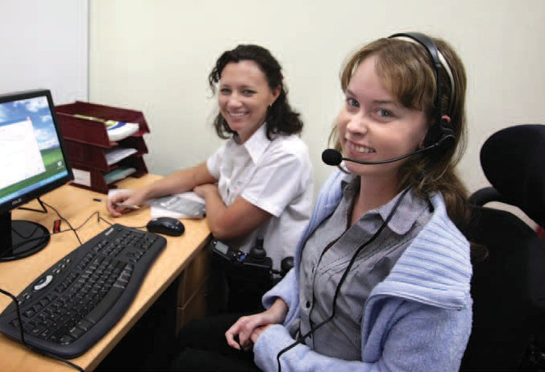on a six-month contract to fulfil these roles and works from STEPS Employment. This ensures her Employment Consultant is on hand to offer work-place assistance and mentoring.

“I was interviewed in the morning and was told I had the job that afternoon,” Chantelle said. “It was very exciting.”
has muscular dystrophy, a disease she has lived with her whole life, but do not think for a minute that has slowed her down.
An avid horse enthusiast, she loves to get out and ride in her buggy and has been appointed the secretary of the Bundaberg Harness Club.
STEPS Employment Consultant Evelyn Thompson said Chantelle was chosen from a large selection as the best person for the job.
“Being able to employ someone with a disability is so empowering for them as well. Employers soon realise that there is so much support available from both local services and government.”
For Chantelle to undertake her role, her work station has been set up with special voice recognition
software and appropriate computer equipment.

employmentreport

26

case study
Work is first for Sam
Sam Miles celebrated 12 months since she began working as a clinic assistant in the relaxed, friendly surrounds of a Townsville day spa.

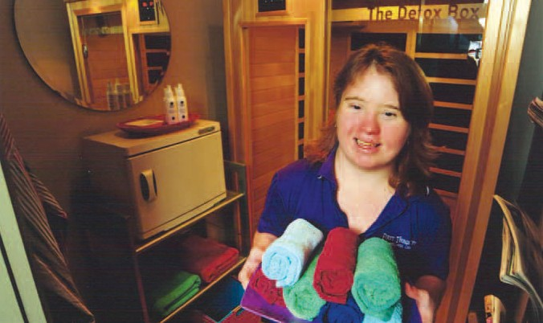The 25-year-old ensures the busy First Things First day spa’s
masseurs have clean freshly dried towels at their fingertips.
It is a far cry from the fish and chips shop where she had worked previously. Since starting at First Things First, Sam has quickly become a valued member of the team at First Things First.

“My job is to clean and dry towels, which I do in two dryers and two washing machines,” Miss Miles said. “I love this job, it is my dream come true.

“All the girls I work with are very nice. I think I will be here for a while.
“I like to play Bon Jovi and I can listen to them when I am at work
– I am their biggest fan. I also like Michael Jackson.”
First Things First general manager Megan Flux said Miss Miles had come to them through STEPS Employment, and she didn’t know what they would do without her now.
“We went with STEPS because we get so much support from them,” Mrs Flux said. “They have people who will train and learn the job alongside the new employee.
“Sam does her job better than most and she takes ownership of her work.”
STEPS Employment Support Consultant for Miss Miles is Chrissey Sheriff who is as proud as a parent of her young trainee’s achievements.
“Sam came to us nearly two years ago and her family had just come over from Perth,” Mrs Sheriff said. “She is a delightful young lady and we were very fortunate to get her a job at First Things First. She has
fitted in there very well and the staff have embraced her.

“They have supported and encouraged her and she has grown so much since she has been there.”

Employment Outcomes Achieved
350

300

250
2006 FY
2006 FY
2006 FY
2006 FY
200

150

100

50

0
4 Week Outcomes
13 Week Outcomes
26 Week Outcomes
Number of Outcomes Achieved
employmentreport

27
Other
Jobs found for participants
by industry type
Transport and storage
Accommodation, cafes and restaurants
Property and business services
Agriculture, forestry and fishing
Manufacturing
Personal and other services
Retail trade
Health and community services
Accommodation, cafes
and restaurants Manufacturing Retail trade
Health and community
services
Personal and other services
Agriculture, forestry and fishing Property and business services Transport and storage
Other
Hearing (3%)
Acquired brain injury (4%)
Other/not specified (5%)
Vision (2%)
Autism (2%)
Speech (1%)
Breakdown of participants
by disability type
Psychiatric (29%)
Intellectual (11%)
Psychiatric (29%)
Physical (15%)
Neurological (15%)
Intellectual (11%)
Other/not specified (5%) Acquired brain injury (4%) Hearing (3%)
Autism (2%)
Vision (2%)
Speech (1%)
Neurological (15%)
Physical (15%)

employmentreport

28 Future Developments
The draft tender for the new Disability Employment Network contract was released on 20th May 2009. This is to be followed by
an Invitation to Treat (ITT) process which is a roll over of the capped program places for providers who are performing at three stars or above. Current uncapped clients will also transition into Program
B for providers receiving ITT. It is expected approximately 90% of our capped program will receive ITT and 90% of our uncapped clients will transition into Program B.
The tender process is well underway, with Senior Management Team members attending the Donna Eiby training program in the Rapid Response Bid Management System. Research is being compiled and we have narrowed
a possible 116 ESAs down to 31. We intend that STEPS Employment will tender for 27 ESA’s across four states.

To ensure the continued smooth running of employment services for the period during and following the tender process acting Regional Managers have been appointed.
I am pleased to announce that from June 2009 these roles have been filled by Lee-Anne Whalley for the region covering North Queensland and Northern Territory and Steven Chand for South-East Queensland.
The “Big Art Project” funded under the DEEWR Innovation Fund has been approved in Alice Springs commencing in October 2009.
Funding of $650,000 over three years for this social enterprise project has been secured.

In Closing
Our work is not possible without the support of many people, Regional Managers, Employment Managers and staff, Corporate Services, Divisional Managers and staff and of course our hard working Board. We thank everyone who has made a contribution to our success. We would also like to express our thanks to DEEWR, employers and our business partners.
Next year marks the 21st year of delivering successful services
helping people achieve their goals and aspirations. In the year ahead we look forward to continuing the delivery of services to our existing clients, and the prospect of the opportunities that will unfold during the next 12 months with the roll out of the new services.

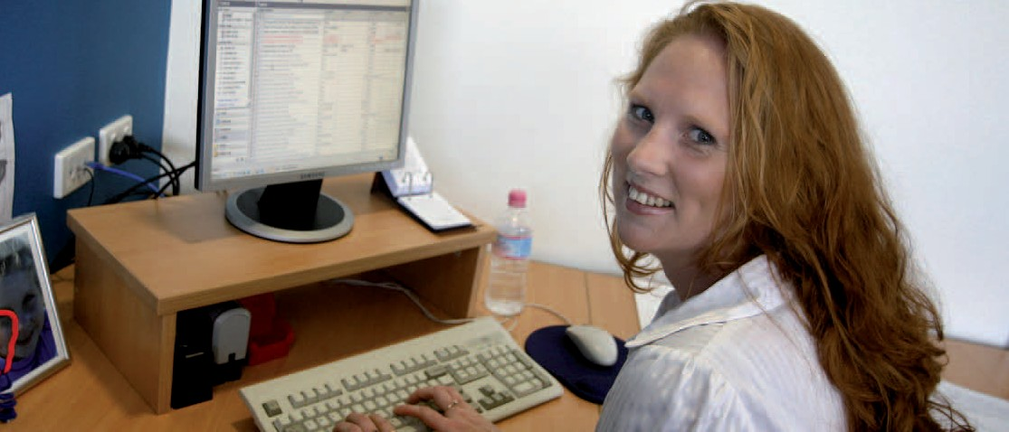corporate services report

corporateservicesreport

30 The consistency of growth and change throughout STEPS over the past

Now for a snapshot of these achievements:

12 months required innovation and a flexible approach to how Corporate Services delivered support to the organisation and three divisions.
- The introduction of uniforms across the STEPS organisation
presented a standardised, professional image to clients, businesses and the community.
  - Refurbishment of the Bundaberg office was
completed in late 2008.
  - Administration assisted with the

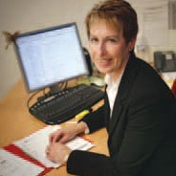
Corporate Services Manager, Paula Payne
Through a cohesive approach to
problem solving, often involving all departments of Corporate Services, the team sought to support Employment, Training, Community Services, and the organisation reach their objectives.
In this challenging, dynamic environment, the emphasis is not only to sustain growth, but also managing growth so it is sustainable over the long-term.
Overcoming challenges presented by the broadening geographical base of the organisation now spread over thousands of kilometres, a 40% increase in staffing levels, and planning for
an increase in office locations needed continual assessment. Could we support the delivery of services at the local level, and could economies of scale and
efficiencies be found by divisions working together or sharing resources?
Additionally, moving the Business
Excellence Unit from Corporate Services to the Executive early in 2009 meant a change to decision making processes and the support Corporate Services gave directly to the divisions and branches.
Departments within Corporate Services – Human Resources, Finance, Information and Communication Technology and Marketing/Public Relations – report elsewhere within this report.
However, I’ll take this opportunity to give an overview of the achievements of the Administration team over the past 12 months.
The role of the Administration team is to ensure the provision of high level administrative support,
records management, management of property, equipment and motor vehicles across the organisation.
I commend the team on their professionalism in reaching many goals and doing so with a spirit of excellence.
Commencing 1st January and mandatory from 1st July, the administration department co- ordinated the ordering, payment and distribution of the uniforms.
  - Community Fleet Services (CFS) operates a fleet management
and administrative service for non-profit organisations in Australia. With a Memorandum of Understanding with CFS in place, STEPS began working with CFS for management of over 70 vehicles. CFS provides valuable assistance in vehicle selection, pricing, procurement and disposal strategies.
  - STEPS’ Bowen branch sustained major flood damage
following heavy rain in early January, resulting in water entering the building from the roof. Fortunately, temporary accommodation became available within the same complex, while office repairs took place. After taking
the opportunity to perform additional refurbishment of the office, the branch re-opened in late February.
purchase and refurbishment
of Community Services office premises in Gin Gin.
  - With the growth of the Training Division, the training room
and shop front at Nambour received a facelift. The training room was remodelled and re- furnished, and the shop front was decorated with signage and painted externally.
  - Additional office space was secured at Alice Springs to
accommodate the growth in the Training and Community Services Divisions.
  - The administration team has supported all divisions with
preparation and submission of tenders, travel arrangements and the production and distribution of Stepping Stone newsletter.
  - In addition to these accomplishments Corporate
Services continues to assist in developing the overall strategic direction of the organisation.

corporateservicesreport

Business Excellence Unit (BEU) 31

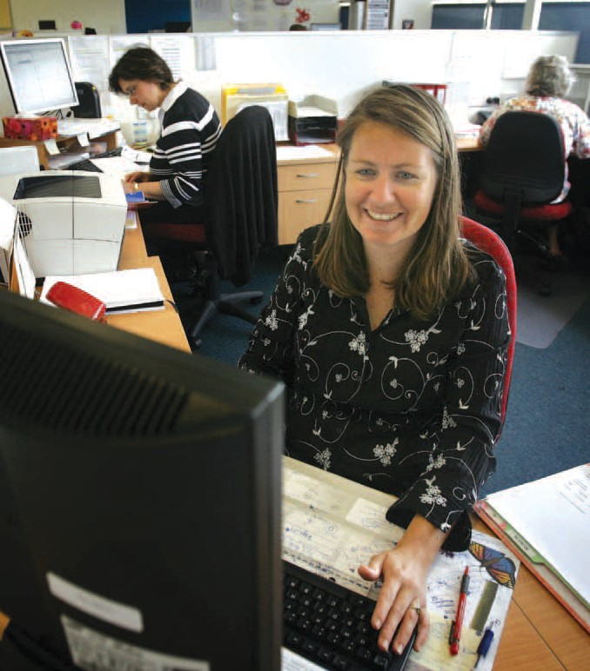In this financial year, the Business Excellence Unit (BEU) started the process of building the principles of Business Excellence into the day- to-day operations of STEPS. This process commenced with a review of the current communication strategies, and the quality management and continuous improvement systems.
In addition to this review, the BEU also began development of an organisational performance management system and a
comprehensive customer feedback process to measure satisfaction and understand what customers value.
As the organisation continues to grow and diversify the BEU will support the continued
development and evolution of the quality management systems to ensure high quality service that meets customer expectations and contractual requirements.
In early 2009 Blake McMillan and Andrew Spark joined Samantha
Geeson, Kris Hobbs, Isabel Hooper and Narelle Jones in the BEU team.
The BEU was actively involved in STEPS achieving certification
under ISO 9002:2008 in December 2008. This certification recognises the application and commitment shown by STEPS to its quality management system.
In the Disability Employment Services Quality Assurance (DESQA) audit, STEPS Employment was commended for its high level of commitment to providing quality employment outcomes for people with disabilities.
The auditors also noted that the smooth merger of Impact
Employment and the consistency of service delivered across all sites demonstrated the integrity of the quality management system.

corporateservicesreport

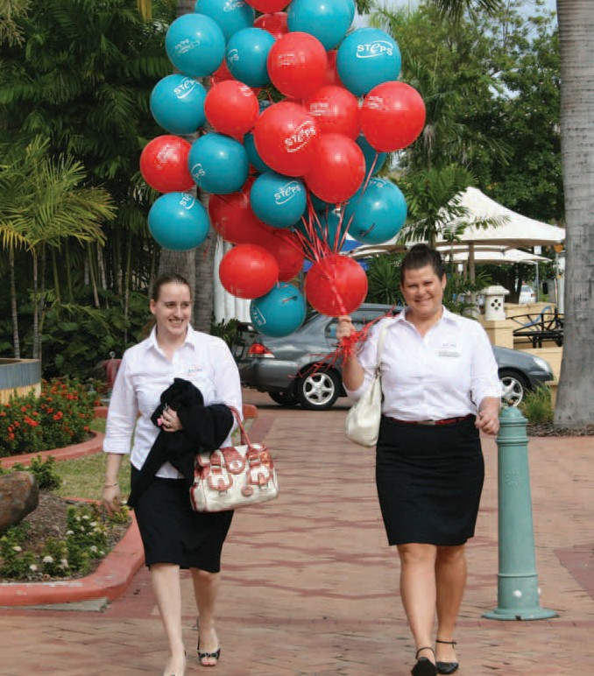32 Human Resources

Staff Statistics at a glance
Since 1 July 2008 the number
of employees at STEPS Disability Qld Inc. (SDQ) has increased by 40 to 134.
The 134 staff are distributed as follows:
Division | Number of Staff
Community Services | 15
Corporate Services | 18
Employment Services | 84
Executive Services | 8
Training Services | 9

The 84 staff employed in the Employment Services Division are located at the following branches:
Branch | Number of Staff
Aitkenvale | 7
Alice Springs | 8
Bowen | 6
Bundaberg | 10
Caloundra | 10
Forest Glen | 1
(Corporate Office)
Hervey Bay/Maryborough | 11
Maroochydore | 10
Nambour | 15
Townsville | 6

During the same period 28 staff left the organisation. These 28 staff include eight casual and two specific period staff who did not continue in regular employment.

STEPS welcomed 13 new staff members to the team on 1 July 2008 as a result of successful merges with Capability Concepts in Gin Gin and Impact Employment in Townsville.
Some of the major achievements of Human Resources in the past year include:
    - Roll-out of the new Performance Management and
Development Policy.
    - A review of the Workplace Health and Safety Policy
and the introduction of Workplace Health and Safety Representatives in each site. All representatives were elected by staff and undertook a three day external training course.
    - Start of research into a comprehensive Human
Resources Information Management System combining both Human Resources and Payroll functions.
    - Development and roll-out of the following policies:
      - Uniform
      - Salary Packaging
      - Motor Vehicle Transition
      - Mobile Phone

corporateservicesreport

Marketing and Public Relations 33

The scope of communication methods and technology in today’s society continues to increase; so too the scope of marketing and communications used by STEPS to connect with our customers and stakeholders.
Over the past 12 months, through small and large scale events, electronic media, print and internet technology, STEPS promoted
its message in the four regions of Sunshine Coast, Wide Bay, Townsville and Alice Springs.
Though the method of delivery diversified, the message and its purpose remained consistent and true to the vision of the organisation.
The marketing and communication function of each division of
STEPS – Community Services, Employment and Training – differed considerably, mostly due to each division’s different stage of growth.
Employment being in a mature stage of its growth enjoyed greater levels of innovation in its marketing, for example 20 Jobs in 20 Days campaign and the launch of the Equity Employer Group. While marketing/communication activities for Community Services and Training focused on foundational needs.
For all the obvious achievements over the past 12 months for
the marketing department, the most critical element within the marketing mix will continue to be integration. That is, melding and integrating the marketing of STEPS within the strategies, systems and operations of the organisation.
Great efficiencies and improved performance and customer relationship management will result.
STEPS extends sincere thanks to Wayne Bennett, the iconic rugby league coach, for his generosity over the past 12 months. His voluntary contribution has lifted the public profile of STEPS, STEPS’ services, and the cause of people with disability.
Mr Bennett appeared as guest speaker at two employer breakfasts
- one held on the Sunshine Coast and the other in Townsville. A combined crowd of over 250 people attended the events, captivated
by the personal insights shared by Mr Bennett into employing people with disability and also his highly successful coaching career.
The STEPS Equity Employer Group, a membership group designed to reward and recognise employers who provide opportunities to people with disabilities, was launched at the Townsville breakfast. Awards were given to two quality local employers. The Equity Employer Group will continue to grow and expand – watch this space.
All branches continued to increase their community profile through attending numerous expos and events, and actively pursuing publicity in local media. Caloundra branch for example, held an engaging art exhibition, showcasing the work of four Sunshine Coast clients. The opening of the exhibition, part of STEPS 20th anniversary celebrations, was well attended and attracted excellent local publicity (not to mention promoting the work of our clients).
The 20 Jobs in 20 Days campaign is possibly the biggest marketing campaign in STEPS, history. Held in March 2009, the campaign (named to coincide with STEPS 20th anniversary) coordinated printed material and radio advertising/live reads in four regions, and for the first time, jobseeker details were posted on our website. Through the generosity of local radio stations, STEPS received just over $13,000 worth of radio advertising free as part of the campaign.
The Bundaberg branch held a highly successful 20/20 cricket day as part of the campaign, engaging clients, employers and community groups.

Hot on the heels of the 20 Jobs Campaign came a revised television campaign in three regions – Sunshine Coast, Wide Bay and Townsville. This campaign featured employer testimonials specific to each region, and again due to the generosity of television stations, STEPS received significant levels of complimentary advertising.
The new STEPS website launched early this financial year continues to be a strong focus for all communication/marketing initiatives.
Sending the right message, to the right people using the right media at the right time will continue to build the brand of STEPS so it is synonymous with empowering individuals and building communities. Everyone has a vital role to play in achieving this goal.

corporateservicesreport

34

Information and Communication Technology (ICT)
2008-2009 proved a busy year for STEPS’ Information and Communication Technology (ICT) Department, with significant developments across the entire organisation.

  - All senior and line managers received a Blackberry,
contributing to the organisation’s goals to improve service by enhancing manager’s accessibility and productivity, streamlining communications and information sharing.

for their contribution (through DonorTec) for supplying the upgraded Cisco switches now installed at various branches.
Software donations were also received from Project Companion.

video conferencing was installed across the Next IP network. Units are located at STEPS’ Head office, Bundaberg and Townsville. Telstra showcased STEPS’ video conferencing facilities through a video case study as part of their

The growth in Community Services
and Training, and opening of new offices in Alice Springs and Gin Gin, stretched existing ICT resources. As a result, during the year thin clients and laptops increased by 55 units. An additional two servers were added, and in June ICT increased staff by one with a full-time help- desk technician.
Other achievements:
- The Queensland Government Gambling Community Fund
provided funding to establish four resource centres on the Sunshine Coast, assisting our job seekers with their job search.
  - ICT capabilities were greatly aided by access to low cost
Microsoft software through DonorTec, a program assisting nonprofits in Australia through technology infrastructure.
Through DonorTec STEPS purchased SharePoint, a key program used in the tendering process. STEPS thanks Cisco
- STEPS implemented a new
virus and anti-spam solution,
moving platforms to a hosted solution, which has not only effectively stopped SPAM, but reduced internet traffic downloads.
- Using state-of-the art Polycom room-based videoconferencing
equipment, Telstra IP based
B2B marketing strategy. The video case study is currently being shown nationally at all Telstra hosted events. The video is included in Telstra’s latest advertising campaign, was shown on Kochies’ Business Builders TV show, and can be currently viewed on YouTube (enter search criteria “STEPS Disability”).

financereport
STEPS Disability Qld Inc
ABN 77 168 213 648

Finance report 35

Income Statement for the year ended 30 June 2009

 | 2009 | 2008
Revenue | 10,049,391 | 7,597,672
Salaries & employee benefits expenses | 5,513,853 | 4,284,012
Advertising & promotion expenses | 199,977 | 44,128
Depreciation expenses | 414,016 | 367,609
Other Expenses | 2,753,114 | 2,108,661
Profit from activities before income tax expense | 1,168,431 | 793,262
Income tax expense
Profit from activities after income tax expense | 1,168,431 | 793,262

financereport
STEPS Disability Qld Inc
ABN 77 168 213 648

36 Statement of Financial Position as at 30th June 2009
2009 2008
CURRENT ASSETS

A full financial report is produced as
Cash and cash equivalents | 1,934,244.15 | 698,521.31
Trade and other receivables | 454,356.28 | 329,241.37
Other current assets | 90,107.64 | 28,502.45
TOTAL CURRENT ASSETS | 2,478,708.07 | 1,056,265.13
NON-CURRENT ASSETS
Trade and other receivables | 514,915.41 | 316,337.65
Property, plant and equipment | 1,917,992.61 | 1,608,487.35
TOTAL NON-CURRENT ASSETS | 2,432,908.02 | 1,924,825.00
TOTAL ASSETS | 4,911,616.09 | 2,981,090.13
CURRENT LIABILITIES
Trade and other payables | 467,465.05 | 357,700.40
Financial liabilities | 541,218.51 | 423,244.41
Short-term provisions | 356,816.60 | 237,131.62
Other accruals | 645,073.71 | _
TOTAL CURRENT LIABILITIES | 2,010,573.87 | 1,018,076.43
NON-CURRENT LIABILITIES
Financial liabilities | 462,131.56 | 710,031.38
Long term provisions | 77,850.78 | 60,353.23
TOTAL NON-CURRENT LIABILITIES | 539,982.34 | 770,384.61
TOTAL LIABILITIES | 2,550,556.21 | 1,788,461.04
NET ASSETS | 2,361,059.88 | 1,192,629.09
EQUITY
Members Equity | 2,361,059.88 | 1,192,629.09
TOTAL EQUITY | 2,361,059.88 | 1,192,629.09

an appendum to this annual report and is available upon request from STEPS’ Central Office.

STEPSlocations

Central Office

Level 1, 60 Wises Road
MAROOCHYDORE QLD 4558
PO Box 8027
MAROOCHYDORE DC QLD 4558 Ph: (07) 5458 3000
Fax: (07) 5458 5033

STEPS’ Sites

AITKENVALE
210 Ross River Rd PO Box 122
AITKENVALE QLD 4814
Ph: (07) 4727 2600
Fax: (07) 4727 2666

ALICE SPRING
Jock Nelson Centre Shop 9/16 Hartley Street
ALICE SPRINGS NT 0870 PO BOX 79
ALICE SPRINGS NT 0871 Ph: (08) 8950 7600
Fax: (08) 8950 7650

AYR
139B Young Street PO Box 587
AYR QLD 4807 | Ph: | (07) 5438 5500
Ph: (07) 4783 4811 | Fax: | (07) 5438 5599
Fax: (07) 4783 3800

BOWEN
Shop 4/36 Powell Street PO Box 574
BOWEN QLD 4805
Ph: (07) 4786 9700
Fax: (07) 4786 9777

BUNDABERG
Shop 3/2 Bourbong Street PO Box 2059
BUNDABERG QLD 4670
Ph: | (07) 4150 1900
Fax: | (07) 4150 1919 | HERVEY BAY  2/17 Torquay Road

CALOUNDRA
37 Bowman Road

COLLINSVILLE
Shop 1, 45/47 Railway Road COLLINSVILLE QLD 4804
PO Box 574
BOWEN QLD 4805

GIN GIN
21 Mulgrave Street GIN GIN QLD 4671
Ph: (07) 4157 2884
Fax: (07) 4157 2883

PO Box 3040
PIALBA QLD 4655
CALOUNDRA QLD 4551 | Ph: | (07) 4194 3900
PO Box 8027 | Fax: | (07) 4194 1504
MAROOCHYDORE DC QLD 4558

MAROOCHYDORE
78 Duporth Avenue
PO Box 8027
MAROOCHYDORE DC QLD 4558 Ph: (07) 5409 9000
Fax: (07) 5409 9090

37
MARYBOROUGH
Shop 1, 373 Kent Street
PO Box 597
MARYBOROUGH QLD 4650
Ph: (07) 4120 2800
Fax: (07) 4123 4600

NAMBOUR
Shop 29 Centenary Square Currie Street
NAMBOUR QLD 4560
PO Box 8027
MAROOCHYDORE DC QLD 4558 Ph: (07) 5453 8700
Fax: (07) 5453 8770

NOOSA
Suite 2, 3 Lanyana Way Noosa Fair Shopping Centre NOOSA HEADS QLD 4567 PO Box 8027
MAROOCHYDORE DC QLD 4558 Ph: (07) 5447 2711
Fax: (07) 5474 9302

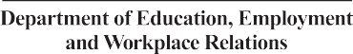STEPS would like to thank our funding bodies for their continued support.

Department of Employment and Training

STEPS Disability QLD Inc. PO Box 8027, MAROOCHYDORE DC 4558

Phone: (07) 5458 3000 Fax: (07) 5458 3033 Email: enquiries@steps.net.au
www.steps.net.au

